**NETWORKING & SYSTEM ADMINISTRATION LAB**

**Name: Merin joseph**

**Roll No: 20**

**Batch: B**

**Date: 04/04/2022**

**Experiment No.: 5**

**Aim**

Familiarization of the linux commands.

**Procedure**

**1. cp**

cp means copy. 'cp' command is used to copy a file or a directory.

Syntax :- $ cp filename1 filenme2

Output :-



**2. cp -r**

This command is used to copy a directory along with its sub dirctories..

Syntax :- $ cp -r directory1 directory2

Output :-



**3. cp -i**

This command asks for confirmtion.

Syntax :- $ cp -i filename1 directory1

Output :-

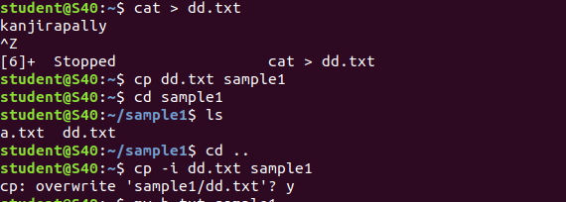

**4. mv**

This command is used to move existing file or directory from one location to another. It is also used to rename a file or directory.

Syntax :- $ mv file1 directory1

Output :-



->This command is used to move existing file or directory from one location to another.

Syntax :- $ mv directory1 directory2

Output :-

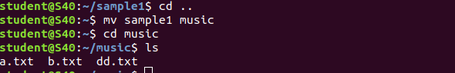

**5. mv -i**

This command is asks for permission to over write

Syntax :- $ mv -i file1 directory1

Output:-

