**NETWORKING & SYSTEM ADMINISTRATION LAB**

**Name: Merin joseph**

**Roll No: 20**

**Batch:MCAB**

**Date: 5-4-2022**

**Experiment No.: 2**

**Aim:-**

Identify the major components of a computer such as motherboard,RAM modules,daughter guards,bus slots,SMPS,internal storage devices and interfacing ports.

# Motherboard

A motherboard (also called mainboard, main circuit board or mobo) is the main printed circuit board (PCB) in general-purpose computers and other expandable systems. It holds and allows communication between many of the crucial electronic components of a system, such as the central processing unit (CPU) and memory, and provides connectors for other peripherals. Unlike a backplane, a motherboard usually contains significant sub-systems, such as the central processor, the chipset's input/output and memory controllers, interface connectors, and other components integrated for general use.

Motherboard means specifically a PCB with expansion capabilities. As the name suggests, this board is often referred to as the "mother" of all components attached to it, which often include peripherals, interface cards, and daughterboards: sound cards, video cards, network cards, host bus adapters, TV tuner cards, IEEE 1394 cards; and a variety of other custom components.

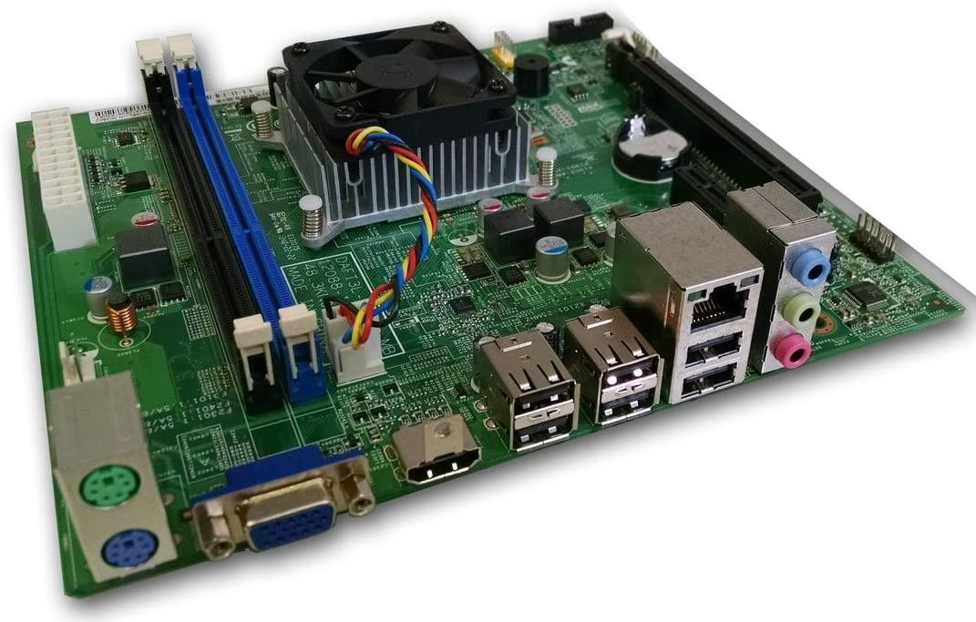

# RAM modules

A memory module is another name for a RAM chip. It is often used as a general term used to describe SIMM, DIMM, and SO-DIMM memory. While there are several different types of memory modules available, they all serve the same purpose, which is to store temporary data while the computer is running.

Memory modules come in different sizes and have several different pin configurations. For example, the original SIMMs had 30 pins (which are metal contacts that connect to the motherboard). However, newer SIMM chips have 72 pins. DIMMs commonly come in 168-pin configurations, but some DIMMs have as many as 240 pins. SO-DIMMs have a smaller form factor than standard DIMM chips, and come in 72-pin, 144-pin, and 200-pin configurations.

While "memory module" is the technical term used to describe computer memory, the terms "RAM," "memory," and "RAM chip" are just as acceptable. But remember, while memory terms may be interchangeable, the memory itself is not. This is because most computers only accept one type of memory. Therefore, if you decide to upgrade you computer's RAM, make sure the memory modules you buy are compatible with your machine.

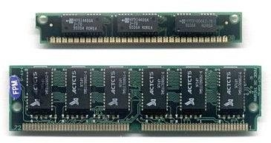

# Daughter guards

A daughterboard is type of circuit board that plugs in or is attached to the motherboard or similar expansion card to extend its features and services. A daughterboard complements the existing functionality of a motherboard or an expansion card.

A daughterboard is connected directly to the motherboard. Unlike expansion cards, which connect with the motherboard using bus and other serial interfaces, daughterboards are usually directly embedded through soldering. Like a motherboard, a daughterboard has sockets, pins, plugs and connectors to be attached to other boards. Typically, daughterboards are released as a post-launch update to a motherboard or expansion card. For example, a MIDI daughterboard is used to add on the functionality of the sound card.

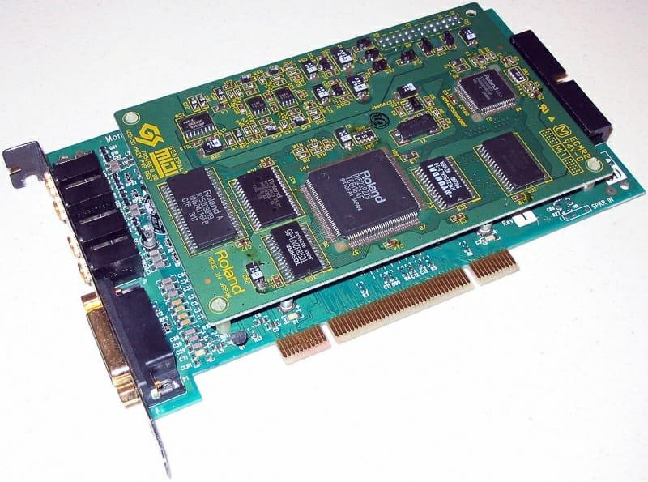

# Bus Slots

Alternatively known as a bus slot or expansion port, an expansion slot is a connection or port inside a computer on the motherboard or riser card. It provides an installation point for a hardware expansion card to be connected. For example, if you wanted to install a new video card in the computer, you'd purchase a video expansion card and install that card into the compatible expansion slot.

Below is a listing of expansion slots commonly found in a computer and the devices associated with those slots.

* AGP - Video card.
* AMR - Modem, sound card.
* CNR - Modem, network card, sound card.
* EISA - SCSI, network card, video card.
* ISA - Network card, sound card, video card.
* PCI - Network card, SCSI, sound card, video card.
* PCI Express - Video card, modem, sound card, network card.
* VESA - Video card.

Many of the expansion card slots above are obsolete. You're most likely only going to encounter AGP, PCI, and PCI Express when working with computers today.

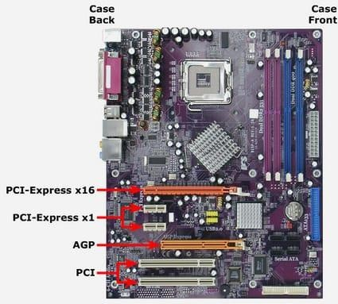

# SMPS

SMPS (Switched Mode Power Supply ) is an electronic power supply system that makes use of a switching regulator to transfer electrical power effectively. It is a PSU (power supply unit) and is usually used in computers to change the voltage to the appropriate range for the computer.

An SMPS adjusts output voltage and current between different electrical configurations by switching the basics of typically lossless storage such as capacitors and inductors. Ideal switching concepts determined by transistors controlled outside of their active state that have no resistance when ‘on’ and carry no current when ‘off.’ It is the idea why switches with an ideal function will operate with 100 per cent output, that is, all input energy is provided to the load; no power is wasted as dissipated heating. In fact, such ideal systems do not exist, which is why a switching power source can not be 100 per cent proficient, but it is still a vital improvement in effectiveness over a linear regulator.

In the SMPS device, the switching regulators are used which switches on and off the load current to maintain and regulate the voltage output. Suitable power generation for a system is the mean voltage between off and on. Unlike the linear power supply, the SMPS carry transistor switches among low dissipation, full-on and full-off phase, and spend much less time in high dissipation cycles, which decreases depleted strength.

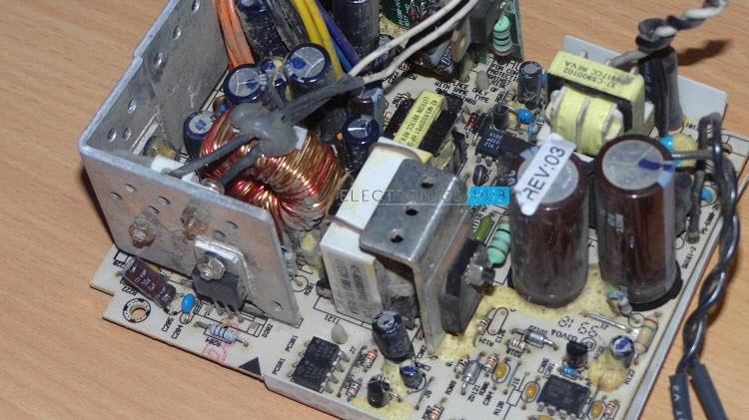

## Benefits of SMPS

* The switch-mode power source is small in scale.
* The SMPS is very lightweight.
* SMPS power consumption is typically 60 to 70 per cent, which is ideal for use.
* SMPS is strongly anti-interference.
* The SMPS production range is large.

## Limitations of SMPS

* The complexity of SMPS is very large.
* The production reflection is high and its control is weak in the case of SMPS.
* Use of SMPS can only be a step-down regulator.
* In SMPS, the voltage output is just one.

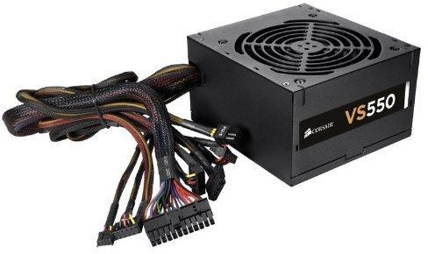

# Internal storage devices

A storage device is a piece of hardware that is primarily used for storing data. Every desktop computer, laptop, tablet, and smartphone will have some kind of storage device within it. There are also standalone, external storage drives that can you can use across devices.Storage is not only necessary for saving files, but also for running tasks and applications. Any file you create or save on your computer saves to your computer’s storage device. This storage device also stores any applications and your computer operating system.

A storage device is also known as a storage medium or storage media. Digital storage is measured in megabytes (MB), gigabytes (GB), and, these days, terabytes (TB).

Some computer storage devices are able to hold information permanently while others can only hold information temporarily. Every computer has both primary and secondary storage, with primary storage acting as a computer’s short-term memory, and secondary as a computer’s long-term memory.

## Primary Storage: Random Access Memory (RAM)

Random Access Memory, or RAM, is the primary storage of a computer.

When you’re working on a file on your computer, it will temporarily store data in your RAM. RAM allows you to perform everyday tasks like opening applications, loading webpages, editing a document or playing games. It also allows you to jump from one task to another without losing your progress. In essence, the larger the RAM of your computer, the smoother and quicker it is for you to multitask.

RAM is a volatile memory, meaning it cannot hold onto information once the system turns off. For example, if you copy a block of text, restart your computer, and then attempt to paste that block of text into a document, you’ll find that your computer has forgotten the copied text. This is because it was only stored temporarily in your RAM.

RAM makes it possible for a computer to access data in a random order, and thus reads and writes much faster than a computer’s secondary storage.

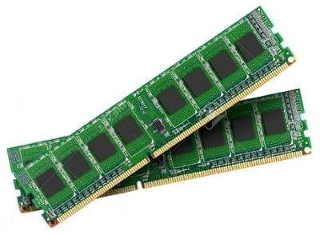

## Secondary Storage: Hard Disk Drives (HDD) & Solid-State Drives (SSD)

In addition to RAM, every computer also has another storage drive that’s used for storing information on a long-term basis. This is secondary storage. Any file you create or download saves to the computer’s secondary storage. There are two types of storage device used as secondary storage in computers: HDD and SSD. While HDDs are the more traditional of the two, SSDs are fast overtaking HDD as the preferred tech for secondary storage.

Secondary storage devices are often removable, so you can replace or upgrade your computer’s storage, or move your storage drive to a different computer. There are notable exceptions, like MacBooks, which don’t offer removable storage.

## Hard Disk Drives (HDD)

The hard disk drive (HDD) is the original hard drive. These are magnetic storage devices that have been around since the 1950s, though they’ve evolved over time.

A hard disk drive is comprised of a stack of spinning metal disks known as platters. Each spinning disk has trillions of tiny fragments that can be magnetized in order to represent bits (1s and 0s in binary code). An actuator arm with a read/write head scans the spinning platters and magnetizes fragments in order to write digital information onto the HDD, or detects magnetic charges to read information from it.

## Solid-State Drives (SSD)

Solid-state drives emerged far more recently, in the ‘90s. SSDs don’t rely on magnets and disks, instead they use a type of flash memory called NAND. In an SSD, semiconductors store information by changing the electrical current of circuits contained within the drive. This means that unlike HDDs, SSDs don’t require moving parts to operate.

Because of this, SSDs not only work faster and smoother than HDDs (HDDs take longer to gather information due to the mechanical nature of their platters and heads), they also generally last longer than HDDs (with so many intricate moving parts, HDDs are vulnerable to damage and wear).

Outside of newer PCs and high-end laptops, you can find SSDs in smartphones, tablets, and sometimes video cameras.

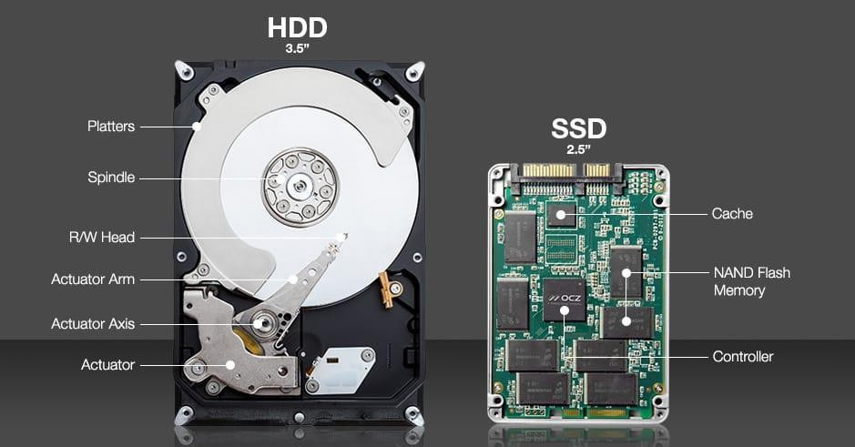

# Interfacing ports

A port is a physical docking point using which an external device can be connected to the computer. It can also be programmatic docking point through which information flows from a program to the computer or over the Internet.

## Characteristics of Ports

A port has the following characteristics −

* External devices are connected to a computer using cables and ports.
* Ports are slots on the motherboard into which a cable of external device is plugged in.
* Examples of external devices attached via ports are the mouse, keyboard, monitor, microphone, speakers, etc.

A few important types of ports −

## Serial Port

* Used for external modems and older computer mouse
* Two versions: 9 pin, 25 pin model
* Data travels at 115 kilobits per second

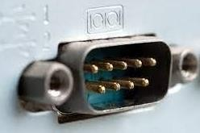

## Parallel Port

* Used for scanners and printers
* Also called printer port
* 25 pin model
* IEEE 1284-compliant Centronics port

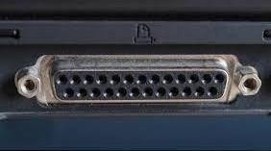

## PS/2 Port

* Used for old computer keyboard and mouse
* Also called mouse port
* Most of the old computers provide two PS/2 port, each for the mouse and keyboard
* IEEE 1284-compliant Centronics port

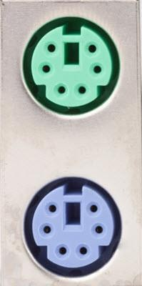

## Universal Serial Bus (or USB) Port

* It can connect all kinds of external USB devices such as external hard disk, printer, scanner, mouse, keyboard, etc.
* It was introduced in 1997.
* Most of the computers provide two USB ports as minimum.
* Data travels at 12 megabits per seconds.
* USB compliant devices can get power from a USB port.

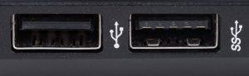

## VGA Port

* Connects monitor to a computer's video card.
* It has 15 holes.
* Similar to the serial port connector. However, serial port connector has pins, VGA port has holes.

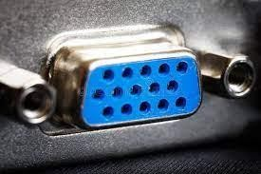

## Power Connector

* Three-pronged plug.
* Connects to the computer's power cable that plugs into a power bar or wall socket.

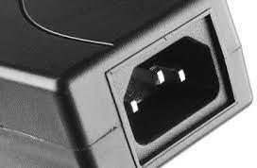

## Firewire Port

* Transfers large amount of data at very fast speed.
* Connects camcorders and video equipment to the computer.
* Data travels at 400 to 800 megabits per seconds,Invented by Apple.
* It has three variants: 4-Pin FireWire 400 connector, 6-Pin FireWire 400 connector, and 9-Pin FireWire 800 connector.

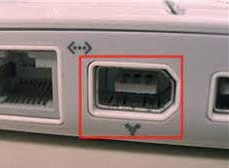

## Modem Port

* Connects a PC's modem to the telephone network.

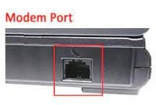

## Ethernet Port

* Connects to a network and high speed Internet.
* Connects the network cable to a computer,resides on an Ethernet Card.
* Data travels at 10 megabits to 1000 megabits per seconds depending upon the network bandwidth.

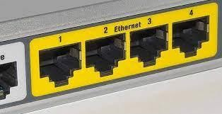

## Game Port

* Connect a joystick to a PC
* Now replaced by USB

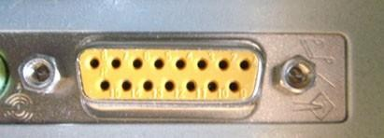

## Digital Video Interface, DVI port

* Connects Flat panel LCD monitor to the computer's high-end video graphic cards.
* Very popular among video card manufacturers.

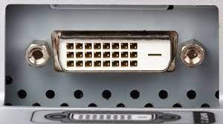

## Sockets

* Sockets connect the microphone and speakers to the sound card of the computer.

