**Name: merin joseph**

**Roll No:20**

**Batch:mca b**

**Date:21-4-2022**

**NETWORKING & SYSTEM ADMINISTRATION LAB**

**Experiment No.: 7**

**Aim**

Familirization of a linux commands

**Procedure**

**1.read**

The Linux read command is used to read the contents of a line into a variable.

*Syntax*

*$ read variable_name*

**Output Screenshot**



**2.locate**

The locate command and [find](https://www.javatpoint.com/linux-find) command is used to search a file by name. But, the difference between both commands is that locate command is a background process and searches the file in the database whereas, find command searches in the filesystem. The locate command is much faster than find command.

Syntax

$locate filename.txt

**output**



**3.locate -i**

It is used to ignore case sensitivity of the specified patterns.

Syntax

$locate -i filename.txt

**output**

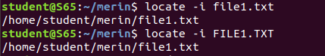

**4.find**

The find command helps us to find a particular file within a directory.

**output**

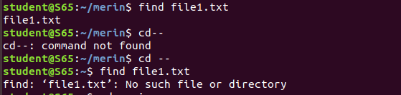

**5.grep**

The 'grep' command stands for "global regular expression print". grep command filters the content of a file which makes our search easy.

**Output**

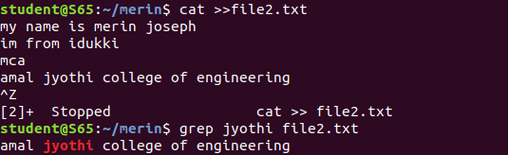

**6.grep -i**

The 'grep -i' command filters output in a case-insensitive way.

**Output**

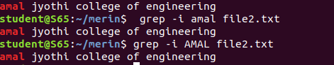

**7.grep -v**

The 'grep -v' command displays lines not matching to the specified word.

**Output**



**8.grep A1**

*grep -A1 command is used to display the line after the result.*

**Output**



**9.grep B1**

grep -B command is used to display the line before the result.

**Output**



**10.grap C1**

grep -C command is used to display the line after and line before the result.

**Output**



**11.df**

Linux df command is used to display the disk space used in the file system. The 'df' stands for "disk filesystem."

**output**

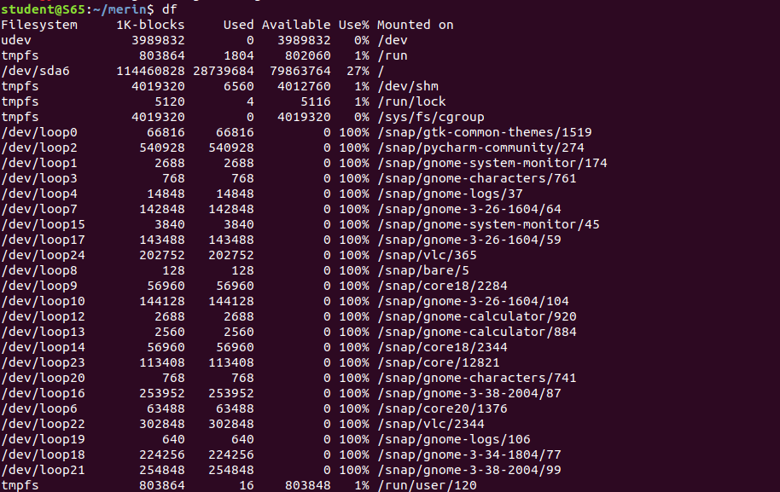

**12.df -m**

it is used to se the file in mega byte

**output**

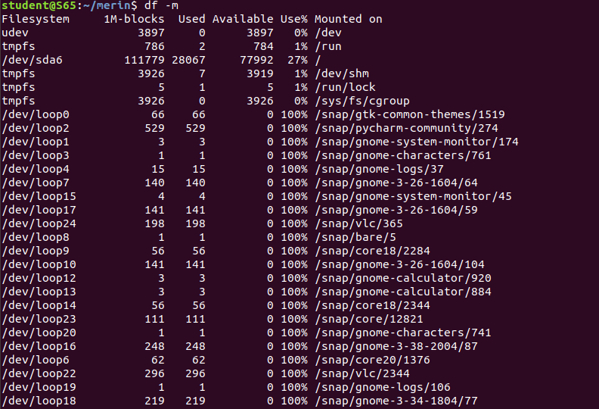**13 du**

Command du stands for Disk Usage. It is used to check the information of disk usage of files and directories on a system.

**Output**



**14 wc**

Linux wc command helps in counting the lines, words, and characters in a file. It displays the number of lines, number of characters, and the number of words in a file. Mostly, it is used with pipes for counting operation.

-l, --lines: It is used to print the newline counts.

-w, --words: It is used to print the word counts.

-c, --bytes: It is used to print the byte counts.

-m, --chars: It is used to print the character counts.

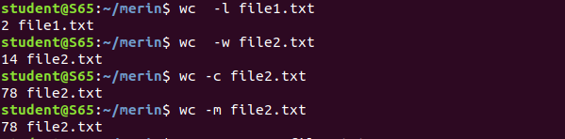**output**