DAY8 SESSION ASSIGNMENTS

**1.When to use (Rapid Application Development) RAD model When not to use (Rapid Application Development) RAD model**

RAD model can be used when:

* development time is very less
* highy expert developers are available
* there is a need to create a system that can be modularized in 2-3 months of time.
* The budget can accomodate developing tools as well as expert developers
* when the requirements are well known
* Modifications need to be accomodated
* reusability of component is required

RAD model is not used when:

* strong technical team is not available
* When the system is not properly modularized.
* technical risks are high
* the syatem requires high performance
* the system is not component based and scalable.
* When the management complexity is more.
* When the project requires larger development times.
* Project budgt is small

**2.Define an ER diagram of a software Organization with all the relationship model that was discussed in the classroom**

Belongs

to

employee

department

undertakes

has

project

Salary details

**3.Describe the Entity Relationships for the following diagram**

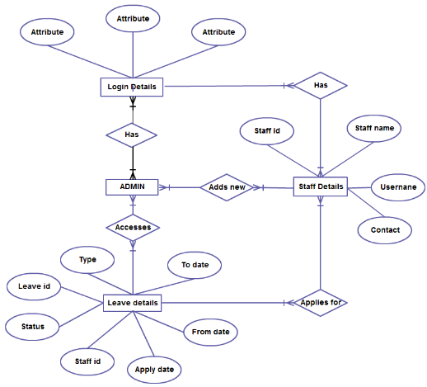

Different entities in the ER diagram are:

* Admin
* Staff details
* Login details
* Leave details

Attributes of various entities are as follows:

* Login details have different attributes
* Staff details have 4 atributes

-Staffid

-Staffname

-username

-contact

* Login details have 7 atributes

-Type

-Leave id

-Status

-Staff id

-Apply date

-From date

-To date

Different Relationships are in the ER Diagram

* Relationship between Login details and Admin

- There exist many to many relationship.

- Different employees have different login details and can login as different admins.

* Relationship between Login detials and staff details

- There exist many to many relationship.

- Different employees have different login details and can login as different staff.

* Relationship between Admin and Staff details

- There exist many to many relationship.

- Different Admins can add multiple staff.

* Relationship between Staff details and leave details

- There exist many to many relationship.

- different staff can apply for leave

* Relationship between Admin and Leave details

- There exist many to many relationship.

- Different admins can access and proceed leave applications of different staff