**Q: ASSIGNMENT2: Using ALV, display Header details (Doc date, payer, net value) of custom VBRK table.**  
1.   When double clicking on document-number, display item data corresponding to document number.  
2.    when double clicking on payer number in header table, go to transaction ‘XD03’and skip the first screen and display payer details.  
3.   when double clicking on material number in item table, go to transaction ‘mm03’and display material details.

**Header Table-:**

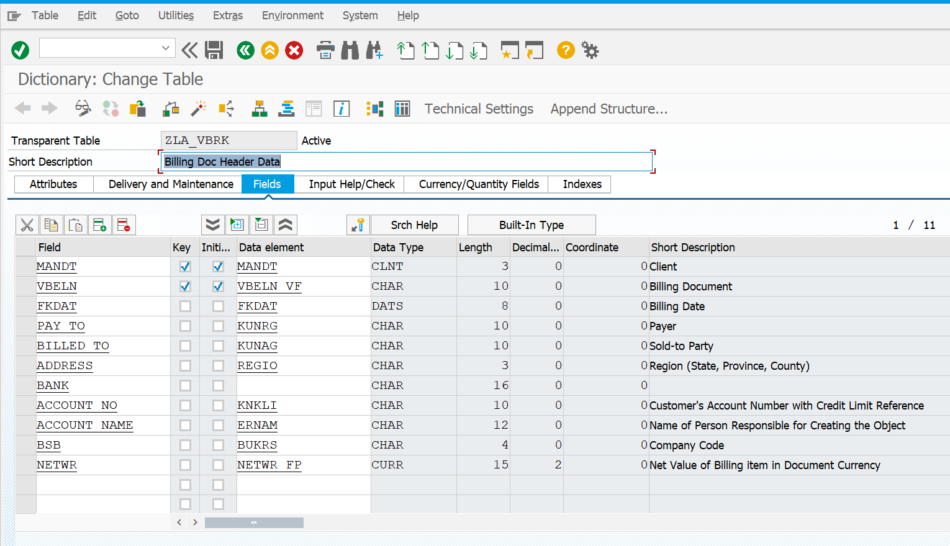

**Contents-:**

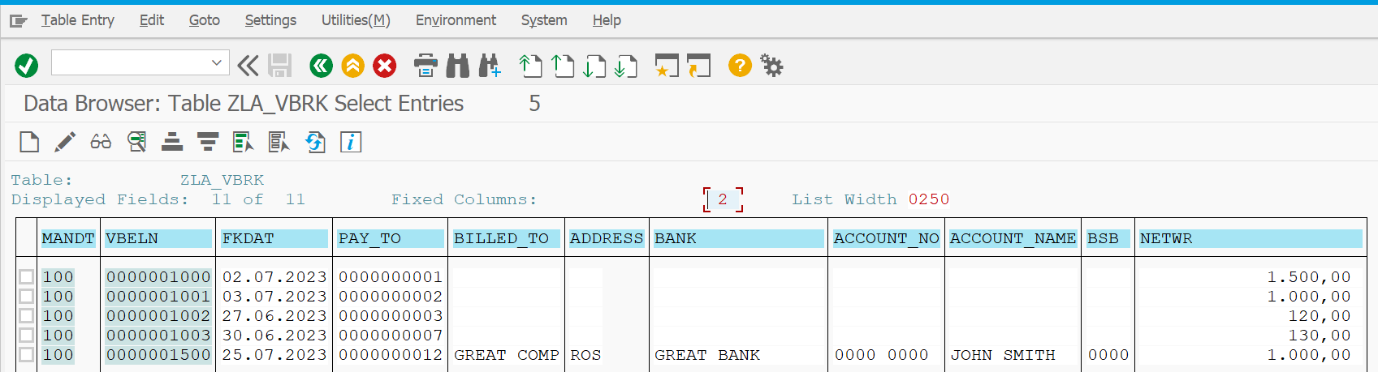

**Item Table-:**

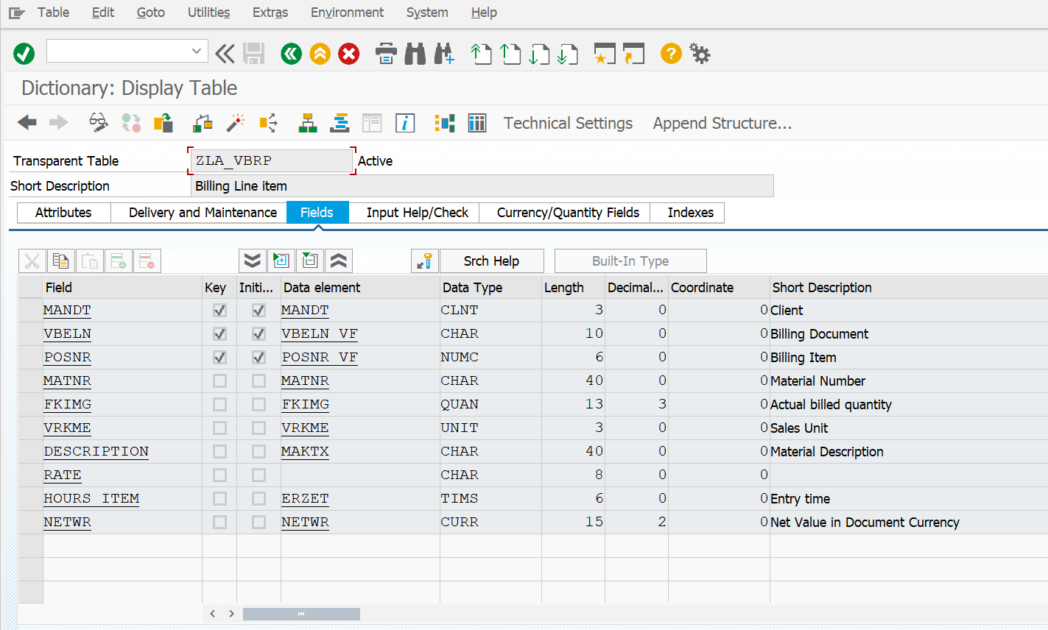

**Contents-:**

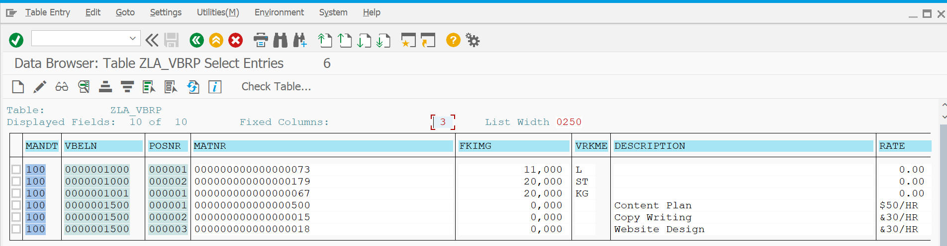

**CODE:-**

*\*&---------------------------------------------------------------------\**  
*\*& Report ZLA_ASSIGNMENT2*  
*\*&---------------------------------------------------------------------\**  
*\*&*  
*\*&---------------------------------------------------------------------\**  
REPORT zla_assignment2.  
  
DATA : it_vbrk TYPE STANDARD TABLE OF zla_vbrk,  
 wa_vbrk LIKE LINE OF it_vbrk,  
 it_vbrp TYPE STANDARD TABLE OF zla_vbrp,  
 wa_vbrp LIKE LINE OF it_vbrp.  
  
DATA v_vbeln TYPE zla_vbrk-vbeln.  
  
SELECT-OPTIONS s_vbeln FOR v_vbeln.  
  
START-OF-SELECTION.  
 PERFORM get_data.  
 PERFORM display.  
END-OF-SELECTION.  
*\*&---------------------------------------------------------------------\**  
*\*& Form get_data*  
*\*&---------------------------------------------------------------------\**  
*\*& text*  
*\*&---------------------------------------------------------------------\**  
*\*& --> p1 text*  
*\*& <-- p2 text*  
*\*&---------------------------------------------------------------------\**  
FORM get_data .  
 SELECT * FROM zla_vbrk INTO TABLE it_vbrk WHERE vbeln IN s_vbeln.  
ENDFORM.  
  
  
*\*&---------------------------------------------------------------------\**  
*\*& Form display*  
*\*&---------------------------------------------------------------------\**  
*\*& text*  
*\*&---------------------------------------------------------------------\**  
*\*& --> p1 text*  
*\*& <-- p2 text*  
*\*&---------------------------------------------------------------------\**  
FORM display .  
  
 DATA : lt_fcat TYPE slis_t_fieldcat_alv,  
 lw_fcat LIKE LINE OF lt_fcat.  
  
 lw_fcat-col_pos = 1.  
 lw_fcat-fieldname = 'VBELN'.  
 lw_fcat-tabname = 'IT_VBRK'.  
 lw_fcat-seltext_m = 'Document No'.  
 lw_fcat-outputlen = 20.  
 lw_fcat-hotspot = 'X'.  
 APPEND lw_fcat TO lt_fcat.  
  
  
 lw_fcat-col_pos = 2.  
 lw_fcat-fieldname = 'FKDAT'.  
 lw_fcat-tabname = 'IT_VBRK'.  
 lw_fcat-seltext_m = 'Document Date'.  
 lw_fcat-outputlen = 20.  
 APPEND lw_fcat TO lt_fcat.  
 CLEAR lw_fcat.  
  
 lw_fcat-col_pos = 3.  
 lw_fcat-fieldname = 'PAY_TO'.  
 lw_fcat-tabname = 'IT_VBRK'.  
 lw_fcat-seltext_m = 'Payer'.  
 lw_fcat-outputlen = 20.  
 APPEND lw_fcat TO lt_fcat.  
  
 lw_fcat-col_pos = 4.  
 lw_fcat-fieldname = 'NETWR'.  
 lw_fcat-tabname = 'IT_VBRK'.  
 lw_fcat-seltext_m = 'Net Value'.  
 lw_fcat-outputlen = 20.  
 APPEND lw_fcat TO lt_fcat.  
  
CALL FUNCTION 'REUSE_ALV_GRID_DISPLAY'  
 EXPORTING  
*\* I_INTERFACE_CHECK = ' '*  
*\* I_BYPASSING_BUFFER = ' '*  
*\* I_BUFFER_ACTIVE = ' '*  
 i_callback_program = 'ZLA_ASSIGNMENT2'  
 i_callback_pf_status_set = 'PF_STATUS'  
 i_callback_user_command = 'USER_COMMAND'  
*\* I_CALLBACK_TOP_OF_PAGE = ' '*  
*\* I_CALLBACK_HTML_TOP_OF_PAGE = ' '*  
*\* I_CALLBACK_HTML_END_OF_LIST = ' '*  
*\* I_STRUCTURE_NAME = ''*  
*\* I_BACKGROUND_ID = ' '*  
*\* I_GRID_TITLE =*  
*\* I_GRID_SETTINGS =*  
*\* IS_LAYOUT =*  
 it_fieldcat = lt_fcat  
*\* IT_EXCLUDING =*  
*\* IT_SPECIAL_GROUPS =*  
*\* IT_SORT =*  
*\* IT_FILTER =*  
*\* IS_SEL_HIDE =*  
*\* I_DEFAULT = 'X'*  
*\* I_SAVE = ' '*  
*\* IS_VARIANT =*  
*\* IT_EVENTS =*  
*\* IT_EVENT_EXIT =*  
*\* IS_PRINT =*  
*\* IS_REPREP_ID =*  
*\* I_SCREEN_START_COLUMN = 0*  
*\* I_SCREEN_START_LINE = 0*  
*\* I_SCREEN_END_COLUMN = 0*  
*\* I_SCREEN_END_LINE = 0*  
*\* I_HTML_HEIGHT_TOP = 0*  
*\* I_HTML_HEIGHT_END = 0*  
*\* IT_ALV_GRAPHICS =*  
*\* IT_HYPERLINK =*  
*\* IT_ADD_FIELDCAT =*  
*\* IT_EXCEPT_QINFO =*  
*\* IR_SALV_FULLSCREEN_ADAPTER =*  
*\* O_PREVIOUS_SRAL_HANDLER =*  
*\* IMPORTING*  
*\* E_EXIT_CAUSED_BY_CALLER =*  
*\* ES_EXIT_CAUSED_BY_USER =*  
 TABLES  
 t_outtab = it_vbrk  
 EXCEPTIONS  
 program_error = 1  
 OTHERS = 2.  
 IF sy-subrc <> 0.  
*\* Implement suitable error handling here*  
 ENDIF.  
  
  
ENDFORM.  
  
  
 DATA : lt_fcat TYPE slis_t_fieldcat_alv,  
 lw_fcat LIKE LINE OF lt_fcat.  
  
FORM USER_COMMAND USING r_ucomm LIKE sy-ucomm  
 rs_selfield TYPE slis_selfield.  
IF r_ucomm EQ '&IC1' AND rs_selfield-fieldname EQ 'VBELN'.  
SELECT * FROM zla_vbrp INTO TABLE it_vbrp WHERE vbeln = rs_selfield-value.  
 ENDIF.  
IF r_ucomm EQ '&IC1' AND rs_selfield-fieldname EQ 'PAY_TO'.  
 SET PARAMETER ID 'KUN' FIELD rs_selfield-value.  
 CALL TRANSACTION 'XD03' AND SKIP FIRST SCREEN.  
 ENDIF.  
Clear lt_fcat.  
 lw_fcat-col_pos = 1.  
 lw_fcat-fieldname = 'POSNR'.  
 lw_fcat-tabname = 'IT_VBRP'.  
 lw_fcat-seltext_m = 'Item No'.  
 lw_fcat-outputlen = 15.  
 APPEND lw_fcat TO lt_fcat.  
 CLEAR lw_fcat.  
  
 lw_fcat-col_pos = 2.  
 lw_fcat-fieldname = 'MATNR'.  
 lw_fcat-tabname = 'IT_VBRP'.  
 lw_fcat-seltext_m = 'Material No'.  
 lw_fcat-outputlen = 40.  
 APPEND lw_fcat TO lt_fcat.  
  
 lw_fcat-col_pos = 3.  
 lw_fcat-fieldname = 'FKIMG'.  
 lw_fcat-tabname = 'IT_VBRP'.  
 lw_fcat-seltext_m = 'UoM'.  
 lw_fcat-outputlen = 40.  
 APPEND lw_fcat TO lt_fcat.  
  
 lw_fcat-col_pos = 4.  
 lw_fcat-fieldname = 'NETWR'.  
 lw_fcat-tabname = 'IT_VBRP'.  
 lw_fcat-seltext_m = 'Net value'.  
 lw_fcat-outputlen = 40.  
 APPEND lw_fcat TO lt_fcat.  
  
 CALL FUNCTION 'REUSE_ALV_GRID_DISPLAY'  
 EXPORTING  
*\* I_INTERFACE_CHECK = ' '*  
*\* I_BYPASSING_BUFFER = ' '*  
*\* I_BUFFER_ACTIVE = ' '*  
 i_callback_program = 'ZLA_ASSIGNMENT2'  
 i_callback_pf_status_set = 'PF_STATUS'  
 i_callback_user_command = 'USER_COMMAND'  
*\* I_CALLBACK_TOP_OF_PAGE = ' '*  
*\* I_CALLBACK_HTML_TOP_OF_PAGE = ' '*  
*\* I_CALLBACK_HTML_END_OF_LIST = ' '*  
*\* I_STRUCTURE_NAME = ''*  
*\* I_BACKGROUND_ID = ' '*  
*\* I_GRID_TITLE =*  
*\* I_GRID_SETTINGS =*  
*\* IS_LAYOUT =*  
 it_fieldcat = lt_fcat  
*\* IT_EXCLUDING =*  
*\* IT_SPECIAL_GROUPS =*  
*\* IT_SORT =*  
*\* IT_FILTER =*  
*\* IS_SEL_HIDE =*  
*\* I_DEFAULT = 'X'*  
*\* I_SAVE = ' '*  
*\* IS_VARIANT =*  
*\* IT_EVENTS =*  
*\* IT_EVENT_EXIT =*  
*\* IS_PRINT =*  
*\* IS_REPREP_ID =*  
*\* I_SCREEN_START_COLUMN = 0*  
*\* I_SCREEN_START_LINE = 0*  
*\* I_SCREEN_END_COLUMN = 0*  
*\* I_SCREEN_END_LINE = 0*  
*\* I_HTML_HEIGHT_TOP = 0*  
*\* I_HTML_HEIGHT_END = 0*  
*\* IT_ALV_GRAPHICS =*  
*\* IT_HYPERLINK =*  
*\* IT_ADD_FIELDCAT =*  
*\* IT_EXCEPT_QINFO =*  
*\* IR_SALV_FULLSCREEN_ADAPTER =*  
*\* O_PREVIOUS_SRAL_HANDLER =*  
*\* IMPORTING*  
*\* E_EXIT_CAUSED_BY_CALLER =*  
*\* ES_EXIT_CAUSED_BY_USER =*  
 TABLES  
 t_outtab = it_vbrp  
 EXCEPTIONS  
 program_error = 1  
 OTHERS = 2.  
 IF sy-subrc <> 0.  
*\* Implement suitable error handling here*  
 ENDIF.  
  
 IF r_ucomm EQ '&IC1' AND rs_selfield-fieldname EQ 'MATNR'.  
 SET PARAMETER ID 'MAT' FIELD rs_selfield-value.  
 CALL TRANSACTION 'MM03'.  
ENDIF.  
ENDFORM.

**OUTPUT-:**

**1.Header**

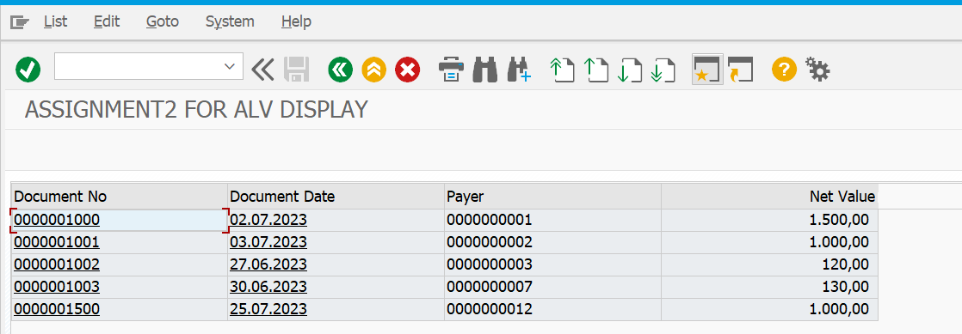

**2.On clicking Payer '1'.**

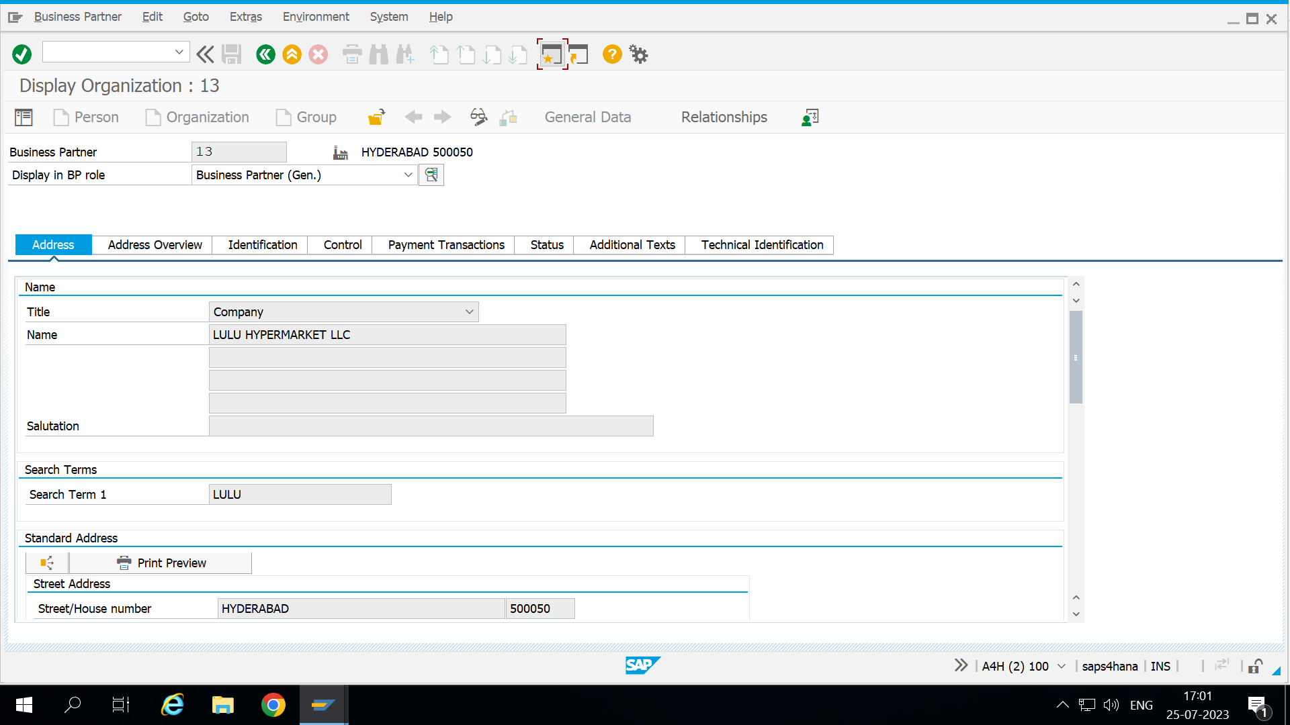

**3.On clicking document number, 'item table data'**

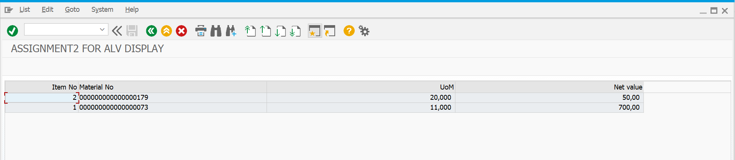

**4.on clicking material number,'179'**

