1) Implement Queue operations (Insert, delete, display front & rear values) - 04/10/23

source code

#include <stdio.h>

#define MAX_SIZE 100

int queue[MAX_SIZE];
int front = -1, rear = -1;

void enqueue(int value)
{
if (rear == MAX_SIZE - 1)
{
printf("Queue is full. Cannot enqueue.\n");
return;
}

if (front == -1)
front = 0;
rear++;
queue[rear] = value;
}

void dequeue()
{
if (front == -1)
{
printf("Queue is empty. Cannot dequeue.\n");
return;
}

printf("Dequeued element: %d\n", queue[front]);

if (front == rear)
front = rear = -1;
else
front++;
}

void displayFrontRear()
{
if (front == -1)
{
printf("Queue is empty.\n");
return;
}

printf("Front element: %d\n", queue[front]);
printf("Rear element: %d\n", queue[rear]);
}

int main()
{
int choice, value;

do {
printf("\nQueue Operations:\n");
printf("1. Enqueue\n");
printf("2. Dequeue\n");
printf("3. Display Front & Rear\n");
printf("4. Quit\n");

printf("Enter your choice: ");
scanf("%d", &choice);

switch (choice)
{
case 1:
printf("Enter value to enqueue: ");
scanf("%d", &value);
enqueue(value);
break;

case 2:
dequeue();
break;

case 3:
displayFrontRear();
break;

case 4:
printf("Exiting...\n");
break;

default:
printf("Invalid choice. Please try again.\n");
break;
}
} while (choice != 4);

return 0;
}

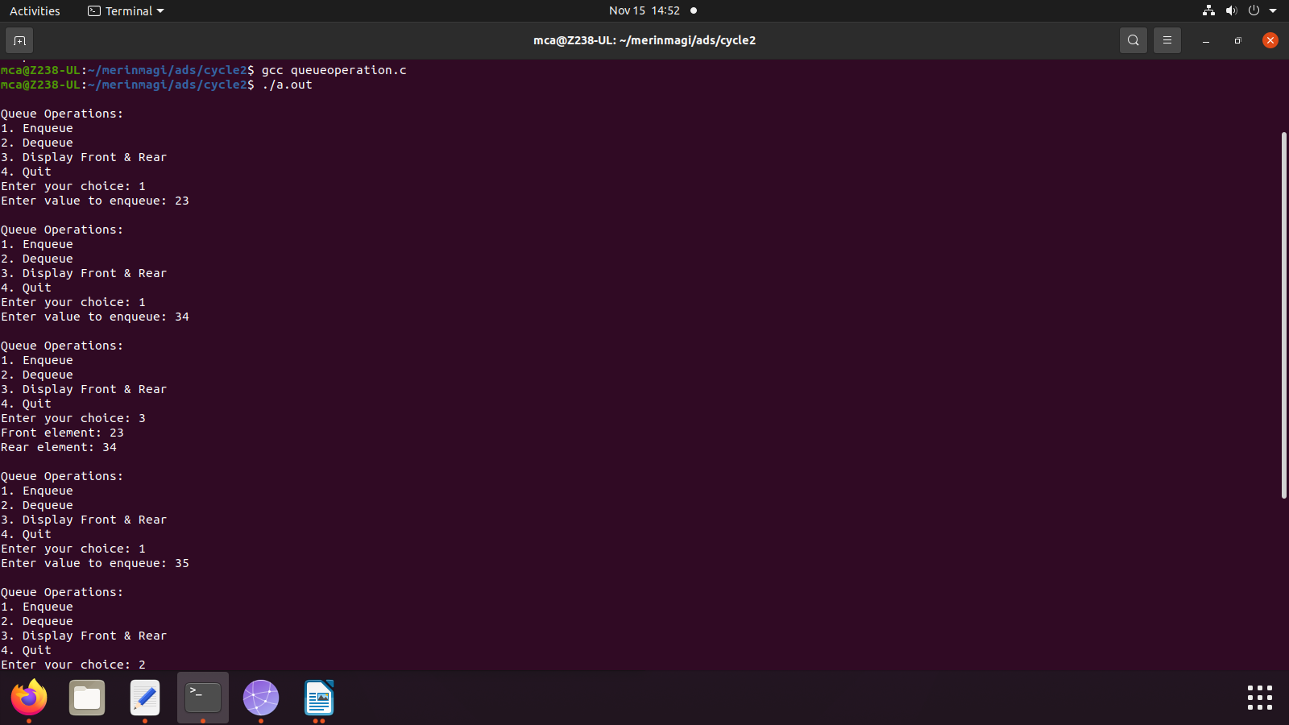

2) Implement Circular Queue operations (Insert, delete, display front & rear values)

Source code

#include <stdio.h>

#define MAX_SIZE 100

int circularQueue[MAX_SIZE];
int front = -1, rear = -1;

void enqueue(int value) {
if ((rear + 1) % MAX_SIZE == front) {
printf("Queue is full. Cannot enqueue.\n");
return;
}

if (front == -1)
front = 0;

rear = (rear + 1) % MAX_SIZE;
circularQueue[rear] = value;
}

void dequeue() {
if (front == -1) {
printf("Queue is empty. Cannot dequeue.\n");
return;
}

printf("Dequeued element: %d\n", circularQueue[front]);

if (front == rear)
front = rear = -1;
else
front = (front + 1) % MAX_SIZE;
}

void displayFrontRear() {
if (front == -1) {
printf("Queue is empty.\n");
return;
}

printf("Front element: %d\n", circularQueue[front]);
printf("Rear element: %d\n", circularQueue[rear]);
}

int main() {
int choice, value;

do {
printf("\nCircular Queue Operations:\n");
printf("1. Enqueue\n");
printf("2. Dequeue\n");
printf("3. Display Front & Rear\n");
printf("4. Quit\n");

printf("Enter your choice: ");
scanf("%d", &choice);

switch (choice) {
case 1:
printf("Enter value to enqueue: ");
scanf("%d", &value);
enqueue(value);
break;

case 2:
dequeue();
break;

case 3:
displayFrontRear();
break;

case 4:
printf("Exiting...\n");
break;

default:
printf("Invalid choice. Please try again.\n");
break;
}
} while (choice != 4);

return 0;
}

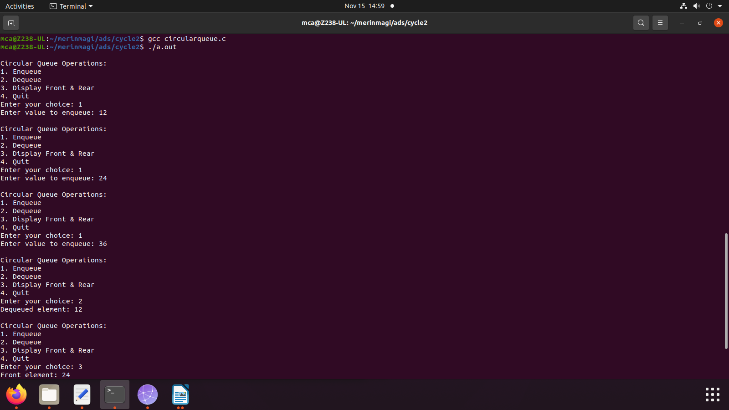

3) Implement singly linked list (Insert at the head, insert at tail, insert at a position, delete at the
head, delete at tail, delete form a position, search an element).

Source code

#include <stdio.h>
#include <stdlib.h>

struct Node {
int data;
struct Node* next;
};

struct Node* head = NULL;

void insertAtHead(int value) {
struct Node* newNode = (struct Node*)malloc(sizeof(struct Node));
newNode->data = value;
newNode->next = head;
head = newNode;
}

void insertAtTail(int value) {
struct Node* newNode = (struct Node*)malloc(sizeof(struct Node));
newNode->data = value;
newNode->next = NULL;

if (head == NULL) {
head = newNode;
return;
}

struct Node* temp = head;
while (temp->next != NULL)
temp = temp->next;

temp->next = newNode;
}

void insertAtPosition(int value, int position) {
struct Node* newNode = (struct Node*)malloc(sizeof(struct Node));
newNode->data = value;

if (position == 1) {
newNode->next = head;
head = newNode;
return;
}

struct Node* temp = head;
for (int i = 1; i < position - 1 && temp != NULL; i++)
temp = temp->next;

if (temp == NULL) {
printf("Invalid position.\n");
return;
}

newNode->next = temp->next;
temp->next = newNode;
}

void deleteAtHead() {
if (head == NULL) {
printf("List is empty. Cannot delete.\n");
return;
}

struct Node* temp = head;
head = head->next;
free(temp);
}

void deleteAtTail() {
if (head == NULL) {
printf("List is empty. Cannot delete.\n");
return;
}

if (head->next == NULL) {
free(head);
head = NULL;
return;
}

struct Node* temp = head;
while (temp->next->next != NULL)
temp = temp->next;

free(temp->next);
temp->next = NULL;
}

void deleteAtPosition(int position) {
if (head == NULL) {
printf("List is empty. Cannot delete.\n");
return;
}

if (position == 1) {
struct Node* temp = head;
head = head->next;
free(temp);
return;
}

struct Node* temp = head;
for (int i = 1; i < position - 1 && temp != NULL; i++)
temp = temp->next;

if (temp == NULL || temp->next == NULL) {
printf("Invalid position.\n");
return;
}

struct Node* toDelete = temp->next;
temp->next = temp->next->next;
free(toDelete);
}

void search(int value) {
struct Node* temp = head;
int position = 1;
while (temp != NULL) {
if (temp->data == value) {
printf("%d found at position %d.\n", value, position);
return;
}
temp = temp->next;
position++;
}
printf("%d not found in the list.\n", value);
}

void display() {
struct Node* temp = head;
while (temp != NULL) {
printf("%d ", temp->data);
temp = temp->next;
}
printf("\n");
}

int main() {
int choice, value, position;

do {
printf("\nSingly Linked List Operations:\n");
printf("1. Insert at Head\n");
printf("2. Insert at Tail\n");
printf("3. Insert at Position\n");
printf("4. Delete at Head\n");
printf("5. Delete at Tail\n");
printf("6. Delete at Position\n");
printf("7. Search\n");
printf("8. Display\n");
printf("9. Quit\n");

printf("Enter your choice: ");
scanf("%d", &choice);

switch (choice) {
case 1:
printf("Enter value to insert: ");
scanf("%d", &value);
insertAtHead(value);
break;

case 2:
printf("Enter value to insert: ");
scanf("%d", &value);
insertAtTail(value);
break;

case 3:
printf("Enter value to insert: ");
scanf("%d", &value);
printf("Enter position: ");
scanf("%d", &position);
insertAtPosition(value, position);
break;

case 4:
deleteAtHead();
break;

case 5:
deleteAtTail();
break;

case 6:
printf("Enter position: ");
scanf("%d", &position);
deleteAtPosition(position);
break;

case 7:
printf("Enter value to search: ");
scanf("%d", &value);
search(value);
break;

case 8:
display();
break;

case 9:
printf("Exiting...\n");
break;

default:
printf("Invalid choice. Please try again.\n");
break;
}
} while (choice != 9);

return 0;
}

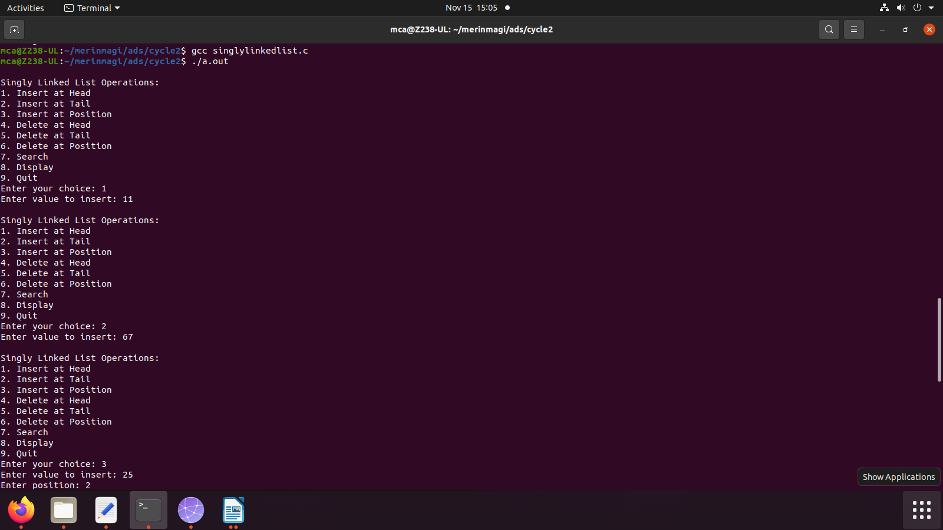

4) Implement doubly linked list (Insert at the head, insert at tail, insert at a position, delete at the
head, delete at tail, delete form a position, search an element).

Source code

#include <stdio.h>
#include <stdlib.h>

struct Node {
int data;
struct Node* next;
struct Node* prev;
};

struct Node* head = NULL;

void insertAtHead(int value) {
struct Node* newNode = (struct Node*)malloc(sizeof(struct Node));
newNode->data = value;
newNode->next = head;
newNode->prev = NULL;

if (head != NULL)
head->prev = newNode;

head = newNode;
}

void insertAtTail(int value) {
struct Node* newNode = (struct Node*)malloc(sizeof(struct Node));
newNode->data = value;
newNode->next = NULL;

if (head == NULL) {
newNode->prev = NULL;
head = newNode;
return;
}

struct Node* temp = head;
while (temp->next != NULL)
temp = temp->next;

temp->next = newNode;
newNode->prev = temp;
}

void insertAtPosition(int value, int position) {
struct Node* newNode = (struct Node*)malloc(sizeof(struct Node));
newNode->data = value;

if (position == 1) {
newNode->next = head;
newNode->prev = NULL;
if (head != NULL)
head->prev = newNode;
head = newNode;
return;
}

struct Node* temp = head;
for (int i = 1; i < position - 1 && temp != NULL; i++)
temp = temp->next;

if (temp == NULL) {
printf("Invalid position.\n");
return;
}

newNode->next = temp->next;
newNode->prev = temp;
if (temp->next != NULL)
temp->next->prev = newNode;
temp->next = newNode;
}

void deleteAtHead() {
if (head == NULL) {
printf("List is empty. Cannot delete.\n");
return;
}

struct Node* temp = head;
head = head->next;

if (head != NULL)
head->prev = NULL;

free(temp);
}

void deleteAtTail() {
if (head == NULL) {
printf("List is empty. Cannot delete.\n");
return;
}

if (head->next == NULL) {
free(head);
head = NULL;
return;
}

struct Node* temp = head;
while (temp->next != NULL)
temp = temp->next;

temp->prev->next = NULL;
free(temp);
}

void deleteAtPosition(int position) {
if (head == NULL) {
printf("List is empty. Cannot delete.\n");
return;
}

if (position == 1) {
struct Node* temp = head;
head = head->next;

if (head != NULL)
head->prev = NULL;

free(temp);
return;
}

struct Node* temp = head;
for (int i = 1; i < position - 1 && temp != NULL; i++)
temp = temp->next;

if (temp == NULL || temp->next == NULL) {
printf("Invalid position.\n");
return;
}

struct Node* toDelete = temp->next;
temp->next = temp->next->next;
if (temp->next != NULL)
temp->next->prev = temp;
free(toDelete);
}

void search(int value) {
struct Node* temp = head;
int position = 1;
while (temp != NULL) {
if (temp->data == value) {
printf("%d found at position %d.\n", value, position);
return;
}
temp = temp->next;
position++;
}
printf("%d not found in the list.\n", value);
}

void display() {
struct Node* temp = head;
while (temp != NULL) {
printf("%d ", temp->data);
temp = temp->next;
}
printf("\n");
}

int main() {
int choice, value, position;

do {
printf("\nDoubly Linked List Operations:\n");
printf("1. Insert at Head\n");
printf("2. Insert at Tail\n");
printf("3. Insert at Position\n");
printf("4. Delete at Head\n");
printf("5. Delete at Tail\n");
printf("6. Delete at Position\n");
printf("7. Search\n");
printf("8. Display\n");
printf("9. Quit\n");

printf("Enter your choice: ");
scanf("%d", &choice);

switch (choice) {
case 1:
printf("Enter value to insert: ");
scanf("%d", &value);
insertAtHead(value);
break;

case 2:
printf("Enter value to insert: ");
scanf("%d", &value);
insertAtTail(value);
break;

case 3:
printf("Enter value to insert: ");
scanf("%d", &value);
printf("Enter position: ");
scanf("%d", &position);
insertAtPosition(value, position);
break;

case 4:
deleteAtHead();
break;

case 5:
deleteAtTail();
break;

case 6:
printf("Enter position: ");
scanf("%d", &position);
deleteAtPosition(position);
break;

case 7:
printf("Enter value to search: ");
scanf("%d", &value);
search(value);
break;

case 8:
display();
break;

case 9:
printf("Exiting...\n");
break;

default:
printf("Invalid choice. Please try again.\n");
break;
}
} while (choice != 9);

return 0;
}

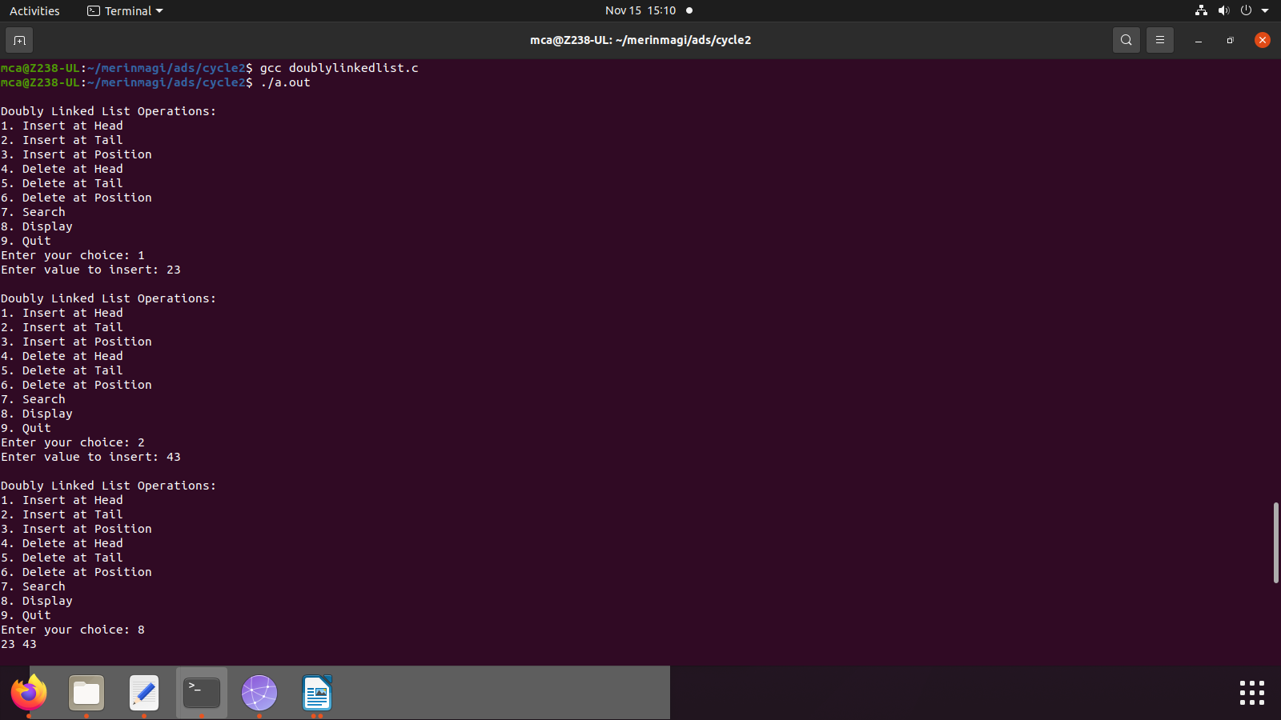

5) Implement circular linked list (Insert at the head, insert at tail, insert at a position, delete at the
head, delete at tail, delete form a position, search an element)

Source code

#include <stdio.h>
#include <stdlib.h>

struct Node {
int data;
struct Node* next;
};

struct Node* head = NULL;

void insertAtHead(int value) {
struct Node* newNode = (struct Node*)malloc(sizeof(struct Node));
newNode->data = value;

if (head == NULL) {
newNode->next = newNode;
head = newNode;
return;
}

struct Node* temp = head;
while (temp->next != head)
temp = temp->next;

temp->next = newNode;
newNode->next = head;
head = newNode;
}

void insertAtTail(int value) {
struct Node* newNode = (struct Node*)malloc(sizeof(struct Node));
newNode->data = value;

if (head == NULL) {
newNode->next = newNode;
head = newNode;
return;
}

struct Node* temp = head;
while (temp->next != head)
temp = temp->next;

temp->next = newNode;
newNode->next = head;
}

void insertAtPosition(int value, int position) {
if (position == 1) {
insertAtHead(value);
return;
}

struct Node* newNode = (struct Node*)malloc(sizeof(struct Node));
newNode->data = value;

struct Node* temp = head;
for (int i = 1; i < position - 1 && temp->next != head; i++)
temp = temp->next;

newNode->next = temp->next;
temp->next = newNode;
}

void deleteAtHead() {
if (head == NULL) {
printf("List is empty. Cannot delete.\n");
return;
}

if (head->next == head) {
free(head);
head = NULL;
return;
}

struct Node* temp = head;
while (temp->next != head)
temp = temp->next;

temp->next = head->next;
struct Node* toDelete = head;
head = head->next;
free(toDelete);
}

void deleteAtTail() {
if (head == NULL) {
printf("List is empty. Cannot delete.\n");
return;
}

if (head->next == head) {
free(head);
head = NULL;
return;
}

struct Node* temp = head;
while (temp->next->next != head)
temp = temp->next;

struct Node* toDelete = temp->next;
temp->next = head;
free(toDelete);
}

void deleteAtPosition(int position) {
if (head == NULL) {
printf("List is empty. Cannot delete.\n");
return;
}

if (position == 1) {
deleteAtHead();
return;
}

struct Node* temp = head;
for (int i = 1; i < position - 1 && temp->next != head; i++)
temp = temp->next;

if (temp->next == head) {
printf("Invalid position.\n");
return;
}

struct Node* toDelete = temp->next;
temp->next = temp->next->next;
free(toDelete);
}

void search(int value) {
struct Node* temp = head;
int position = 1;
do {
if (temp->data == value) {
printf("%d found at position %d.\n", value, position);
return;
}
temp = temp->next;
position++;
} while (temp != head);
printf("%d not found in the list.\n", value);
}

void display() {
if (head == NULL) {
printf("List is empty.\n");
return;
}

struct Node* temp = head;
do {
printf("%d ", temp->data);
temp = temp->next;
} while (temp != head);
printf("\n");
}

int main() {
int choice, value, position;

do {
printf("\nCircular Linked List Operations:\n");
printf("1. Insert at Head\n");
printf("2. Insert at Tail\n");
printf("3. Insert at Position\n");
printf("4. Delete at Head\n");
printf("5. Delete at Tail\n");
printf("6. Delete at Position\n");
printf("7. Search\n");
printf("8. Display\n");
printf("9. Quit\n");

printf("Enter your choice: ");
scanf("%d", &choice);

switch (choice) {
case 1:
printf("Enter value to insert: ");
scanf("%d", &value);
insertAtHead(value);
break;

case 2:
printf("Enter value to insert: ");
scanf("%d", &value);
insertAtTail(value);
break;

case 3:
printf("Enter value to insert: ");
scanf("%d", &value);
printf("Enter position: ");
scanf("%d", &position);
insertAtPosition(value, position);
break;

case 4:
deleteAtHead();
break;

case 5:
deleteAtTail();
break;

case 6:
printf("Enter position: ");
scanf("%d", &position);
deleteAtPosition(position);
break;

case 7:
printf("Enter value to search: ");
scanf("%d", &value);
search(value);
break;

case 8:
display();
break;

case 9:
printf("Exiting...\n");
break;

default:
printf("Invalid choice. Please try again.\n");
break;
}
} while (choice != 9);

return 0;
}

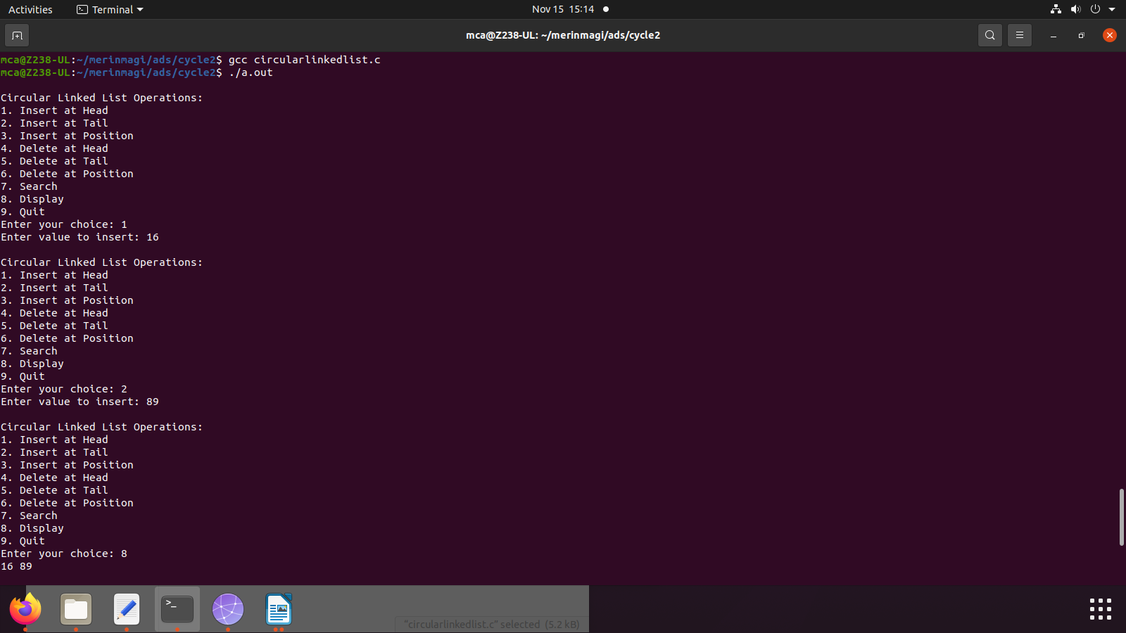

6) Implement binary search tree

source code
#include <stdio.h>
#include <stdlib.h>

#define MAX_SIZE 100

struct Node {
int data;
int height;
struct Node* left;
struct Node* right;
};

struct Node* createNode(int value) {
struct Node* newNode = (struct Node*)malloc(sizeof(struct Node));
newNode->data = value;
newNode->height = 1;
newNode->left = newNode->right = NULL;
return newNode;
}
//calculate height for rotation.
int calculateHeight(struct Node* node) {
int leftHeight = (node->left) ? node->left->height : 0;
int rightHeight = (node->right) ? node->right->height : 0;
return (leftHeight > rightHeight) ? leftHeight + 1 : rightHeight + 1;
}
//update height as it rotates.
void updateHeight(struct Node* node) {
node->height = calculateHeight(node);
}
//rotate node to right and update height
struct Node* rightRotate(struct Node* y) {
struct Node* x = y->left;
struct Node* T = x->right;
x->right = y;
y->left = T;
updateHeight(y);
updateHeight(x);
return x;
}
//rotate node to left and update height
struct Node* leftRotate(struct Node* x) {
struct Node* y = x->right;
struct Node* T = y->left;
y->left = x;
x->right = T;
updateHeight(x);
updateHeight(y);
return y;
}
//check for balance and update nodes if not-balanced
struct Node* balanceNode(struct Node* node) {
int balance = (node->left ? node->left->height : 0) - (node->right ? node->right->height : 0);
if (balance > 1) {
if (node->left->left) {
return rightRotate(node);
} else {
node->left = leftRotate(node->left);
return rightRotate(node);
}
}
if (balance < -1) {
if (node->right->right) {
return leftRotate(node);
} else {
node->right = rightRotate(node->right);
return leftRotate(node);
}
}

return node;
}
//adding new nodes to the tree and thus updating height and check balance
struct Node* insert(struct Node* root, int value) {
if (root == NULL) {
struct Node* newNode = createNode(value);
return newNode;
}
if (value < root->data)
root->left = insert(root->left, value);
else if (value > root->data)
root->right = insert(root->right, value);
updateHeight(root);
return balanceNode(root);
}
//find the min (new node) for attaching after deleted a node
struct Node* findMin(struct Node* node) {
struct Node* current = node;
while (current && current->left != NULL)
current = current->left;
return current;
}
//delete node and update values accordingly ( reccursion )
struct Node* deleteNode(struct Node* root, int value) {
if (root == NULL)
return root;
if (value < root->data)
root->left = deleteNode(root->left, value);
else if (value > root->data)
root->right = deleteNode(root->right, value);
else {
if (root->left == NULL) {
struct Node* temp = root->right;
free(root);
return temp;
} else if (root->right == NULL) {
struct Node* temp = root->left;
free(root);
return temp;
}

struct Node* temp = findMin(root->right);
root->data = temp->data;
root->right = deleteNode(root->right, temp->data);
}
updateHeight(root);
return balanceNode(root);
}
//searching for a node ( based on value )
struct Node* search(struct Node* root, int value) {
if (root == NULL || root->data == value)
return root;
if (value < root->data)
return search(root->left, value);
return search(root->right, value);
}
//traverse through ( display ) all existing nodes ( use in-order as default )
void inOrderTraversal(struct Node* root) {
if (root != NULL) {
inOrderTraversal(root->left);
printf("%d ", root->data);
inOrderTraversal(root->right);
}
}

int main() {
struct Node* root = NULL;
int choice, value;
do {
printf("\nBalanced Binary Search Tree Operations:\n");
printf("1. Insert\n");
printf("2. Delete\n");
printf("3. Search\n");
printf("4. In-order Traversal\n");
printf("5. Quit\n");
printf("Enter your choice: ");
scanf("%d", &choice);
switch (choice) {
case 1:
printf("Enter value to insert: ");
scanf("%d", &value);
if (search(root, value) == NULL)
root = insert(root, value);
else
printf("%d is already in the tree.\n", value);
break;

case 2:
printf("Enter value to delete: ");
scanf("%d", &value);
if (search(root, value) != NULL)
root = deleteNode(root, value);
else
printf("%d not found in the tree.\n", value);
break;

case 3:
printf("Enter value to search: ");
scanf("%d", &value);
struct Node* result = search(root, value);
if (result != NULL)
printf("%d found in the tree.\n", value);
else
printf("%d not found in the tree.\n", value);
break;

case 4:
printf("In-order Traversal: ");
inOrderTraversal(root);
printf("\n");
break;

case 5:
printf("Exiting...\n");
break;

default:
printf("Invalid choice. Please try again.\n");
break;
}
} while (choice != 5);
// Free memory (cleanup)
while (root != NULL) {
struct Node* temp = root;
root = deleteNode(root, temp->data);
}
return 0;
}

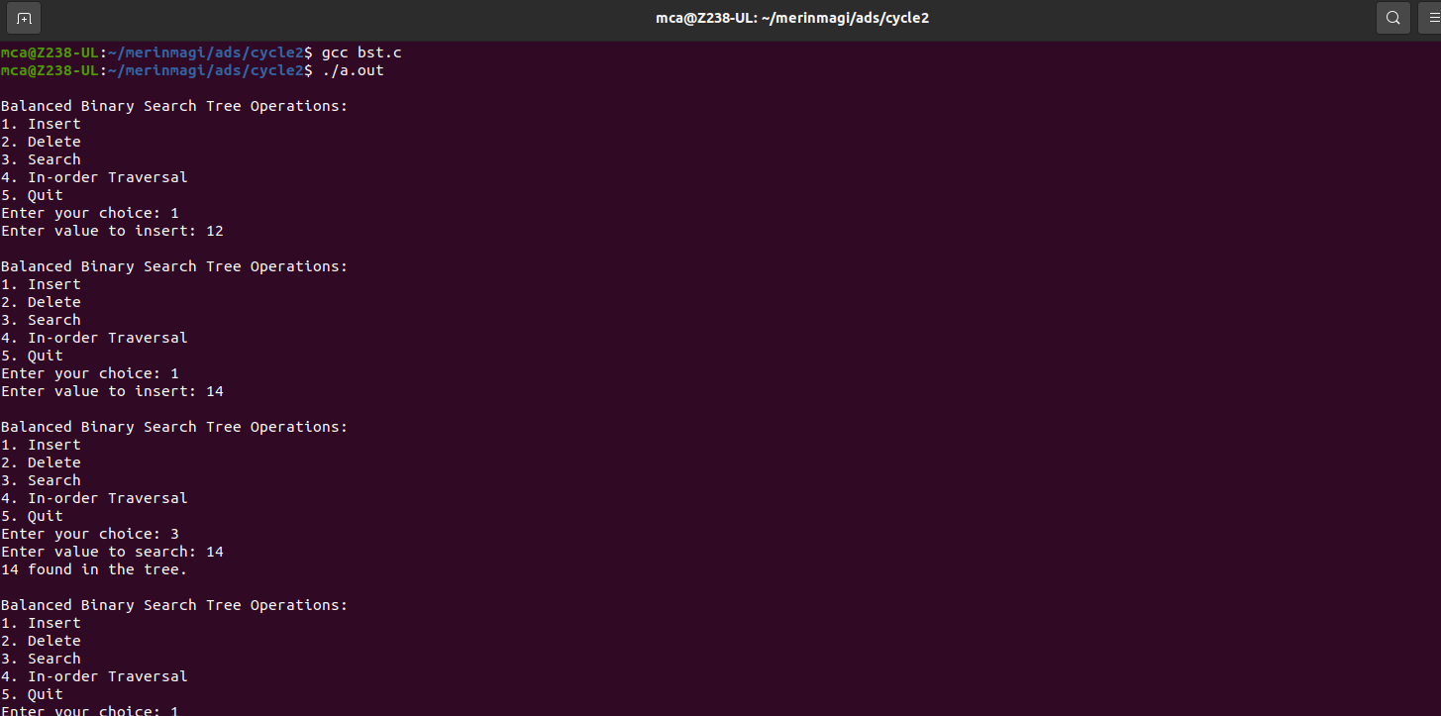

7) Implement balanced-binary-search tree

source code

#include <stdio.h>
#include <stdlib.h>

#define MAX_SIZE 100

struct Node {
int data;
int height;
struct Node* left;
struct Node* right;
};

struct Node* createNode(int value) {
struct Node* newNode = (struct Node*)malloc(sizeof(struct Node));
newNode->data = value;
newNode->height = 1;
newNode->left = newNode->right = NULL;
return newNode;
}
//calculate height for rotation.
int calculateHeight(struct Node* node) {
int leftHeight = (node->left) ? node->left->height : 0;
int rightHeight = (node->right) ? node->right->height : 0;
return (leftHeight > rightHeight) ? leftHeight + 1 : rightHeight + 1;
}
//update height as it rotates.
void updateHeight(struct Node* node) {
node->height = calculateHeight(node);
}
//rotate node to right and update height
struct Node* rightRotate(struct Node* y) {
struct Node* x = y->left;
struct Node* T = x->right;
x->right = y;
y->left = T;
updateHeight(y);
updateHeight(x);
return x;
}
//rotate node to left and update height
struct Node* leftRotate(struct Node* x) {
struct Node* y = x->right;
struct Node* T = y->left;
y->left = x;
x->right = T;
updateHeight(x);
updateHeight(y);
return y;
}
//check for balance and update nodes if not-balanced
struct Node* balanceNode(struct Node* node) {
int balance = (node->left ? node->left->height : 0) - (node->right ? node->right->height : 0);
if (balance > 1) {
if (node->left->left) {
return rightRotate(node);
} else {
node->left = leftRotate(node->left);
return rightRotate(node);
}
}
if (balance < -1) {
if (node->right->right) {
return leftRotate(node);
} else {
node->right = rightRotate(node->right);
return leftRotate(node);
}
}

return node;
}
//adding new nodes to the tree and thus updating height and check balance
struct Node* insert(struct Node* root, int value) {
if (root == NULL) {
struct Node* newNode = createNode(value);
return newNode;
}
if (value < root->data)
root->left = insert(root->left, value);
else if (value > root->data)
root->right = insert(root->right, value);
updateHeight(root);
return balanceNode(root);
}
//find the min (new node) for attaching after deleted a node
struct Node* findMin(struct Node* node) {
struct Node* current = node;
while (current && current->left != NULL)
current = current->left;
return current;
}
//delete node and update values accordingly ( reccursion )
struct Node* deleteNode(struct Node* root, int value) {
if (root == NULL)
return root;
if (value < root->data)
root->left = deleteNode(root->left, value);
else if (value > root->data)
root->right = deleteNode(root->right, value);
else {
if (root->left == NULL) {
struct Node* temp = root->right;
free(root);
return temp;
} else if (root->right == NULL) {
struct Node* temp = root->left;
free(root);
return temp;
}

struct Node* temp = findMin(root->right);
root->data = temp->data;
root->right = deleteNode(root->right, temp->data);
}
updateHeight(root);
return balanceNode(root);
}
//searching for a node ( based on value )
struct Node* search(struct Node* root, int value) {
if (root == NULL || root->data == value)
return root;
if (value < root->data)
return search(root->left, value);
return search(root->right, value);
}
//traverse through ( display ) all existing nodes ( use in-order as default )
void inOrderTraversal(struct Node* root) {
if (root != NULL) {
inOrderTraversal(root->left);
printf("%d ", root->data);
inOrderTraversal(root->right);
}
}

int main() {
struct Node* root = NULL;
int choice, value;
do {
printf("\nBalanced Binary Search Tree Operations:\n");
printf("1. Insert\n");
printf("2. Delete\n");
printf("3. Search\n");
printf("4. In-order Traversal\n");
printf("5. Quit\n");
printf("Enter your choice: ");
scanf("%d", &choice);
switch (choice) {
case 1:
printf("Enter value to insert: ");
scanf("%d", &value);
if (search(root, value) == NULL)
root = insert(root, value);
else
printf("%d is already in the tree.\n", value);
break;

case 2:
printf("Enter value to delete: ");
scanf("%d", &value);
if (search(root, value) != NULL)
root = deleteNode(root, value);
else
printf("%d not found in the tree.\n", value);
break;

case 3:
printf("Enter value to search: ");
scanf("%d", &value);
struct Node* result = search(root, value);
if (result != NULL)
printf("%d found in the tree.\n", value);
else
printf("%d not found in the tree.\n", value);
break;

case 4:
printf("In-order Traversal: ");
inOrderTraversal(root);
printf("\n");
break;

case 5:
printf("Exiting...\n");
break;

default:
printf("Invalid choice. Please try again.\n");
break;
}
} while (choice != 5);
// Free memory (cleanup)
while (root != NULL) {
struct Node* temp = root;
root = deleteNode(root, temp->data);
}
return 0;
}

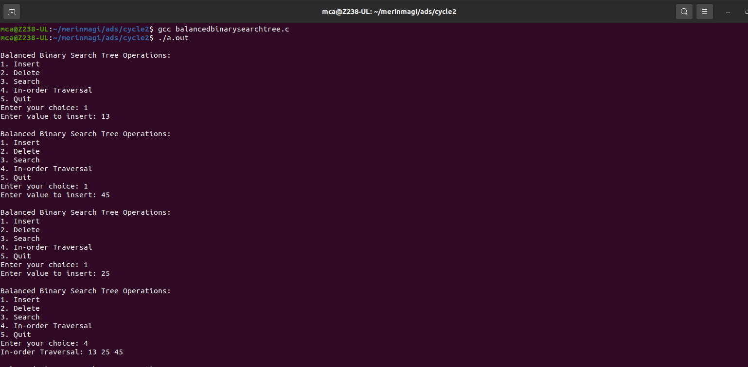

8) Implement set operations (union, intersection, difference)

source code

#include <stdio.h>

#define MAX_SIZE 100

// Function to read elements of a set from the user
int readSet(int set[]) {
int size, i;

printf("Enter the size of the set: ");
scanf("%d", &size);

printf("Enter elements of the set:\n");
for (i = 0; i < size; i++) {
scanf("%d", &set[i]);
}

return size;
}

// Function to display the elements of a set
void displaySet(int set[], int size) {
int i;

printf("Set: { ");
for (i = 0; i < size; i++) {
printf("%d ", set[i]);
}
printf("}\n");
}

// Function to perform set union
int setUnion(int set1[], int size1, int set2[], int size2, int result[]) {
int i, j, k = 0;

for (i = 0; i < size1; i++) {
result[k++] = set1[i];
}

for (i = 0; i < size2; i++) {
int found = 0;
for (j = 0; j < size1; j++) {
if (set2[i] == set1[j]) {
found = 1;
break;
}
}
if (!found) {
result[k++] = set2[i];
}
}

return k;
}

// Function to perform set intersection
int setIntersection(int set1[], int size1, int set2[], int size2, int result[]) {
int i, j, k = 0;

for (i = 0; i < size1; i++) {
for (j = 0; j < size2; j++) {
if (set1[i] == set2[j]) {
result[k++] = set1[i];
break;
}
}
}

return k;
}

// Function to perform set difference (set1 - set2)
int setDifference(int set1[], int size1, int set2[], int size2, int result[]) {
int i, j, k = 0;

for (i = 0; i < size1; i++) {
int found = 0;
for (j = 0; j < size2; j++) {
if (set1[i] == set2[j]) {
found = 1;
break;
}
}
if (!found) {
result[k++] = set1[i];
}
}

return k;
}

int main() {
int set1[MAX_SIZE], set2[MAX_SIZE], result[MAX_SIZE];
int size1, size2, resultSize;
int choice;

size1 = readSet(set1);
size2 = readSet(set2);

do {
printf("\nSet Operations:\n");
printf("1. Union\n");
printf("2. Intersection\n");
printf("3. Difference (set1 - set2)\n");
printf("4. Display Sets\n");
printf("5. Quit\n");

printf("Enter your choice: ");
scanf("%d", &choice);

switch (choice) {
case 1:
resultSize = setUnion(set1, size1, set2, size2, result);
displaySet(result, resultSize);
break;

case 2:
resultSize = setIntersection(set1, size1, set2, size2, result);
displaySet(result, resultSize);
break;

case 3:
resultSize = setDifference(set1, size1, set2, size2, result);
displaySet(result, resultSize);
break;

case 4:
printf("\nSets:\n");
printf("Set 1: ");
displaySet(set1, size1);
printf("Set 2: ");
displaySet(set2, size2);
break;

case 5:
printf("Exiting...\n");
break;

default:
printf("Invalid choice. Please try again.\n");
break;
}
} while (choice != 5);

return 0;
}

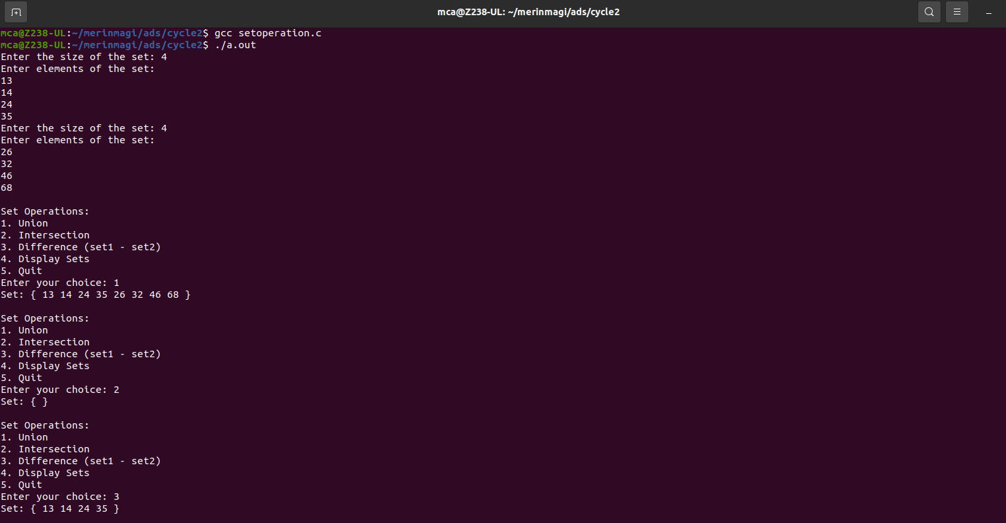

9) Implement disjoint set operations.

Source code

#include <stdio.h>

#define MAX_N 1000

int parent[MAX_N];
int rank[MAX_N];

void make_set(int v) {
parent[v] = v;
rank[v] = 0;
}

int find_set(int v) {
if (v == parent[v])
return v;
return parent[v] = find_set(parent[v]);
}

void union_sets(int a, int b) {
a = find_set(a);
b = find_set(b);
if (a != b) {
if (rank[a] < rank[b]) {
int temp = a;
a = b;
b = temp;
}
parent[b] = a;
if (rank[a] == rank[b])
rank[a]++;
}
}

int main() {
int n,i;
printf("Enter the number of elements of set: ");
scanf("%d", &n);

for (int i = 0; i < n; i++) {
make_set(i);
}

int choice, a, b;
while (1) {
printf("\nMenu:\n");
printf("1. Make a set\n");
printf("2. Find the representative of a set\n");
printf("3. Union two sets\n");
printf("4. Exit\n");
printf("Enter your choice: ");
scanf("%d", &choice);

switch (choice) {
case 1:
printf("Enter an element to add to a set: ");
for(i=0;i<n;i++)
{
scanf("%d", &rank[a]);
}
if (a < 0 || a >= n) {

printf("Element index is out of range.\n");
} else {
make_set(a);
printf("Element %d is added to a new set with itself as its representative.\n", a);
}
break;
case 2:
printf("Enter an element to find its set representative: ");
scanf("%d", &a);
if (a < 0 || a >= n) {
printf("Element index is out of range.\n");
} else {
printf("The representative of element %d is %d\n", a, find_set(a));
}
break;
case 3:
printf("Enter two elements to union their sets: ");
scanf("%d %d", &a, &b);
if (a < 0 || a >= n || b < 0 || b >= n) {
printf("Element index is out of range.\n");
} else {
union_sets(a, b);
printf("Sets containing elements %d and %d are now merged.\n", a, b);
}
break;
case 4:
return 0;
default:
printf("Invalid choice. Please choose again.\n");
}
}

return 0;
}

