- Write a Shell program to check the given number is even or odd.

#!/bin/bash
# Author: Merin Magi Telson
# Rollno: 23MCA043
echo "Enter a Number:"
read number
if(( number % 2 == 0)); then
echo "$number is even."
else
echo "$number is odd."
fi

OUTPUT

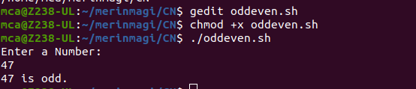

- Write a Shell program to check a leap year.

#!/bin/bash
#Author name:Merin Magi Telson
#Roll no:23MCA043
echo "Enter the year:"
read year
if(( ( year % 4 ==0 && year % 100 != 0) || (year % 100 !=0) || (year % 400==0) )); then
echo "$year is a leap year."
else
echo "$year is a leap year."
fi

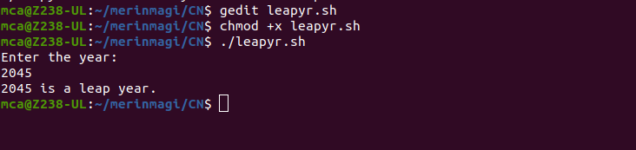
OUTPUT

- Write a Shell program to find the area and circumference of a circle.

#!/bin/bash
#Author: Merin Magi Telson
#Roll no:23MCA043
echo "Enter the radius of the circle:"
read r

area=$(echo "3.14*3.14*$r"| bc )
circum=$(echo "3.14*2*$r" | bc )
echo "Area of the circle:" $area
echo "Circumference of the circle:" $circum

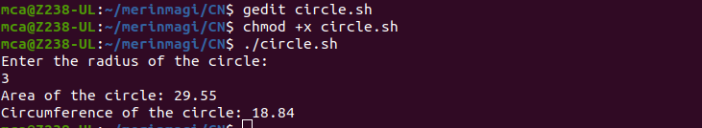

- Write a Shell program to check the given number and its reverse are same.

#!/bin/bash
# Author name: Merin Magi Telson
# Roll no: 23MCA043

echo "Enter a number:"
read number

# Reverse the number
reverse=$(echo "$number" | rev)

if [ "$number" -eq "$reverse" ]; then
echo "$number and its reverse are same."
else
echo "$number and its reverse are not same."
fi

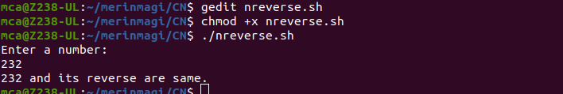

- Write a Shell program to check the given string is palindrome or not.

#!/bin/bash
#Author:Merin Magi Telson
#Roll no:23MCA043
echo "Enter a String"
read input
reverse=""

len=${#input}
for (( i=$len-1; i>=0; i-- ))
do
reverse="$reverse${input:$i:1}"
done
if [ $input == $reverse ]
then
echo "$input is palindrome"
else
echo "$input is not palindrome"
fi

Output

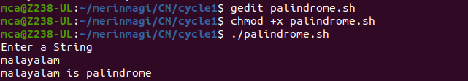

6. Write a Shell program to find the sum of odd and even numbers from a set of numbers.

#!/bin/bash
#Author:Merin Magi Telson
#Roll no:23MCA043
echo "Enter a set of numbers separated by spaces:"
read -a numbers
sum_even=0
sum_odd=0
for num in "${numbers[@]}"; do
if (( num % 2==0 )); then
((sum_even+=num))
else
(( sum_odd +=num))
fi
done
echo "Sum of even numbers: $sum_even"
echo "Sum of odd numbers: $sum_odd"

Output
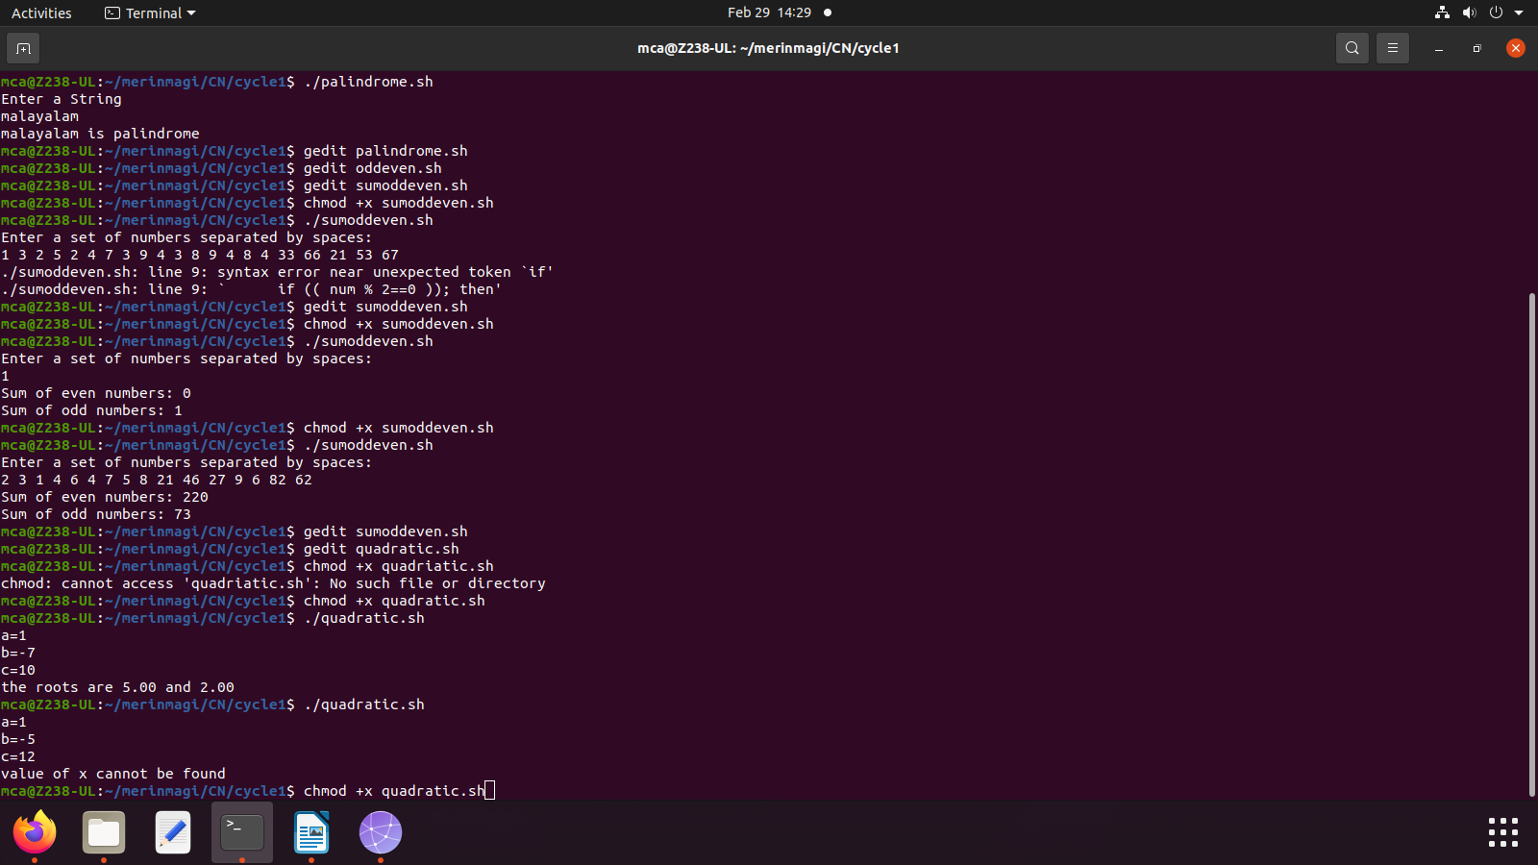

7. Write a Shell program to find the roots of a quadratic equation.

#!/bin/bash
#Author: MERIN MAGI TELSON
#RollNo: 23MCA043
read -p "a=" a
read -p "b=" b
read -p "c=" c

x1=$(echo "scale=2; ((-1*$b) + (sqrt(($b*$b)-(4*$a*$c))))/(2*$a)" | bc 2> /dev/null)
x2=$(echo "scale=2; ((-1*$b) - (sqrt(($b*$b)-(4*$a*$c))))/(2*$a)" | bc 2> /dev/null)

if [[ $x1 == $null && $x2 == $null ]];then
echo value of x cannot be found
else
echo the roots are $x1 and $x2
fi

Output

8. Write a Shell program to check the given integer is Armstrong number or not.

#!/bin/bash
#Author: MERIN MAGI TELSON
#RollNo: 23MCA043
echo "Enter an integer:"
read number
n=$number
sum=0

num_digits=${#number}

while [ $number -gt 0 ]; do
digit=$((number % 10))
sum=$((sum + digit ** num_digits))
number=$((number / 10))
done

if [ $sum -eq $n ]; then
echo "$n is an Armstrong number."
else
echo "$n is not an Armstrong number."
fi

Output

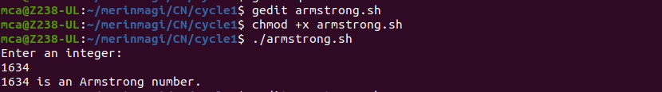

9. Write a Shell program to check the given integer is prime or not.

#!/bin/bash
#Author: MERIN MAGI TELSON
#RollNo: 23MCA043
echo "Enter an integer:"
read number

if [ $number -lt 2 ]; then
echo "$number is not a prime number."
exit
fi

for (( i=2; i<=number/2; i++ )); do
if [ $((number % i)) -eq 0 ]; then
echo "$number is not a prime number."
exit
fi
done

echo "$number is a prime number."

Output
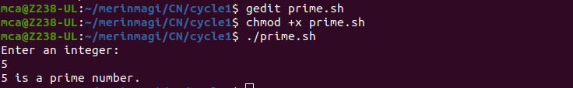

10. Write a Shell program to generate prime numbers between 1 and 50.

#!/bin/bash
#Author: MERIN MAGI TELSON
#RollNo: 23MCA043
echo "Prime numbers between 1 and 50 are:"
for (( num=2; num<=50; num++ )); do
prime=true
for (( i=2; i*i<=num; i++ )); do
if [ $((num % i)) -eq 0 ]; then
prime=false
break
fi
done
if $prime; then
echo $num
fi
done

