**Product.java**

import java.util.Objects;

public class Product

{

String pname,pcode;

int price;

public String getPname()

{

return pname;

}

public Product()

{

}

public Product(String pname, String pcode , int price)

{

this.pname=pname;

this.pcode=pcode;

this.price=price;

}

public void setPname()

{

this.pname=pname;

}

public String getPcode()

{

return pcode;

}

public void setPcode(String pcode)

{

this.pcode=pcode;

}

public int getPrice()

{

return price;

}

public void setPrice(int price)

{

this.price=price;

}

public void display()

{

System.out.println("pcodee: "+this.pcode);

System.out.println("pname: "+this.pname);

System.out.println("price: "+this.price);

}

}

**Exp1**

public class Exp1

{

public static void main(String[] args)

{

System.out.println("Merin Magi Telson");

System.out.println("S1MCA");

System.out.println("Product");

System.out.println("13/02/2024");

Product p1=new Product();

p1.pcode="Car123";

p1.pname="Benz";

p1.price=103000;

System.out.println("*******************Displaying Product1*****************");

p1.display();

Product p2=new Product("Jaguar","Car200",350000);

System.out.println("*******************Displaying Product2*****************");

p2.display();

Product p3=new Product("Maruthi","Car245",72600);

System.out.println("*******************Displaying Product2*****************");

p3.display();

Product p=p3.getPrice()<(p1.price<p2.price?p1.price:p2.price)?p3:(p1.price <p2.price?p1:p2);

System.out.println("\n**************Dispalying product with lowest price************");

p.display();

}

}

**Output**

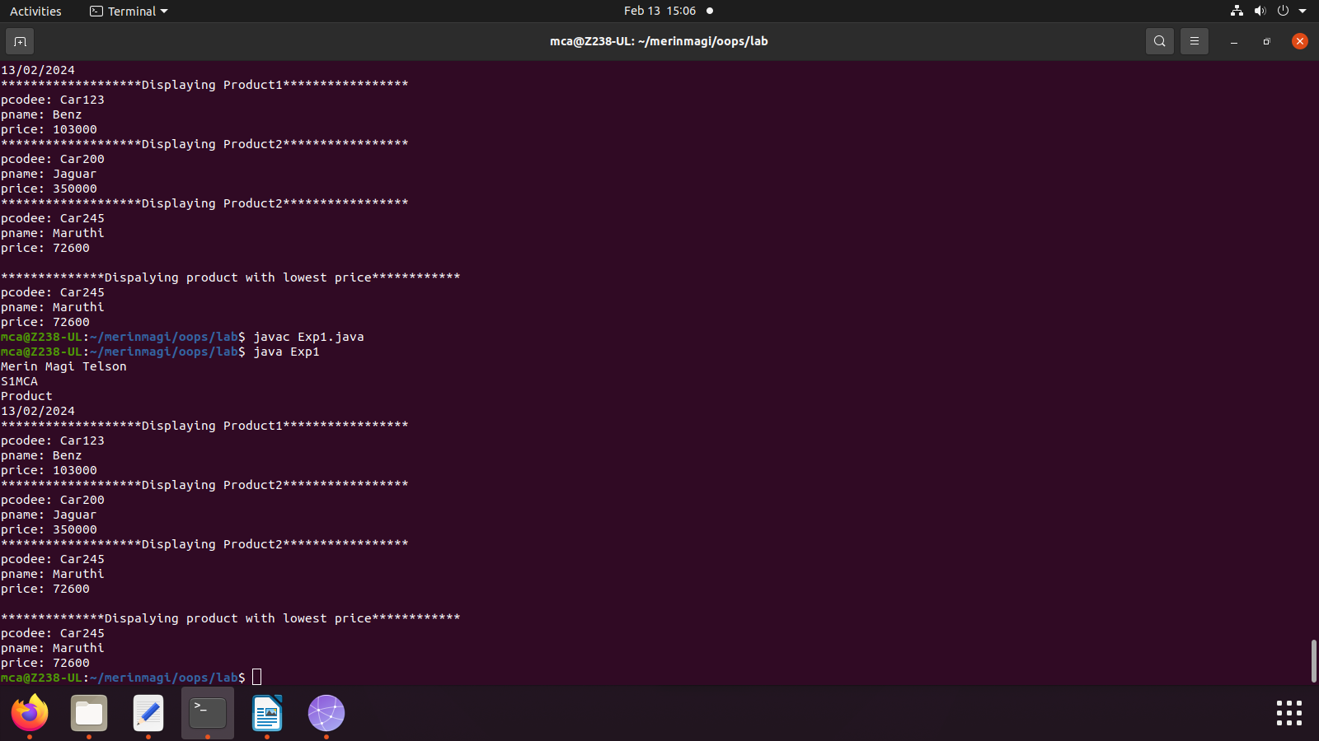

**MatrixAdd.java**

import java.util.Scanner;

public class MatrixAdd

{

public static void main(String args[])

{

System.out.println("Merin Magi Telson");

System.out.println("23MCA043");

System.out.println("13/02/2024");

int p,q,m,n;

Scanner s=new Scanner(System.in);

System.out.println("Enter the number of rows of the first matrix:");

p=s.nextInt();

System.out.println("Enter the number of columns in first matrix:");

q=s.nextInt();

System.out.println("Enter the number of rows in second matrix:");

m=s.nextInt();

System.out.println("Enter the number of columns in second matrix:");

n=s.nextInt();

if(p==m && q==n)

{

int a[][]=new int[p][q];

int b[][]=new int[m][n];

int c[][]=new int[m][n];

System.out.println("Enter the elements of the first matrix:");

for(int i=0;i<p;i++)

for(int j=0;j<q;j++)

a[i][j]=s.nextInt();

System.out.println("Enter the elements of the second matrix:");

for(int i=0;i<m;i++)

for(int j=0;j<n;j++)

b[i][j]=s.nextInt();

System.out.println("First Matrix");

for(int i =0;i<p;i++)

{

for(int j=0;j<q;j++)

{

System.out.print(a[i][j]+" ");

}

System.out.println();

}

System.out.println("Second Matrix");

for(int i=0;i<m;i++)

{

for(int j=0;j<n;j++)

{

System.out.print(b[i][j]+" ");

}

System.out.println();

}

for (int i=0;i<p;i++)

for(int j=0;j<n;j++)

for(int k=0;k<q;k++)

c[i][j]=a[i][j]+b[i][j];

System.out.println("Matrix After Addition:");

for(int i=0;i<p;i++)

{

for(int j=0;j<n;j++)

System.out.print(c[i][j]+" ");

System.out.println(" ");

}

}

else

{

System.out.println("Addition is not possible");

}

}

}

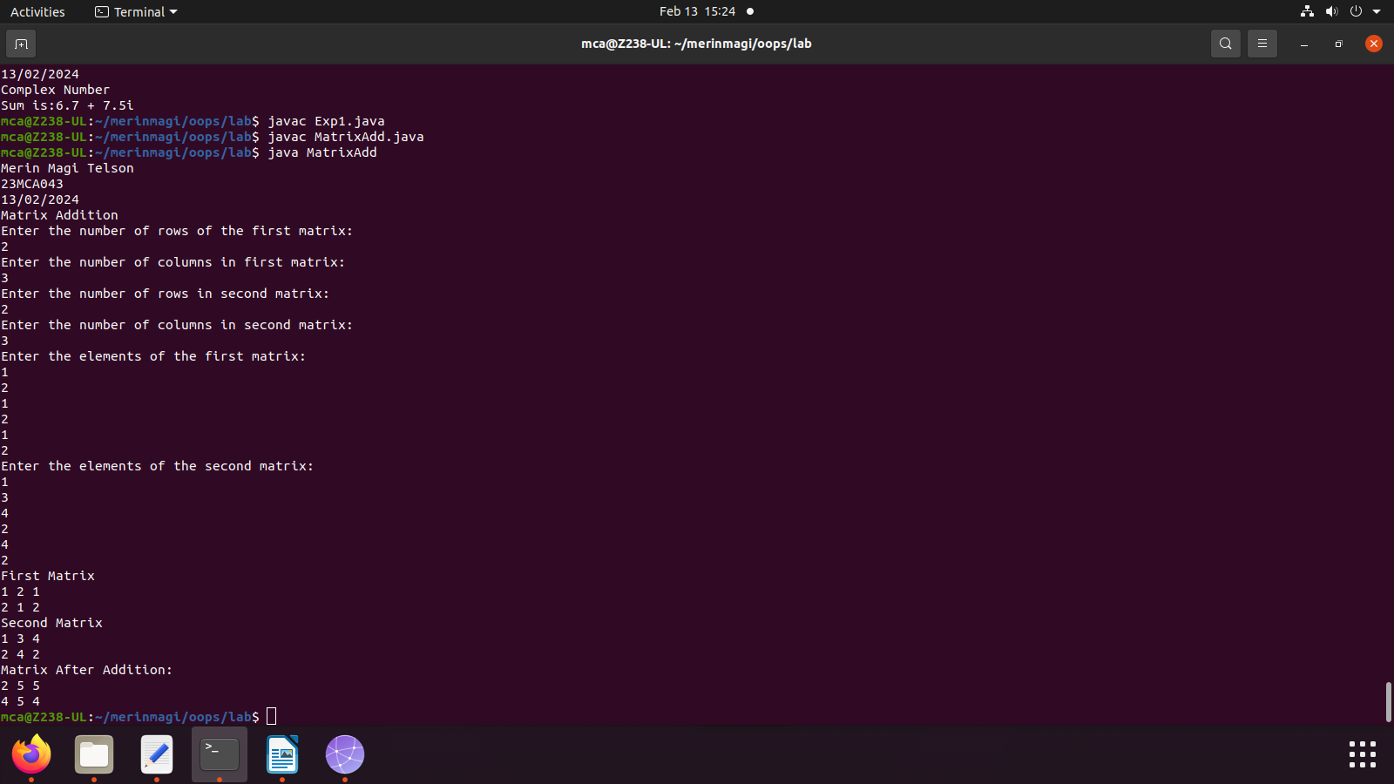

**ComplexNumber.java**

public class ComplexNumber

{

double real,img;

ComplexNumber(double r,double i)

{

this.real=r;

this.img=i;

}

public static ComplexNumber sum(ComplexNumber c1,ComplexNumber c2)

{

ComplexNumber temp=new ComplexNumber(0,0);

temp.real=c1.real+c2.real;

temp.img=c1.img+c2.img;

return temp;

}

public static void main(String args[])

{

System.out.println("Merin Magi Telson");

System.out.println("23MCA043");

System.out.println("13/02/2024");

System.out.println("Complex Number");

ComplexNumber c1=new ComplexNumber(5.5,4);

ComplexNumber c2=new ComplexNumber(1.2,3.5);

ComplexNumber temp=sum(c1,c2);

System.out.println("Sum is:"+temp.real+" + "+ temp.img +"i");

}

}

**Output**

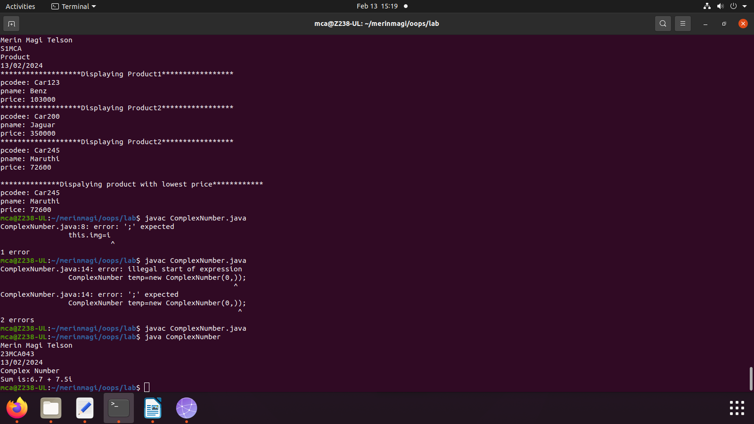

**SymmetricMatrixProgram.java**

import java.util.Scanner;

public class SymmetricMatrixProgram

{

public static void main(String[] args)

{

System.out.println("Merin Magi Telson");

System.out.println("23MCA043");

System.out.println("13/02/2024");

System.out.println("Symmetric Matrix Program");

Scanner s=new Scanner(System.in);

System.out.println("Enter the number of rows:");

int rows=s.nextInt();

System.out.println("Enter the number of columns:");

int cols=s.nextInt();

int matrix[][]=new int[rows][cols];

System.out.println("Enter the elements of the matrix:");

for(int i=0;i<rows;i++)

{

for(int j=0;j<cols;j++)

{

matrix[i][j]=s.nextInt();

}

}

s.close();

System.out.println("Printing the input Matrix:");

for(int i=0;i<rows;i++)

{

for(int j=0;j<cols;j++)

{

System.out.print(matrix[i][j]+"\t");

}

System.out.println();

}

if(rows !=cols)

System.out.println("The given matrix is not a square matrix");

else

{

boolean symmetric=true;

for(int i=0;i<rows;i++)

for(int j=0;j<cols;j++)

if(matrix[i][j] !=matrix[j][i])

{

symmetric=false;

break;

}

if(symmetric)

{

System.out.println("the given matrix is symmetric....");

}

else

{

System.out.println("The given matrix is not symmetric..");

}

}

}

}

**Output**

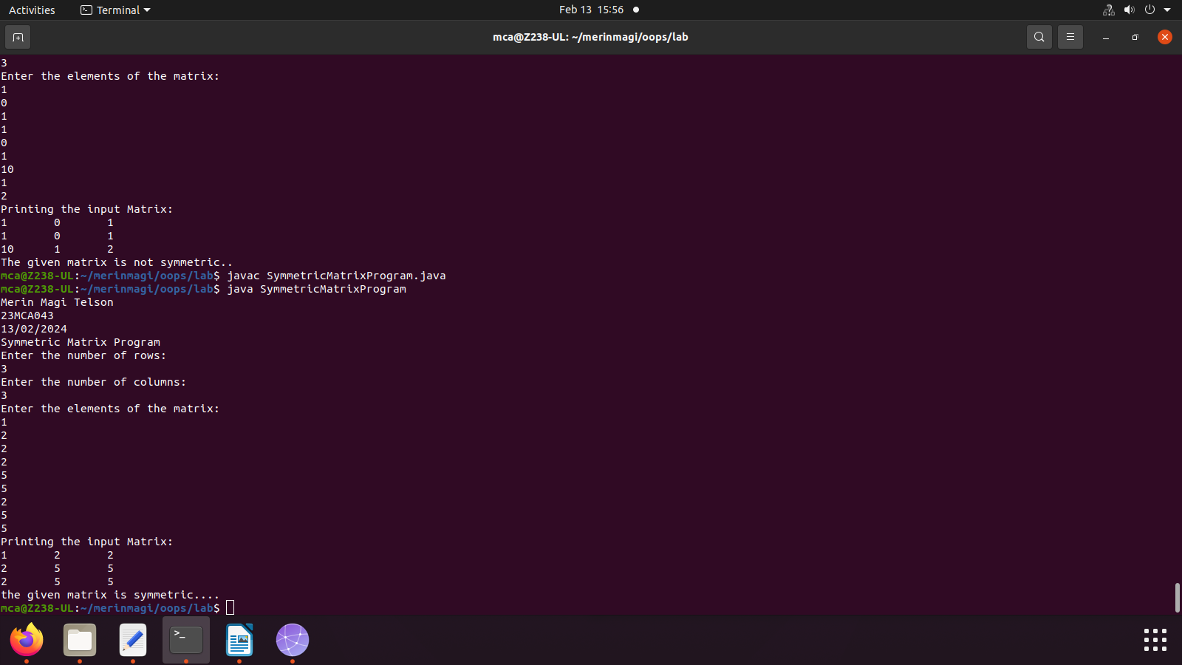

**CPUDetails**

class CPU

{

double price;

class Processor

{

double cores;

String manufacturer;

double getCache()

{

return 4.3;

}

}

protected class RAM

{

double memory;

String Manufacturer;

double getClockSpeed()

{

return 5.5;

}

}

}

public class CPUDetails

{

public static void main(String[] args)

{

System.out.println("Merin Magi Telson");

System.out.println("23MCA043");

System.out.println("13/02/2024");

System.out.println("CPU Details");

CPU cpu=new CPU();

CPU.Processor processor=cpu.new Processor();

CPU.RAM ram=cpu.new RAM();

System.out.println("Processor_Cache = " + processor.getCache());

System.out.println("Ram Clock Speed = " + ram.getClockSpeed());

}

}

**Output**

