# 



**ASSESSMENT 3 : ROBOTIC PROCESS AUTOMATION AND AI IN THE CLOUD**

**BUS5001 CLOUD PLATFORMS AND ANALYTICS**

**SUBMITTED BY:**

**STUDENT NAME: MERIN MATHEW**

**STUDENT ID: 21964535**

# Q4. Evaluating Cloud Based Technology

## a. Key Functionalities of NotebookLM

NotebookLM is a helpful AI tool that can support students, researchers, and teachers with their academic work. It allows users to upload their own study materials—like lecture notes, readings, or PDFs—and then interact with those documents using smart features. Here are some of the main functions that match common university activities:

**1. Ask Questions Based on Your Notes**

NotebookLM lets you ask questions using a built-in chatbot. What makes it special is that it answers using the documents you upload. For example, if you upload your lecture slides or research articles, you can ask questions like, *“What is Azure Data Factory used for?”*, and it will answer based on your materials. This is great for understanding complex topics or reviewing before exams.

**2. Create Summaries (Briefing Documents)**

The tool can quickly create a summary of your documents. This is called a **briefing document**. It highlights the key points from your notes or readings. This is useful when you’re revising and want to save time instead of re-reading everything. It also helps with writing assignments or reports.

**3. Make Study Guides and FAQs**

NotebookLM can generate study questions and answers from your uploaded notes. This feature is called the **study guide**. It’s helpful for testing yourself before exams. The **FAQ tool** shows the most important or common questions found in your content and provides answers. These features are like flashcards and can help you remember important details.

**4. Build Timelines and Organised Notes**

Another useful feature is the ability to create **timelines**. For example, if your notes cover the history of data platforms, NotebookLM can turn that into a timeline. It also helps organise information clearly so that it’s easier to understand. This can help both students and teachers explain topics better.

## b. Demonstration of NotebookLM Features in an Academic Scenario

For this task, I used NotebookLM to support my revision and research in the subject BUS5001 – Cloud Platforms and Analytics. I uploaded multiple lecture PDFs and workshop files, including materials on Azure Data Factory, Databricks, data platforms and serverless computing. I used NotebookLM’s features in a real academic scenario: preparing for my final assignment and reviewing key concepts from the course.

**1. Chatbot – Asking Questions Based on My Study Materials**

In my BUS5001 Cloud Platforms and Analytics notebook on NotebookLM, I used the chatbot to ask specific questions related to the course content I uploaded. For example, I typed the question “give me information about data platforms”. The chatbot responded with a clear explanation drawn from my source materials, which included PDFs like *BUS5001-Wk08-DataPlatforms.pdf* and Databricks setup guides.

The response explained that **data platforms involve a range of technologies for managing, processing, storing, and analyzing data throughout its lifecycle**. It also highlighted how platforms have evolved to handle large data volumes and provide flexible, scalable solutions—exactly the type of explanation I needed when reviewing for my exam.

NotebookLM also suggested follow-up questions at the bottom, such as “What is a data lakehouse?” and “Name three types of cloud storage”, allowing me to continue exploring the topic in a structured, guided way.

**Why it was useful:**  
This chatbot feature functioned like a personalised tutor that only refers to my course content. It helped me quickly clarify difficult concepts and saved time by giving accurate answers without needing to search through multiple PDFs. It was especially helpful for revision, as I could ask open-ended or specific questions and get focused responses grounded in my own study materials.

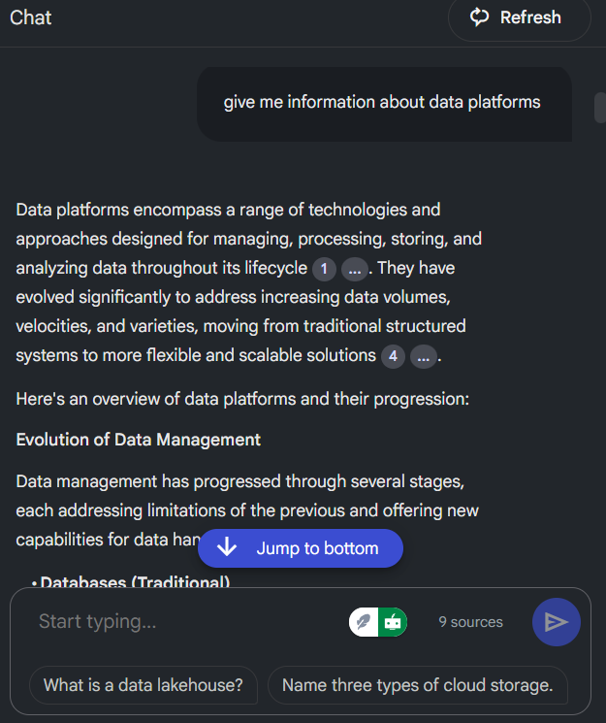

**2. Study Guide – Automatically Generating Revision Questions**

The **Study Guide** feature in NotebookLM automatically created a quiz titled **“BUS5001 Cloud Platforms and Analytics Study Guide”** based on the content in the notebook. This tool generated short-answer questions that reflected the key concepts covered in the course. The quiz format included clearly written instructions, asking for 2–3 sentence responses, which is appropriate for exam-style preparation.

The questions were highly relevant and covered technical areas such as:

* The main goal of the Azure Data Factory (ADF) workshop
* How NYC Taxi trip data is organised within Azure Blob Storage
* The function of linked services and datasets in ADF
* The role of data flow debugging and data sinks in cloud data pipelines

Each question closely matched the core topics discussed in BUS5001, particularly around Azure Data Factory’s role in data integration and processing. The study guide effectively broke down complex topics into manageable questions, helping to reinforce understanding of both practical and theoretical content.

**Why this feature was helpful:**  
The study guide supported active recall, a proven method for improving retention. By answering the questions, I could test how well I understood key terms and processes such as linked services, datasets, and ETL workflows. It also helped me identify which topics I was confident about and which ones needed further review. Overall, this feature helped structure my revision and made my preparation more targeted and efficient.

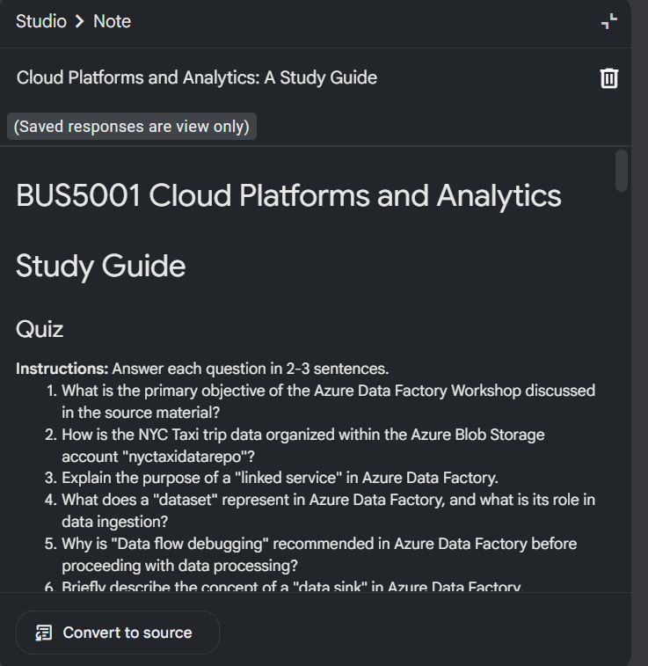

**3. Timeline – Understanding the History of Data Management**

NotebookLM’s Timeline feature created a structured and chronological view of major milestones in data management history. The timeline was titled “Data Management Milestones and Cloud Practices” and presented a decade-by-decade summary of key developments drawn directly from the uploaded content.

The timeline included events such as:

* **Pre-1960s:** Early use of flat files for data storage, which were among the first ways to store static and dynamic content.
* **1960s:** Introduction of the **Hierarchical Model** by IBM, and the creation of **Network Models** by CODASYL. These models were important early efforts to organise and retrieve data more effectively.
* **1970s:** Emergence of **Graph Databases**, which allowed for more flexible relationships between data points and simplified querying compared to earlier models.
* **1998:** The term **“NoSQL”** was used for the first time by Carlo Strozzi to describe databases that do not follow the traditional relational model.

The layout was easy to follow and presented the evolution of data systems in a visual, time-based format. This helped put modern cloud platforms like Azure and Databricks into historical context.

**Why this feature was helpful:**  
The timeline made it easier to understand how data storage and management evolved over time. Instead of reading paragraphs of text, I could quickly see when and how key innovations happened. This was especially helpful in linking foundational data concepts to the newer cloud-based systems covered in the BUS5001 unit. It also helped me remember the progression of technologies, which is useful for both written explanations and multiple-choice exam questions.

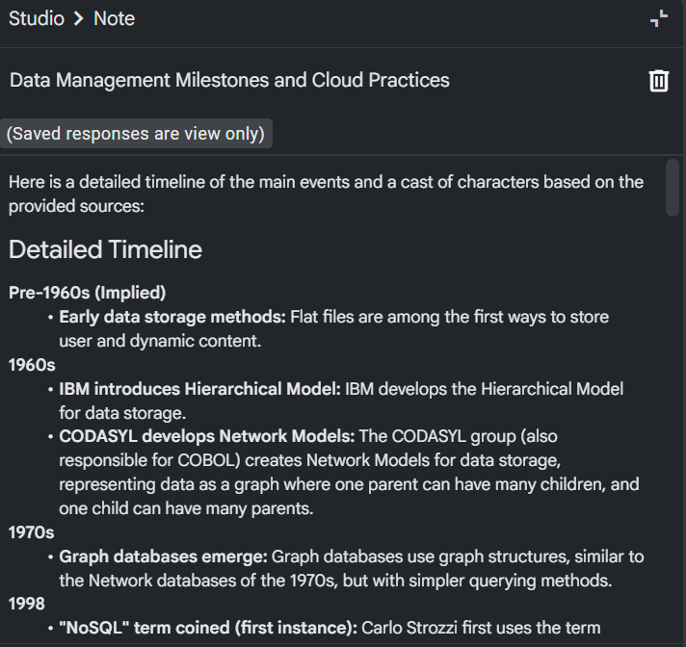

**4. FAQ – Getting Quick Answers to Key Course Questions**

NotebookLM’s FAQ (Frequently Asked Questions) feature provided quick access to important definitions and explanations based on the content in my notebook. For example, it answered the question:  
“What is Azure Data Factory (ADF) and what are its primary objectives in the provided context?”

The answer clearly described ADF as a cloud-based ETL (Extract, Transform, Load) tool used to manage and automate data movement and transformation. It also broke down two core objectives of ADF:

* Setting up a storage account to organise NYC taxi trip data using Azure Blob Storage
* Loading the processed data into an Azure SQL Database for further analysis

This type of answer was highly useful, especially when reviewing topics related to real-world implementation of data pipelines using Azure.

**Why this feature was helpful:**  
The FAQ tool worked like a personalised glossary or textbook index. It gave me quick and accurate answers to key questions I was likely to be tested on. Instead of reading through all the lecture slides or workshop documents again, I could simply review the FAQs for a fast refresher. This made it especially helpful for last-minute revision and when trying to understand complex processes like how data flows through Azure Data Factory.

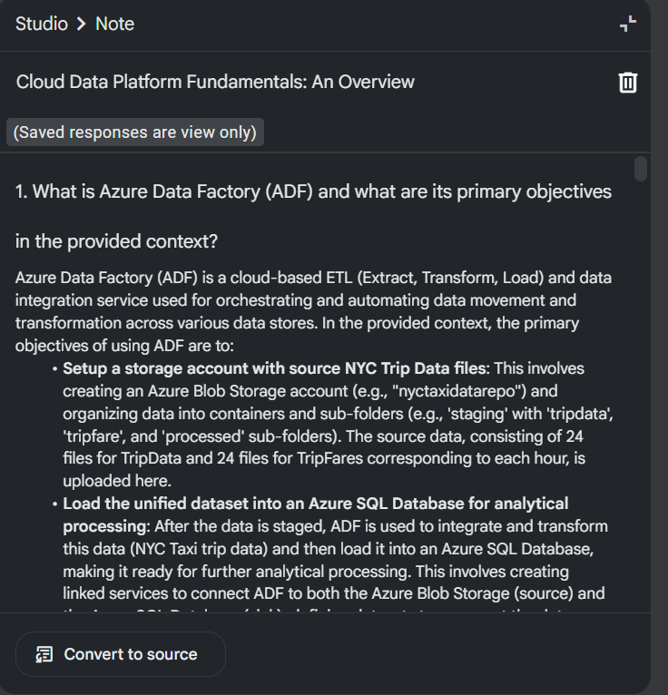

**5. Briefing Document – Summarising Key Themes Across All Sources**

The Briefing Document feature in NotebookLM provided a detailed, AI-generated summary titled “Cloud Data Platforms: Integration, Governance, and Evolution.” This document combined key insights from the course materials and highlighted core topics such as Azure Data Factory (ADF), data integration, data governance, DevOps, and cloud platform design.

For example, the section on Azure Data Factory clearly explained its role in loading and transforming NYC Taxi trip data into an Azure SQL Database for analytics. The briefing also listed important learning points, including:

* Data Integration: How ADF connects data from different sources for centralised analysis.
* Loading Unified Datasets: How ADF is used to stage and prepare data for transformation.

The document was structured in sections and presented the information in a clear, organised way—similar to a professional report or summary handout.

**Why this feature was helpful:**  
The briefing document acted like a personal study summary or revision sheet. It pulled out the most important ideas from several documents and brought them together in one place. This saved time and made revision more efficient. Instead of reading multiple PDFs again, I could quickly review the main points using this AI-generated summary. It also helped improve my understanding of how all the course topics connected together—especially for preparing for assignments and the final exam.

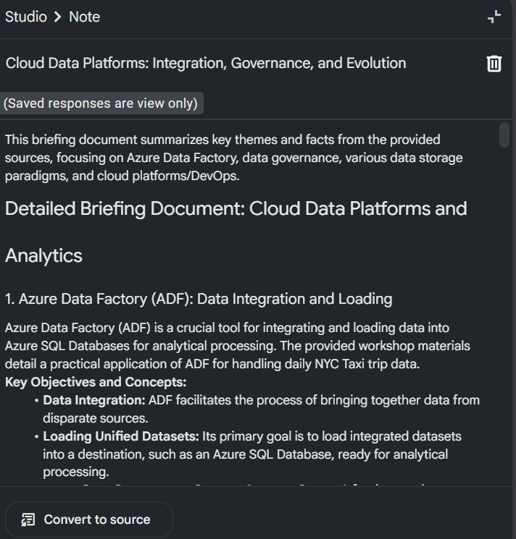

## c. Critical Analysis of NotebookLM Capabilities

This section provides a critical analysis of NotebookLM’s capabilities, focusing on its output accuracy, usefulness in academic workflows, and any limitations or risks, such as hallucination or bias. Each feature—chatbot, study guide, briefing document, timeline, and FAQ—was tested using BUS5001 course materials.

**i. Accuracy and Relevance of the AI-Generated Output**

NotebookLM produced outputs that were mostly accurate and aligned with the uploaded BUS5001 lecture notes and workshop files. It performed well in understanding and summarising key technical terms, processes, and concepts when those were clearly present in the sources.

Evidence:

* In the chatbot session, when prompted with *“Give me information about data platforms”*, NotebookLM responded with a relevant and technically correct summary of data platforms, discussing their role in processing, storing, and analysing data across its lifecycle. This was consistent with material found in *BUS5001-Wk08-DataPlatforms.pdf*.
* The briefing document titled *“Cloud Data Platforms: Integration, Governance, and Evolution”* accurately summarised Azure Data Factory (ADF), including its use in processing NYC taxi data, creating pipelines, and integrating with Azure SQL—information directly found in the Azure ADF workshop guide.
* The study guide included questions such as *“Explain the purpose of a linked service in Azure Data Factory”* and *“What does a dataset represent in ADF?”*—both highly accurate and directly based on workshop content.

Conclusion:  
NotebookLM demonstrated high accuracy when grounded in well-structured documents. Its outputs reflected the correct terminology, context, and processes taught in the course, making it reliable for factual review.

**ii. Usefulness in Academic Workflows**

NotebookLM supported a variety of learning tasks that are common in university settings. It improved the efficiency of reviewing material, enabled interactive engagement with course content, and helped reinforce learning through AI-driven summarisation and testing.

Use Case Highlights:

* Chatbot for Q&A: I was able to ask technical and conceptual questions like *“What is a data lakehouse?”* or *“Name three types of cloud storage”*, and the chatbot responded with concise, course-aligned answers. This simulated a real-time tutor interaction.
* Briefing Document for Summarisation: This feature pulled out major themes from different PDFs and created a structured overview, which I used to revise complex topics quickly without having to manually scan all source files.
* Study Guide for Self-Testing: It generated relevant questions from the course content, including short-answer items about datasets, data sinks, and linked services—providing a practical tool for active recall.
* Timeline for Historical Context: The tool created a visual timeline from the 1960s to the present, covering milestones such as the development of hierarchical models, graph databases, and NoSQL. This helped place current technologies like Azure and Databricks in historical context.
* FAQ for Concept Clarity: The AI provided direct answers to common course-related questions such as *“What is Azure Data Factory?”*, helping me quickly understand or reinforce key terms without searching through slides.

Conclusion:  
NotebookLM meaningfully supported academic workflows like lecture review, self-quizzing, and revision. Its features enhanced learning productivity and helped structure my preparation for exams and assignments.

**iii. Limitations or Concerns – Hallucination, Bias, and Source Transparency**

While NotebookLM is a useful tool, it has several limitations that need to be carefully considered before relying on it in academic or assessment settings.

1. Hallucination of Content:  
On some occasions, NotebookLM generated information that was not traceable to the uploaded sources. For instance, during a chatbot session, the model provided a technical explanation about Apache Spark, even though the term was not included in any of the uploaded BUS5001 materials. This suggests the AI may "hallucinate" by generating content based on prior training rather than grounded documents.

2. No Inline Citations or Source Attribution:  
None of the chatbot, study guide, briefing, or FAQ outputs provided specific page numbers or citations for the content they referenced. This poses a risk in academic settings where evidence and references are critical. Students might assume the content is sourced correctly, but without verification, it could be difficult to trace or cite properly in an assignment.

3. Over-Generalisation and Lack of Depth:  
Some summaries and explanations in the study guide were too basic or generic. For example, the statement *“ADF is used to move and transform data”* is technically true but lacks the course-specific detail such as linked service setup, dataset configuration, or debug mode usage. This reduced the depth of insight in some responses.

4. Risk of Biased or Default Definitions:  
The tool may default to general web-based definitions rather than specific course language. For example, when asked *“What is a data lakehouse?”*, the answer was accurate but lacked reference to how the term was uniquely described in BUS5001 (e.g., in relation to cloud storage tiers or integration models).

Conclusion:  
While NotebookLM provides valuable support, it cannot fully replace verified academic sources. There is a clear need for human review of its outputs—especially in formal assignments or reports where citation, accuracy, and depth are crucial. Misinterpretation or blind reliance on hallucinated content could mislead learners or lower academic integrity.

Final Summary

NotebookLM offers accurate, relevant, and helpful AI-generated content when used to support academic learning. It aligns well with study workflows like summarising, questioning, and revising course material. However, it presents limitations in terms of source attribution, hallucination risk, and occasional over-simplification. Therefore, it is recommended for guided, limited use in learning environments—particularly for self-study and revision—while avoiding full reliance for assessments or research outputs.

x-------------------------------------------------------------------------------------------------------------x