Coding Challenge. 4

Maryam Saeed Noor Fatima

2025-02-25

# Coding Challenge 3

## **Q.No.3 (a)**

## **Q.No.6 (b)**

###Readme file link

[link to my Readme file](Coding%20challenge.4.md)

### Clickable Link to the ManuscDript

[Manuscript Link](i.%20Noel,%20Z.A.,%20Roze,%20L.V.,%20Breunig,%20M.,%20Trail,%20F.%202022.%20Endophytic%20fungi%20as%20promising%20biocontrol%20agent%20to%20protect%20wheat%20from%20Fusarium%20graminearum%20head%20blight.%20Plant%20Disease.%20https://doi.org/10.1094/PDIS-06-21-1253-RE)

## **Q.No.6 (b)**

##File Tree of Github

[pdf file](Coding-challenge.4.pdf)

[word file](Coding-challenge.4.docx)

[md file](Coding-challenge.4.md)

[Mycotoxin csv file](MycotoxinData.csv)

### Libraries

library(readr)  
library(ggplot2)  
library(tidyverse)

## ── Attaching core tidyverse packages ──────────────────────── tidyverse 2.0.0 ──  
## ✔ dplyr 1.1.4 ✔ stringr 1.5.1  
## ✔ forcats 1.0.0 ✔ tibble 3.2.1  
## ✔ lubridate 1.9.4 ✔ tidyr 1.3.1  
## ✔ purrr 1.0.2   
## ── Conflicts ────────────────────────────────────────── tidyverse_conflicts() ──  
## ✖ dplyr::filter() masks stats::filter()  
## ✖ dplyr::lag() masks stats::lag()  
## ℹ Use the conflicted package (<http://conflicted.r-lib.org/>) to force all conflicts to become errors

library(ggpubr)  
library(ggrepel)   
cbbPalette <- c("#000000", "#E69F00", "#56B4E9", "#009E73",  
 "#F0E442", "#0072B2", "#D55E00", "#CC79A7")

## **Q.No.3 (b)**

### Importing the excel file

MycotoxinData <- read.csv("MycotoxinData.csv",na = "na")

## **Q.No.3 (c)**

### Creating a ggplot box plot

plot.1<- ggplot(data = MycotoxinData, aes(x = Treatment, y = DON, fill = Cultivar)) +  
 geom_boxplot(color = "black") +   
 geom_point(aes(fill = Cultivar), shape = 21, color = "black", alpha = 0.6,   
 width = 0.9) +   
 scale_fill_manual(values = c(cbbPalette[6], cbbPalette[4])) +   
 xlab("") +  
 ylab("DON(ppm)") +   
 theme_classic() +   
 facet_wrap(~Cultivar, scale = "free")

## Warning in geom_point(aes(fill = Cultivar), shape = 21, color = "black", :  
## Ignoring unknown parameters: `width`

plot.1

## Warning: Removed 8 rows containing non-finite outside the scale range  
## (`stat_boxplot()`).

## Warning: Removed 8 rows containing missing values or values outside the scale range  
## (`geom_point()`).

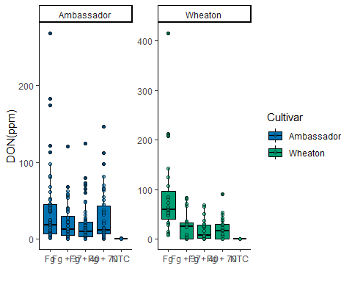

### Changing the factor levels

MycotoxinData$Treatment <- factor(MycotoxinData$Treatment,  
 levels = c("NTC", "Fg", "Fg + 37", "Fg + 40", "Fg + 70"))

### a. Using 15ADON as Y variable

plot.2 <- ggplot(data = MycotoxinData, aes(x = Treatment, y = X15ADON, fill = Cultivar)) +  
 geom_boxplot(color = "black") +  
 geom_point(aes(fill = Cultivar), shape = 21, color = "black", alpha = 0.6,   
 position = position_jitterdodge(dodge.width = 0.9)) +   
 scale_fill_manual(values = c(cbbPalette[6], cbbPalette[4])) +  
 ylab("15ADON") +  
 theme_classic() +  
 facet_wrap(~Cultivar, scale = "free")  
plot.2

## Warning: Removed 10 rows containing non-finite outside the scale range  
## (`stat_boxplot()`).

## Warning: Removed 10 rows containing missing values or values outside the scale range  
## (`geom_point()`).

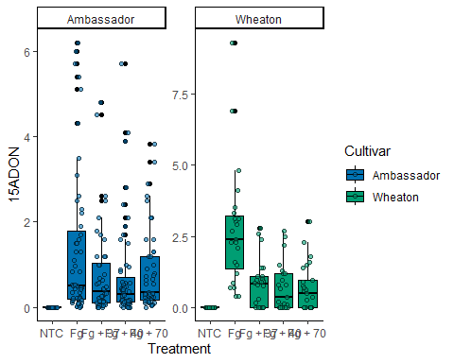

### b. using MassperSeed_mg as Y variable

plot.3<- ggplot(data = MycotoxinData, aes(x = Treatment, y = MassperSeed_mg , fill = Cultivar)) +  
 geom_boxplot(color = "black") +   
 geom_point(aes(fill = Cultivar), shape = 21, color = "black", alpha = 0.6,   
 position = position_jitterdodge(dodge.width = 0.9)) +   
 scale_fill_manual(values = c(cbbPalette[6], cbbPalette[4])) +   
 xlab("") +  
 ylab("MassperSeed_mg") +   
 theme_classic() +   
 facet_wrap(~Cultivar, scale = "free")  
plot.3

## Warning: Removed 2 rows containing non-finite outside the scale range  
## (`stat_boxplot()`).

## Warning: Removed 2 rows containing missing values or values outside the scale range  
## (`geom_point()`).

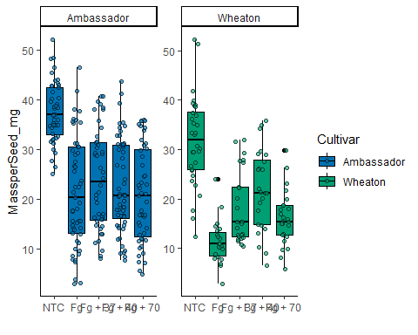

### using ggarrange

plot.4<- ggarrange(plot.1, plot.2, plot.3,  
 nrow =3,  
 ncol= 1,  
 labels = "auto",  
 common.legend = T)

## Warning: Removed 8 rows containing non-finite outside the scale range  
## (`stat_boxplot()`).

## Warning: Removed 8 rows containing missing values or values outside the scale range  
## (`geom_point()`).

## Warning: Removed 8 rows containing non-finite outside the scale range  
## (`stat_boxplot()`).

## Warning: Removed 8 rows containing missing values or values outside the scale range  
## (`geom_point()`).

## Warning: Removed 10 rows containing non-finite outside the scale range  
## (`stat_boxplot()`).

## Warning: Removed 10 rows containing missing values or values outside the scale range  
## (`geom_point()`).

## Warning: Removed 2 rows containing non-finite outside the scale range  
## (`stat_boxplot()`).

## Warning: Removed 2 rows containing missing values or values outside the scale range  
## (`geom_point()`).

plot.4

