

FITCORE : A web-based Gym Management System

ALLYSA SHARISE CAGUI-AT
MERJOHN PAGENTE
ANGELLIE JERUSALEM

May 2026

GYM MANAGEMENT SYSTEM
-------------------------------------------------------------------------------

A Project Paper

Presented to

Ma’am Genevieve B. Hilot

Instructor of the Institute of Computer Studies

Tangub City Global College

-------------------------------------------------------------------------------

In Partial Fulfillment of the Course

Software Engineering II

-------------------------------------------------------------------------------

Allysa Sharise Cagui-at
Merjohn B. Pagente
Angellie G. Jerusalem

May 2026

Introduction
In recent years, the global fitness industry has experienced significant growth due to increasing awareness of health and wellness. The global health and fitness club market exceeded $96 billion in 2023 and continues to expand as more individuals recognize the importance of regular exercise in preventing diseases such as obesity, diabetes, and hypertension (International Health, Racquet & Sportsclub Association [IHRSA], 2023; World Health Organization [WHO], 2022). This trend is particularly evident in urban areas, where access to gyms is more widespread, resulting in increased membership and a growing demand for structured fitness services.
In the Philippines and Southeast Asia, the fitness industry is also expanding due to rising incomes, evolving lifestyles, and a stronger emphasis on preventive healthcare (Statista, 2023). The increasing number of gym facilities in metropolitan areas reflects this trend but also presents operational challenges in managing larger memberships and more complex administrative tasks.
Despite this growth, many small to medium-sized gyms continue to rely on manual processes such as paper-based records and spreadsheets. While cost-effective, these methods often lead to disorganized data, increased administrative workload, and a higher risk of errors, while lacking real-time reporting capabilities (Laudon & Laudon, 2020). Manual management of tasks such as registration, attendance, payments, scheduling, inventory, and reporting can result in inefficiencies that negatively impact service quality and customer retention (O’Brien & Marakas, 2019; Kotler & Keller, 2016).
To address these challenges, this study proposes a web-based Gym Management System (GMS) to automate and centralize operations. The system is designed to securely manage member data, track payments and attendance, organize schedules, monitor equipment, and generate real-time reports. Automation features, such as payment reminders and scheduling tools, improve efficiency and reduce errors, while role-based access control enhances data security. Overall, the GMS aims to improve operational performance and support long-term business growth.

General Description

The Gym Management System (FitCore) is a web-based application designed to centralize and automate the administrative workflows of small and local fitness centers. Its primary objective is to replace traditional, error-prone manual methods, such as handwritten logbooks, with a structured digital environment that ensures data consistency and operational efficiency.
The system serves a diverse user community consisting of administrators who oversee financial reporting and user management, staff members who handle daily member registration and attendance monitoring, and trainers who utilize the system to manage their session schedules and prevent appointment conflicts, and members who use a self-service dashboard for their daily QR code, attendance, messages, and announcements.
By integrating core features such as automated billing, secure data storage, and real-time reporting, the Gym Management System provides a reliable platform that reduces administrative workload and minimizes human error. Ultimately, this system is vital for modernizing gym operations, allowing small businesses to improve service quality and enhance overall customer satisfaction.

Objectives of the Project

General Objective
To design and develop a web-based Gym Management System that automates administrative processes and improves operational efficiency for small and local fitness centers.

Specific Objectives
- To develop a secure module for registering, updating, and managing member information to ensure accurate record-keeping and efficient data retrieval.
- To implement a billing and payment tracking feature that monitors membership dues and generates automated renewal reminders.
- To design a trainer scheduling system that prevents overlapping appointments and efficiently organizes session assignments.
- To generate comprehensive summary reports, including attendance records and revenue summaries, to support informed decision-making by gym management.
- To implement a Walk-In feature that allows non-members to access the gym facility with a fixed single-day fee that the Administrator can configure in the system settings, providing a simple and accurate billing option for occasional users.

Project Scope and Delimitation

Project Scope
This project focuses on the design and development of a web-based Gym Management System intended for small and local fitness centers. The system aims to replace manual processes with a centralized and efficient digital platform that improves accuracy, accessibility, and overall operational performance.

The system includes a Membership Management Module that allows the registration, updating, and storage of member information such as personal details and assigned membership plans in a centralized data repository. It also features a Billing and Payment Tracking Module that records transactions, monitors membership dues, updates expiration dates, and generates automated renewal reminders displayed within the system dashboard.

For scheduling, the system provides a Trainer Scheduling Module that allows trainers to manage their assigned sessions while preventing overlapping schedules. Staff and Administrators are given view-only access to ensure proper coordination and monitoring.

An Operational Reporting Module is included to generate real-time reports such as daily attendance, walk-in records, and monthly revenue summaries, supporting performance tracking and informed decision-making.

The system also includes a Membership Plan Management Module, where Administrators and Staff can create, update, and manage membership plans, which are also visible to Trainers and Members.

Additionally, a Walk-In Management Module is implemented to allow Staff and Administrators to record one-time gym visitors who are not registered members. This module uses a fixed single-day fee set by the Administrator in the system settings, ensuring simple and accurate billing. The recorded walk-in transactions are automatically integrated into the system’s revenue reports.

Project Delimitation
The Gym Management System is delimited by specific conditions to clearly define the boundaries of the study and its implementation.

First, the system does not include hardware integration. It operates purely as a software-based solution and does not support devices such as biometric fingerprint scanners, RFID systems, or other physical access control technologies. This ensures that the system remains simple, cost-effective, and easy to deploy.

Second, the system is designed specifically for small and local fitness centers. It is not intended to support the complex operational requirements of large-scale or enterprise-level gyms, such as multi-branch management or advanced analytics systems.

Third, the system is limited to a web-based platform accessible. through modern web browsers. It does not include a dedicated mobile application for Android or iOS devices, and access is restricted to browser-based usage.

Lastly, for development and demonstration purposes, the system uses browser-based local storage for data management. This approach may result in data loss if browser data is cleared. However, the system is designed to be easily upgraded to a server-based database in future implementations to ensure data persistence and scalability.
Analysis and Design

System Analysis
Prior to system development, the proponents conducted a thorough analysis of the existing processes used by small and local fitness centers. The study revealed that many gyms still rely on manual methods such as paper-based records, logbooks, folders, and basic spreadsheets to manage their daily operations. While these methods may be sufficient for small-scale operations, they become inefficient and error-prone as the number of members increases.

The use of manual systems often leads to Issues such as misplaced or lost records, inconsistent data entries, and difficulty in retrieving information. Staff members spend significant time performing routine tasks such as locating member records, manually tracking payments, and checking trainer availability. These processes increase the likelihood of errors, including double-booking of trainer sessions and missed payment deadlines, which can negatively affect the gym’s operational efficiency and professional image.

To better understand these challenges, the proponents conducted interviews with gym staff and observed daily front desk operations. Existing logbooks, files, and record-keeping practices were also examined. These activities provided valuable insights into the actual workflow and operational needs of the gym environment.

Based on the findings, it was determined that there is a need for a centralized digital system that integrates all major functions, including member registration, billing, attendance tracking, and scheduling. The system must be user-friendly to accommodate staff with varying levels of technical expertise and must support role-based access for Administrators, Staff, and Trainers to ensure proper control and security of information.

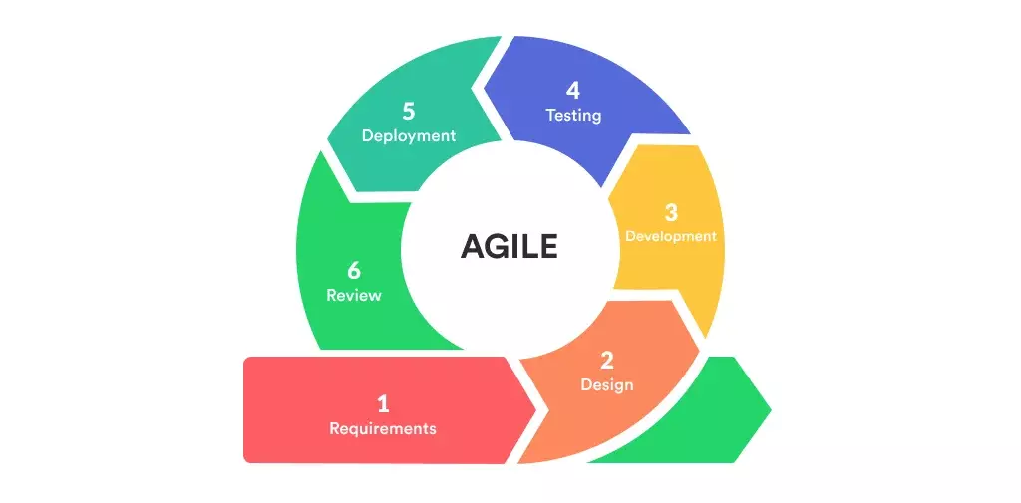

Figure 1: Agile Model

The development of the Gym Management System followed the Agile Software Development Life Cycle (SDLC) model. Agile is an iterative and incremental approach to software development that emphasizes flexibility, collaboration, and continuous delivery of working software. Unlike the traditional Waterfall model, Agile allows the development team to adapt quickly to changing requirements and to receive early feedback from users throughout the development process.
The Agile model was chosen for this project because the requirements of a gym management system are practical and user-driven, meaning regular feedback from gym staff and administrators is essential to ensure the system truly addresses their daily operational needs. The project was divided into short development cycles called sprints, with each sprint lasting approximately one to two weeks.

How Each Agile Phase Supported the Gym Management System:

Phase 1 – Project Planning and Requirements Gathering
In the first phase, the proponents met with gym administrators and staff to identify the core problems with their existing manual processes. The team defined the initial list of features needed: member registration, billing, trainer scheduling, reporting, membership plan management, walk-in tracking, and role-based access control. This phase produced the product backlog — a prioritized list of all system features to be developed.

Phase 2 – Sprint 1: Member Registration and Authentication (Week 1–2)
The first sprint focused on developing the most critical feature — the Member Registration and Profile Management module. The team also built the login system with role-based access for Admin, Staff, and Trainer. At the end of the sprint, the working login and member registration pages were demonstrated to the adviser for feedback and approval before moving forward.

Phase 3 – Sprint 2: Billing, Payment Tracking, and Walk-In Module (Week 3–4)
The second sprint added the Billing and Payment Processing module, which calculates membership expiry dates and generates payment records. An Edit Payment feature was also implemented in this sprint, allowing administrators and staff to correct existing payment records, such as wrong amounts, incorrect dates, or wrong membership plans. Any edit automatically recalculates and updates the affected member’s expiry date. The Walk-In Management feature was also developed in this sprint, enabling staff and the administrator to record daily walk-in visitors with the configured single-day fee automatically integrated into the daily revenue reporting system.The administrator was given additional access to view all walk-in records and include walk-in revenue in financial reports. Feedback from this demo led to adjustments in how payment summaries are displayed on the dashboard.

Phase 4 – Sprint 3: Trainer Scheduling and Membership Plans (Week 5–6)
Staff and administrators manage the trainer schedule by creating, editing, and canceling sessions, while trainers view their own schedule and assigned members. Administrators and staff were restricted to a read-only view of the trainer schedule and cannot create or modify sessions. plan details. Trainers were restricted to their own schedule view only and cannot access billing or member profile settings.

Phase 5 – Sprint 4: Reporting, Automated Notifications, and Refinements (Week 7)
The fourth sprint completed the Operational Reporting module, which generates attendance reports and revenue summaries that include both membership payments and walk-in income. Automated Renewal Notifications were also finalized to alert staff when memberships are expiring within seven days. Based on accumulated sprint feedback, UI improvements were applied to the dashboard for better readability and navigation.

Phase 6 – Testing, Deployment, and Documentation (Week 8)
In the final phase, the complete system underwent functional and User Acceptance Testing (UAT). Bugs and usability issues identified during testing were fixed immediately, consistent with the Agile principle of continuous improvement. The system was then deployed to a live web hosting environment, and the final documentation and user manual were completed.

System Design
Based on the data gathered, the proponents designed a web-based system. This means users can just use a web browser to work with no need to install heavy software. This is a better choice for small gyms that do not have expensive computers or dedicated IT experts.
The system uses a client-side architecture where all data is stored locally in the browser using the localStorage API. This ensures that everyone sees the same updated information and prevents the errors that happen when keeping separate files. The design is split into five main parts:

User Interface Design – The screen is designed to be simple and clear. Important tools like member registration, billing, walk-in recording, and the trainer schedule are easy to find on the main dashboard so staff can learn to use it quickly. Each user role sees only the modules that are relevant to their job to avoid confusion.

Database Design – The system uses an browser-based data store (localStorage) with dedicated collections for Members, Payments, Trainers, Schedules, Membership Plans, Walk-Ins, Messages, Announcements, and other records. These tables are connected so that finding a member’s full history such as their past payments or their assigned trainer only takes a few seconds. The database is designed to prevent duplicate entries and always ensure data consistency.

Modular Architecture – The system is built in separate parts or modules including Membership, Billing, Walk-In, Scheduling, Membership Plan Management, and Reporting. This makes it easier to fix one part or add a new feature later without breaking the rest of the system.

Security and Access Control – Every user has their own login name and password. The system makes sure users only see what they need for their job. Administrators have full access to all modules including system settings, financial reports, and walk-in records. Staff can register members, process payments, edit existing payment records, record walk-ins, and view membership plans in read-only mode, but cannot edit plan details or access administrative settings. Trainers can create, edit, and manage their own sessions and view their assigned members. Administrators and staff can view the trainer schedule in read-only mode but cannot create or modify sessions.

Reporting and Analytics – The system generates automated summary reports that give administrators a real-time view of daily attendance, revenue from memberships, and walk-in income. These reports help gym owners make informed decisions about their operations without manually counting records.

Requirements Elicitation Process

To ensure that the Gym Management System addresses the requirements of local fitness centers, the proponents applied three primary requirement elicitation techniques during the analysis phase. Interviews were conducted with gym administrators and staff to identify challenges in manual processes, including difficulties in membership tracking, scheduling conflicts, and the lack of a proper system for recording walk-in clients, which supported the inclusion of a Walk-In Management module. Observations of daily front desk operations were also carried out to examine workflow inefficiencies in registration and attendance monitoring, as well as the need for improved access to membership plan information and real-time data processing. Lastly, document analysis of existing logbooks and spreadsheet records was performed to determine essential data requirements for the system, including member information, payment records, walk-in transactions, and scheduling data.

Functional Requirements
The following requirements define the core operational behavior of the Gym Management System:
FR-01 Authentication and Access Control: The system shall authenticate users with a unique username and password, identify their role (Administrator, Staff, Trainer, or Member), and display only the panels and features allowed for that role. After three consecutive failed login attempts, the system shall temporarily lock the account and require the administrator to unlock it.
FR-02 Member Registration and Profile Management: The system shall allow staff and administrators to register new members, store their personal information (name, contact, age, sex, address, emergency contact), assign a membership plan, and update or archive member records. Guests shall be able to self-register by choosing an active plan, entering personal details, and creating login credentials; the new account shall be marked Pending Payment until staff confirms the payment.
FR-03 Membership Plan Management: The system shall allow the administrator to create, update, deactivate, and delete membership plans with name, price, duration, session count (or Unlimited), and benefits. Only active plans shall appear on the member sign-up page, and staff shall have read-only access to the plan list.
FR-04 Billing and Payment Processing: The system shall record member payments in Cash or GCash, automatically compute the new membership expiry date, and generate a receipt for every transaction. Payments made by self-registered members from the Payment Queue shall activate their membership upon confirmation by staff.
FR-05 Renewal Notifications: The system shall automatically detect memberships expiring within seven days and flag those expiring within seven days so staff can follow up on renewals.
FR-06 Trainer Scheduling: The system shall allow staff and administrators to create, edit, and cancel trainer sessions (trainer, member, date, time) with statuses Scheduled, Completed, and Cancelled, and shall prevent overlapping time slots for the same trainer. Trainers shall manage their own schedule and view their assigned members only.
FR-07 Walk-In Management: The system shall allow staff and administrators to register one-time walk-in visitors and collect the single-day walk-in fee, which the administrator can configure. Each walk-in shall produce a receipt and be included in the monthly revenue report.
FR-08 QR-Based Check-In: The system shall generate a personal QR code for each active member with a token that rotates daily. Staff shall scan the QR at the entrance to verify and check the member in, and the system shall record the check-in time and duration. The scanner shall block members whose payment is pending, whose plan has expired, or whose account is archived.
FR-09 Member Self-Service Dashboard: The system shall provide each member a personal dashboard showing their membership status, expiry date, daily QR code, and attendance history, and shall allow the member to refresh or download the QR code.
FR-10 Messaging: The system shall allow members to send messages to the front desk and shall let staff reply from the messages panel.
FR-11 Announcements: The system shall allow staff and administrators to post announcements categorized as General, Event, Holiday/Closed, or Alert, and shall display them to members on the member dashboard.
FR-12 User Management: The system shall allow the administrator to approve pending staff and trainer registrations, lock or unlock accounts, and manage all user records.
FR-13 Reports: The system shall generate financial summaries, attendance records, trainer performance statistics, and an activity log of system actions, all filterable by date range.
FR-14 Profile Photos: The system shall allow every user role to upload a profile picture, which shall be displayed in the sidebar, topbar, and member records.
Non-Functional Requirements

Security: The system implements a secure authentication module requiring unique usernames and encrypted passwords. Role-based access control is enforced, where administrators have full system access including reports and walk-in records, staff can manage members, payments, walk-ins, and view membership plans in read-only mode, while trainers can manage their own sessions and view assigned members only.

Data Integrity: The system utilizes a structured data collections stored in the browser’s localStorage, with unique identifiers and input validation rules to prevent duplicate entries and maintain data accuracy. Validation mechanisms ensure consistency across member records, payment transactions, and walk-in data.

Application Compatibility and Portability: The system is web-based and accessible through modern browsers such as Google Chrome, Mozilla Firefox, and Microsoft Edge without requiring additional software installation.

Reliability: The system is designed to run reliably inside the web browser during operating hours and includes validation mechanisms to prevent input errors and system failures.

Scalability Capacity: The database is designed to support system growth, maintaining stable performance even with several hundred active members, long-term payment history, and accumulated walk-in records..

Preliminary Schedule and Budget
The preliminary project schedule outlines the estimated timeline for the analysis, design, development, testing, and deployment of the Gym Management System. The Gantt Chart below presents the key phases of the project and their corresponding durations

Gantt Chart — 2-month accelerated timeline (8 weeks)
Task | W1 | W2 | W3 | W4 | W5 | W6 | W7 | W8
Planning & Analysis
System Design
Database Development
Member Module
Billing Module
Scheduler Module
Reports Module
Testing & QA
Deployment
Documentation

Table 1: Gantt Chart

Preliminary Budget
The preliminary budget covers all estimated costs associated with the development and deployment of the system, including software tools, hardware components, documentation materials, and testing expenses.
Table 2:
Preliminary Budget
No. | Item / Expense | Description | Qty | Unit Cost | Total
A. Software & Tools
1 | Visual Studio Code | Free code editor for HTML, CSS, and JavaScript | 1 | Free | Free
2 | GitHub Pages (Hosting & Deployment) | Free static hosting via GitHub Pages; no local server needed | 1 | Free | Free
3 | jsQR Library | Open-source QR code scanning library (pure JavaScript) | 1 | Free | Free
4 | Git / GitHub | Version control & code collaboration | 1 | Free | Free
B. Hardware
5 | Development Laptops/PCs | Used by proponents for coding & testing | 3 | Existing | Existing
6 | Internet Connection | Research, GitHub push, & cloud hosting | 1 mo. | Existing | Existing
C. Hosting & Deployment
7 | GitHub Pages (Static Hosting) | Free static hosting via github.io; no paid server needed | 1 | Free | Free
8 | Domain Name (optional) | Professional URL (.com or .site) | 1 yr. | P 200.00 | P 200.00
D. Documentation & Printing
9 | Printed Documentation | Final report & user manuals (3 sets) | 3 sets | P 150.00 | P 450.00
10 | Presentation Materials | Printed slides & visual aids | 1 set | P 100.00 | P 100.00
E. Contingency
11 | Miscellaneous / Contingency | Transportation & unforeseen expenses | 1 | P 200.00 | P 200.00
GRAND TOTAL |  |  |  |  | P 950.00

Hardware and Software Specifications

Hardware Specifications

The proposed Gym Management System can be effectively developed and operated using standard computing devices such as desktop computers, laptops, or tablets. For operational use within the gym environment, a device equipped with at least a dual-core processor, 4 GB of RAM, and a minimum of 128 GB storage is sufficient to handle daily tasks such as member registration, attendance tracking, and record management. A display resolution of at least 1366 × 768 is recommended to ensure proper visibility of the system interface. Additionally, a stable internet connection is required during the initial access of the system, particularly for loading the application from its deployment platform. However, once the system is loaded, it can continue to function without continuous internet connectivity.
For development purposes, more advanced hardware specifications are recommended to ensure efficient coding, testing, and system maintenance. A computer with a quad-core processor, at least 8 GB of RAM, and a minimum of 256 GB SSD storage is ideal for handling development tools and multitasking. A Full HD display (1920 × 1080) further enhances productivity by providing a clearer and more spacious working interface. Optional peripherals such as a keyboard, mouse, and QR code scanner may also be utilized to improve usability, particularly for implementing the attendance feature of the system.

Software Specifications
The Gym Management System is developed as a client-side web application utilizing modern web technologies. It is compatible with major operating systems, including Windows, macOS, and Linux. The system is built using HTML5 for structuring the application, CSS3 for styling and layout design, and JavaScript for implementing the application logic and handling data operations. The front-end design is custom-built with CSS3 without any external framework, ensuring a responsive and consistent user interface across different devices and screen sizes. QR scanning is handled by the jsQR library in the QR Scanner module.
For development, Visual Studio Code is used as the primary code editor, offering essential tools and extensions for efficient coding and debugging. Version control and collaboration are managed through Git and GitHub, allowing for organized code management and tracking of project changes. The system is deployed using GitHub Pages, which provides a free and accessible platform for hosting the web application without requiring paid server infrastructure.
To access the system, users must have a modern web browser such as Google Chrome, Mozilla Firefox, or Microsoft Edge, all of which fully support the localStorage API used by the application. The system relies on this browser-based storage mechanism to perform all dataoperations, including saving, retrieving, updating, and deleting records. As a result, while an internet connection is necessary for initial system access, continuous connectivity is not required for the system’s regular operation.
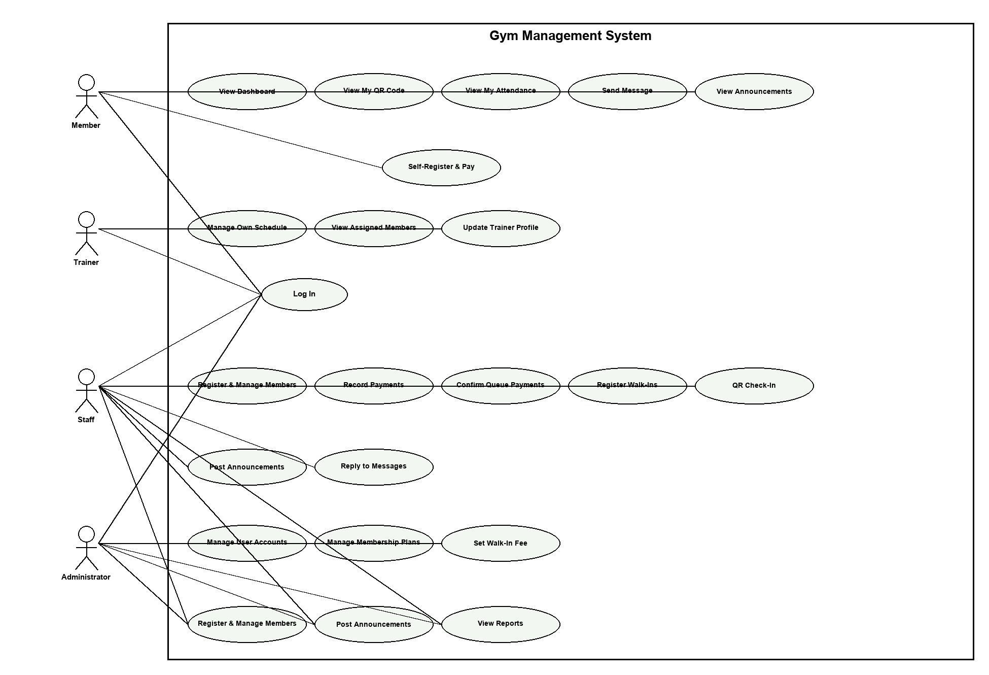

Figure 2: Use case Diagram

The Use Case Diagram illustrates the interactions among the Administrator, Staff, Trainer, and Member and the core functions of the Gym Management System. The Administrator has full access, including user management, membership plans, walk-in recording, and report generation. The Staff handles front desk operations such as member registration, billing, and walk-in recording with read-only access to membership plans. The Trainer can only view their assigned schedule. Overall, the diagram presents the system’s scope and role-based functionality.

Use Case Description
Table 3:
Log in
Use Case Name | Login
Actor/s | Administrator, Staff, Trainer, Member
Description | Describes how registered users access the Gym Management System using their credentials. Each actor is redirected to a role-appropriate dashboard upon successful login.
Pre-Condition | • The actor must have a registered account in the system.  • The system must be accessible via a web browser.
Normal Flow | 1. Actor opens the system login page.  2. Actor enters their username and password.  3. Actor clicks the "Log In" button.  4. System validates the entered credentials against the database.  5. System identifies the actor's role (Administrator, Staff, Trainer, or Member).  6. System redirects the actor to the role-appropriate dashboard.
Alternative Flow | A1: Invalid Credentials  • At step 4, system detects that the username or password does not match any record in the database.  • System displays "Invalid username or password."  • Actor re-enters their credentials.  • Use case resumes at step 2.  A2: Empty Fields  • At step 3, system detects that one or both fields are left blank.  • System displays "Please fill in all required fields."  • Actor completes the missing fields.  • Use case resumes at step 2.  A3: Account Locked  • At step 4, after 3 consecutive failed login attempts, the system temporarily locks the account.  • System displays "Account locked. Please contact the administrator."  • Actor must contact the Administrator to unlock.  • Use case ends.
Post-Condition | • The actor is successfully logged in.  • System displays the dashboard with features appropriate to the actor's assigned role.
Assumption | • Internet connection is stable.  • The actor's device supports a modern web browser compatible with the system.

Table 4:
Create System User Account
Use Case Name | Create System User Account
Actor/s | Administrator
Description | Describes how the Administrator creates new user accounts for Staff and Trainers, assigning the appropriate role and login credentials to access the system.
Pre-Condition | • Administrator is logged into the system.  • The User Management module is accessible.
Normal Flow | 1. Administrator navigates to the User Management module from the sidebar.  2. Administrator clicks "Add New User."  3. Administrator enters the user's Full Name, Username, Password, Confirm Password, and selects the Role (Staff or Trainer).  4. Administrator clicks "Create Account."  5. System validates that all required fields are filled and the username is not already taken.  6. System verifies that the password and confirm password fields match.  7. System saves the new user account with the assigned role to the database.  8. System displays a "User Account Created" confirmation.  9. The new user can now log in using the provided credentials based on their assigned role.
Alternative Flow | A1: Duplicate Username  • At step 5, system detects the entered username already exists in the database.  • System displays "Username already taken. Please choose a different username."  • Administrator enters a different username.  • Use case resumes at step 3.  A2: Missing Required Fields  • At step 5, system detects one or more required fields are empty.  • System displays "Please fill in all required fields."  • Administrator completes the missing information.  • Use case resumes at step 3.  A3: Password Mismatch  • At step 6, system detects the password and confirm password fields do not match.  • System displays "Passwords do not match."  • Administrator re-enters the password correctly.  • Use case resumes at step 3.
Post-Condition | • A new user account is successfully created and saved.  • The new user can log in and access role-based features.
Assumption | • Internet connection is stable.  • Only the Administrator has authority to create accounts.

Table 5:
Register Member
Use Case Name | Register Member
Actor/s | Administrator, Staff, Member
Description | Describes how Staff or Administrator registers new members into the Gym Management System by entering their personal details and selecting a membership plan. Members may also self-register through the public sign-up page; their accounts remain Pending Payment until staff confirms the payment.
Pre-Condition | • Actor is logged into the system.  • The system is accessible.  • At least one membership plan exists in the system.
Normal Flow | 1. Actor navigates to the Members module from the sidebar.  2. Actor clicks "Add New Member."  3. Actor enters the member's Full Name, Contact Number, Address, and Membership Type.  4. Actor clicks "Save."  5. System validates that all required fields are filled and the data format is correct.  6. System checks the database for duplicate records.  7. System assigns a unique member ID and calculates the membership expiry date.  8. System saves the new member record to the database.  9. System displays a "Member Profile Created" notification.
Alternative Flow | A1: Missing Required Fields  • At step 5, system detects one or more required fields are left blank.  • System displays "Please fill in all required fields."  • Actor completes the missing details.  • Use case resumes at step 3.  A2: Duplicate Record  • At step 6, system detects a member with the same name and contact number already exists.  • System displays "Member already registered."  • Actor revises the information or cancels registration.  • Use case resumes at step 3.  A3: Invalid Input Format  • At step 5, system detects data entered does not match the required format.  • System displays an error indicating the invalid field.  • Actor corrects the input.  • Use case resumes at step 3.  - A4: Member Self-Registration  - A guest registers through the public sign-up page by selecting a plan, entering personal details, and creating login credentials.  - System saves the account as Pending Payment.  - Member pays at the front desk and staff confirms the payment to activate the membership.  - Use case ends.
Post-Condition | • A new member profile is successfully created and saved.  • The member record is immediately accessible for real-time retrieval and updates.
Assumption | • Internet connection is stable.  • The actor's device is compatible with the system.

Table 6:
Manage Membership Plans
Use Case Name | Manage Membership Plans
Actor/s | Administrator, Staff
Description | Describes how the Administrator and Staff create, edit, and delete the membership plans offered by the gym. Plans are used during member registration and self-registration, and are visible to all roles in read-only mode outside the management module.
Pre-Condition | • Administrator is logged into the system.  • The Membership Plans module is accessible.
Normal Flow | 1. Actor navigates to the Membership Plans module from the sidebar.  2. Actor clicks "Add New Plan."  3. Actor enters the plan name, price, duration, session limits, and included benefits.  4. Actor clicks "Save Plan."  5. System validates that all required fields are filled.  6. System saves the new membership plan to the database.  7. System displays a confirmation message.  8. The new plan is immediately visible to Staff in read-only mode and available during member registration.
Alternative Flow | A1: Missing Required Fields  • At step 5, system detects one or more required fields are empty.  • System displays "Please fill in all required fields."  • Actor completes the missing information.  • Use case resumes at step 3.  A2: Edit Existing Plan  • At step 1, Actor selects an existing plan and clicks "Edit."  • Actor modifies the plan details and clicks "Save."  • System updates the plan record in the database.  • System displays an update confirmation message.  • Use case ends.  A3: Delete Plan  • At step 1, Actor selects an existing plan and clicks "Delete."  • System displays "Are you sure you want to delete this plan?"  • Actor confirms the deletion.  • System permanently removes the plan from the database.  • Use case ends.
Post-Condition | • The membership plan database is updated.  • Changes are immediately reflected for all users.
Assumption | • Internet connection is stable.  • Only the Administrator has authority to manage plans.

Table 7:
Billing and Payment Processing
Use Case Name | Billing and Payment Processing
Actor/s | Administrator, Staff
Description | Describes how Staff or Administrator records and processes membership billing and payment transactions for gym members.
Pre-Condition | • Actor is logged into the system.  • The member profile exists in the system.
Normal Flow | 1. Actor navigates to the Billing and Payments module.  2. Actor searches for the member by name or member ID.  3. Actor selects the member from the search results.  4. Actor enters the Amount Paid and Payment Date.  5. Actor selects the applicable membership plan.  6. Actor clicks "Save Payment."  7. System calculates the new expiry date based on the selected plan duration.  8. System generates a digital payment record linked to the member's profile.  9. System updates the member's status to "Active."  10. System displays a payment confirmation message.
Alternative Flow | A1: Member Not Found  • At step 2, system finds no matching record.  • System displays "No member found."  • Actor verifies the search details or registers the member first.  • Use case resumes at step 2.  A2: Incomplete Payment Details  • At step 6, system detects Amount Paid or Payment Date field is empty.  • System displays "Please fill in all required fields."  • Actor completes the missing information.  • Use case resumes at step 4.  A3: Invalid Amount  • At step 7, system detects the amount entered does not match the selected plan price.  • System flags the discrepancy and displays a warning.  • Actor confirms or corrects the amount.  • Use case resumes at step 4.
Post-Condition | • A payment record is successfully created and linked to the member's profile.  • The member's expiry date and active status are updated.
Assumption | • Internet connection is stable.  • The member has physically provided payment to the actor.

Table 8:
Record Walk-In Visit
Use Case Name | Record Walk-In Visit
Actor/s | Administrator, Staff
Description | Describes how Staff or Administrator records a one-time gym visitor who is not a registered member and collects the fixed walk-in fee. The walk-in fee is a single-day rate set by the Administrator in the system settings (default PHP 100).
Pre-Condition | •Actor is logged into the system.  •The Walk-In module is accessible.
Normal Flow | Actor navigates to the Walk-In module from the sidebar.  Actor clicks "Add Walk-In."  Actor enters the visitor’s Full Name.  System displays the current walk-in fee, which the Administrator can adjust in the system settings.  Actor clicks "Record Walk-In."  System saves the walk-in record with the visitor’s name, date, and fee paid.  System increments the total walk-in visitor count on the dashboard.  System updates the daily revenue report based on the fee.  System displays "Walk-In Recorded Successfully."
Alternative Flow | - A1: Empty Visitor Name  - At step 3, system detects that the visitor name field is left blank.  - System displays "Please enter the visitor’s name."  - Actor enters the visitor’s name.  - Use case resumes at step 4.  - A2: Fee Adjustment  - At step 4, the actor may update the displayed fee (for example, for a promotional rate) before recording the visit.  - System records the adjusted amount with the walk-in record.  - Use case resumes at step 5.  - A3: System Save Failure  - At step 6, system fails to save the record due to a system error.  - System displays "Record could not be saved. Please try again."  - Actor retries saving the record.  - Use case resumes at step 4.
Post-Condition | - A walk-in record is successfully stored in the system.  - Daily revenue and the walk-in visitor count are updated in the dashboard and reports.  - The Administrator can view the record in the Reports module.
Assumption | - The visitor has paid the configured walk-in fee.  - Internet connection is stable.

Table 9:
View Membership Plans
Use Case Name | View Membership Plans
Actor/s | Administrator, Staff, Trainer, Member
Description | Describes how actors view the available membership plans in read-only mode. Members view the active plans when choosing a membership during self-registration and on the public landing page, while Staff and Administrators can add, edit, or delete plans in the Membership Plans module.
Pre-Condition | • Actor is logged into the system.  • At least one membership plan exists in the database.
Normal Flow | 1. Actor navigates to the Membership Plans section from the sidebar.  2. System retrieves all active membership plans from the database.  3. System displays each plan's name, price, duration, session limits, and included benefits.  4. All add, edit, and delete controls are hidden or disabled for the Trainer and Member roles.  5. Actor uses the displayed information to assist a member in selecting a plan.
Alternative Flow | A1: No Plans Available  • At step 2, system finds no membership plans in the database.  • System displays "No plans available."  • Actor advises the member to wait while the Administrator sets up the plans.  • Use case ends.
Post-Condition | • Actor views the plan details.  • No changes are made to the database.
Assumption | • Membership plans have been created by the Administrator.  • Internet connection is stable.

Table 10:
View Renewal Notifications
Use Case Name | View Renewal Notifications
Actor/s | Administrator, Staff
Description | Describes how the system automatically scans membership expiry dates daily and generates renewal reminders for memberships expiring within seven days. Staff and Administrator can view and act on these reminders.
Pre-Condition | • Actor is logged into the system.  • Member records with expiry dates exist in the database.  • The system is running and accessible.
Normal Flow | 1. System performs a daily automated scan of all expiry date fields in the Members table.  2. System compares each expiry date with the current system date.  3. System identifies all records where the expiry date is within 7 days from today.  4. System generates a renewal reminder notification for each identified member.  5. Notifications are displayed on the Staff and Administrator dashboards under "Renewal Reminders."  6. Actor reviews the list and contacts concerned members for renewal.
Alternative Flow | A1: No Expiring Memberships  • At step 3, system finds no records expiring within the next 7 days.  • System displays "No reminders" on the Renewal Reminders section.  • No notifications are generated.  • Use case ends.  A2: System Scan Fails  • At step 1, the automated scan does not execute due to a system error.  • System logs the error internally.  • Actor may manually check the Members list for upcoming expiry dates.  • Use case ends.
Post-Condition | • Renewal reminders are visible on the dashboards.  • Actor is alerted to follow up with members whose memberships are about to expire.
Assumption | • The system clock is synchronized with the correct date.  • Internet connection is stable.

Table 11:
View Trainer Schedule
Use Case Name | View Trainer Schedule
Actor/s | Administrator, Staff, Trainer
Description | Describes how a Trainer views their own session schedule and list of assigned members for the current day and upcoming week. Trainers cannot modify any schedule details.
Pre-Condition | • Trainer is logged into the system with a valid account.  • Sessions have been assigned to the trainer by Staff or Administrator.
Normal Flow | 1. Trainer logs into the system and is directed to the Trainer Dashboard.  2. Dashboard displays summary cards: "My Sessions Today," "Sessions This Week," and "Total Assigned Members."  3. Trainer clicks "Trainer Schedule" from the sidebar.  4. System retrieves all session records assigned to that trainer from the database.  5. System displays the schedule showing Date, Time, Member Name, and Session Type.
Alternative Flow | A1: No Sessions Assigned  • At step 4, system finds no session records assigned to the trainer.  • System displays "No sessions today" and "No upcoming sessions."  • Trainer may contact Staff or Administrator for schedule updates.  • Use case ends.
Post-Condition | • Trainer views their complete schedule.  • No modifications can be made by the Trainer.
Assumption | • Internet connection is stable.  • Sessions have been properly assigned by Staff or Administrator beforehand.

Table 12:
Trainer Scheduling and Conflict Prevention
Use Case Name | Trainer Scheduling and Conflict Prevention
Actor/s | Administrator, Staff
Description | Describes how Staff or Administrator assigns a member to a trainer at a specific date and time slot, and how the system automatically detects and prevents overlapping schedule conflicts.
Pre-Condition | • Actor is logged into the system.  • Both the trainer and member profiles exist in the system.
Normal Flow | 1. Actor navigates to the Trainer Schedule module.  2. Actor clicks "Add New Session."  3. Actor selects the Trainer Name, Member Name, Session Type, Date, and Time slot.  4. Actor clicks "Save Session."  5. System checks the database for any existing appointments assigned to the same trainer at the same date and time.  6. System finds no conflict.  7. System saves the session assignment to the database.  8. System displays a session confirmation message.  9. Session appears on the trainer's schedule and the member's profile.
Alternative Flow | A1: Schedule Conflict Detected  • At step 5, system detects the selected trainer already has an existing appointment at the same date and time.  • System displays "Schedule Overlap Detected. Please choose a different time."  • The session is not saved.  • Actor selects a different date or time slot.  • Use case resumes at step 3.  A2: Missing Required Fields  • At step 4, system detects one or more required fields are left blank.  • System displays "Please fill in all required fields."  • Actor completes the missing information.  • Use case resumes at step 3.
Post-Condition | • The session is successfully saved and reflected on the trainer's schedule.  • The assigned member's profile is updated with the session details.
Assumption | • Internet connection is stable.  • The trainer and member are both active in the system.

Table 13:
View Membership Details and QR Code
Use Case Name | View Membership Details and QR Code
Actor/s | Member
Description | Describes how a Member accesses the personal dashboard, views the daily QR code used for entrance check-in, tracks attendance history, sends messages to the front desk, and views announcements.
Pre-Condition | - The Member must have a registered account whose payment has been confirmed by the staff.  • The system is accessible.  • At least one membership plan exists in the system.  - The Member must be logged into the system.  - The system must be accessible via a web browser.
Normal Flow | Member logs in using their username and password.  System displays the personal dashboard with a greeting, membership status, plan details, and expiry date.  Member opens the My QR Code panel; the system generates a QR token that rotates daily.  Member presents the QR code at the entrance; staff scans it with the QR Scanner module to verify and check the Member in.  Member opens My Attendance to review personal check-in history.  Member sends a message to the front desk and reads the staff reply.  Member reads the latest announcements posted by the staff.
Alternative Flow | - A1: QR Code Disabled - the QR code is disabled and the system blocks check-in for members whose payment is pending or whose plan has expired. The Member is directed to the front desk to settle payment or renew.  - A2: Invalid or Expired QR Token - the scanner rejects the token and prompts staff to verify the Member manually.  - A3: No Active Membership - the Member cannot generate a QR code until the plan is active.
Post-Condition | - The Member is successfully checked in and the attendance record is saved.  - Messages and announcements are displayed to the Member.
Assumption | - Internet connection is stable.  • The actor's device is compatible with the system.  - The Member device supports a modern web browser.

Table 14:
QR-Based Check-In
Use Case Name | QR-Based Check-In
Actor/s | Staff, Administrator
Description | Describes how Staff or Administrator verifies a member’s daily QR code using the QR Scanner module to record attendance and grant gym access.
Pre-Condition | - Staff or Administrator is logged into the system.  - The member has an active membership and a valid daily QR code.  - The scanner device has camera permission enabled.
Normal Flow | Actor navigates to the QR Scanner module from the sidebar.  System requests camera access and displays the scanner view.  Member presents their QR code from the My QR Code panel.  System decodes the QR token.  System validates the token and checks the member’s membership status.  System records the attendance check-in with the current date and time.  System displays the member’s name and a "Check-In Successful" message.
Alternative Flow | - A1: Invalid or Expired QR Token  - At step 5, system rejects the token.  - System displays "Invalid or expired QR code."  - Actor verifies the Member manually before granting entry.  - Use case ends.  - A2: Pending Payment or Expired Plan  - At step 5, system detects the member’s payment is pending or the plan has expired.  - System blocks the check-in and displays the member’s status.  - Actor directs the Member to the front desk to settle payment or renew.  - Use case ends.  - A3: Camera Permission Denied  - At step 2, the browser blocks camera access.  - System prompts the actor to enable camera permission and retry.  - Use case resumes at step 2.
Post-Condition | - The attendance record is saved and linked to the member’s profile.  - The Member is granted access to the gym facility.
Assumption | - Internet connection is stable.  - The member presents a device with a modern web browser.
Table 15:
Member Messaging
Use Case Name | Member Messaging
Actor/s | Member, Staff, Administrator
Description | Describes how a Member sends messages to the front desk and how Staff or Administrator replies from the Member Messages panel.
Pre-Condition | - The Member is logged into the system.  - Staff or Administrator is logged into the system.
Normal Flow | Member opens the Messages panel on their dashboard.  Member types a message and clicks "Send."  System saves the message and marks it unread for the staff.  Staff opens the Member Messages panel; the unread badge shows the new message.  Staff replies to the Member.  System saves the reply and marks it unread for the Member.  Member sees the reply on their dashboard.
Alternative Flow | - A1: Empty Message  - At step 2, system detects the message field is blank.  - System displays "Please enter a message."  - Member types the message.  - Use case resumes at step 3.  - A2: Inactive Member  - At step 5, system detects the Member’s membership is not active.  - System prevents the reply and displays the Member’s status to staff.  - Staff advises the Member to settle payment or renew.  - Use case ends.
Post-Condition | - The message thread is stored and visible to both parties.  - Unread badges are updated on both sides.
Assumption | - Internet connection is stable.  - Both actors use a modern web browser.
Table 16:
Announcements
Use Case Name | Announcements
Actor/s | Staff, Administrator, Member
Description | Describes how Staff or Administrator posts announcements and how Members view them on their dashboard.
Pre-Condition | - Staff or Administrator is logged into the system.  - The Member is logged into the system to view announcements.
Normal Flow | Actor navigates to the Announcements module from the sidebar.  Actor clicks "Post Announcement."  Actor enters the title and message and selects a category (General, Event, Holiday/Closed, or Alert).  Actor clicks "Save."  System validates the required fields and saves the announcement.  System displays the announcement in the Announcements panel.  System shows the announcement on the Member dashboard.
Alternative Flow | - A1: Missing Required Fields  - At step 5, system detects empty required fields.  - System displays "Please fill in all required fields."  - Actor completes the missing details.  - Use case resumes at step 4.  - A2: Delete Announcement  - At step 1, Actor selects an existing announcement and clicks "Delete."  - System displays "Are you sure you want to delete this announcement?"  - Actor confirms the deletion.  - System removes the announcement from all dashboards.  - Use case ends.
Post-Condition | - The announcement is saved and visible to all relevant roles.  - Members can read the announcement on their dashboard.
Assumption | - Internet connection is stable.  - The announcement content does not contain inappropriate material.
Table 17:
Payment Queue
Use Case Name | Payment Queue
Actor/s | Staff, Administrator, Member
Description | Describes how Staff or Administrator confirms pending member payments from the Payment Queue to activate memberships.
Pre-Condition | - Staff or Administrator is logged into the system.  - At least one member has a Pending Payment status.
Normal Flow | Actor navigates to the Payment Queue from the sidebar; the queue badge shows the pending count.  System lists all members with pending payments.  Actor opens a member’s details from the queue.  Member pays at the front desk in Cash or GCash.  Actor confirms the payment.  System saves the payment record and computes the new expiry date based on the plan duration.  System updates the member’s status to "Active."  System removes the member from the queue and updates the badge.
Alternative Flow | - A1: Member Not Yet Paid  - At step 5, the member has not paid yet.  - Actor keeps the member in the queue and waits for payment.  - Use case ends.  - A2: Wrong Plan or Amount  - At step 5, system detects the selected plan or amount does not match.  - Actor edits the payment details before confirming.  - Use case resumes at step 5.
Post-Condition | - The payment is recorded and the membership is activated.  - The queue count is updated.
Assumption | - Internet connection is stable.  - The member is present at the front desk during confirmation.
Table 18:
Logout
Use Case Name | Logout
Actor/s | Administrator, Staff, Trainer, Member
Description | Describes how any authenticated user securely ends their active session and exits the Gym Management System. The system terminates the session and redirects the actor to the login page.
Pre-Condition | • The actor is currently logged into the system.  • The actor has an active session.
Normal Flow | 1. Actor clicks the "Logout" button from the navigation bar or sidebar.  2. System displays a confirmation prompt: "Are you sure you want to log out?"  3. Actor confirms by clicking "Yes, Logout."  4. System terminates the actor's active session.  5. System clears all session data and authentication tokens from memory.  6. System redirects the actor to the login page.  7. System displays "You have been successfully logged out."
Alternative Flow | A1: Actor Cancels Logout  • At step 3, actor clicks "Cancel" on the confirmation prompt.  • System dismisses the prompt and returns the actor to their current page.  • The active session remains intact.  • Use case ends.  A2: Session Already Expired  • At step 4, system detects the session has already expired due to inactivity timeout.  • System automatically clears all session data.  • System redirects the actor to the login page with the message "Your session has expired. Please log in again."  • Use case ends.  A3: System Connection Lost During Logout  • At step 4, a connection error occurs while the system attempts to terminate the session.  • System displays "Logout failed. Please try again."  • Actor retries clicking the "Logout" button.  • Use case resumes at step 1.
Post-Condition | • The actor's session is fully terminated.  • All session data and authentication tokens are cleared.  • The actor is redirected to the login page and cannot access any system features without logging in again.
Assumption | • Internet connection is stable during the logout process.  • The system is configured with an automatic session timeout for inactive users.
Sequence Diagram

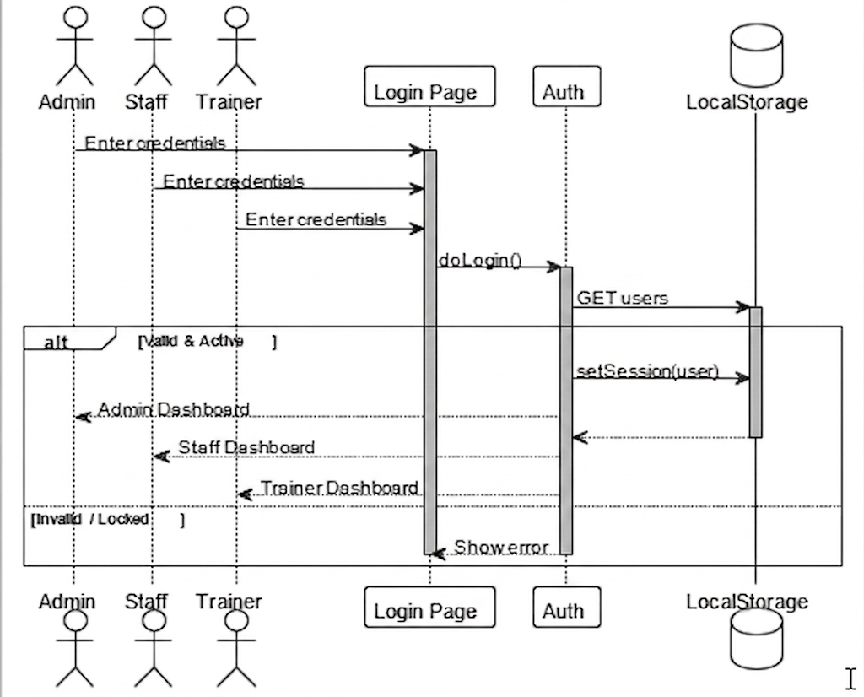
Figure 3: Authentication

This shows the login process. Any user (Admin, Staff, or Trainer) enters their credentials on the Login Page. The system calls doLogin(), fetches users from LocalStorage, then checks if the credentials are valid and the account is active. If yes, a session is saved and the user is sent to their specific dashboard. If invalid or locked, an error is shown.

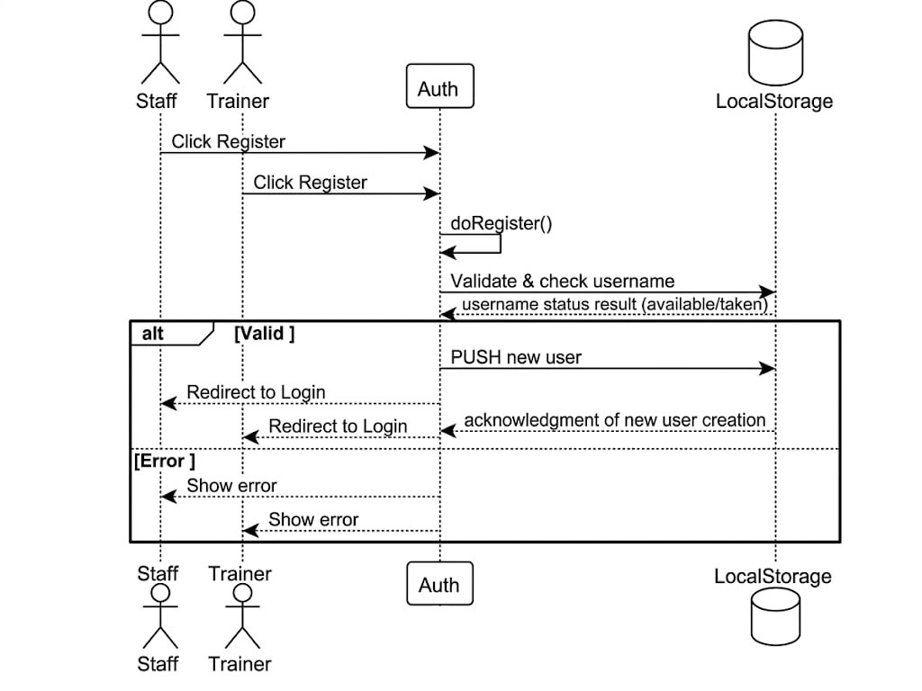

Figure 4: Registration

All three roles can self-register: Staff and Trainers through the Register page, and Members through the public sign-up page with plan selection. When they click Register, doRegister() runs, validates the input, and checks if the username is already taken. If everything is valid, the new user is saved to LocalStorage and redirected to Login. If there's a problem (duplicate username, empty fields), an error is shown.
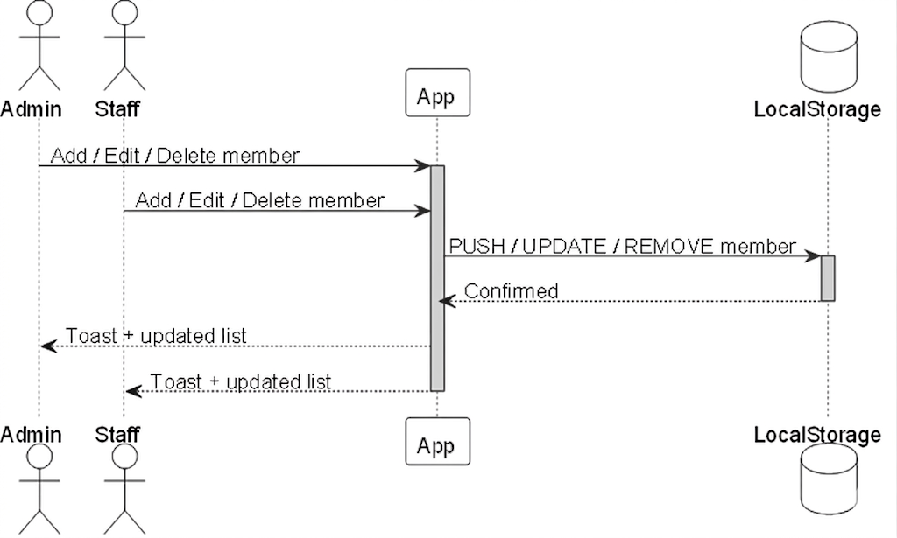

Figure 5: Member Management

Admin and Staff can add, edit, or delete gym members. Every action (create, update, remove) is sent directly to LocalStorage. Once confirmed, a toast notification appears and the member list refreshes automatically for both roles.

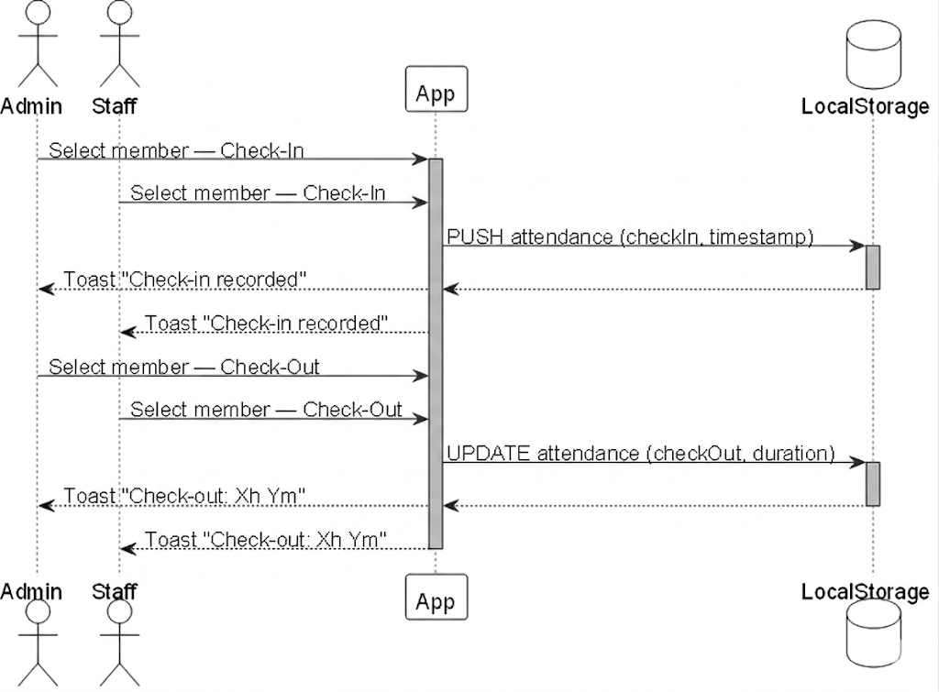

Figure 6: Attendance Monitoring (Check-In / Check-Out)

Admin and Staff can check members in and out. When checking in, the system records the member ID and a timestamp in LocalStorage. When checking out, it updates that record with the checkout time and calculates the total duration. A toast confirms each action with either "Check-in recorded" or the actual time spent (e.g. "Check-out: 1h 30m").


Figure 7: Billing and Payment Process

Admin and Staff record payments tied to a member, their plan, and the amount paid. The system saves the payment and also updates the member's expiry date. They can also edit or delete existing payments, with each action confirmed by a toast. This keeps the financial and membership records in sync.

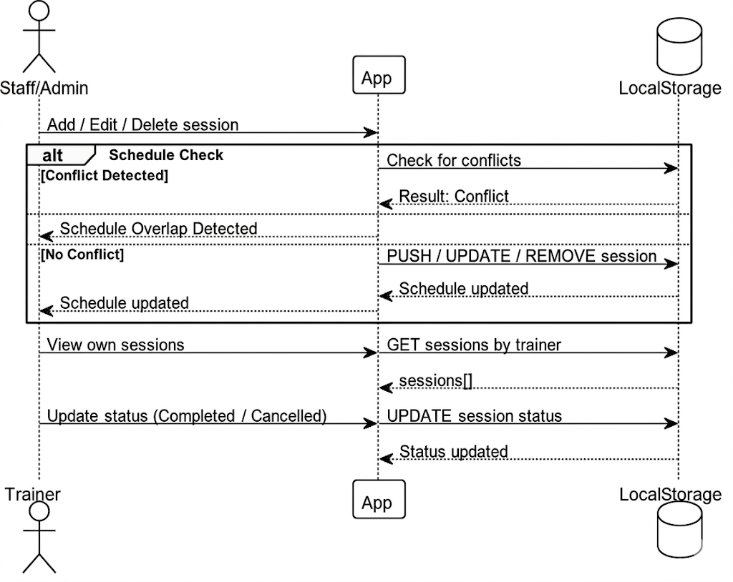

Figure 8: Trainer Schedule

Staff/Administrators manage the overall schedule; they can add, edit, or delete sessions, and the schedule updates in LocalStorage immediately after passing a conflict check. Trainers, on the other hand, are restricted to their own schedule view; they can only view their own sessions by fetching records filtered by their trainer ID. After a session happens, trainers are permitted to mark it as Completed or Cancelled, which updates its status in storage.

Admin
Admin
Staff
Staff
App
App
LocalStorage
LocalStorage
Log visitor (name, contact, fee)
Log visitor (name, contact, fee)
PUSH walk-in record
Toast "Walk-in recorded"
Toast "Walk-in recorded"

Figure 9: Walk-In Management

Admin and Staff can log visitors who aren't registered members — recording their name and the configured single-day fee they paid. This is pushed to LocalStorage as a walk-in record and confirmed with a toast. It's essentially a quick entry log for drop-in guests.

Admin
Admin
Staff
Staff
App
App
LocalStorage
LocalStorage
View Reminders
View Reminders
GET members expiring within 7 days
expiring[]
Alert list
Alert list

Figure 10: Renewal Reminder

When Admin or Staff opens the Reminders section, the app queries LocalStorage for any members whose membership expires within the next 7 days. It returns that list and displays it as an alert list, giving staff a heads-up on who to follow up with before their membership lapses.

Admin
Admin
Staff
Staff
App
App
LocalStorage
LocalStorage
Add / Edit / Delete plan
Add / Edit / Delete plan
PUSH / UPDATE / REMOVE plan
Plans updated

Figure 11: Membership Plan Management

Admin and Staff can manage the gym's available plans (e.g. monthly, quarterly, annual). They can add new ones, edit existing ones, or delete outdated ones. Each change is pushed to LocalStorage and the plans list updates immediately.

Admin
Admin
Staff
Staff
App
App
LocalStorage
LocalStorage
View Reports
View Reports
GET members, payments, attendance
data
Charts + tables
Charts + tables
Export PDF
Export PDF
Printable report
Printable report

Figure 12: Reports

Admin and Staff can view a full report dashboard that pulls members, payments, and attendance data all at once from LocalStorage. The app renders this as charts and tables. They can also export the report as a printable PDF — useful for management reviews or record keeping.

Admin
Admin
App
App
LocalStorage
LocalStorage
Add / Lock / Delete user
PUSH / TOGGLE / REMOVE user
Toast confirmation

Figure 13: User Management

This is Admin-only. The Admin can create new user accounts, lock existing ones (to prevent login without deleting the account), or permanently delete users. Each action modifies LocalStorage and shows a toast confirmation. Staff and Trainers have no access to this section.

Admin
Admin
Staff
Staff
Trainer
Trainer
Auth
Auth
LocalStorage
LocalStorage
Log Out
Log Out
Log Out
clearSession()
Show Login page
Show Login page
Show Login page

Figure 14: Log out

Any user — Administrator, Staff, Trainer, or Member — can log out. This triggers clearSession(), which removes the active session from LocalStorage, and the app returns everyone to the Login page. No data is deleted, just the session token that was keeping them signed in.

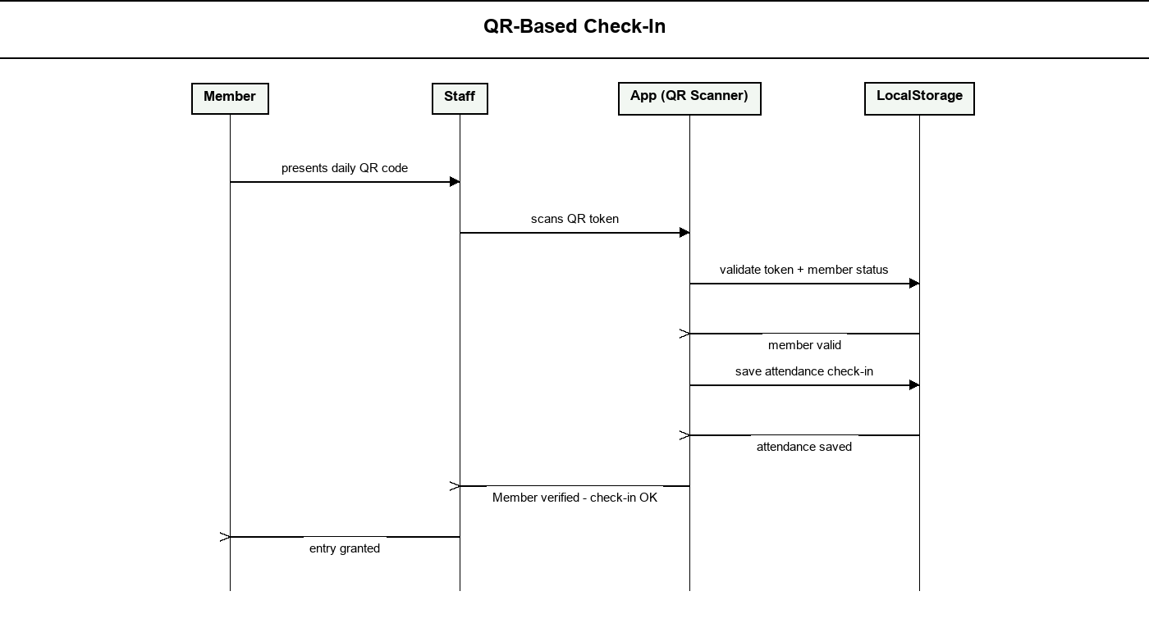
Figure 15: QR-Based Check-In
Staff or Administrator uses the QR Scanner module to scan the member’s daily QR code. The system validates the token and membership status, saves the attendance check-in, and grants entry.
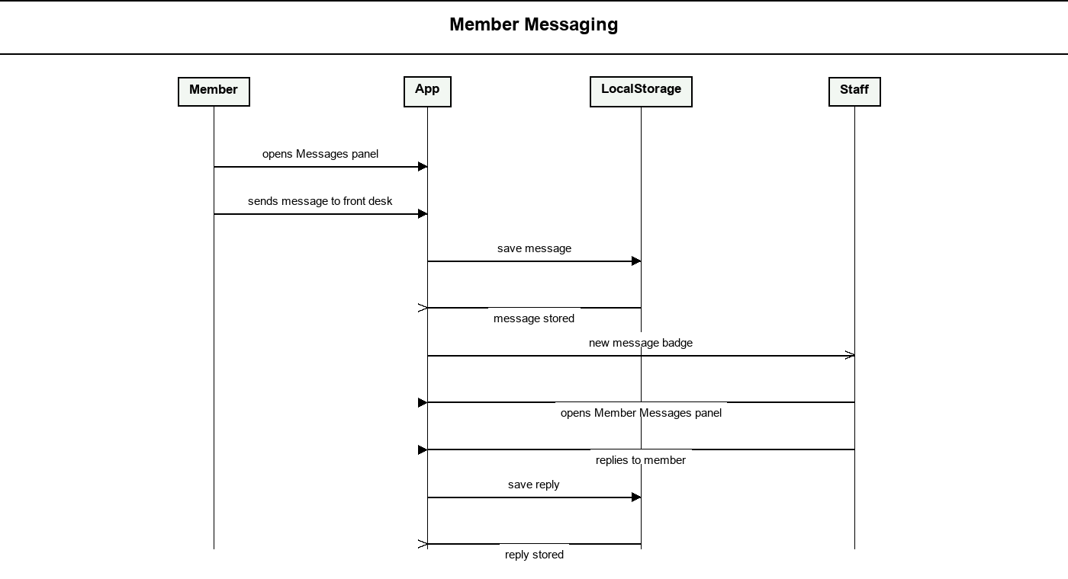
Figure 16: Member Messaging
The Member sends a message to the front desk. The message is stored locally, Staff replies from the Member Messages panel, and the reply appears on the Member’s dashboard.
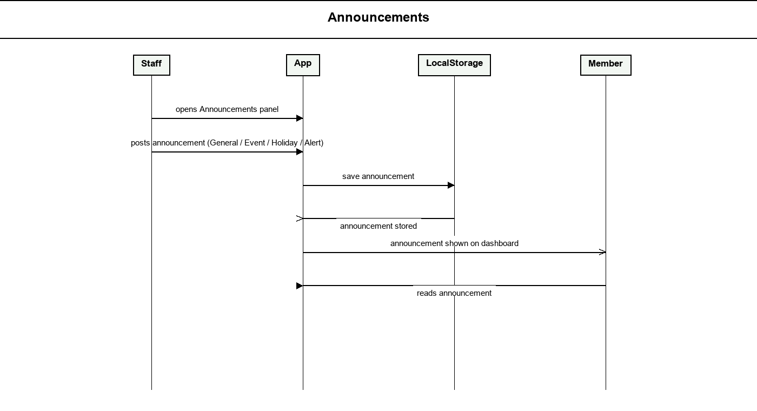
Figure 17: Announcements
Staff or Administrator posts an announcement categorized as General, Event, Holiday/Closed, or Alert. The announcement is stored locally and displayed on the Member dashboard.
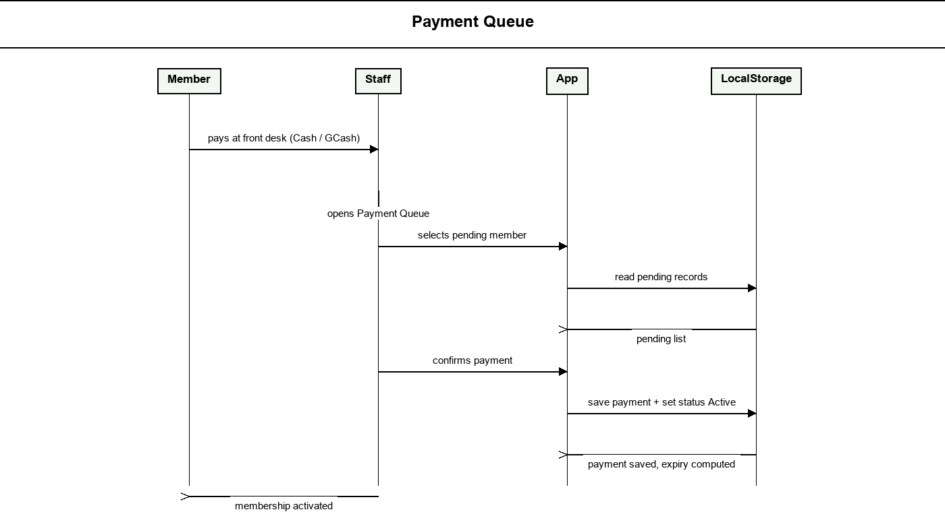
Figure 18: Payment Queue
Staff opens the Payment Queue, selects a member whose payment is pending, and confirms the payment after the member pays. The system saves the payment, computes the new expiry date, and activates the membership.
Activity Diagram
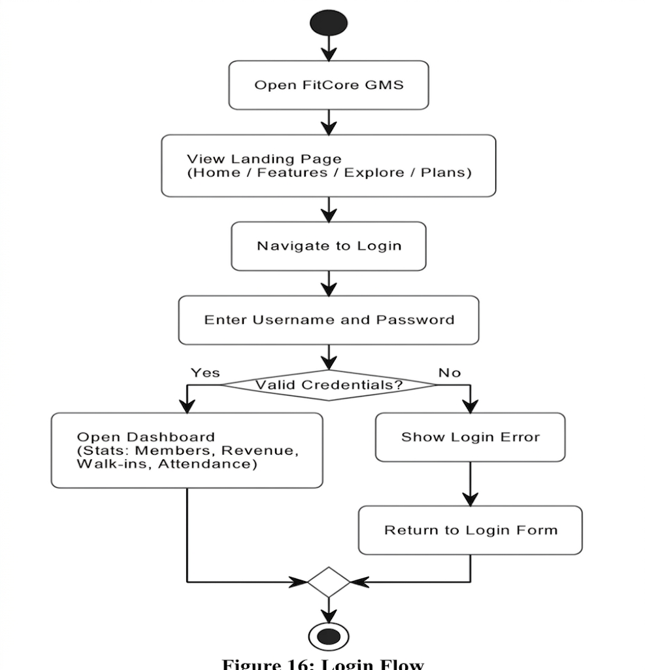
Figure 19: Login Flow

This diagram shows how a user accesses the FitCore Gym Management System. The process begins when the user opens the application and lands on the landing page, which includes sections like Home, Features, Explore, and Plans. The user then navigates to the Login page and enters their username and password. The system then checks whether the credentials are valid. If they are correct, the user is taken to the Dashboard, which displays key statistics such as Members, Revenue, Walk-ins, and Attendance. If the credentials are incorrect, the system shows a login error and returns the user back to the login form to try again. The flow ends after either a successful login or a failed attempt that loops back.

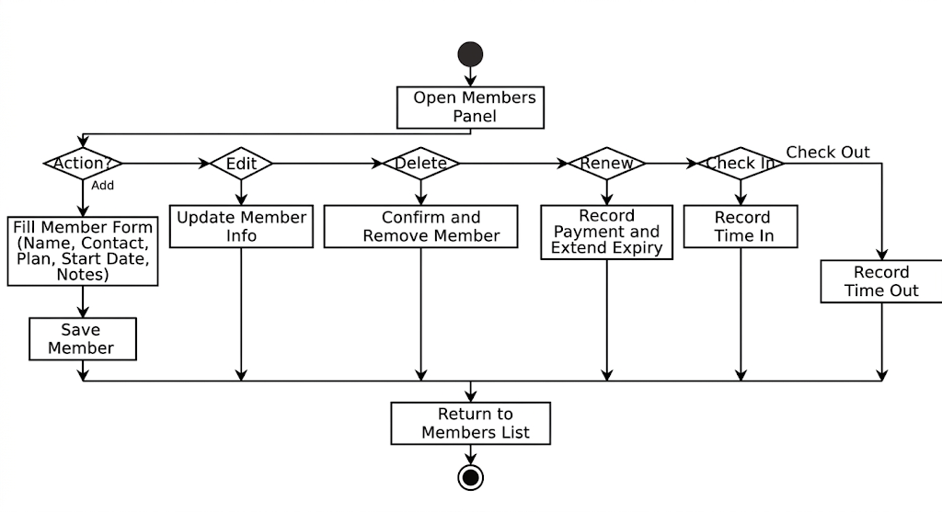
Figure 20: Members Panel

This diagram illustrates how the admin manages gym members from the Members Panel. Once the panel is opened, the admin chooses an action. If adding a member, they fill out a form with details such as name, contact, plan, start date, and notes, then save it. If editing, the admin updates the member's existing information. If deleting, the system asks for confirmation before removing the member. If renewing, the system records the payment and extends the member's expiry date. If checking in, the system records the time in, and for check out, it records the time out. All actions lead back to the Members List at the end.
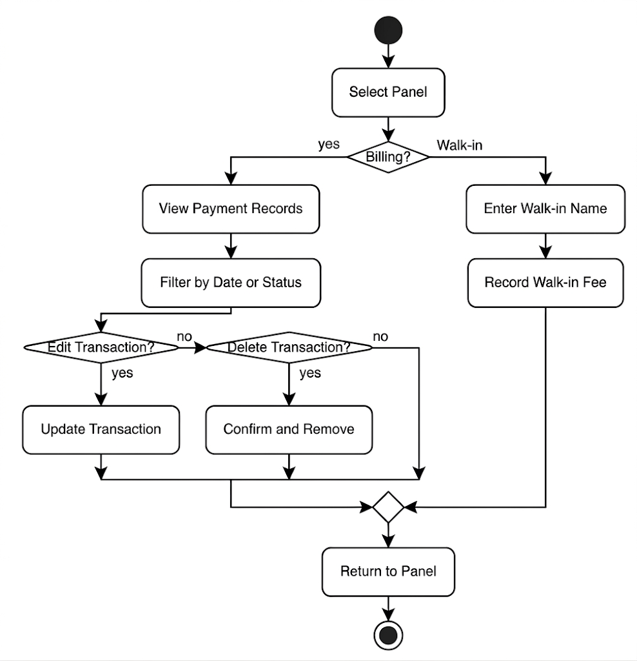

Figure 21: Billing and Walk-in Panel

This diagram covers two separate flows accessed from the same panel selection. If the user selects Billing, they can view payment records and filter them by date or status. From there, they can choose to edit a transaction, which updates it, or delete a transaction, which prompts a confirmation before removal. If the user selects Walk-in instead, they enter the walk-in customer's name and record the walk-in fee. Both the Billing and Walk-in flows converge at a merge point before returning to the panel.
Figure 22: Plans and Schedule Panel

This diagram shows how the admin manages membership plans and trainer schedules. After selecting a panel, the flow branches into two paths. For Plans, the admin can add or edit a plan by filling out a form with the name, price, and duration, then saving it, or delete a plan with confirmation. For Schedule, the admin can add a new session by filling in details such as trainer, date, time, and session type, then saving it. They can also edit an existing session by updating its details, or delete a session with a confirmation step. All paths merge and return to the panel at the end.
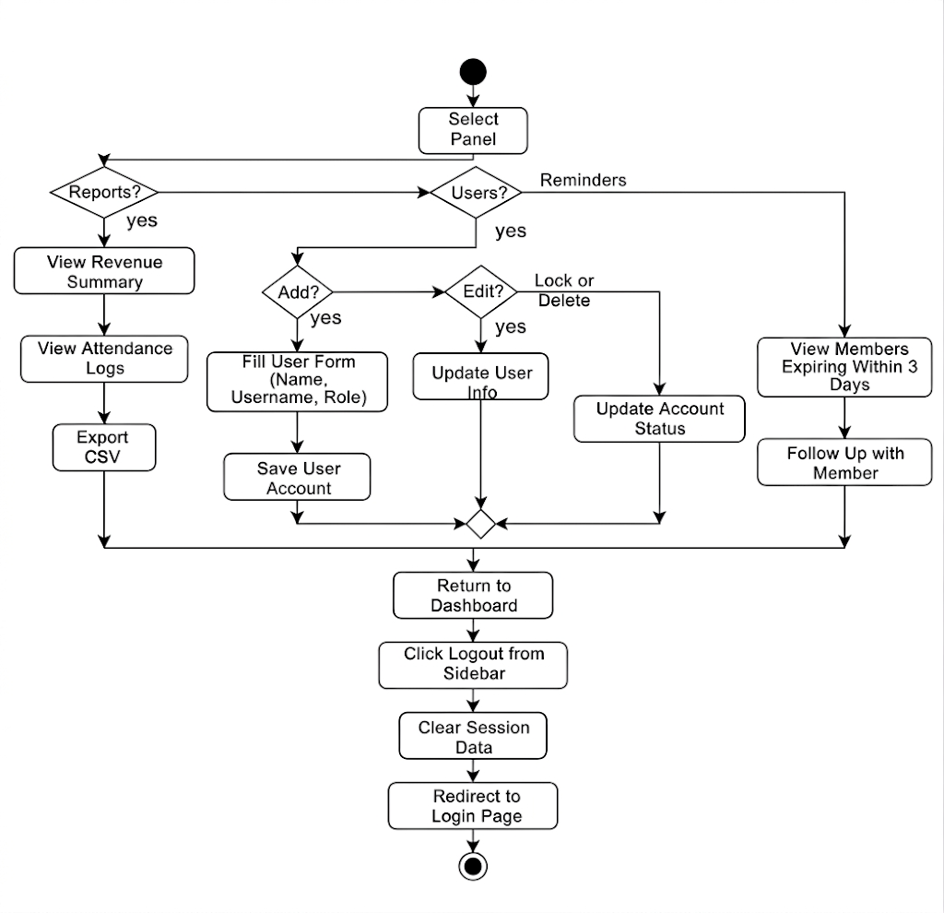
Figure 23: Reports, Users, Reminders and Logout

This is the most comprehensive diagram, covering four distinct functionalities from the panel. If Reports is selected, the admin views a revenue summary and attendance logs, and can export the data as a CSV file. If Users is selected, the admin can add a new user by filling out a form with name, username, and role, then saving the account, or edit an existing user's information, or lock/delete a user account by updating the account status. If Reminders is selected, the system shows members whose memberships are expiring within 7 days so the admin can follow up with them. After completing any of these tasks, all paths converge back to the Dashboard. Finally, the admin can click Logout from the sidebar, which clears the session data and redirects the user back to the Login page, ending the flow.

Entity-Relationship Diagram

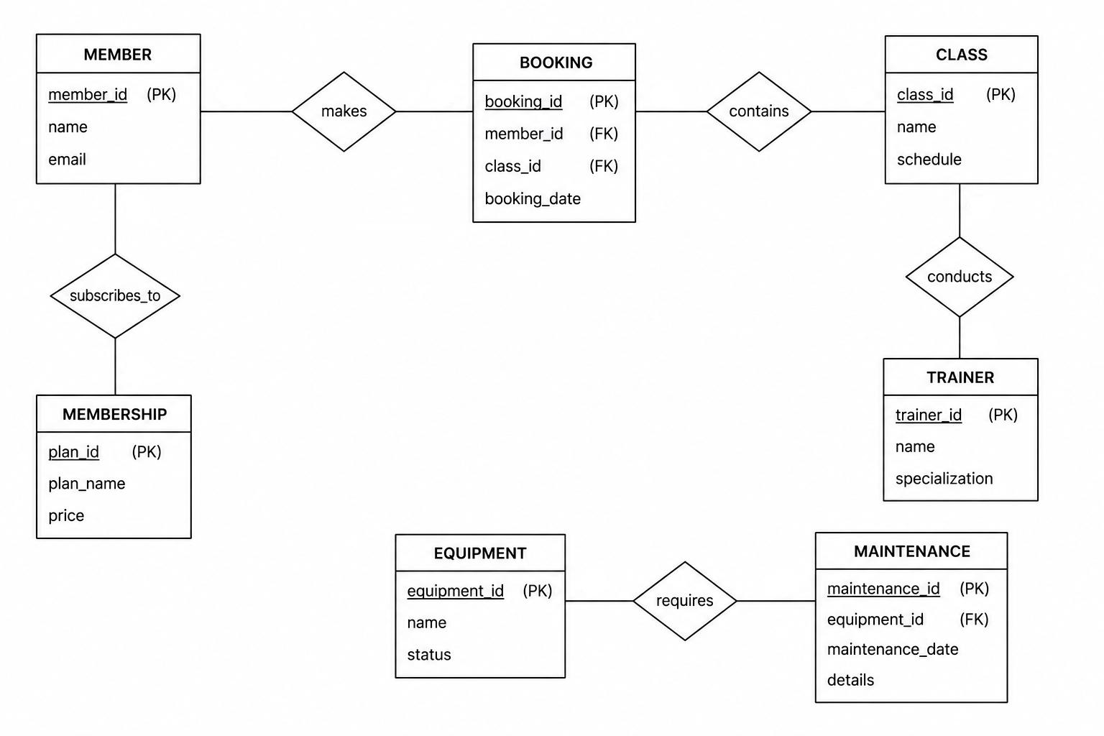

APPENDIX A
REFERENCES

Beck, K., et al. (2001). Manifesto for agile software development. Agile Alliance. https://agilemanifesto.org/
Connolly, T., & Begg, C. (2015). Database systems: A practical approach to design, implementation, and management (6th ed.). Pearson.
Fielding, R. T. (2000). Architectural styles and the design of network-based software architectures. University of California, Irvine.
Gamma, E., Helm, R., Johnson, R., & Vlissides, J. (1994). Design patterns: Elements of reusable object-oriented software. Addison-Wesley.
Kotler, P., & Keller, K. L. (2016). Marketing management (15th ed.). Pearson.
jsQR Contributors. (2024). jsQR: A pure JavaScript QR code reading library. https://github.com/cozmo/jsQR
Larman, C. (2004). Applying UML and patterns: An introduction to object-oriented analysis and design and iterative development (3rd ed.). Prentice Hall.
Laudon, K. C., & Laudon, J. P. (2020). Management information systems: Managing the digital firm (16th ed.). Pearson.
O’Brien, J. A., & Marakas, G. M. (2019). Introduction to information systems (16th ed.). McGraw-Hill.
Pressman, R. S., & Maxim, B. R. (2020). Software engineering: A practitioner’s approach (9th ed.). McGraw-Hill.
Sommerville, I. (2016). Software engineering (10th ed.). Pearson.
Statista. (2023). Fitness industry in Southeast Asia. Statista Research Department. https://www.statista.com/
World Health Organization. (2022). Physical activity. https://www.who.int/
APPENDIX B

CURRICULUM VITAE
Allysa Sharise A. Cagui-at
Purok 1, Misom, Baliangao
7206 Misamis Occidental
allysasharise@gmail.com
0956-9325-781

PERSONAL INFORMATION
Date Of Birth : December 10,2003
Place Of Birth : Tagbilaran City, Bohol
Sex : Female
Religion : Evangelical
Citizenship : Filipino
Civil Status : Single

EDUCATIONAL BACKGROUND
Primary: Quezon Elementary School
Purok 5, Misom, Baliangao, Misamis Occidental
2015-2016

Secondary:
Senior high School:
Baliangao School of Fisheries
TVL-Technical Vocational & Livelihood Track -ICT
2021-2022

Junior High School:
Baliangao School of Fisheries
Purok 4, Misom, Baliangao, Misamis Occidental
2019-2020

Tertiary: Tangub City Global College
Maloro, Tangub City
2025 – Present

CURRICULUM VITAE

Merjohn B. Pagente
Agura IBJT Carangan Ozamis City
7200 Misamis Occidental
merjohnmacalisang@gmail.com
0915-0435-696

PERSONAL INFORMATION
Date Of Birth : November 6, 2004
Place Of Birth : San Juan Siquijor
Sex : Male
Religion : Roman Catholic
Citizenship : Filipino
Civil Status : Single

EDUCATIONAL BACKGROUND
Primary: Andrea D. Costomera Elementary School
Purok 5 Aguada Ozamis City, Misamis Occidental
2016-2017

Secondary:
Senior high School:
Ozamis City School of Arts and Trades
Senior High School – Humanities and Social Sciences (HUMSS)
2022-2023
Junior High School:
Ozamis City School of Arts and Trades
Maningcol Ozamis City, Misamis Occidental
2020-2021

Tertiary: Tangub City Global College
Maloro, Tangub City
2025 – Present
CURRICULUM VITAE

Angellie G. Jerusalem
Casilak San Agustin, Tudela
7202 Misamis Occidental
angelliejerusalem.08@gmail.com
0951-6742-375

PERSONAL INFORMATION
Date Of Birth : August 4, 2006
Place Of Birth : Canibungan Proper, Tudela
Sex : Female
Religion : Roman Catholic
Citizenship : Filipino
Civil Status : Single

EDUCATIONAL BACKGROUND
Primary: Casilak San Agustin Elementary School
Purok 1, Casilak San Agustin, Tudela, Misamis Occidental
2013-2018

Secondary:
Senior high School:
Clarin National High School
Poblacion 3, Clarin, Misamis Occidental
Senior High School – Humanities and Social Sciences (HUMSS)
2021-2024
Junior High School:
FelinaSevillaOaminal National High School
Pan-ay, Clarin, Misamis Occidental
2021-2022

Tertiary: Tangub City Global College
Maloro, Tangub City
2025 – Present
APPENDIX C
DEFINITION OF TERMS
Agile Model. The software development approach used in this project, where the system is built in short development cycles called sprints to allow continuous improvement and feedback from users throughout the process.
Announcements. A system feature that lets Staff and Administrators post notices categorized as General, Event, Holiday/Closed, or Alert, which are then displayed on the member dashboard.
jsQR. A lightweight, pure JavaScript library used by the system’s QR Scanner module to read and decode member QR codes directly in the web browser.
Centralized Data Management. The practice of storing and organizing all gym records such as member profiles, payments, schedules, and walk-in records in a single, unified data storage accessible to all authorized users of the system.
CSS3 (Cascading Style Sheets 3). A styling language used to control the visual appearance of the system's web pages, including colors, fonts, spacing, and overall layout design.
Data Integrity. The accuracy and consistency of all records stored in the system, maintained through input validation rules and structured data storage that prevent duplicate or incorrect entries.
FitCore. The name of the web-based Gym Management System developed in this study, designed to automate and centralize the administrative operations of small and local fitness centers.
Functional Requirements. Specifications that describe the specific actions the system must be able to perform, such as registering members, processing payments, recording walk-in visitors, and generating reports.
Git / GitHub. Version control tools used by the development team to track changes in the source code, manage revisions, and store the project online for collaboration and backup purposes.
GitHub Pages. A free web hosting service provided by GitHub used to deploy and publish the Gym Management System online, making it publicly accessible through a web browser without requiring a paid server.
HTML5 (HyperText Markup Language 5). The standard markup language used to build and structure all web pages of the system, defining the content and layout of each interface element.
JavaScript. A programming language used to add interactivity and application logic to the system's web pages, handling features such as form validation, data processing, dynamic content updates, and local data management.
localStorage. A browser-based data storage mechanism used by the system to save, retrieve, and manage gym records such as member profiles, payments, and walk-in logs directly within the user's web browser without requiring an external database or server.
Membership Plan. A structured subscription option created by the Administrator that defines the price, duration, session limits, and included benefits available to gym members upon registration.
Modular Architecture. A system design approach where the application is divided into separate, independent modules including Membership, Billing, Walk-In, Scheduling, Membership Plan Management, and Reporting, making it easier to maintain, update, or expand individual sections without affecting the rest of the system.
Non-Functional Requirements. Specifications that describe how the system should perform in terms of quality attributes, including security, reliability, scalability, compatibility, and ease of use.
Operational Reporting. A system feature that automatically generates summary reports such as daily attendance records and monthly revenue summaries including both membership payments and walk-in income to help administrators make informed business decisions.
Payment Queue. A system panel that lists members whose payments are still pending confirmation, allowing Staff and Administrators to confirm payments and activate memberships.
Product Backlog. A prioritized list of all features and functionalities to be developed in the project, created during the planning phase to guide the Agile development process across all sprints.
QR Code Check-In. A system feature that generates a daily rotating QR code for each active member and lets Staff scan it with the QR Scanner module to record attendance.
Profile Photo. An optional image that each user can upload and that the system displays in the sidebar, the topbar, and in member and user records.
Read-Only Access. A permission level assigned to certain user roles, such as Trainers and Members, who can view information like schedules and plans without being able to modify records.
Data Storage (Browser Local Storage). The mechanism used by the system to organize all records, such as Members, Payments, Sessions, Walk-Ins, Messages, and Announcements, into structured JavaScript collections saved in the browser’s localStorage.
Renewal Notification. An automated alert generated by the system to inform Staff and Administrators when a member's membership is expiring within seven days, prompting timely follow-up for renewal.
Role-Based Access Control (RBAC). A security mechanism that restricts each user's access to only the features and data relevant to their assigned role such as Administrator, Staff, or Trainer, preventing unauthorized actions within the system.
Scalability. The system's capacity to handle increasing amounts of data and a growing number of users such as several hundred active members and accumulated records without experiencing a decline in performance.
Sprint. A short, time-boxed development cycle used in the Agile methodology, typically lasting one to two weeks, during which a specific set of system features is designed, built, tested, and reviewed.
Trainer Scheduling. A system module that allows Staff and Administrators to assign members to trainers at specific dates and times, while automatically detecting and preventing overlapping appointments or double-bookings.
User Acceptance Testing (UAT). The final phase of system testing in which actual end users such as gym staff and administrators evaluate the system to verify that it meets all specified requirements and functions correctly before deployment.
User Interface (UI). The visual layout and interactive elements of the system that users interact with, designed to be simple, intuitive, and role-specific so that each user sees only the tools and information relevant to their assigned function.
Visual Studio Code. A free, lightweight source code editor used by the development team to write, organize, debug, and manage all system source code during the development process.
Walk-In Management. A system module that allows Staff and Administrators to record one-time gym visitors who are not registered members, automatically applying a fixed fee of ₱100.00 per visit and updating the daily revenue report accordingly.
Walk-In Fee. A fixed single-day rate charged to non-member visitors, configurable by the Administrator in the system settings.
Web-Based Application. A software system accessed entirely through a modern web browser without requiring the installation of any additional programs on the user's device, making it accessible from any compatible computer or tablet.

