**Name: Merlin Moncy**

**Roll No: 21**

**Batch: MCA-B**

**Date:08-04-2022**

**ADVANCED DATABASE MANAGEMENT LAB**

EXPERIMENT NO. 2

AIM

To familiarize with selecting data from single table

Questions

1. List all data from table deposit.

2. List all data from borrow

3. List all data from customer

4. List all data from branch

5. Give account no and amount of deposit.

6. Give customer name and account no of depositors

7. Give name of customers

8. Give name of branches

9. Give name of borrows

10. Give names of customer living in city Nagpur

11. Give names of depositors having amount greater than 4000

12. Give account date of Anil

13. Give name of all branches located in Bombay

14. Give name of borrower having loan number l205

15. Give names of depositors having account at VRCE

16. Give names of all branched located in city Delhi

17. Give name of the customers who opened account date ‘1-12-96’

18. Give account no and deposit amount of customers having account opened between dates ‘1-12-96’ and ‘1-5-96’

19. Give name of the city where branch KAROLBAGH is located

20. Give details of customer ANIL

PROCEDURE

1. select * from deposit;

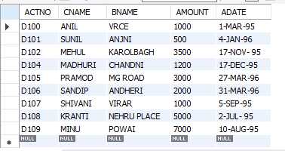

1. select * from deposit.borrow;

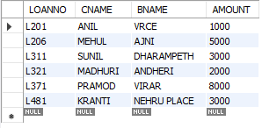

1. SELECT * FROM deposit.customer;

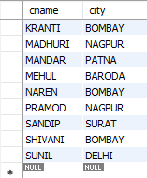

1. SELECT * FROM deposit.branch;

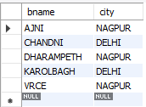

1. select ACTNO,AMOUNT from deposit;

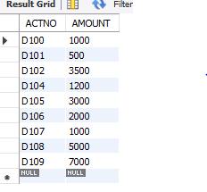

1. select CNAME,ACTNO from deposit;

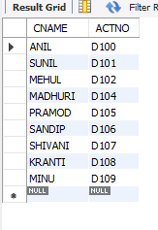

1. select CNAME from customer;

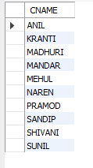

1. select BNAME from branch;

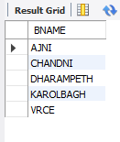

1. select CNAME from borrow;

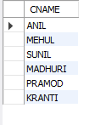

1. select CNAME from customer where CITY='NAGPUR';

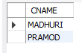

1. select CNAME from deposit where AMOUNT>4000;



1. select ADATE from deposit where CNAME='ANIL';



1. SELECT BNAME from BRANCH where CITY='Bombay';



1. select CNAME from borrow where LOANNO='L205';



1. select CNAME from deposit where BNAME='VRCE';



1. BNAME from BRANCH WHERE CITY='Delhi';



1. SELECT CNAME from DEPOSIT WHERE ADATE='1-12-1996';



1. SELECT ACTNO,AMOUNT from DEPOSIT WHERE ADATE BETWEEN '1-DEC-1996' AND '1-MAY-1996';



1. SELECT CITY from BRANCH WHERE BNAME='KAROLBAGH';



1. SELECT * from customer join borrow on customer.cname=borrow.cname join deposit on deposit.cname=borrow.cname WHERE customer.cname='ANIL';

