**20MCA134 - ADVANCED DBMS LAB**

**EXPERIMENT NO. 1**

**AIM**

To study various DDL commands.

Create the following Tables:

**Code:**

create database deposit;

use deposit;

create table Branch(bname varchar(20) primary key,city varchar(30) NOT NULL);

alter table Branch modify city varchar(30) check(city in ("nagpur","delhi","banglore","bombay"));

create table Customer(cname varchar(15) primary key,city varchar(20) NOT NULL);

CREATE TABLE DEPOSIT (ACTNO VARCHAR(5) CHECK (ACTNO LIKE 'D%') PRIMARY KEY ,CNAME

VARCHAR(15) REFERENCES CUSTOMER(CNAME) ,BNAME VARCHAR(20) REFERENCES

BRANCH(BNAME),AMOUNT FLOAT(8) CHECK (AMOUNT>0) NOT NULL, ADATE VARCHAR(30));

drop table DEPOSIT;

CREATE TABLE BORROW (LOANNO VARCHAR(8) CHECK (LOANNO LIKE 'L%') PRIMARY KEY,CNAME

VARCHAR(15) REFERENCES CUSTOMER(CNAME) ,BNAME VARCHAR(20) REFERENCES

BRANCH(BNAME),AMOUNT FLOAT(8) CHECK (AMOUNT>0) NOT NULL);

INSERT INTO CUSTOMER VALUES('ANIL','CALCUTTA');

INSERT INTO CUSTOMER VALUES('SUNIL','DELHI');

INSERT INTO CUSTOMER VALUES('MEHUL','BARODA');

INSERT INTO CUSTOMER VALUES('MANDAR','PATNA');

INSERT INTO CUSTOMER VALUES('MADHURI','NAGPUR');

INSERT INTO CUSTOMER VALUES('PRAMOD', 'NAGPUR');

INSERT INTO CUSTOMER VALUES('SANDIP','SURAT');

INSERT INTO CUSTOMER VALUES('SHIVANI','BOMBAY');

INSERT INTO CUSTOMER VALUES('KRANTI','BOMBAY');

iNSERT INTO CUSTOMER VALUES('NAREN','BOMBAY');

INSERT INTO BRANCH VALUES('VRCE','NAGPUR');

INSERT INTO BRANCH VALUES('AJNI','NAGPUR');

INSERT INTO BRANCH VALUES('KAROLBAGH','DELHI');

INSERT INTO BRANCH VALUES('CHANDNI','DELHI');

INSERT INTO BRANCH VALUES('DHARAMPETH','NAGPUR');

INSERT INTO BRANCH VALUES('MG ROAD','BANGALORE');

INSERT INTO BRANCH VALUES('ANDHERI','BOMBAY');

INSERT INTO BRANCH VALUES('NEHRU PALACE','DELHI');

INSERT INTO BRANCH VALUES('POWAI','BOMBAY');

INSERT INTO DEPOSIT VALUES('D100','ANIL','VRCE',1000.00,'1-MAR-95');

INSERT INTO DEPOSIT VALUES('D101','SUNIL','ANJNI',500.00,'4-JAN-96');

INSERT INTO DEPOSIT VALUES('D102','MEHUL','KAROLBAGH',3500.00,'17-NOV- 95');

INSERT INTO DEPOSIT VALUES('D104','MADHURI','CHANDNI',1200.00,'17-DEC-95');

INSERT INTO DEPOSIT VALUES('D105','PRAMOD','MG ROAD',3000.00,'27-MAR-96');

INSERT INTO DEPOSIT VALUES('D106','SANDIP','ANDHERI',2000.00,'31-MAR-96');

INSERT INTO DEPOSIT VALUES('D107','SHIVANI','VIRAR',1000.00,'5-SEP-95');

INSERT INTO DEPOSIT VALUES('D108','KRANTI','NEHRU PLACE',5000.00,'2-JUL- 95');

INSERT INTO DEPOSIT VALUES('D109','MINU','POWAI',7000.00,'10-AUG-95');

INSERT INTO BORROW VALUES('L201','ANIL','VRCE',1000.00);

INSERT INTO BORROW VALUES('L206','MEHUL','AJNI',5000.00);

INSERT INTO BORROW VALUES('L311','SUNIL','DHARAMPETH',3000.00);

INSERT INTO BORROW VALUES('L321','MADHURI','ANDHERI',2000.00);

INSERT INTO BORROW VALUES('L371','PRAMOD','VIRAR',8000.00);

INSERT INTO BORROW VALUES('L481','KRANTI','NEHRU PLACE',3000.00);

SCREENSHOT :

1. BRANCH TABLE

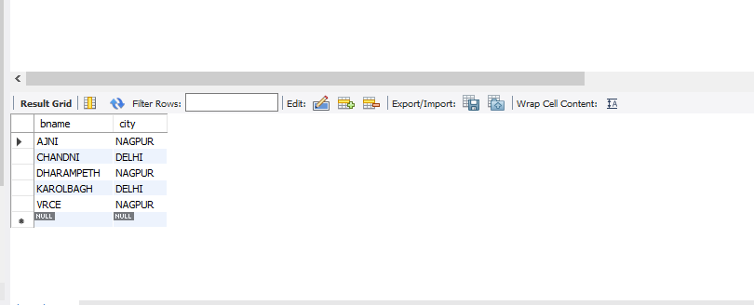

1. CUSTOMER TABLE

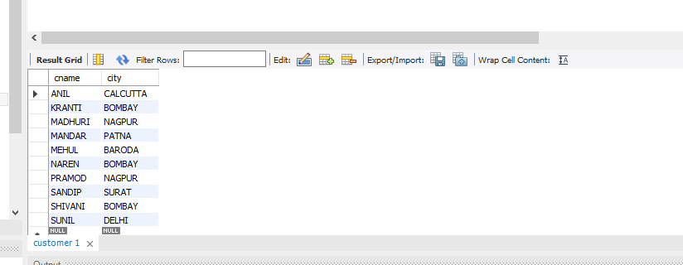

1. DEPOSIT TABLE

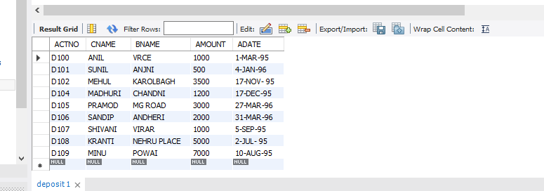

1. BORROW TABLE

