**Name: Merlin Moncy**

**Roll No: 21**

**Batch: MCA-B**

**Date: 25-10-2022**

**ANDROID LAB**

**Experiment No.: 10**

**Aim**

Gradient tool image button

**Procedure**

<?xml version="1.0" encoding="utf-8"?>

<selector xmlns:android="http://schemas.android.com/apk/res/android">

<item>

<shape android:shape="rectangle">

<solid android:color="#7C84AC"> </solid>

<stroke android:color="#7AEAEA"

android:width="30dp"

android:dashGap="20dp"

android:dashWidth="10dp">

<corners android:bottomLeftRadius="50dp" android:topRightRadius="45dp"></corners>

</stroke>

</shape>

</item>

</selector>

**Output**

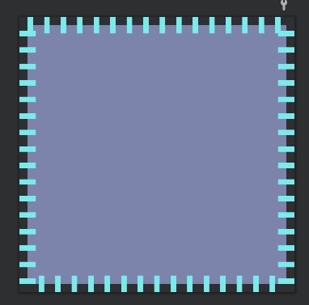

<?xml version="1.0" encoding="utf-8"?>  
<selector xmlns:android="http://schemas.android.com/apk/res/android">  
<item>  
 <shape android:shape="rectangle">  
 <solid android:color="#33AC64"> </solid>  
 <corners android:bottomLeftRadius="500dp" android:topLeftRadius="500dp"></corners>  
 <size android:width="200dp" android:height="200dp"></size>  
  
 <gradient android:startcolor="#FB8D14"  
 android:endcolor="#9BCA44"  
 android:angle="360"  
 android:centerColor="#D63575"  
 android:type="radial"  
 android:gradientRadius="100dp"></gradient>  
  
 </shape>  
</item>  
</selector>

**Output**

