Assignment 3
Ling 201 – Spring 2026
(100 pts total)
Please do not use external sources such as the internet or AI to find the answers. If you need an extension, please ask before the deadline.

Part 1: Tree Structure of Simple Sentences.
Using the English phrase structure rules given below, draw a syntax tree for each of the following sentences. (6 points each, 48 points total)
- NP → (D) (AdjP+) N (PP+)
- PP → P NP
- AdjP → (AdvP) Adj
- AdvP → (AdvP) Adv
- VP → (AdvP+) V (NP) (NP) (AdvP+) (PP+) (AdvP+)
- TP → NP T VP

- in the park

- very old

- the very old cat

- the old man in the small kitchen of the big house

- That girl under the tree loves syntax.

- The very old cat walks in the park quickly.

- A small cat slept on the warm bed.

- The teacher gave the student a book.

Part 2: Tree Structure of Complex Sentences.
Using the revised English phrase structure rules given below, draw a syntax tree for each of the following sentences. (6 points each, 12 points total)
- NP → (D) (AdjP+) N (PP+) (CP+)
- PP → P NP
- AdjP → (AdvP) Adj
- AdvP → (AdvP) Adv
- VP → (AdvP+) V (NP) ({NP, CP}) (AdvP+) (PP+) (AdvP+) (CP+)
- TP → {NP, CP} (T) VP
- CP → C TP

- Merlin has told Arthur that Rutgers is becoming the best University in the world.

- That Merlin was winning the game tore Arthur apart.

Part 3: Tree Structure of Structural Ambiguity.
In Homework II, Part 3, we examined the following sentence:
The spy saw the agent with the binoculars on the roof.
We showed that this sentence has at least four possible interpretations:
- The spy saw the agent who was on the roof and who had the binoculars.
- The spy who was on the roof saw the agent who had the binoculars.
- The spy who was on the roof used the binoculars to see the agent.
- The spy used the binoculars that were on the roof to see the agent.
Recall from class that structural ambiguity often arises when a prepositional phrase (PP) modifying different heads in a tree, resulting in different meanings.
From four interpretations above:
- Choose any two interpretations from (a)–(d)
You choose interpretation ____ and interpretation ____.
- Draw a syntactic tree for each of your chosen interpretations, and
- Briefly explain why the two structures yield different meanings.
(32 points in total, 2 points for question (1),
10 points for each tree in question (2), and
10 points for question (3).)

Part 4: Dutch Syntax. (8 points)
We know that English has SVO (i.e. Subject – Verb - Object) word order as in:

(1) | My brother |  | likes | dogs.
 | S |  | V | O
(2) | Arthur | will | cook | soup.
 | S |  | V | O
and English phrase-structure rule for TP is: TP → NP T VP.
The tree diagrams for (1) and (2) above are as follows:
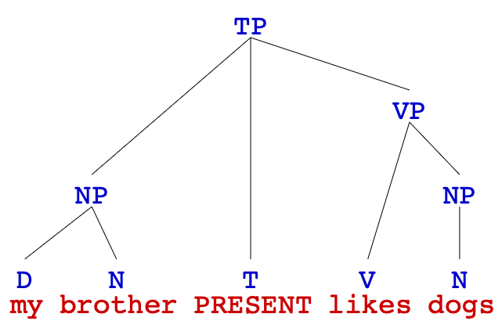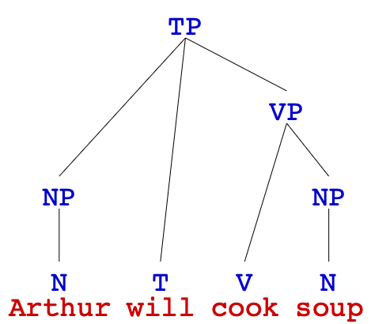

Consider the following sentences from Dutch. (Data from Ferdinand de Haan).

a. | De | man | in | de | regenjas | is | naar | Amsterdam |  | gegaan
 | the | man | in | the | raincoat | is | to | Amsterdam |  | going
 | ‘The man in the raincoat is going to Amsterdam.’
b. | De | man | heeft | een | gele | auto | met | een | aanhanger | gekocht
 | the | man | has | a | yellow | car | with | a | trailer | bought
 | ‘The man has bought a yellow car with a trailer.’
c. | De | vrouw | heeft | een | auto | gekocht
 | the | woman | has | a | car | bought
 | ‘The woman has bought a car.’
d. | Jan | is | vertrokken.
 | John | is | gone
 | ‘John left’

(If you speak Dutch, please confine your answer to the data given above and do not add any other examples.)
- Assume that an AdjP phrase structure rule is AdjP → Adj, what is the NP rule of Dutch?

- What is the PP rule of Dutch?

- What is the VP rule of Dutch?

- Assume that is and heeft are of the category T and are not part of the VP, what is the TP rule for Dutch?

Extra Credit (5 points)
This part is optional. Two extra credit questions are provided. You may answer either question, but only one may be submitted for credit. If you attempt it, you will receive at least 1 extra point on top of your grade. Up to 5 points may be awarded based on the quality of your answer.

- Draw syntactic trees for (a) and (b) in Part 4 for Dutch sentences.
Notes: You should include the Dutch words in the tree, not the English translation.

- Draw a possible syntactic tree for the following sentence.
The irritable bluejay noisily warned
the other small birds
about the very large circling hawk
in the clear sky.

