Practice Worksheet for Midterm Exam
Ling 201 – Fall 2025

Part A. Morphemes
- For each of the following words, state whether it is monomorphemic or polymorphemic and whether it is simple or compound. Then write each morpheme separately, state whether each morpheme is a root, prefix, or suffix, and state whether it is free or bound. If it is an affix, state whether it is inflectional or derivational.
  - improperly
- improperly polymorphemic, simple
- im- prefix, bound, derivational
- proper root, free
- -ly suffix, bound, derivational

  - caterpillar
- caterpillar monomorphemic, simple
- caterpillar root, free

  - housecats
- housecats polymorphemic, compound
- house root, free
- cat root, free
- -s suffix, bound, inflectional

  - internationalism
- internationalism polymorphemic, simple
- inter- prefix, bound, derivational
- nation root, free
- -al suffix, bound, derivational
- -ism suffix, bound, derivational

Part B. Morphological Analysis
Examine the following words from Michoacán Aztec, an indigenous language spoken in Mexico, and answer the questions below:
a. nokali ‘my house’ f. mopelo ‘your dog’
b. nokalimes ‘my houses’ g. mopelomes ‘your dogs’
c. mokali ‘your house’ h. ikwahmili ‘his cornfield’
d. ikali ‘his house’ i. nokwahmili ‘my cornfield’
e. nopelo ‘my dog’ j. mokwahmili ‘your cornfield’

- Fill in the blanks with the corresponding Michoacán Aztec morphemes:
  - ‘house’ kali
  - ‘dog’ pelo
  - ‘cornfield’ kwahmili
  - plural mes
  - ‘my’ no
  - ‘your’ mo
  - ‘his’ i

- What is the English translation of the Michoacán Aztec word ipelo?
his dog

- How would you say ‘his cornfields’ in Michoacán Aztec?
ikwahmilimes
Part C. Constituency Tests
Use one of the constituency tests (substitution, movement, stand alone, coordination) to determine whether the underlined sequence of words is a constituent.
- We went to the airport.
Not a constituent

- We waited in line.
Constituent
- Movement: In line, we waited. OR It was in line that we waited.
- Replacement: We waited there.
- Stand-alone: Where did we wait? In line.

- The plane flew up into the clouds.
Not a constituent – but up into the clouds is a constituent.

- We saw the mountains far below.
Constituent
- Movement: It was the mountains that we saw far below.
- Replacement: We saw them far below.
- Stand-alone: What did we see far below? The mountains.
- Coordination: We saw the mountains and the rivers far below.
Part E. Syntactic Structures
Given the following phrase structure rules, draw syntax trees for the sentences below. Make sure to label the part of speech of each word.
TP → NP (T) VP
NP → (D) (AdjP+) N (PP+) (CP+)
PP → P NP
AdjP → (AdvP) Adj
AdvP → (AdvP) Adv
VP → (AdvP+) V (NP) (NP/CP) (AdvP+) (PP+) (AdvP+) (CP+)
CP → (C) TP

- The cheerful cook made an omelet.
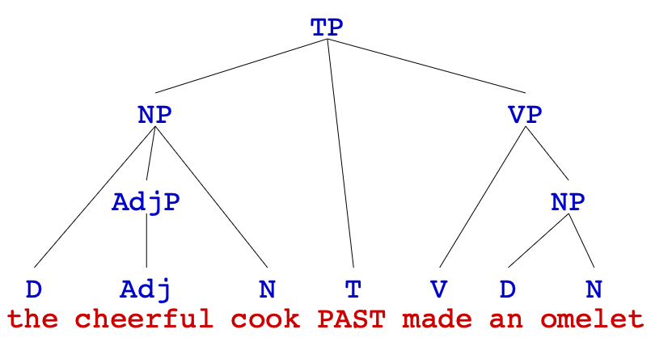

- The birds in the tree sang very beautifully.
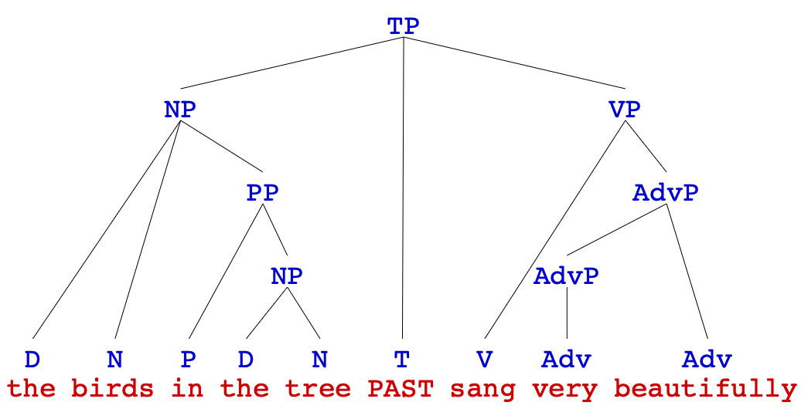
- She carefully put the nice cups on the table.
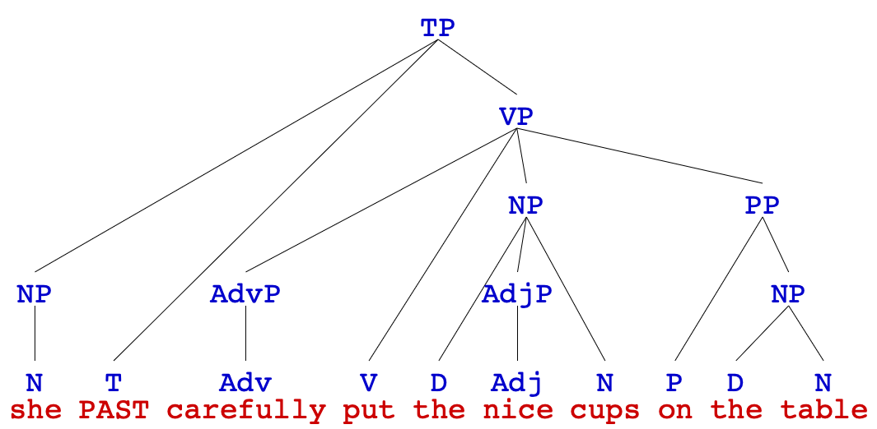

- I ate a big hot bowl of soup.
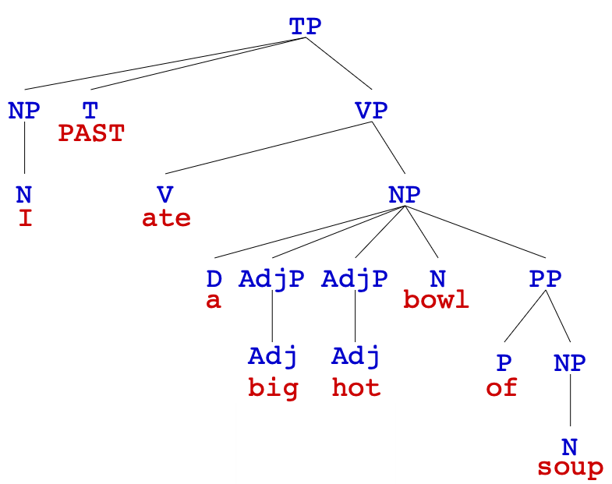

- Tim studied hard so he could ace the exam.
