Assignment 2: Syntax I
Ling 201 – Fall 2026
(100 pts total)
Please do not use external sources such as the internet or AI to find the answers. If you need an extension, please ask before the deadline.

Part 1: Parts of Speech.
Label the part of speech (N, V, Adj, Adv, D, Prep, Conj, T, C) of each word in the following sentences. (6 points/sentence, 24 points total)
Example:
I | will | show | the | boys | and | the | girls | that | the | good
N | T | V | D | N | Conj | D | N | C | D | Adj
 | apple | fell | off | from | the | table | terribly
 | N | V | Prep | Prep | D | N | Adv

The | smart | sailor | quickly | repaired | the | boat | and | sailed | away

The | tall | teacher | carefully | opened | the | window | and | smiled | kindly

birds | can | fly | because | they | have | light | bones | and | wings

I | know | that | a | young | leopard | can | run | very | fast

Part 2: Constituency Tests.
For each underlined sequence of words below,
(1) determine whether it is a constituent,
(2) use at least two constituency tests to support your answer, and
(3) explain in your own words why or why not the tests work.
(6 points each/36 points total)

- The small dog chased the frightened cat.

- She walked quickly to the neighborhood park.

- The boy ran very fast home.

- They saw a big red balloon near the trees.

- The girl sang a beautiful song in the sunny garden.

- He ate the pizza with extra pepperoni.

Part 3: Structural Ambiguity.
Consider the following sentence:
The spy saw the agent with the binoculars on the roof.
This sentence is structurally ambiguous and gives rise to four distinct interpretations. In the colour-coded version below, each interpretation is indicated by different colouring. For each colour-coded interpretation:
- paraphrase the meaning in clear, natural English; and
- explain briefly why the sentence can be interpreted that way.
(10 points/item, 40 points total)
Notes:
- If you have difficulty distinguishing colours, please let me know. An alternative version is available.
- Some interpretations may not be immediately obvious, so do not worry if you are unsure about every possible interpretation.
- In the meantime, aim to be both creative and accurate in your analysis and you are not required to draw syntactic trees now.
Example:

[[green tea] cup]
a cup specifically designed for green tea
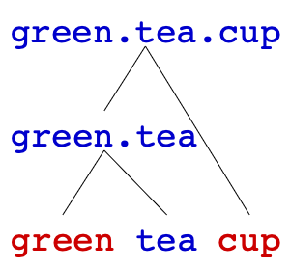
[green [tea cup]]
a tea cup whose colour is green
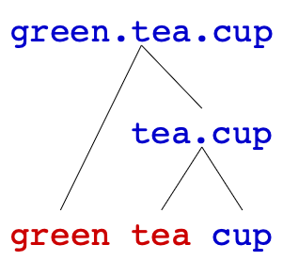

- The spy saw the agent with the binoculars on the roof.

- The spy saw the agent with the binoculars on the roof.

- The spy saw the agent with the binoculars on the roof.

- The spy saw the agent with the binoculars on the roof.

Extra Credit (5 points)
This question is optional. If you complete it and provide a reasonable explanation, you will receive 5 extra points on top of your grade.

In addition to the four interpretations above, consider the colour-coded sentence below:
* The spy saw the agent with the binoculars on the roof.
One logically imaginable interpretation of this sentence is difficult to obtain in English.
If you agree with this judgement, then:
- describe the interpretation that is less readily accessible; and
- explain why this reading creates oddness.
On the other hand, if you find this reading fully acceptable, then:
- paraphrase the meaning in clear, natural English; and
- explain briefly why the sentence can be interpreted that way.

Notes: Your explanation does not need to rely on formal syntactic analysis, and you may base your reasoning on your English intuition or your understanding of English.

