Assignment 5: Semantics II - Welcome to the World of Mario
Ling 201 – Fall 2026
(100 pts total)
Please do not use external sources such as the internet or AI to find the answers. If you need an extension, please ask before the deadline.

Part 1. Presupposition Test [difficulty level: ☆☆☆☆]

For each pair of sentences below, determine whether or not sentence (a) presupposes sentence (b), and justify your answer using semantic reasoning (truth conditions, etc.). Do not panic, if you follow the steps shown in the example, you will find it manageable. (5 points/item, 30 points total)

Example: (a). Mario ate the cookie.
(b). There exists a cookie.

As we said for (a) to presuppose (b), (a) must entail (b) first, since a presupposition relation is a special kind of entailment relation.
step 1: (a) ENTAILS (b), if Mario ate the cookie, then there must be at least one cookie for him to eat. Hence, if (a) is true, (b) must also be true.

We have also mentioned in class, that presupposition survives negation, which means that the negation of (a) must entail (b) as well to form a presupposition relation.
step 2: NOT-(a) ENTAILS (b), if Mario DID NOT eat the cookie, then the cookie must still exist. Hence, if NOT-(a) is true, (b) must also be true.

Two steps together: if (a) is true, (b) must also be true;
if NOT- (a) is true, (b) must also be true.
This means, sentence (a) PRESUPPOSES sentence (b).

Note: Please explicitly state whether each entailment holds ((a) entails (b), NOT-(a) entails (b)) before giving your final answer.
- (a). Toad texted Toadette again.
(b). Toad texted Toadette before.

- (a). Baby Luigi did his homework.
(b). Baby Luigi redid his homework.

- (a). The world of Mario is fantastic.
(b). Bowser knows that the world of Mario is fantastic.

- (a). What Boo wanted was the crown.
(b). Boo wanted something.

- (a). Daisy finished reading the paper.
(b). Daisy started reading the paper.

Part 2. Set Theory [difficulty level: ☆☆]
Here’s a photo of characters in the game Mario Kart.
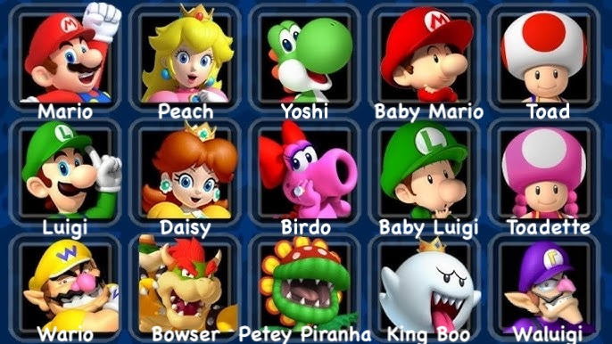
Answer the following questions, assuming the following subsets:
- M = { x | x has a giant mouth } = { Yoshi, Birdo, Wario, Bowser, Petey Piranha, King Boo, Waluigi }
- N = { x | x has a big nose } = { Mario, Yoshi, Baby Mario, Luigi, Baby Luigi, Wario, Bowser, Waluigi }
- H = { x | x is humanoid } = { Yoshi, Toad, Birdo, Toadette, Bowser, Petey Piranha, King Boo }
- C = { x | x wears a cap } = { Mario, Baby Mario, Luigi, Baby Luigi, Wario, Waluigi }
- G = { x | x ‘wears’ green } = { Peach, Yoshi, Luigi, Daisy, Baby Luigi, Bowser, Petey Piranha} (Here, Peach and Daisy are included because of their earrings.)
- T = { x | x’s tongue is visible} = { Mario, Yoshi, Bowser, Petey Piranha, King Boo }
- K = {x | x is crowned} = { Peach, Daisy, King Boo }
- State whether the expression is true or false and briefly explain why. (4 points/item, 24 points total)
  - |M| = |H|

  - G ∩ T ≠ ∅

  - King Boo ∈ ( N ∩ H )

  - T ⊆ M

  - Peach ∈ C ′

  - K - M = { King Boo }

- Calculate the following and describe the resulting set in words. (3 points/item, 24 points total)
Example: C – S | calculated set: {Felix, Chantelle, Lily}
| description in words: cats without stripes on their faces

  - N ∩ H

  - G – C

  - K ∩ H ′

  - ( K ∪ N )′

  - T – ( K ∪ M )

  - ( H – M ) ∪ ( K ∩ T )

- Define two more subsets of your own to add to the top list. Use both predicate notation and list notation for each set. (2 points/item, 4 points total)

i. ____ = { x | x________________} = { ___________________________}

ii. ____ = {x | x________________} = { ___________________________}

- Using these two sets alongside the sets already given, come up with three phrases that could describe characters above. Represent the phrase in set notation, then calculate the resulting set and write it in list notation. You must use at least two operators in the sentence, out of the following: union (∪), intersection (∩), difference (–), complement (′). (6 points/item, 18 points total)

Example phrase: humanoid character that wears red or is crowned
in set notation: H ∩ ( R∪K ) = { Toad, KingBoo }

  - phrase 1: __________________________________________________
in set notation: _________________= { ______________________________ }

  - phrase 2: __________________________________________________
in set notation: _________________= { ______________________________ }

  - phrase 3: __________________________________________________
in set notation: _________________= { ______________________________ }

