# Nginx

1. 需要安装依赖

yum install gcc gcc-c++

 yum install -y zlib-devel

<http://nginx.org/download/nginx-1.13.2.tar.gz>

<http://www.openssl.org/source/openssl-fips-2.0.9.tar.gz>

<http://zlib.net/zlib-1.2.11.tar.gz>

<ftp://ftp.csx.cam.ac.uk/pub/software/programming/pcre/pcre-8.38.tar.gz>

以上几个 用 下面这个命令安装

./configure && make && make install

Nginx默认安装路径

/usr/local/nginx

#解压nginx-1.1.13 并安装

#tar –zxvf nginx-1.1.13.tar.gz

cd nginx-1.1.13

./configure && make && make install

#启动nginx

/usr/local/nginx/sbin/nginx

#检查nginx运行是否成功

#cd /usr/local/nginx/sbin

#./nginx –t

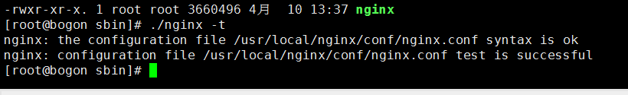

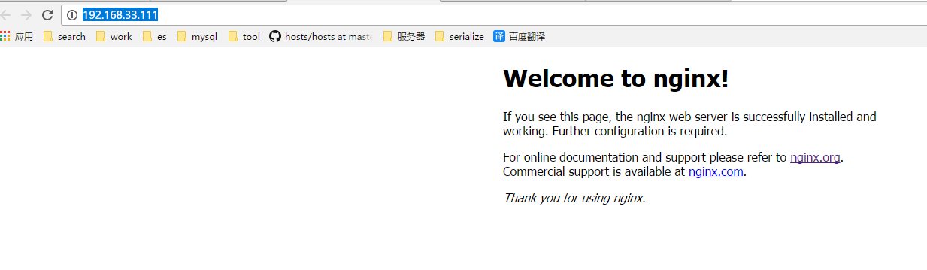

# Keepalived

下载 <http://www.keepalived.org/>



需要先安装

 yum -y install openssl-devel

tar –zxvf keepalived-1.3.5.tar.gz

cd keepalived-1.3.5/

./configure && make && make install

安装相关组件

yum install -y pcre-devel