# RoketMQ

## clone代码

git clone -b release-4.1.0-incubating

<https://github.com/apache/rocketmq.git>

## 编译

# cd rocketmq

# mvn -Prelease-all -DskipTests clean install -U

# cd distribution/target/apache-rocketmq

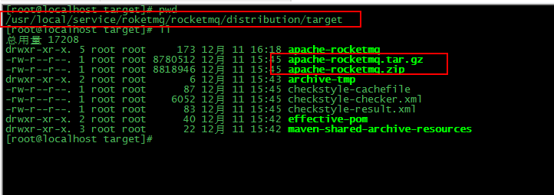

apache-roketmq.tar.gz为编译后roketmq压缩包

## 启动

将apache-roketmq.tar.gz复制到/opt/apache-roketmq目录

# cp apache-roketmq.tar.gz /opt/apache-roketqm

# tar –zxvf apache-roketmq.tar.gz

### 启动 name server

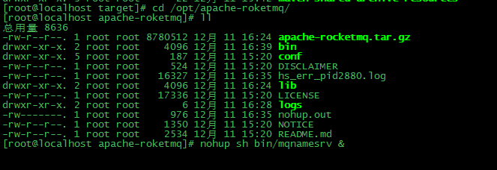

# nohup sh bin/mqnamesrv &

# tail -f ~/logs/rocketmqlogs/namesrv.log

### 启动broker

因为roketmq启动默认jvm参数是

-server -Xms8g -Xmx8g -Xmn4g

bin/runbroker.sh

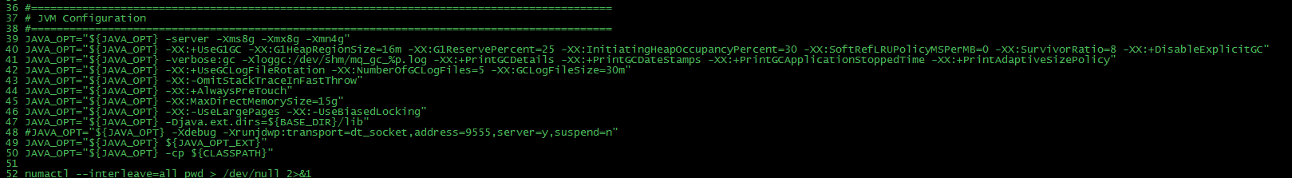

如果内存不足8G则 修改该文件

# nohup sh bin/mqbroker -n localhost:9876 &