# Twemproxy+redis集群配置

## 编译安装autoconf

wget <http://ftp.gnu.org/gnu/autoconf/autoconf-2.69.tar.gz>

tar -zxvf autoconf-2.69.tar.gz

./configure && make && make install



提示需要安装m4

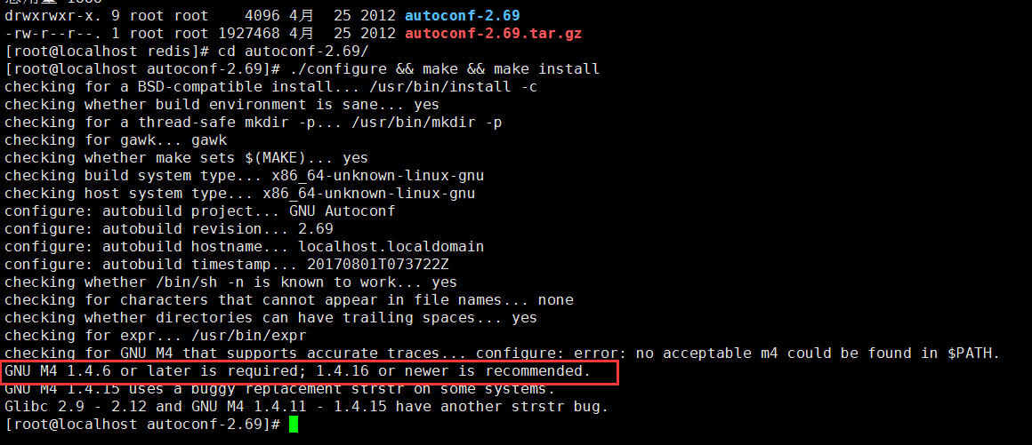

wget <http://ftp.gnu.org/gnu/m4/m4-1.4.18.tar.gz>

tar –zxvf m4-1.4.18.tar.gz

cd m4-1.4.18/

./configure && make && make install

还需要安装perl

yum install perl*

## 编译安装automake

wget <http://ftp.gnu.org/gnu/automake/automake-1.15.tar.gz>

cd automake-1.15/

./configure && make && make install

## 编译安装libtool

wget <https://ftp.gnu.org/gnu/libtool/libtool-2.4.6.tar.gz>

tar –zxvf libtool-2.4.6.tar.gz

cd libtool-2.4.6/

./configure && make && make install

## 安装编译twemproxy

wget <https://github.com/twitter/twemproxy/archive/master.zip>

unzip master.zip

cd twemproxy-master

aclocal

autoreconf -f -i -Wall,no-obsolete

./configure --prefix=/usr/local/twemproxy/

make && make install

## twemproxy配置