Brandon Merluzzo

ELEC 3200-04

Lab 4

**Part 1:**

**Problem:**

Write a program in Verilog to design a 3-input majority circuit, program your code to your board and record a video to demo your results

To get the circuit of the problem, the truth table was made with 3 inputs and 1 output shown below:

|  |  |  |  |
| --- | --- | --- | --- |
| **A** | **B** | **C** | **Z** |
| 0 | 0 | 0 | 0 |
| 0 | 0 | 1 | 0 |
| 0 | 1 | 0 | 0 |
| 0 | 1 | 1 | 1 |
| 1 | 0 | 0 | 0 |
| 1 | 0 | 1 | 1 |
| 1 | 1 | 0 | 1 |
| 1 | 1 | 1 | 1 |

Then to find the circuit equation a K-Map was used, and the circuit schematic was formed:

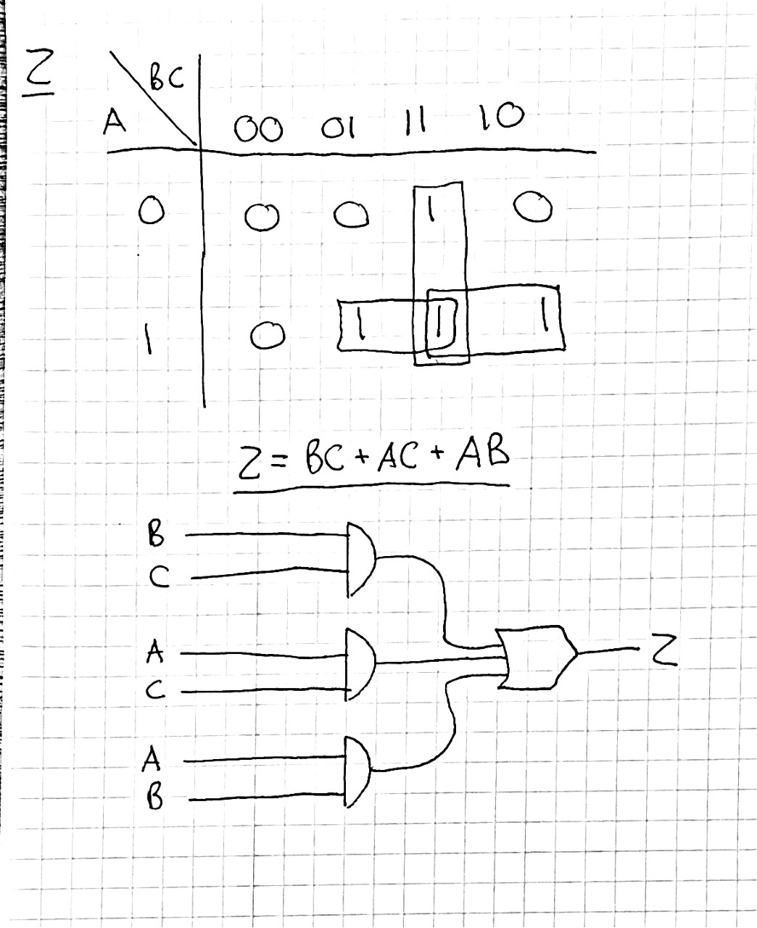

The following equation was derived from the K-map:

Z = B*C + A*C + A*B

In the code, a vector of A was used to represent the 3 inputs A, B, and C

Used the DE10 – Lite board to test the equation, the pin layout window and results video with link below:

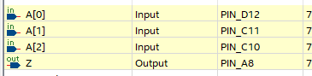

<https://www.youtube.com/watch?v=LLnHc8yP3Ps>

**Part 2:**

**Problem:**

▪ Write a program in Verilog (new project) to design the following circuit by using only 3-input majority circuits that you implemented in part 1. Record a video to demo your result

▪ AimBig; a venture capital, hires you to design a voting system to decide if they want to invest in a new project. AimBig will invest in a project if this project is approved by at least 2 out of 3 departments; financial, marketing, and engineering.

▪ Decision of each department is from the majority voting of their team member. Each department has 3 members.

▪ Note: Voting result of each department must be display on the board along with their final decision

**Code Description:**

For this problem the code was setup to have multiple subsystems in a main system. There are four subsystems total, each using the circuit made in the previous problem of this lab. Three of the subsystems would represent three separate departments with 3 people voting as inputs and would ultimately output a logic ‘1’ for yes and logic ‘0’ for no. The results of those 3 subsystems would then be inputted into the last subsystem which would output the final answer. The main system code would ultimately have 9 inputs and 3 outputs the would be bound to a switch or LED on the DE-10 Lite board.

Schematic of the main system with each subsystem:

(Dept 1 = Financial, Dept 2 = Marketing, Dept 3 = Engineering)

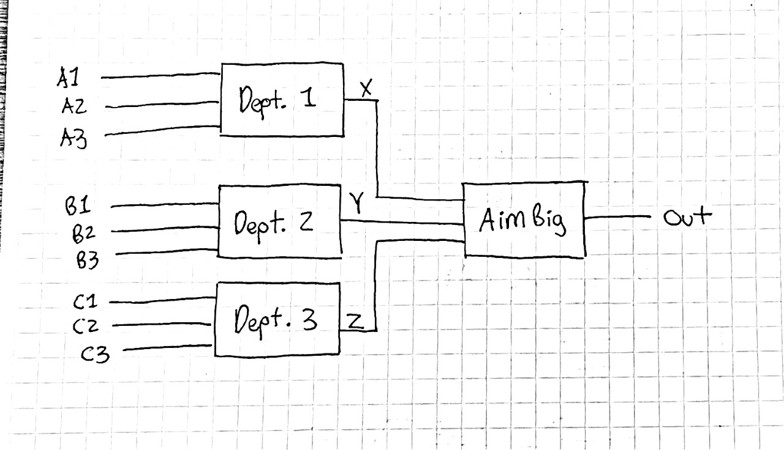

Used the DE10 – Lite board to test the equation, the pin layout window and results video with link below:

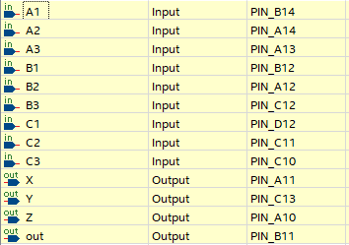

<https://www.youtube.com/watch?v=EaaU-Ruvh2k>