**Design**

1. **Brand Name of the Project**

**Smith IS Career Center**

1. **Business Functions and Transactions**

* There are three types of users: CareerService user, student and hiring manager. Each user is identified by a unique userID.
* Each student is identified by a unique S_userID.
* Each hiring manager is identified by his/her unique HM_userID.
* Each company is identified by their unique companyId.
* CareerService is identified by a unique ocs_userID.
* Each event is identified by a unique eventId.
* Each job posting will have a unique jobId.
* The company can assign multiple hiring managers.
* Each hiring manager can belong to one company.
* Each hiring manager can post multiple job posting.
* Multiple students can apply for multiple job postings.
* Multiple students can register for multiple events.
* CareerService posts multiple events.
* All events are posted by CareerService .

**3. ER Schema**

**Entities, Attributes and Primary Keys**

UserLogin(**userID**, password, userType)

* Student(S_userID, fName, lName, major, graduation, username, password, resume)
* HiringManager(HM_userID, fName, lName, departmentName, designation, email, phone, location)
* CareerService(ocs_userID, ocsName, phoneNo)

Company(**companyID**,companyName, companyRegion)

JobPosting(**jobID**, jobTitle, jobLocation, jobType, experience, workAuthorization, qualification, description, salary)

Event(**eventID**, eventName, eventDesc, date, location, targetAudience)

**Relationships, Attributes, Degrees, Participating Entities**

Assigns: Binary relationship

1 company to 0 or more hiring managers

1 hiring manager to 1 company

PostsJob: Binary relationship

1 hiring manager to 0 or more job postings

1 job posting to 1 hiring manager

AppliesTo(date): Binary relationship

1 students to 0 or more job postings

1 job posting to 0 more more students

RegistersFor: Binary relationship

1 student to 0 or more events

1 event to 0 or more students

PostsEvent: Binary relationship

1 CareerService user organizes 0 or more events

1 Event is organized by 1 CareerService user

**4. ER diagram**

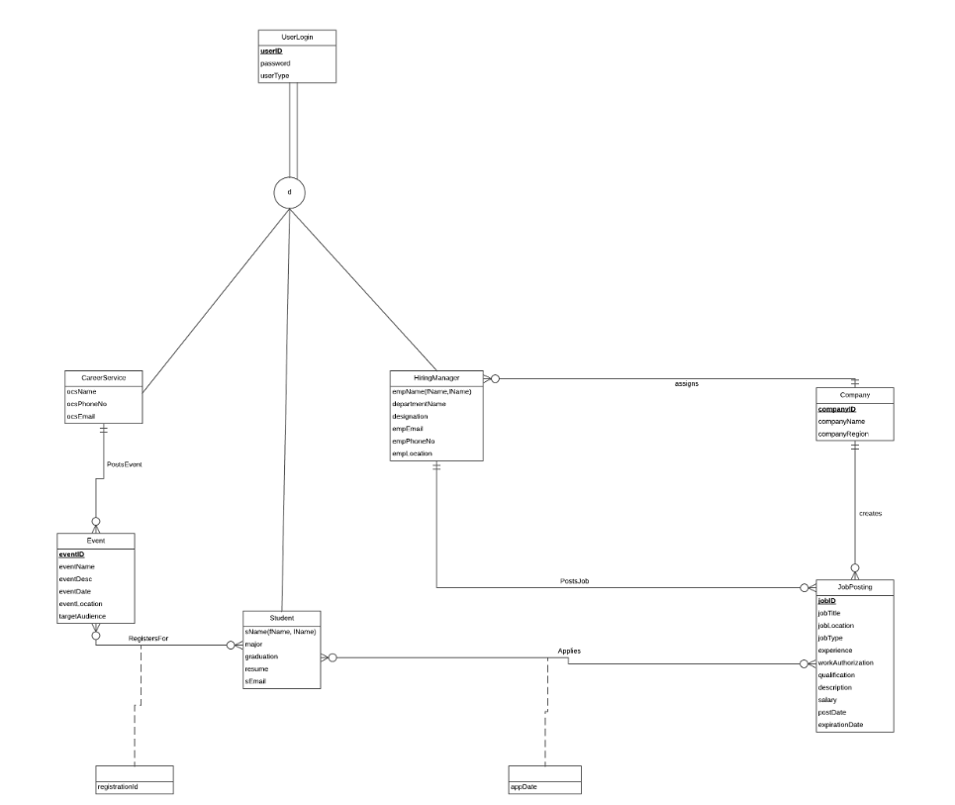

**PROPOSAL**

Mission Statement: The purpose of Smith IS Career Center is to maintain the data of jobs or internships posted by companies and allow the students to apply for the same via a common interface

Mission Objectives:

* Maintain a complete record of IS students looking for jobs or internships
* Maintain a complete record of all available job or internship postings for IS students
* Maintain a record of all the events managed by Career Services and the record corresponding registrations by students attending those events
* Provide a simple interface for companies to post jobs or internships and for students to apply for jobs or internships

Finalized ER Diagram



**Relations:**

UserLogin (**userID**, password, userType)

-Student (S_userID, sFName, sLName, major, graduation, resume, sEmail)

-HiringManager (HM_userID, empFName, empLName, department, designation, empEmail, empPhoneNo, empLocation*, companyID*)

-CareerService (ocs_userID, ocsName, ocsPhoneNo, ocsEmail)

Company (**companyID**, companyName, companyRegion)

JobPosting (**jobID**, jobTitle, jobLocation, jobType, experience, workAuthorization, qualification, description, salary, postDate, expirationDate, *HM_userID, companyID*)

Application (***S_userID****,* ***jobID****,* appDate)

Event (**eventID**, eventName, eventDesc, eventDate, eventLocation, targetAudience, *ocs_userID*)

Registration (**registrationId**, *eventID*, *S_userID*)

After normalizing to 3NF below are the functional dependencies and relations

**Functional Dependency:**

userID → password, userType

* S_userID→ sFName, sLName, major, graduation, resume, sEmail,
* HM_userID→ empFName, empLName, department, designation, empEmail, empPhoneNo, empLocation, *companyID*
* ocs_userID → ocsName, ocsPhoneNo, ocsEmail,

companyID → companyName, companyRegion

jobID → jobTitle, jobLocation, jobType, experience, workAuthorization, qualification, description, salary, postDate, expirationDate, *HM_userID, companyID*

applicationID →*S_userID, jobID,* appDate

eventID → eventName, eventDesc, eventDate, eventLocation, targetAudience, *ocs_userID*

registrationID → *eventID, S_userID*

**Normalization:**

UserLogin (**userID**, password, userType)

* Student (*S_userID*, sFName, sLName, major, graduation, resume, sEmail)
* HiringManager (*HM_userID*, empFName, empLName, department, designation, empEmail, empPhoneNo, empLocation*, companyID*)
* CareerService (*ocs_userID* , ocsName, ocsPhoneNo, ocsEmail)

Company (**companyID**, companyName, companyRegion)

JobPosting (**joID**, jobTitle, jobLocation, jobType, experience, workAuthorization, qualification, description, salary, postDate, expirationDate, *HM_userID, companyID*)

Application (**applicationID**, *S_userID, jobID,* appDate)

Event (**eventID**, eventName, eventDesc, eventDate, eventLocation, targetAudience, *ocs_userID*)

Registration (**registrationID**, *eventID, S_userID*)

**Business Rules:**

[R1] When a userlogin is deleted the corresponding student/hiringManager/ocsUser should be deleted.

[R2] When a student is deleted the corresponding event registrations in Registration table should be deleted.

[R3] When a student is deleted the corresponding job applications in Application table should be deleted.

[R4] When a HiringManager is deleted the corresponding jobPosts created by him/her should be set to NULL

[R5] When a Company is deleted, if there is corresponding employee in the HiringManager table then deletion should not be allowed.

[R6] When CareerService user is deleted the corresponding events in Event table created by that user should be set to NULL

[R7] When a JobPosting is deleted, if there are corresponding applications in the Application table, then deletion should not be allowed.

[R8] When an event in the Event table is deleted, if there are corresponding registrations is the Registration table, then deletion should not be allowed.

[R9] When a userlogin is updated the corresponding student/hiringManager/ocsUser should be updated.

[R10] When a student is updated the corresponding event registrations in Registration table should be updated.

[R11] When a student is updated the corresponding job applications in Application table should be updated.

[R12] When a HiringManager is updated the corresponding jobPosts created by him/her should be updated.

[R13] When a Company is updated the corresponding HiringManagers should be updated.

[R14] When CareerService user is updated the corresponding events in Event table created by that user should be updated.

[R15] When a JobPosting is updated the corresponding applications in the Application table are updated.

[R16] When an event in the Event table is updated the corresponding registrations is the Registration table are updated.

[R17] When a Company is deleted, if there are corresponding postings in the JobPosting table, then deletion should not be allowed.

[R18] When a Company is updated, if there are corresponding postings in the JobPosting table, then updation should not be allowed.

**Referential Integrity:**

|  |  |  |  |  |  |  |  |
| --- | --- | --- | --- | --- | --- | --- | --- |
| **Relation** | **Foriegn Key** | **Base Relation** | **Primary Key** | **Business Rule** | **Constraint: ON DELETE** | **Business Rule** | **Constraint: ON UPDATE** |
| Student | *S_userID* | UserLogin | userID | R1 | CASCADE | R9 | CASCADE |
| HiringManager | *HM_userID* | UserLogin | userID | R1 | CASCADE | R9 | CASCADE |
| HiringManager | *companyID* | Company | companyID | R5 | NO ACTION | R13 | CASCADE |
| JobPosting | *HM_userID* | HiringManager | *HM_userID* | R4 | SET NULL | R12 | CASCADE |
| JobPosting | *companyID* | Company | companyID | R17 | NO ACTION | R18 | NO ACTION |
| Application | *S_userID* | Student | *S_userID* | R3 | CASCADE | R11 | CASCADE |
| Application | *jobID* | JobPosting | jobID | R7 | NO ACTION | R15 | NO ACTION |
| CareerService | *ocs _userID* | UserLogin | userID | R1 | CASCADE | R9 | CASCADE |
| Event | *ocs _userID* | CareerService | ocs *_userID* | R6 | SET NULL | R14 | CASCADE |
| Registration | *S_userID* | Student | *S_userID* | R2 | CASCADE | R10 | CASCADE |
| Registration | *eventID* | Event | eventID | R8 | NO ACTION | R16 | NO ACTION |

**Sample Data:**

UserLogin (**123**, pass123, Student)

Student (***123***, Asmita, Natekar, Information Systems, 2019, C:\Resume\2019\789\20191117, asmita.natekar@rhsmith.umd.edu)

JobPosting (**234**, Company X, Systems Developer, Baltimore, Entry Level, 0-1 years, F-1 Eligible, MS, Design Algorithms, $80000, 11/17/18, 12/17/18, *456, 501*)

Application (**1**, *123, 234,* 11/17/18)

Event (**0215**, JobFair, Networking Event, 11/26/18, UMD, IS, *321*)

Registration (**1**,*0215***,** *123*)

UserLogin (**456**, pass456, Company)

Company (**501**, Company X, Maryland)

HiringManager (**456**, Urvash, Chheda, Human Resources, Manager, urvash@companyx.com, 1 987-654-3210, Maryland, *501)*

JobPosting (**234**, Company X, Systems Developer, Baltimore, Entry Level, 0-1 years, F-1 Eligible, MS, Design Algorithms, $80000, 11/17/18, 12/17/18, 456*, 501*)

UserLogin (**321**, pass321, Career Officer)

CareerService (**321**, Smith School, 1 202-978-4565, ocs@rhsmith.umd.edu)

Event (**0215**, JobFair, networking event, 11/26/18, UMD, IS, *321*)