Please update the bolt (Payment Gateway UP) and lovable(flow-wizardry-checkout) git as instructed.
- https://flow-wizardry-checkout.lovable.app/ we have added coupon code option, remove any text from it 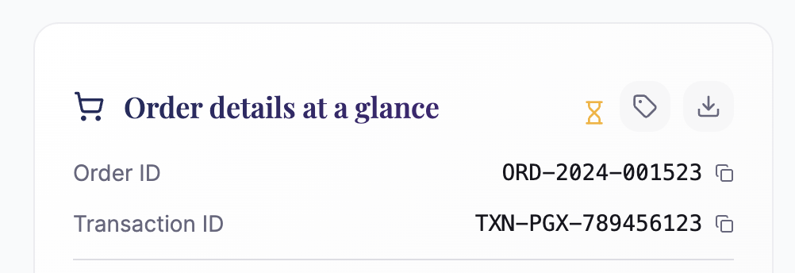
- 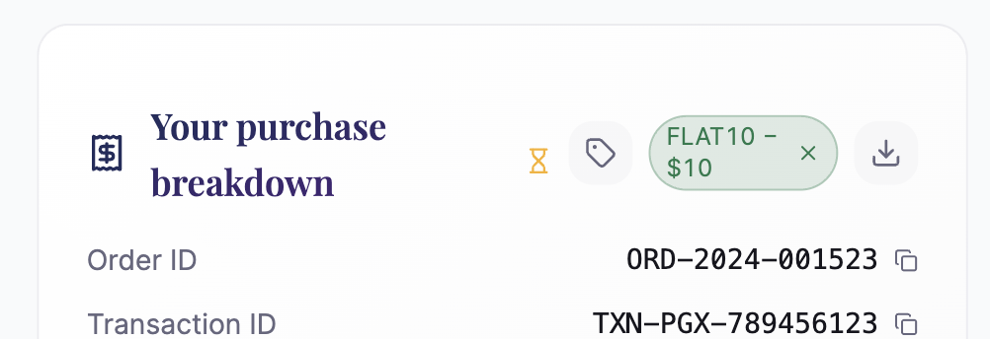also remove coupon code option when the copon code already applied.
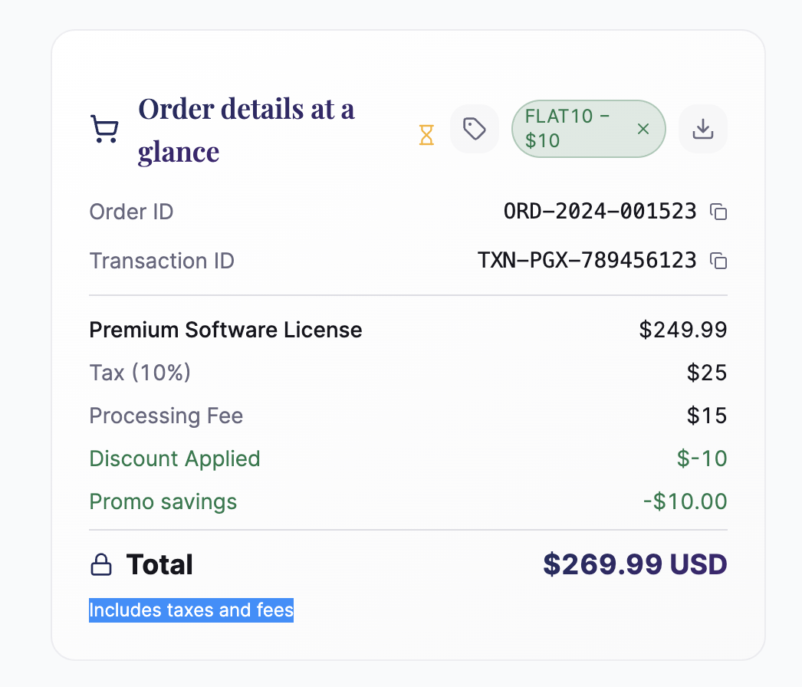add include tax and fee under the total amount
- Allign the processing icon which is down from the other icon, also if it could be animated icon
- Select payment method will have small search icon which will be extended afrer click 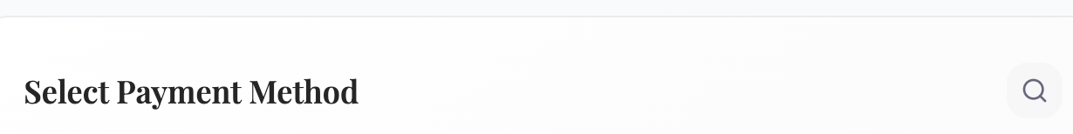
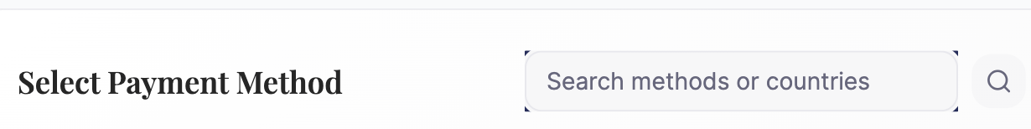

- Customer details asection add with address,

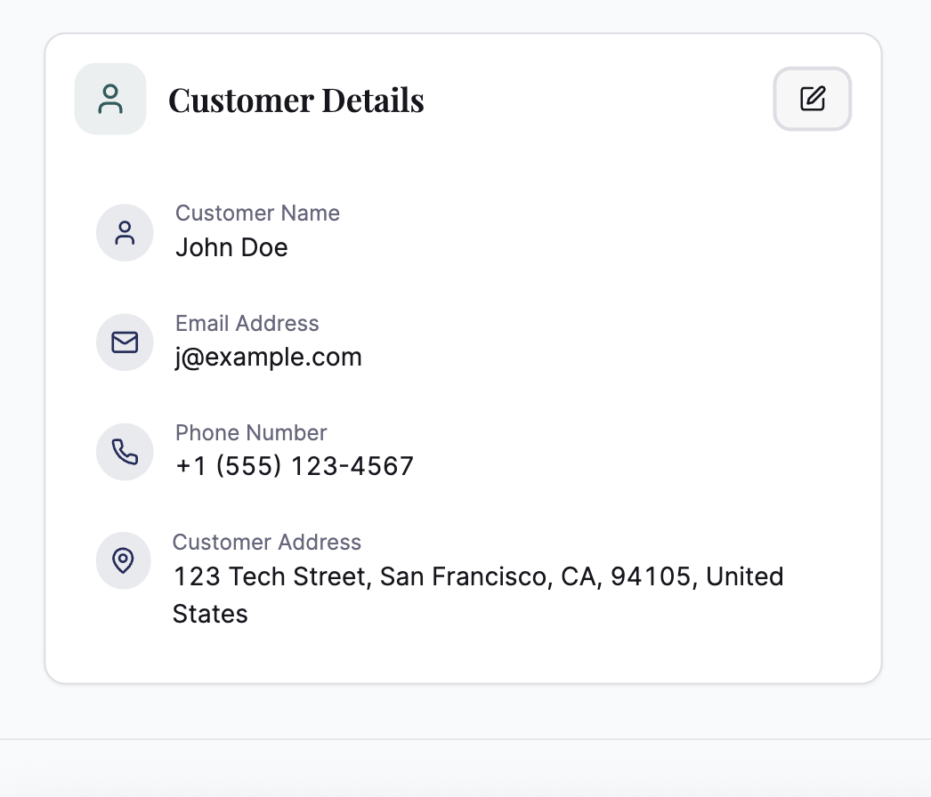
also in mobile collaps screen no need to sho edit only expand to show after expand the edit button will show
- When you click on credit card payment, it should show this form, which has more user experience-related fields
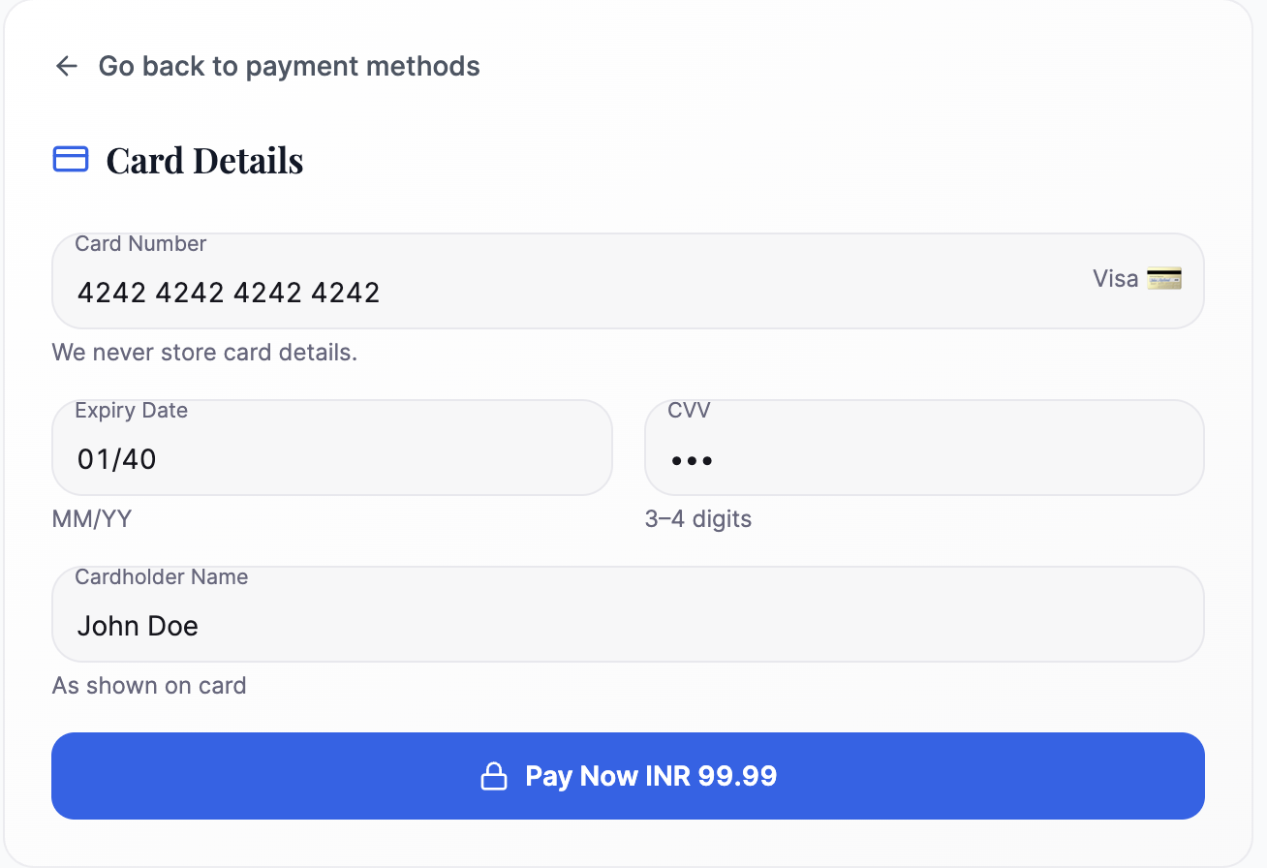

- After clicking on the Pay Now button, it should take to pre-3ds page, remove the sandbox mode from here and end the page on timer; after that setup next screen which will ask for ther OTP not this screen and then the same page which we have already.
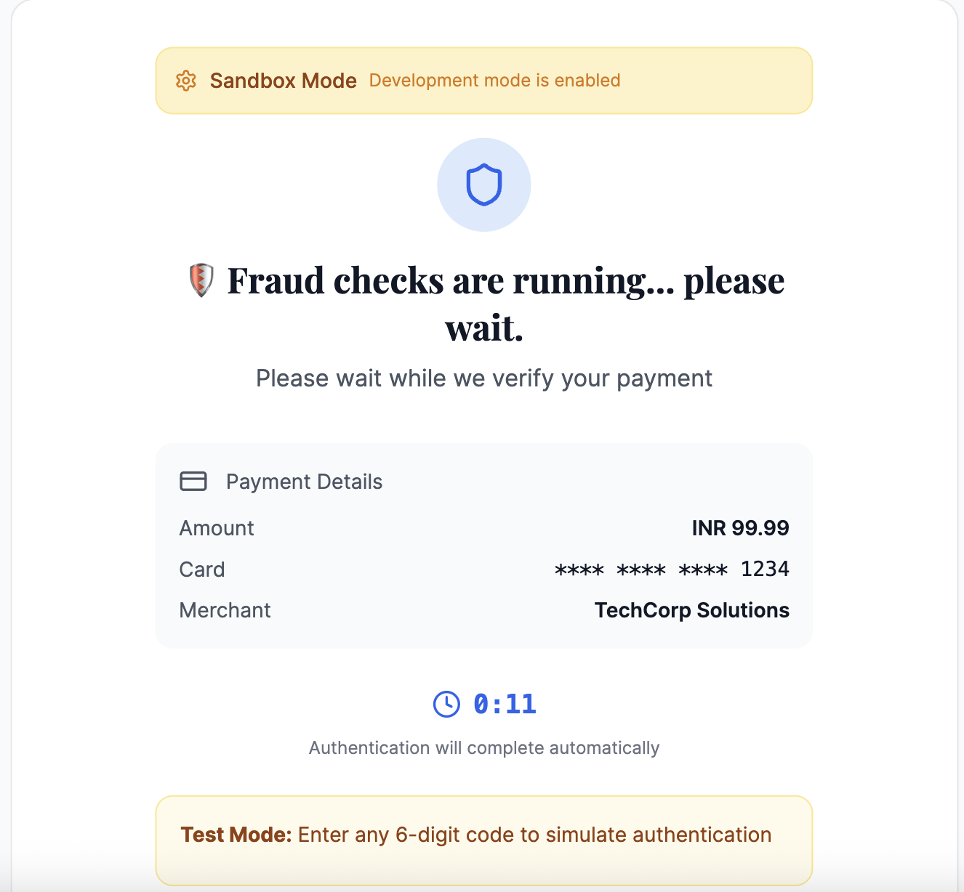

- Apply below design to crypto payments USDT, 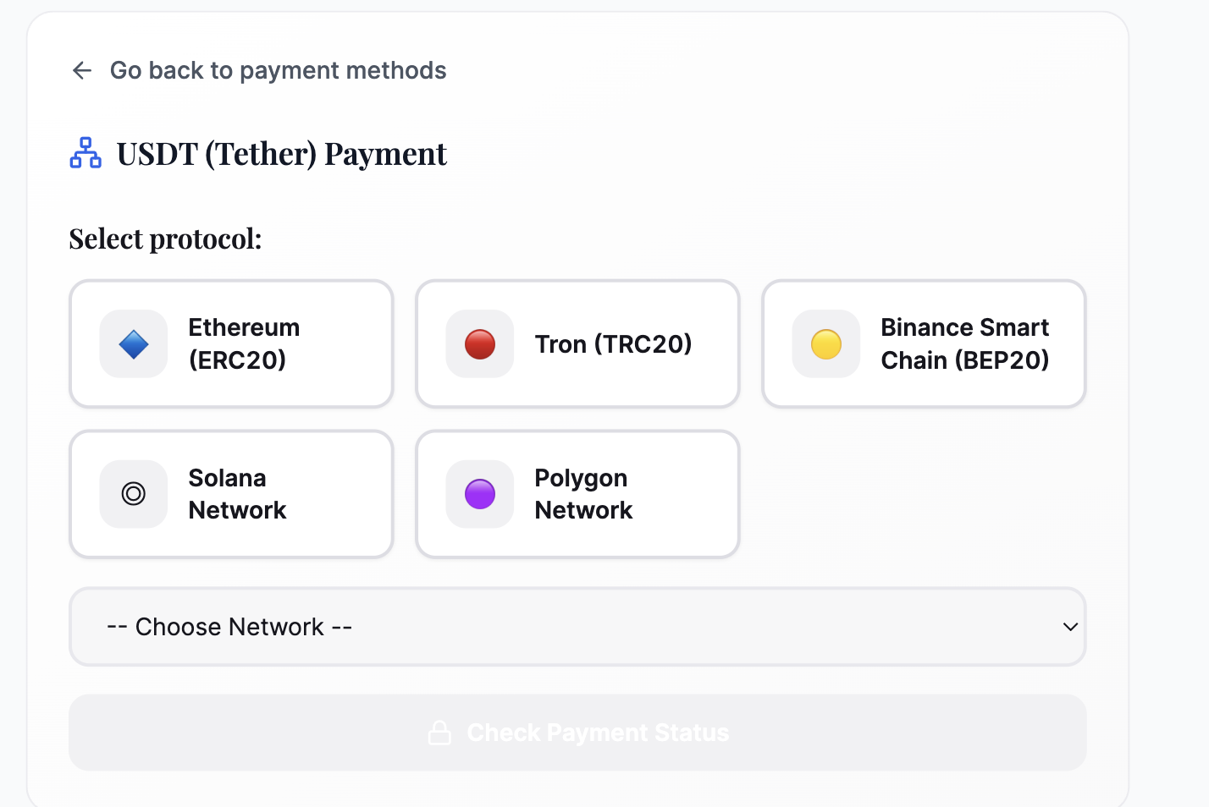
apply only as per existing design as all crypto does not have these networks, only a few crypto have, hence follow what we have in our existing pattern and then design.

- Use reference from https://techone-checkout-flow.lovable.app/



- Use this icon for image on top 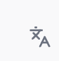
- Move configure button from the header and plan somewhere on write with setting icon, as on the top it’s creating issue while testing and responsive its.
- Reference from https://pay-brand-spark.lovable.app/ need to add a layer on the top having powered by
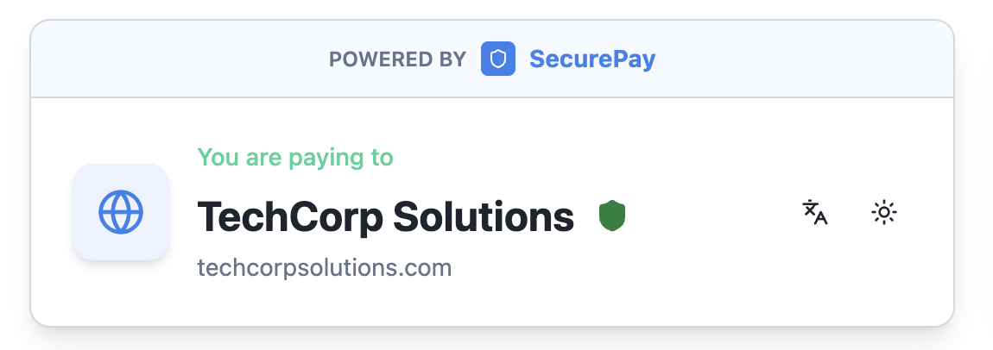
So if I can explain, you need to change below image
the final one should look like below
