Preliminary Information Request for the ASP Audit

Organizational overview for ASP Audit

Sr No | Particulars | Details
 | Name of the Organization | ITIO Innovex Pvt Ltd (Brand / ASP product: Documantra)
 | Location Address | Registered office: C-32, Sector-14, Kaushambi, Ghaziabad, Uttar Pradesh 201010, India (CIN: U72300UP2015PTC070364)  Operational / hosting: DigitalOcean cloud — New York (NYC1) datacenter, United States  Production URL: https://esp.documantra.in
 | Auditee Representative along with Designation and Department | Pawnesh Kumar — Technical Lead / Product Owner, IT / Product Department  Email: pawneshk@itio.in | Phone: +91-120-4638249
 | E-Sign Service Provider Name | Document signing: Internal PKI (ASP-issued RSA 2048 certificates via e-sign-service).  Aadhaar eSign: V-Sign ESP via standard eSign API v4.1.  Identity verification (Aadhaar KYC): Surepass DigiLocker Via Link integration.  Agreements: See Annexure A14 (V-Sign ESP + Surepass; NSDL copy from legal if applicable).

ASP Application Details

Sr No | Particulars | Details
 | ASP Application Name and URL | Documantra (ASP Platform) — https://esp.documantra.in (Admin: https://esp.documantra.in/admin/)
 | ASP–ESP communication must be encrypted and digitally signed. | Yes. All ASP-ESP/API traffic over HTTPS (TLS 1.3). Application APIs use JWT / httpOnly cookies.  Digital signing uses PKI (certificate + private key per signer, SHA-256). Payloads JSON over TLS.  Webhook callbacks (DigiLocker) over HTTPS with server-side validation.
 | Module Implemented | User authentication and 2FA (TOTP)  Organization and subscription management  Document upload, storage, sharing  e-Sign envelope workflow (sequential/parallel signing)  Digital signature (PKI embed + audit trail)  Aadhaar e-KYC via Surepass DigiLocker  PDF tools, templates, admin moderation  Audit trail and completion certificate generation
 | Application Developed by | ITIO Innovex Pvt Ltd (in-house development team)
 | Database Details | MongoDB (Mongoose ODM). Collections include users, envelopes, documents, recipients,  digital signatures, certificates, audittrails, organizations, subscriptions.  Connection via MONGO_URI (production credentials stored in server .env).
 | Location of Servers | Production server: DigitalOcean Droplet (ubuntu-s-1vcpu-2gb-nyc1-DandS)  Hostname: esp.documantra.in  Architecture: nginx (443/HTTP2) to Docker microservices on localhost (127.0.0.1)  Static SPA: /var/www/draft-and-sign (user), /var/www/admin-esp (admin)

Documentation and Other Details:

Sr No | Particulars | Details
 | Information Security Policy and Procedures | Information Security Policy: Annexure A4 (Information-Security-Policy.docx).  Application controls: password policy, session timeout (8h), concurrent session limit (5),  2FA (user + admin TOTP), VAPT-hardened headers, SSRF guards, input validation.
 | ISO 27001 Certification details (if any) | ISO 27001: Not certified for Documantra ASP at present. Security controls aligned with ISO 27001 practices.
 | Network Administration - Network Diagram  (Communication Details between ASP and ESP) | Network diagram: Annexure A1 (Network-Diagram.png).  Summary: Internet → nginx (TLS) → Docker services (auth, e-sign, document, identity)  e-sign-service → MongoDB; identity-service → Surepass DigiLocker API (HTTPS)  Backend ports bound to 127.0.0.1; only 80/443 public.
 | System Audit Report | System hardening report: Annexure A5 (System-Hardening-Report.docx).
 | Internet connections controls - Firewall protection, Intrusion Detection system | DigitalOcean Cloud Firewall (inbound: 22, 80, 443)  UFW on host; backend Docker ports localhost-only  nginx security headers (HSTS, CSP, X-Frame-Options)
 | Virus protection - Controls to mitigate the virus attack/outbreaks | Server security controls: Annexure A6 (Server-Security-Controls.png).  Linux cloud VM hardening: firewall, fail2ban, unattended-upgrades, Docker isolation.
 | ASP must integrate with ESPs exclusively via standard eSign APIs. | Yes. Aadhaar eSign integrates with V-Sign ESP exclusively via CCA standard eSign API v4.1.  Flow diagram: Annexure A2. Sample XML: Annexure A7.  Steps: gettxnrefv4_1 → ESP auth page → EsignResp XML callback → signpdfv4_1.
 | eSign request and response in xml format | Yes. ESP boundary uses XML (EsignResp). Application REST APIs use JSON over HTTPS.  Samples: Annexure A7 (EsignResp.xml) and Annexure A8 (gettxnref request + add-signature API).
 | Application Security Assessment (Vulnerability Assessment and Penetration Testing) Reports of ASP conducted by Cert-In Empanelled Auditor | VAPT retest package: Annexure A9 (Retest Excel + evidence document).  Status as of 29-Jun-2026: 30 CLOSED, 1 PARTIAL (npm transitive components).
 | Audit logs are maintained by ASP. | Yes. AuditTrail collection in MongoDB records envelope actions with timestamp and details.  Evidence: Annexure A11 (MongoDB audit log screenshot + sample JSON).
 | Agreement copies entered with ASP and NSDL. | Agreement index: Annexure A14 (V-Sign ESP, Surepass DigiLocker; NSDL copy from legal if applicable).
 | TLS/SSL Version Used and Snapshot showing the version. | TLS 1.3 (Let's Encrypt). Evidence: Annexure A3 (TLS-Verification.png + .txt). HTTP/2 enabled.
 | Antivirus Name version and snapshot showing Antivirus Installed | Linux cloud endpoint protection model — no legacy desktop AV agent on server.  Evidence: Annexure A6. Controls: Cloud Firewall, UFW, fail2ban, patch management.
 | Snapshot of Consent provided by the user via the front-end application | Signer consent checkbox: "I agree to use electronic records and signatures."  Evidence: Annexure A10 (Consent-UI.png) — Public Signer Page.
 | Snapshot showing that the audit log data is being stored in the database. | MongoDB audittrails storage: Annexure A11 (screenshot + AuditTrail-Sample.json).
 | Integration between the ASP and ESPs is implemented via standard eSign APIs – sample Request and Response xml | API integration samples: Annexure A8.  POST /esign/api/e-sign/public/add-signature (request/response JSON).
 | Sample signed document. | Sample signed document: Annexure A13 (Sample-Signed-Document.pdf).
 | Snapshot showing that ASP application allows the subscriber to download | Download signed document UI: Annexure A12.  Download protected by assertEnvelopeDownloadAccess.

Annexures
The following annexures support the preliminary information request for Documantra. Source folder: E:\esp-public-flow-backup\deploy\docs\asp-audit-annexures

Annexure A1 — Network Diagram
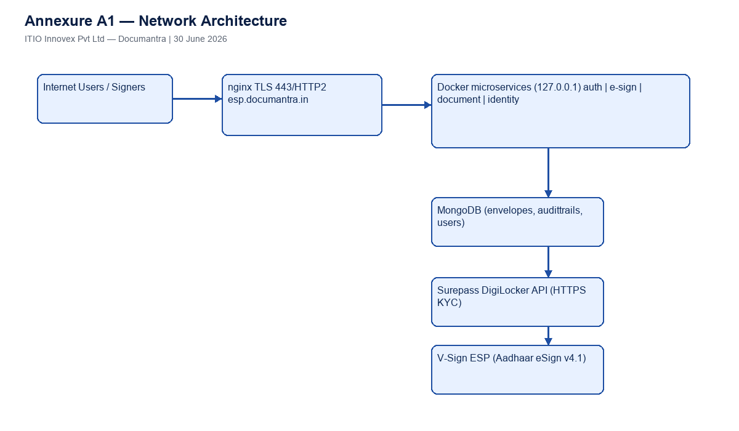

Annexure A2 — ESP Integration Flow
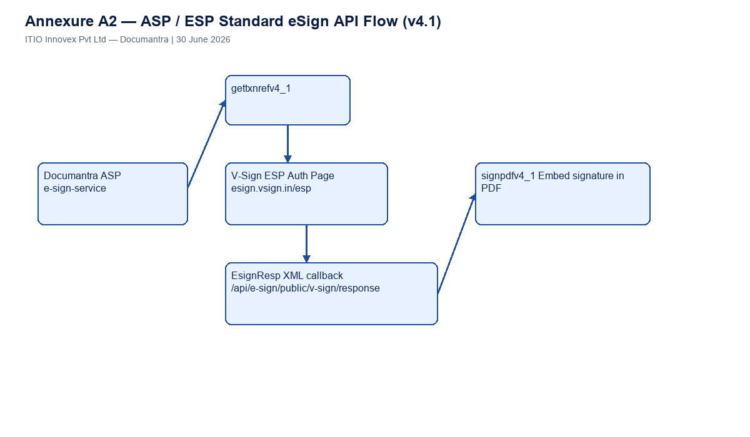

Annexure A3 — TLS Verification
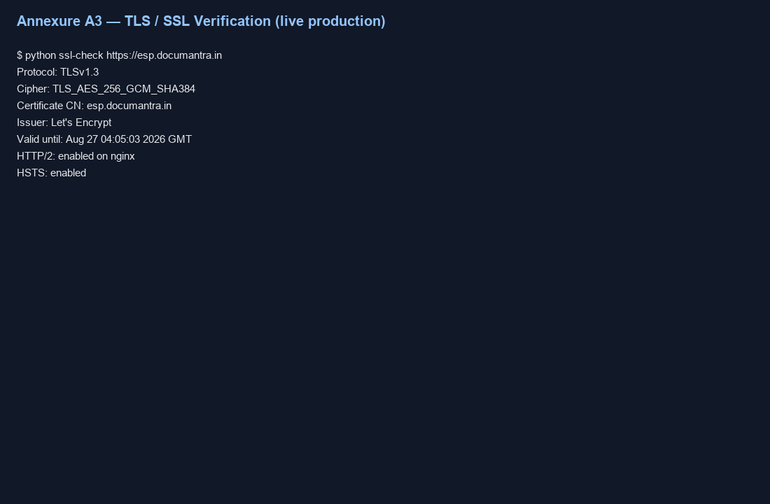

Annexure A6 — Server Security Controls
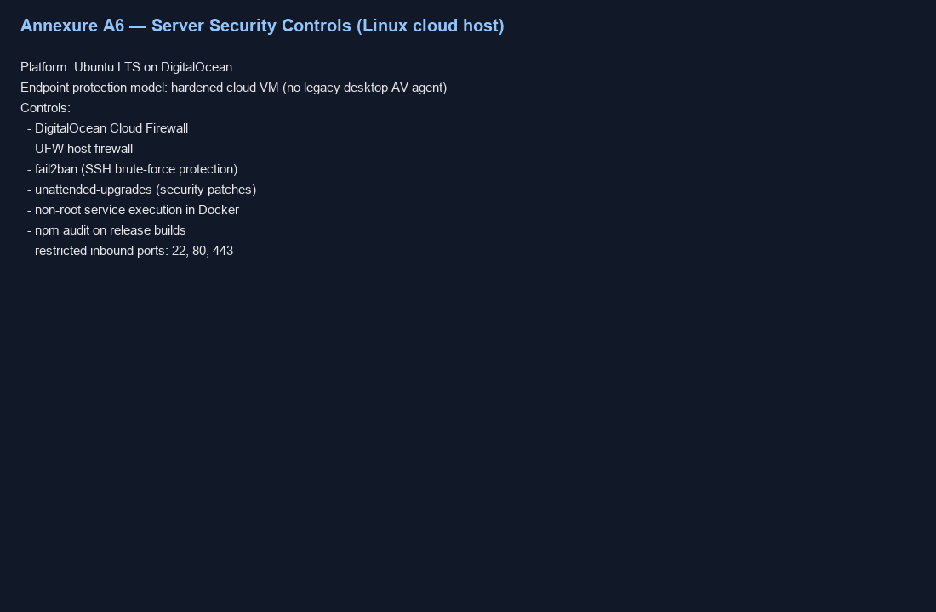

Annexure A10 — Consent UI
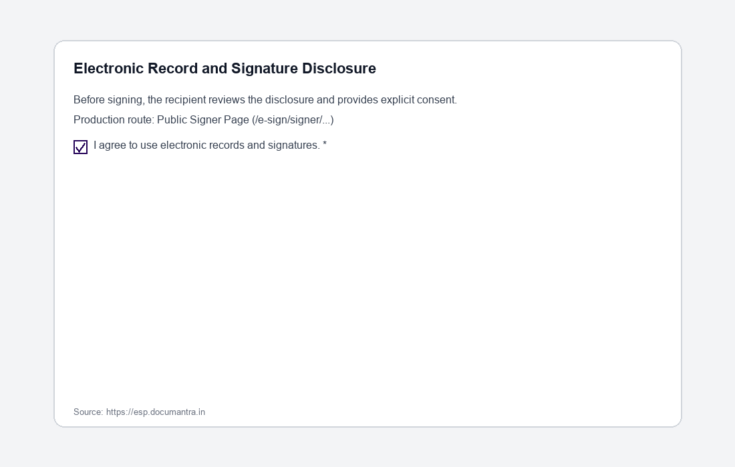

Annexure A11 — MongoDB Audit Logs
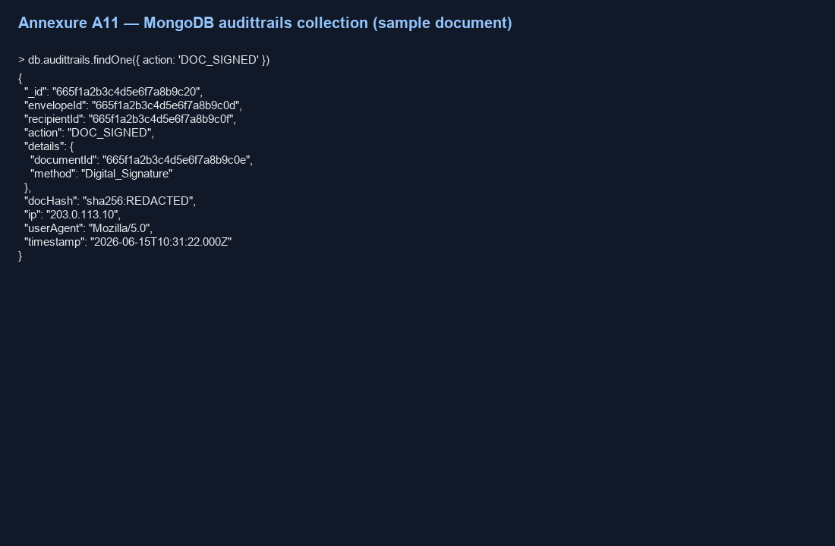

Annexure A12 — Download Signed Document UI
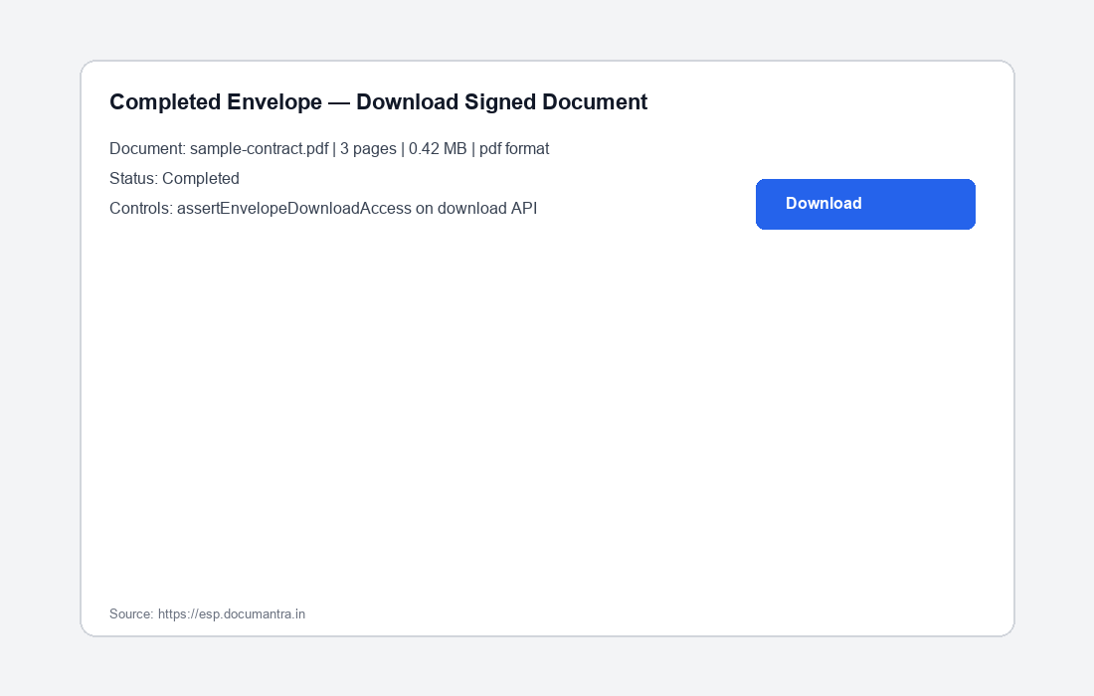

Annexure File Index
• Annexure-A1-Network-Diagram.png
• Annexure-A10-Consent-UI.png
• Annexure-A11-AuditTrail-Sample.json
• Annexure-A11-MongoDB-AuditLogs.png
• Annexure-A12-Download-Signed-Document-UI.png
• Annexure-A13-Sample-Signed-Document.pdf
• Annexure-A14-ESP-Agreements-Index.docx
• Annexure-A2-ESP-Integration-Flow.png
• Annexure-A3-TLS-Verification.png
• Annexure-A3-TLS-Verification.txt
• Annexure-A4-Information-Security-Policy.docx
• Annexure-A5-System-Hardening-Report.docx
• Annexure-A6-Server-Security-Controls.png
• Annexure-A7-Sample-EsignResp.xml
• Annexure-A8-API-Request-add-signature.json
• Annexure-A8-API-Response-add-signature.json
• Annexure-A8-ESP-gettxnref-request.json
• Annexure-A9-VAPT-Retest-Evidence.md
• Annexure-A9-VAPT-Retest-Status.xlsx

