|  |  |
| --- | --- |
| 71gY3c5Y+OL | Prepared by:   * Merna Hany * Sara Kassem * Asmaa Adel * Mahmoud Naguib * Mohamed Ossama   Supervised by:   * Eng. Mahmoud Abo Youssef   Version:   * Component Design Document Draft: V2.1 |

**CLOCK ALARM**

**Buzzer DRIVER COMPONENT DESIGN**

**DOCUMENT**

|  |  |
| --- | --- |
| **Team Members** | **1-Merna Hany**  **2-Mohamed Osama**  **3-Asmaa Elsayed**  **4_Sarah Kassem**  **5_Mahmoud Naguib** |
| **Version** | **V1.1** |
| **Arch. Layer** | **HAL** |
| **Comment** | **This version contain the Buzzer APIs with a simple flow chart for each API** |

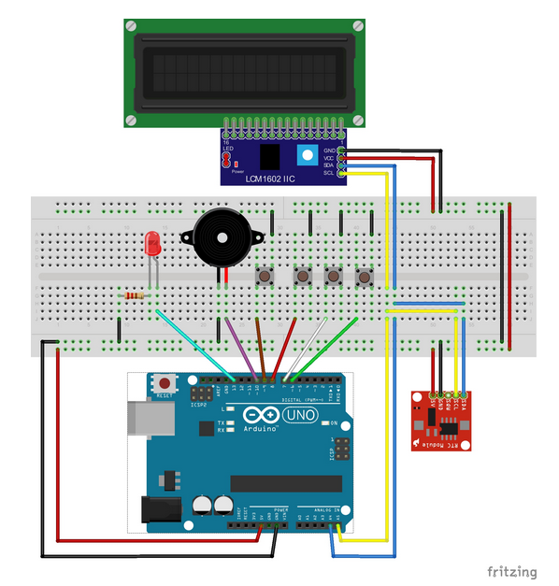

**Introduction**

The document contain a simple Buzzer design used to make a voice alarm.

**Status table**

|  |  |  |  |
| --- | --- | --- | --- |
| Version | Author | Date | Comments |
| V 1.1 | Mohamed Osama | February 27 , 2019 | First Version |

**Version Control**

|  |  |  |  |
| --- | --- | --- | --- |
| **Version** | **Author** | **Date** | **Modifications** |
| V 1.1 | Merna Hany  Sara Kassem  Asmaa Adel  Mahmoud Naguib  Mohamed Osama | February 12 , 2019 | First Version of the CDD, added the initial design for the software |
| V 1.2 | Merna Hany  Sara Kassem  Asmaa Adel  Mahmoud Naguib  Mohamed Osama | February 18 , 2019 | Second version of the CDD, modified some of the functions’ prototypes and the layout of the document |
| V 2.1 | Mohamed Osama | March 13 , 2019 | Third version of the CDD, added the static architecture layers, and modified the layout of the tables of the API’s |

**APIs**

|  |  |
| --- | --- |
| **ID** | **GDD_121 >>>> CDD_121** |
| **Prototype** | void Buzzer_voidStart(void) |
| **Return** | None |
| **Arguments** | None |
| **Description** | This function is aim to latch the buzzer to generate voice. |

|  |  |
| --- | --- |
| **ID** | **GDD_122 >>>> CDD_122** |
| **Prototype** | void Buzzer_voidStop(void) |
| **Return** | None |
| **Arguments** | None |
| **Description** | This function is aim to make the buzzer stop. |

**APIs flow chart**

|  |  |
| --- | --- |
| **ID** | **GDD_121 >>>> CDD_121** |
| **Prototype** | void Buzzer_voidStart(void) |
|  | |

|  |  |
| --- | --- |
| **ID** | **GDD_122 >>>> CDD_122** |
| **Prototype** | void Buzzer_voidStop(void) |
|  | |