|  |  |
| --- | --- |
| 71gY3c5Y+OL | Prepared by:   * Merna Hany * Sara Kassem * Asmaa Adel * Mahmoud Naguib * Mohamed Ossama   Supervised by:   * Eng. Mahmoud Abo Youssef   Version:   * Component Design Document Draft: V2.1 |

**CLOCK ALARM**

**DIO DRIVER COMPONENT DESIGN**

**DOCUMENT**

|  |  |
| --- | --- |
| **Team Members** | **1-Merna Hany**  **2-Mohamed Osama**  **3-Asmaa Elsayed**  **4_Sarah Kassem**  **5_Mahmoud Naguib** |
| **Version** | **V1.3** |
| **Arch. Layer** | **MCAL** |
| **Comment** | **This version contain the DIO APIs with a simple flow chart for each API** |

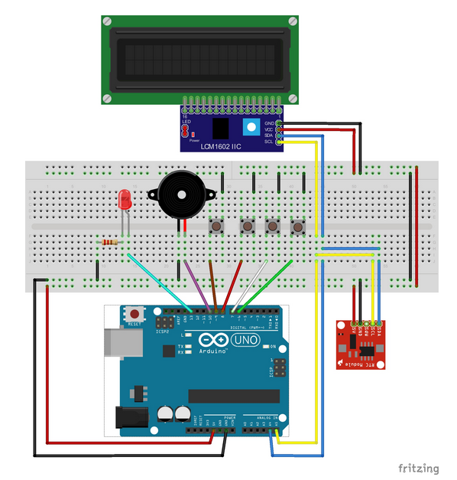

**Introduction**

The document contain a simple DIO design which fit in our target to made a simple clock alarm using a switches and LCD with a flowchart to show the design flow of the API’s.

**Status table**

|  |  |  |  |
| --- | --- | --- | --- |
| Version | Author | Date | Comments |
| V 1.3 | Merna Hany | February 25 , 2019 | First Version |

**Version Control**

|  |  |  |  |
| --- | --- | --- | --- |
| **Version** | **Author** | **Date** | **Modifications** |
| V 1.1 | Merna Hany  Sara Kassem  Asmaa Adel  Mahmoud Naguib  Mohamed Osama | February 12 , 2019 | First Version of the CDD, added the initial design for the software |
| V 1.2 | Merna Hany  Sara Kassem  Asmaa Adel  Mahmoud Naguib  Mohamed Osama | February 18 , 2019 | Second version of the CDD, modified some of the functions’ prototypes and flowcharts |
| V 2.1 | Merna Hany | March 17 , 2019 | Third version of the CDD, divided the documents into separate CDD plans and added the configuration pins |

**APIs**

|  |  |
| --- | --- |
| **ID** | **GDD_001 >>>> CDD_001** |
| **Prototype** | void DIO_voidIntialize(void) |
| **Return** | None |
| **Arguments** | None |
| **Description** | This function is aim to make the initial configuration as per the project need. |

|  |  |
| --- | --- |
| **ID** | **GDD_002 >>>> CDD_002** |
| **Prototype** | u8 DIO_u8SetPinDirection(u8 Copy_u8PinId, u8 Copy_u8PinDirection) |
| **Return** | Local_u8Errorstate: The result of the input validation state |
| **Arguments** | Copy_u8PinId: determine the pin number which is involved in the operation.  Copy_u8PinDirection: determine the pin direction to apply a certain task to this pin in HAL component handlers. |
| **Description** | This function is aim to make change the I/O pin direction so that it can perform a certain functionality. |

|  |  |
| --- | --- |
| **ID** | **GDD_003 >>>> CDD_003** |
| **Prototype** | u8 DIO_u8SetPinValue(u8 Copy_u8PinId, u8 Copy_u8PinValue) |
| **Return** | Local_u8Errorstate: The result of the input validation state |
| **Arguments** | Copy_u8PinId: determine the pin number which is involved in the operation.  Copy_u8PinValue: determine the pin value to apply in the pin output register. |
| **Description** | This function is aim to make change the I/O pin value to carry out a certain user interface through one of the HAL component. |

|  |  |
| --- | --- |
| **ID** | **GDD_004 >>>> CDD_004** |
| **Prototype** | u8 DIO_u8GetPinValue(u8 Copy_u8PinId, u8* Copy_Pu8PinValue) |
| **Return** | Local_u8Errorstate: The result of the input validation state |
| **Arguments** | Copy_u8PinId: determine the pin number which is involved in the operation.  Copy_Pu8PinValue: Pointer to a user defined address such that it save the pin current input value in it. |
| **Description** | This function is aim to get the user input and pass it to the system to behave accordingly. |

**Initial configuration**

|  |  |  |  |
| --- | --- | --- | --- |
| ID | **GDD_005 >>>> CDD_005** | | |
| Pin number | Initial direction | Functionality | Initial Value |
| Pin_0 | Input Pulldown | Switch 0 | Low |
| Pin_1 | Input Pulldown | Switch 1 | Low |
| Pin_2 | Input Pulldown | Switch 2 | Low |
| Pin_3 | Input Pulldown | Switch 3 | Low |
| Pin _4 | Output | LCD D4 | Low |
| Pin _5 | Output | LCD D5 | Low |
| Pin _6 | Output | LCD D6 | Low |
| Pin _7 | Output | LCD D7 | Low |
| Pin _8 | Output | LCD RS | Low |
| Pin _9 | Output | LCD RW | Low |
| Pin _10 | Output | LCD E | Low |
| Pin_11 | Output | Buzzer | Low |
| All Other | Output | Future use | Low |

**APIs flow chart**

|  |  |
| --- | --- |
| **ID** | **GDD_001 >>>> CDD_001** |
| **Prototype** | void DIO_voidIntialize(void) |
|  | |

|  |  |
| --- | --- |
| **ID** | **GDD_002 >>>> CDD_002** |
| **Prototype** | u8 DIO_u8SetPinDirection(u8 Copy_u8PinId, u8 Copy_u8PinDirection) |
|  | |

|  |  |
| --- | --- |
| **ID** | **GDD_003 >>>> CDD_003** |
| **Prototype** | u8 DIO_u8SetPinValue(u8 Copy_u8PinId, u8 Copy_u8PinValue) |
|  | |

|  |  |
| --- | --- |
| **ID** | **GDD_004 >>>> CDD_004** |
| **Prototype** | u8 DIO_u8GetPinValue(u8 Copy_u8PinId, u8* Copy_Pu8PinValue) |
|  | |