|  |  |
| --- | --- |
| 71gY3c5Y+OL | Prepared by:   * Merna Hany * Sara Kassem * Asmaa Adel * Mahmoud Naguib * Mohamed Ossama   Supervised by:   * Eng. Mahmoud Abo Youssef   Version:   * Global Design Document Draft: V1.2 |

**CLOCK ALARM**

**LCD DRIVER COMPONENT DESIGN**

**DOCUMENT**

|  |  |
| --- | --- |
| **Team Members** | **1-Merna Hany**  **2-Mohamed Osama**  **3-Asmaa Elsayed**  **4_Sarah Kassem**  **5_Mahmoud Naguib** |
| **Version** | **V2.0** |
| **Arch. Layer** | **HAL** |
| **Comment** | **This version contain the LCD APIs with a simple flow chart for each API** |

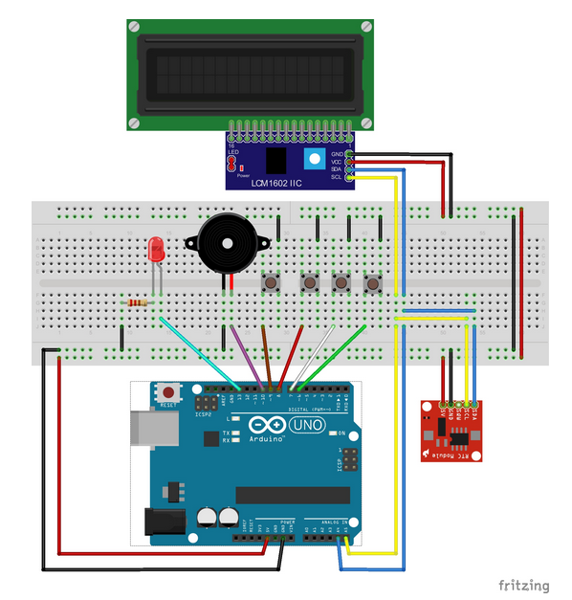

**Introduction**

The document contain the design for the LCD module APIs through which the clock can be displayed and form a type of basic interfacing with the user.

**Status table**

|  |  |  |  |
| --- | --- | --- | --- |
| Version | Author | Date | Comments |
| V 2.0 | Asmaa Adel | Mar 10 , 2019 | Second Version |

**Version Control**

|  |  |  |  |
| --- | --- | --- | --- |
| **Version** | **Author** | **Date** | **Modifications** |
| V 1.1 | Merna Hany  Sara Kassem  Asmaa Adel  Mahmoud Naguib  Mohamed Osama | February 12 , 2019 | First Version of the CDD, added the initial design for the software |
| V 1.2 | Merna Hany  Sara Kassem  Asmaa Adel  Mahmoud Naguib  Mohamed Osama | February 18 , 2019 | Second version of the CDD, modified some of the functions’ prototypes and the layout of the document |
| V 2.1 | Asmaa Adel | March 13 , 2019 | Third version of the CDD, added the static architecture layers, and modified the layout of the tables of the API’s |

**APIs**

|  |  |
| --- | --- |
| **ID** | **GDD_101 >>>> CDD_101** |
| **Prototype** | void LCD_Initailize(void) |
| **Return** | None |
| **Arguments** | None |
| **Description** | This function is aim to make the initial configuration for the LCD and to consider the LCD hardware initialization sequence which is mentioned in datasheet. |

|  |  |
| --- | --- |
| **ID** | **GDD_102 >>>> CDD_102** |
| **Prototype** | void LCD_voidWriteCommand(u8 Copy_u8command) |
| **Return** | None |
| **Arguments** | Copy_u8command: argument carrying a predefined hex value which has a certain interpretation according to the data sheet. |
| **Description** | This function is used to send LCD command setting the RS and RW pin to the suitable value for this task. |

|  |  |
| --- | --- |
| **ID** | **GDD_103 >>>> CDD_103** |
| **Prototype** | void LCD_voidWriteCharatacter(u8 Copy_u8Data) |
| **Return** | None |
| **Arguments** | u8 Copy_u8Data: argument carrying the ASCII code corresponding to the character that will appear to the user. |
| **Description** | This function is used to send ASCII code that will display a character into the screen. |

|  |  |
| --- | --- |
| **ID** | **GDD_104 >>>> CDD_104** |
| **Prototype** | u8 LCD_voidWriteData(u8 *Copy_Pu8Data,u8 Copy_XPos,u8 Copy_YPos) |
| **Return** | Local_u8ErrorState: value reflect the input argument validation |
| **Arguments** | Copy_Pu8Data: Pointer to array of character ended with null terminator.  Copy_XPos: This argument for the horizontal position on the screen.  Copy_YPos: This argument for the vertical position on the screen. |
| **Description** | This function is aim to make the initial configuration as per the project need. |

**APIs flow chart**

|  |  |
| --- | --- |
| **ID** | **GDD_101 >>>> CDD_101** |
| **Prototype** | void LCD_Initailize(void) |
|  | |

|  |  |
| --- | --- |
| **ID** | **GDD_102 >>>> CDD_102** |
| **Prototype** | void LCD_voidWriteCommand(u8 Copy_u8command) |
|  | |

|  |  |
| --- | --- |
| **ID** | **GDD_103 >>>> CDD_103** |
| **Prototype** | void LCD_voidWriteCharatacter(u8 Copy_u8Data) |
|  | |

|  |  |
| --- | --- |
| **ID** | **GDD_104 >>>> CDD_104** |
| **Prototype** | u8 LCD_voidWriteData(u8 *Copy_Pu8Data,u8 Copy_XPos,u8 Copy_YPos) |
|  | |