|  |  |
| --- | --- |
| 71gY3c5Y+OL | Prepared by:   * Merna Hany * Sara Kassem * Asmaa Adel * Mahmoud Naguib * Mohamed Ossama   Supervised by:   * Eng. Mahmoud Abo Youssef   Version:   * Global Design Document Draft: V1.2 |

**CLOCK ALARM**

**TIMER DRIVER COMPONENT DESIGN**

**DOCUMENT**

|  |  |
| --- | --- |
| **Team Members** | **1-Merna Hany**  **2-Mohamed Osama**  **3-Asmaa Elsayed**  **4_Sarah Kassem**  **5_Mahmoud Naguib** |
| **Version** | **V1.2** |
| **Arch. Layer** | **MCAL** |
| **Comment** | **This version contain the timer APIs with a simple flow chart for each API** |

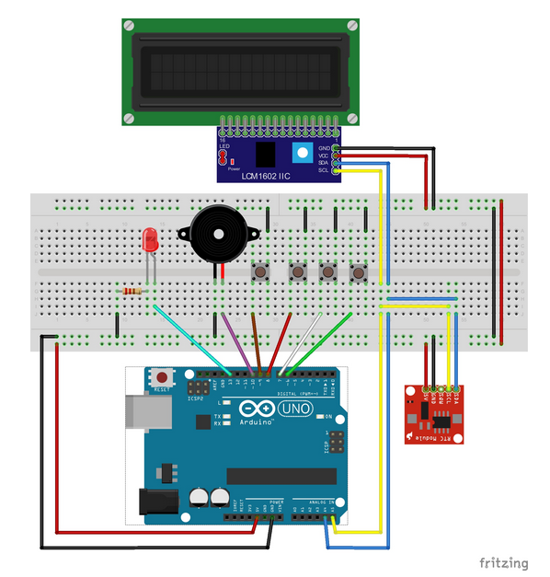

**Introduction**

The document include a simple design for the AVR timer deriver which is used to provide the system with accurate timing facilities through the ticks counting.

**Status table**

|  |  |  |  |
| --- | --- | --- | --- |
| Version | Author | Date | Comments |
| V 2.0 | Mahmoud Naguib | March 3 , 2019 | First Version |

**Version Control**

|  |  |  |  |
| --- | --- | --- | --- |
| **Version** | **Author** | **Date** | **Modifications** |
| V 1.1 | Merna Hany  Sara Kassem  Asmaa Adel  Mahmoud Naguib  Mohamed Osama | February 12 , 2019 | First Version of the CDD, added the initial design for the software |
| V 1.2 | Merna Hany  Sara Kassem  Asmaa Adel  Mahmoud Naguib  Mohamed Osama | February 18 , 2019 | Second version of the CDD, modified some of the functions’ prototypes and the layout of the document |
| V 2.1 | Mahmoud Naguib | March 13 , 2019 | Third version of the CDD, added the static architecture layers, and modified the layout of the tables of the API’s |

**APIs**

|  |  |
| --- | --- |
| **ID** | **GDD_010 >>>> CDD_010** |
| **Prototype** | void timer0(u8 Copy_u8prescaler, u8 Copy_u8ticks, void (*Copy_TimerFunc)(void)) |
| **Return** | None |
| **Arguments** | Copy_u8prescaler: used for making a prescale for the clock cycle frequency source.  Copy_u8ticks: used to define the desired maximum value for the counter which it cannot overflow.  Copy_TimerFunc: this is the function used at the timer interrupt handler and the function is used as a call back function setter. |
| **Description** | This function to initialize the timer, set the maximum value which the timer cannot exceed and the function to implement when responding the handler. |

|  |  |
| --- | --- |
| **ID** | **GDD_011 >>>> CDD_011** |
| **Prototype** | ISR(TIMER0_COMPA_vect) |
| **Return** | None |
| **Arguments** | None |
| **Description** | This function to be called by hardware to perform the task which the user had assign to at the previous function. |

**APIs flow chart**

|  |  |
| --- | --- |
| **ID** | **GDD_010 >>>> CDD_010** |
| **Prototype** | void timer0(u8 Copy_u8prescaler, u8 Copy_u8ticks, void (*Copy_TimerFunc)(void)) |
|  | |

|  |  |
| --- | --- |
| **ID** | **GDD_011 >>>> CDD_011** |
| **Prototype** | ISR(TIMER0_COMPA_vect) |
|  | |