|  |  |
| --- | --- |
|  | PREPARED BY:   * Merna Hany * Sara Kassem * Asmaa Adel * Mahmoud Naguib * Mohamed Osama   SUPERVISED BY:   * Eng. Mahmoud Abo Youssef   VERSION:   * Code Design Document Draft: V1.2 |

**Introduction:**

This document contains a description of all the functions in the system and their inputs and outputs. This makes

**Description:**

There are three main layers to the software, the Micro-controller layer (MCAL), the Hardware layer (HAL) and the Application layer (App.)

The document is divided into those three section with their designated functions that will be used in writing the software for the Alarm Clock project. Each section has a description of the functionality of the API, its inputs, outputs and prototype. Then a flow chart is drawn to describe the sequence of action of the function.

**Version:** This is version 1.1

**Modified by:** Merna Hany

Sara Kassem

Asmaa Adel

Mahmoud Naguib

Mohamed Ossama

**Modifications:** Adding the functions block diagram

Micro-controller Layer (MCAL):

1. **Dio_voidClearBit**

Description:

The function is supposed to take the port number and the pin number to clear its value to zero.

Input: Port number, Pin number

Output: Nothing

Prototype: void DIO_voidClearBit (u8 Copy_u8PortId, u8 Copy_u8PinId)

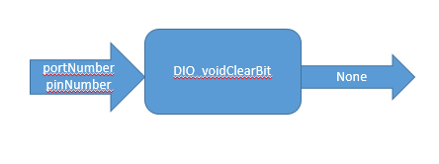

1. **Dio_voidSetBit**

Description:

The function is supposed to take the port number and the pin number to clear its value to one.

Input: Port number, Pin number

Output: Nothing

Prototype: void DIO_voidSetBit (u8 Copy_u8PortId, u8 Copy_u8PinId)

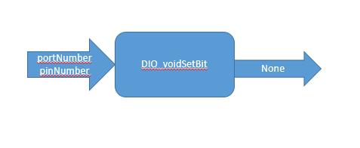

Hardware Layer (HAL):

1. **LCD_voidWriteCharater:**

Description:

The function is supposed to take the data and display it on the LCD

Input: Data

Output: Nothing

Prototype: void LCD_voidClearBit (u8 Copy_u8Data)

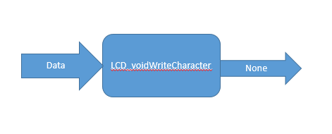

1. **LCD_voidSendCommand:**

Description:

The function is supposed to take the command to send to the LCD

Input: Command

Output: Nothing

Prototype: void LCD_voidClearBit (u8 Copy_u8Command)

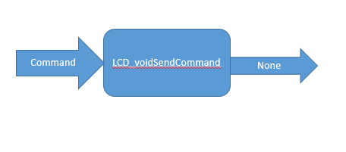

1. **BUTTON_u8IsPressed:**

Description:

The function is supposed to check if the button is pressed or not

Input: The number of the connected pin

Output: status of the button

Prototype: u8 BUTTON_u8IsPressed(u8 Copy_u8PinId)

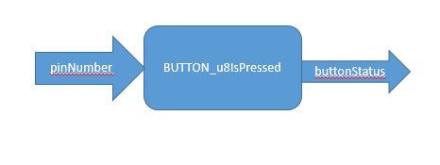

1. **Buzzer_voidStart:**

Description:

The function is supposed to start the buzzer

Input: The number of the connected pin

Output: Nothing

Prototype: void BUZZER_voidStart (u8 Copy_u8PinId)

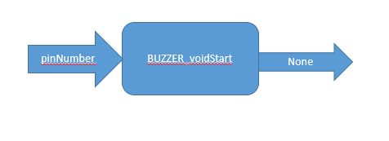

1. **Buzzer_voidStop:**

Description:

The function is supposed to stop the buzzer

Input: The number of the connected pin

Output: Nothing

Prototype: void BUZZER_voidStop(u8 Copy_u8PinId)

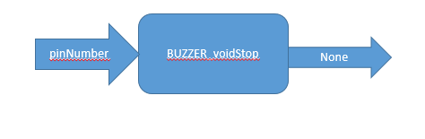

Application Layer (APP):

1. **ALARM_voidSetAlarm:**

Description:

The function is supposed to set the alarm with a given value

Input: Nothing

Output: Nothing

Prototype: void ALARM_voidSetAlarm (void)

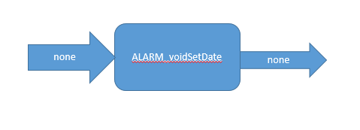

1. **ALARM_voidSetDate:**

Description:

The function is supposed to set the date with a given value

Input: Nothing

Output: Nothing

Prototype: void ALARM_voidSetDate (void)

