BIMM143 Class 4 R Intro
Merna Behnam
January 15th, 2026
x <- 1:50
plot(x,sin(x))
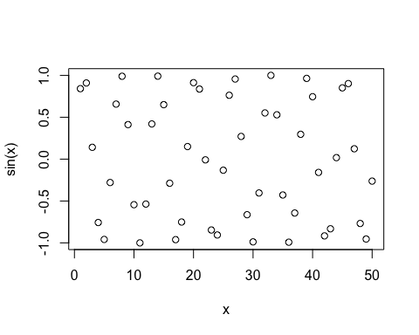
plot(x,sin(x),typ="l",col="pink",lwd=5)
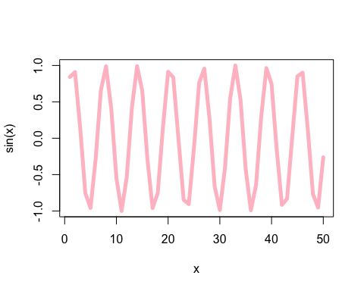
log(10, base=10)
## [1] 1

