**INDEPENDENT STUDY SEMINAR REPORT**

**ON**

**ARTIFICIAL INTELLIGENCE**

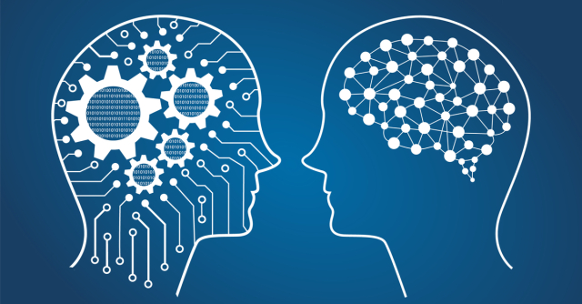

**Bachelor of Technology**

Industrial Engineering & Management (Specialization in TQM)

**Submitted by Team No. (Batch 0716)**

|  |  |
| --- | --- |
| **URN** | **Name** |
| 1624717 | Gurmeet Singh Sandhu |
| 1624740 | Sunod Soman |
| 1624712 | Ankur Chaudhary |

**Submitted to**Department of Industrial Engineering

PTU Campus, Mohali

**Seminar Guide & Mentor: Dr. Gurpratap Singh**

**TABLE OF CONTENTS**

|  |  |  |
| --- | --- | --- |
| **S. No.** | **Description** | **Page No.** |
| 1. | Introduction & Overview of Artificial Intelligence | 1 |
| 2. | What is Intelligence? | 3 |
| 3. | Philosophy of Artificial Intelligence | 7 |
| 4. | History of Artificial Intelligence | 9 |
| 5. | Application of Artificial Intelligence | 11 |
| 6. | Advantages and Disadvantages | 12 |
| 7. | Current Scenario/position of Technology | 17 |
| 8. | Future aspects | 19 |
| 9. | Conclusion | 20 |
| 10. | Glossary | 21 |

**Artificial Intelligence (AI)**

1. **Introduction and Overview of Artificial Intelligence :**

Since the invention of computers or machines, their capability to perform various tasks went on growing exponentially. Humans have developed the power of computer systems in terms of their drivers working domains, their increasing speed, and reducing size with respect to time.

A branch of Computer Science named Artificial Intelligence pursues creating the computers or machines as intelligent as human beings.

The research field of Artificial Intelligence (AI) is concerned with making machines –

Particularly computers – do things that require intelligence when done by humans. In the 60 years of its existence, it has celebrated dramatic successes and equally dramatic failures. Today, AI has become an important and essential part of technology and industry and provides solutions to some of the most complex problems in computer science. Nevertheless, in terms of its original goal – to create true human-level intelligence in machines – Strong AI has not succeeded yet and perhaps never will. Today, AI researchers are able to create computers that can perform jobs that are difficult for persons like logic, algebra problem solving, and path planning, or playing chess.

* 1. **What is Artificial Intelligence (AI)?**

According to the father of Artificial Intelligence **John McCarthy**, AI is the

**“The science and engineering of making intelligent machines, especially intelligent computer programs”.**

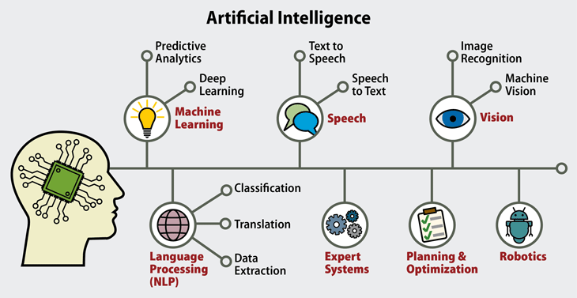

Figure 1: Artificial intelligence

Artificial intelligence (AI) is the simulation of human intelligence processes by machines, especially computer systems. These processes include learning (the acquisition of information and rules for using the information), reasoning (using rules to reach approximate or definite conclusions) and self-correction. Particular applications of AI include [expert systems](https://searchenterpriseai.techtarget.com/definition/expert-system), [speech recognition](https://searchcrm.techtarget.com/definition/voice-recognition) and [machine vision](https://searchenterpriseai.techtarget.com/definition/machine-vision-computer-vision).

Artificial Intelligence is a way of making a computer, a computer-controlled robot, or a software think intelligently, in the similar manner the intelligent humans think.

AI is accomplished by studying how human brain thinks, and how humans learn, decide, and work while trying to solve a problem, and then using the outcomes of this study as a basis of developing intelligent software and systems.

AI can be categorized as either [weak](https://searchenterpriseai.techtarget.com/definition/narrow-AI-weak-AI) or [strong](https://searchenterpriseai.techtarget.com/definition/artificial-general-intelligence-AGI). Weak AI, also known as narrow AI, is an AI system that is designed and trained for a particular task. Virtual personal assistants, such as Apple's Siri, are a form of weak AI. Strong AI, also known as artificial general intelligence, is an AI system with generalized human cognitive abilities. When presented with an unfamiliar task, a strong AI system is able to find a solution without human intervention. AI tools present a range of new functionality for businesses; the use of artificial intelligence raises ethical questions. This is because deep learning algorithms, which underpin many of the most advanced AI tools, are only as smart as the data they are given in training. Because a human selects what data should be used for training an AI program, the potential for human bias is inherent and must be monitored closely.

1. **What is Intelligence?**

What is “intelligence”? Can we emulate intelligent behavior in machines? How far can we take it?

The ability of a system to calculate, reason, perceive relationships and analogies, learn from experience, store and retrieve information from memory, solve problems, comprehend complex ideas, use natural language fluently, classify, generalize, and adapt new situations.

**2.1 Types of Intelligence:**

As described by Howard Gardner, an American developmental psychologist, the

Intelligence comes in multiple forms as described in Figure 2 and Figure 3.

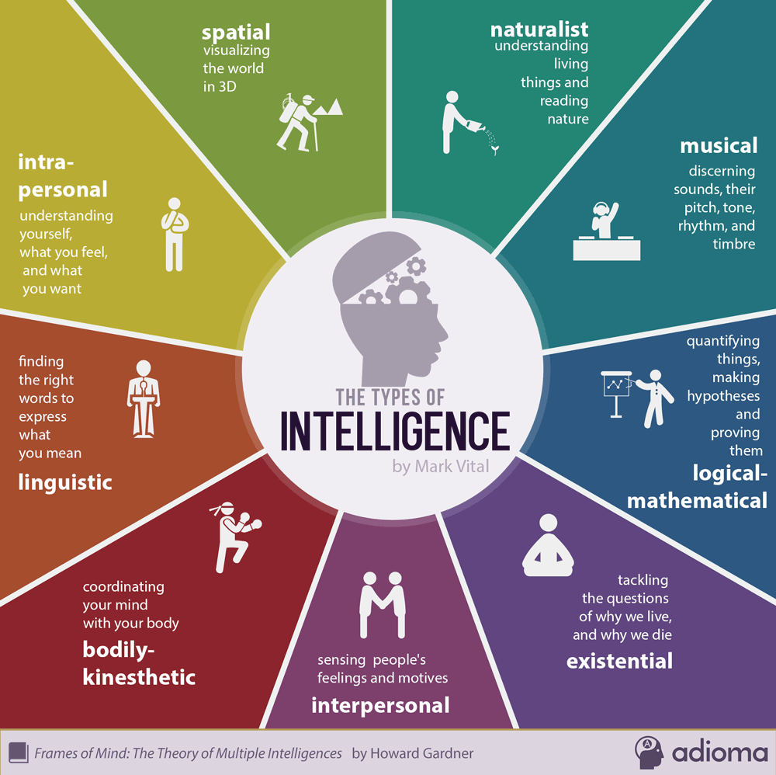

Figure 2: Types of Intelligence

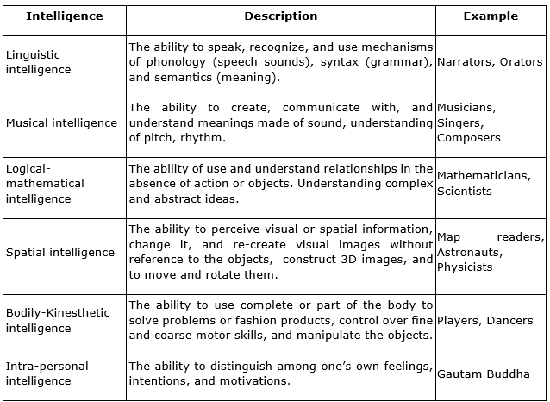

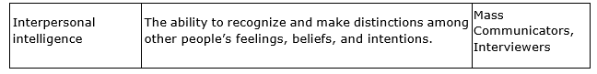

Figure 3: Description of Intelligence with Examples

* 1. **Comparison of Human Brain Vs Computer :**

We can easily understand and compare Human Brain with Computer with the help of Figure 4.

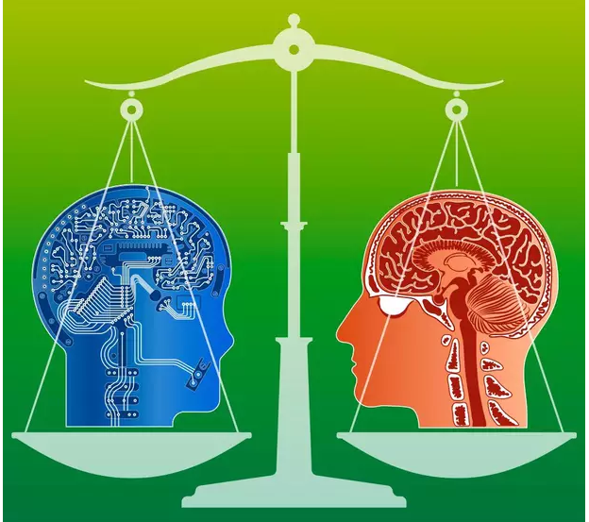

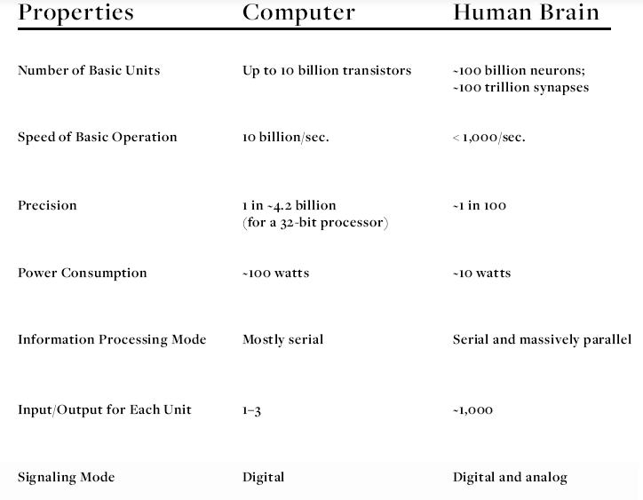

Figure 4: Comparison of Human Brain Vs Computer

**2.3 Intelligent systems:**

Three key steps of a knowledge-based agent (Craik, 1943):

1. The stimulus must be translated into an internal representation.
2. The representation is manipulated by cognitive processes to derive new internal representations.
3. These in turn are translated into action.

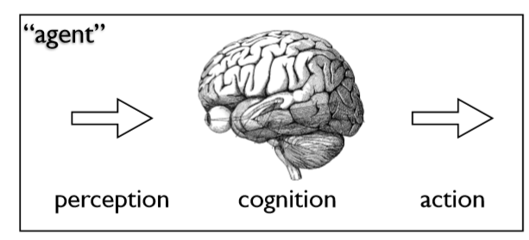

Figure 5: Knowledge-based agent

**2.3.1 Representation**

All AI Problems require some form of representation:

* Chess board
* Maze
* Text
* Object
* Room
* Sound
* visual scene

A major part AI is representing the problem space so as to allow efficient search for the best solution(s).Sometimes the representation is the output. E.g., discovering “patterns”.

**2.3.2 Output**

The output action also can be complex

* Next move
* Text
* Label
* Actuator
* Movement

From a simple chess move to a motor sequence to grasp an object.

1. **Philosophy of Artificial Intelligence :**

While exploiting the power of the computer systems, the curiosity of human, lead him to wonder, “Can a machine think and behave like humans do?”

Thus, the development of AI started with the intention of creating similar intelligence in machines that we find and regard high in humans.

**3.1 Types of Artificial Intelligence**

Arend Hintze, an assistant professor of integrative biology and computer science and engineering at Michigan State University, categorizes AI into four types, from the kind of AI systems that exist today to sentient systems, which do not yet exist. His categories are as follows:

* **Type 1: Reactive machines**: An example is Deep Blue, the [IBM](https://searchitchannel.techtarget.com/definition/IBM-International-Business-Machines) chess program that beat Garry Kasparov in the 1990s. Deep Blue can identify pieces on the chess board and make predictions, but it has no memory and cannot use past experiences to inform future ones. It analyzes possible moves -- its own and its opponent -- and chooses the most strategic move. Deep Blue and Google's [Alpha GO](https://whatis.techtarget.com/definition/AlphaGo) were designed for narrow purposes and cannot easily be applied to another situation.
* **Type 2: Limited memory:** These AI systems can use past experiences to inform future decisions. Some of the decision-making functions in [self-driving cars](https://searchenterpriseai.techtarget.com/definition/driverless-car) are designed this way. Observations inform actions happening in the not-so-distant future, such as a car changing lanes. These observations are not stored permanently.
* **Type 3: Theory of mind:** This psychology term refers to the understanding that others have their own beliefs, desires and intentions that impact the decisions they make. This kind of AI does not yet exist.
* **Type 4:** **Self-awareness:**  In this category, AI systems have a sense of self, have consciousness. Machines with self-awareness understand their current state and can use the information to infer what others are feeling. This type of AI does not yet exist.

### **3.2 Examples of AI technology:**

AI is incorporated into a variety of different types of technology. Here are seven examples.

* **Automation**: What makes a system or process function automatically? For example, [robotic process automation](https://internetofthingsagenda.techtarget.com/definition/robotic-process-automation) (RPA) can be programmed to perform high-volume, repeatable tasks that human normally performed. RPA is different from IT automation in that it can adapt to changing circumstances.
* **Machine learning:** The science of getting a computer to act without programming. [**Deep learning**](https://searchenterpriseai.techtarget.com/definition/deep-learning-deep-neural-network) is a subset of machine learning that, in very simple terms, can be thought of as the automation of predictive analytics. There are three types of machine learning algorithms:
  + [**Supervised learning**](https://searchenterpriseai.techtarget.com/definition/supervised-learning): Data sets are labeled so that patterns can be detected and used to label new data sets.
  + [**Unsupervised learning**](https://whatis.techtarget.com/definition/unsupervised-learning)**:** Data sets aren't labeled and are sorted according to similarities or differences.
  + [**Reinforcement learning**](https://searchenterpriseai.techtarget.com/definition/reinforcement-learning): Data sets aren't labeled but, after performing an action or several actions, the AI system is given feedback
* **Machine vision:** The science of allowing computers to see. This technology captures and analyzes visual information using a camera, analog-to-digital conversion and digital signal processing. It is often compared to human eyesight, but machine vision isn't bound by biology and can be programmed to see through walls, for example. It is used in a range of applications from signature identification to medical image analysis. Computer vision, which is focused on machine-based image processing, is often conflated with machine vision.
* **Natural language processing (NLP):** The processing of human -- and not computer -- language by a computer program. One of the older and best known examples of NLP is spam detection, which looks at the subject line and the text of an email and decides if it's junk. Current approaches to NLP are based on machine learning. NLP tasks include text translation, sentiment analysis and speech recognition.
* **Robotics:** A field of engineering focused on the design and manufacturing of robots. Robots are often used to perform tasks that are difficult for humans to perform or perform consistently. They are used in assembly lines for car production or by NASA to move large objects in space. Researchers are also using machine learning to build robots that can interact in social settings.
* **Self-driving Cars:** These use a combination of computer vision, [image recognition](https://searchenterpriseai.techtarget.com/definition/image-recognition) and deep learning to build automated skill at piloting a vehicle while staying in a given lane and avoiding unexpected obstructions, such as pedestrians.

## **History of Artificial Intelligence:**

It’s unsurprising that artificial intelligence grew rapidly post-1900, but what  is surprising, is how many people thought about AI hundreds of years before there was even a word to describe what they were thinking about.

### **4.1 AI 2010 to present day:**

The current decade has been immensely important for AI innovation. From 2010 onward, artificial intelligence has become embedded in our day-to-day existence. We use smart phones that have voice assistants and computers that have “intelligence” functions most of us take for granted. AI is no longer a pipe dream and hasn’t been for some time.

**2010:** Image Net launched the Image Net Large Scale Visual Recognition Challenge (ILSVRC), their annual AI object recognition competition.

**2010:** Microsoft launched Kinect for Xbox 360, the first gaming device that tracked human body movement using a 3D camera and infrared detection.

**2011:** Watson, a natural language question answering computer created by IBM, defeated two former Jeopardy! Champions, Ken Jennings and Brad Rutter in a televise game. **2011:**  Apple released Siri, a virtual assistant on Apple iOS operating systems. Siri uses a natural-language user interface to infer, observe, answer, and recommend things to its human user. It adapts to voice commands and projects an “individualized experience” per user. **2012:** Jeff Dean and Andrew Ng (Google researchers) trained a large neural network of 16,000 processors to recognize images of cats (despite giving no background information) by showing it 10 million unlabeled images from YouTube videos.

**2013:** A research team from Carnegie Mellon University released Never Ending Image Learner (NEIL), a semantic machine learning system that could compare and analyze image relationships.

**2014:** Microsoft released Cortana, their version of a virtual assistant similar to Siri on iOS.

**2014:** Amazon created Amazon Alexa, a home assistant that developed into smart speakers that function as personal assistants.

**2015:** Elon Musk, Stephen Hawking, and Steve Wozniak among 3,000 others signed an open letter banning the development and use of autonomous weapons (for purposes of war.)

**2015-2017:** Google Deep Mind’s AlphaGo, a computer program that plays the board game Go, defeated various (human) champions. **2016:** A [humanoid robot named Sophia](https://www.youtube.com/watch?v=78-1MlkxyqI) is created by Hanson Robotics. She is known as the first “robot citizen.” What distinguishes Sophia from previous humanoids is her likeness to an actual human being, with her ability to see ([image recognition](https://www.g2crowd.com/categories/image-recognition?__hstc=171774463.b04c6f7a3fbe07dd9de069622d58bd7f.1567855349690.1567855349690.1567855349690.1&__hssc=171774463.1.1567855349691&__hsfp=1721107091)), make facial expressions, and communicate through AI. **2016:** Google released Google Home, a smart speaker that uses AI to act as a “personal assistant” to help users remember tasks, create appointments, and search for information by voice.

**2017:** The Facebook Artificial Intelligence Research lab trained two “dialog agents” (chatbots) to communicate with each other in order to learn how to negotiate. However, as the chatbots conversed, they diverged from human language (programmed in English) and invented their own language to communicate with one another – exhibiting artificial intelligence to a great degree.

**2018:** Alibaba (Chinese tech group) language processing AI outscored human intellect at a Stanford reading and comprehension test. The Alibaba language processing scored “82.44 against 82.30 on a set of 100,000 questions” – a narrow defeat, but a defeat nonetheless.

**2018:** Google developed BERT, the first “bidirectional, unsupervised language representation that can be used on a variety of natural language tasks using transfer learning.”

**2018:** Samsung introduced Bixby, a virtual assistant. Bixby’s functions include Voice, where the user can speak to and ask questions, recommendations, and suggestions; Vision, where Bixby’s “seeing” ability is built into the camera app and can see what the user sees (i.e. object identification, search, purchase, translation, landmark recognition); and Home, where Bixby uses app-based information to help utilize and interact with the user (e.g. weather and fitness applications.)

1. **Applications of Artificial Intelligent :**

Artificial intelligence has made its way into a number of areas. Here are six examples.

* **AI in healthcare**. The biggest bets are on improving patient outcomes and reducing costs. Companies are applying machine learning to make better and faster diagnoses than humans. One of the best known healthcare technologies is [IBM Watson](https://searchenterpriseai.techtarget.com/definition/IBM-Watson-supercomputer). It understands natural language and is capable of responding to questions asked of it. The system mines patient data and other available data sources to form a hypothesis, which it then presents with a confidence scoring schema. Other AI applications include [chatbots](https://searchcrm.techtarget.com/definition/chatbot), a computer program used online to answer questions and assist customers, to help schedule follow-up appointments or aid patients through the billing process, and virtual health assistants that provide basic medical feedback.
* **AI in business**. Robotic process automation is being applied to highly repetitive tasks normally performed by humans. Machine learning algorithms are being integrated into analytics and [CRM](https://searchcrm.techtarget.com/definition/CRM) platforms to uncover information on how to better serve customers. Chatbots have been incorporated into websites to provide immediate service to customers. Automation of job positions has also become a talking point among academics and IT analysts.
* **AI in education**. AI can automate grading, giving educators more time. AI can assess students and adapt to their needs, helping them work at their own pace. AI tutors can provide additional support to students, ensuring they stay on track. AI could change where and how students learn, perhaps even replacing some teachers.
* **AI in finance**. AI in personal finance applications, such as Mint or Turbo Tax, is disrupting financial institutions. Applications such as these collect personal data and provide financial advice. Other programs, such as IBM Watson, have been applied to the process of buying a home. Today, [software](https://searchmicroservices.techtarget.com/definition/software) performs much of the trading on Wall Street.
* **AI in law**. The discovery process, sifting through of documents, in law is often overwhelming for humans. Automating this process is a more efficient use of time. Start-ups are also building question-and-answer computer assistants that can sift programmed-to-answer questions by examining the taxonomy and ontology associated with a [database](https://searchsqlserver.techtarget.com/definition/database).
* **AI in manufacturing**. This is an area that has been at the forefront of incorporating robots into the [workflow](https://searchcio.techtarget.com/definition/workflow). Industrial robots used to perform single tasks and were separated from human workers, but as the technology advanced that changed.

1. **Advantages & Disadvantages of AI :**

Advantages & disadvantages of Artificial Intelligence are described as follows:

## **6.1 Advantages of Artificial Intelligence:**

Artificial intelligence is complex in nature. It uses a very complicated mixture of computer science, mathematics and other complex sciences. Complex programming helps these machines replicate the cognitive abilities of human beings.

### **6.1.1 Error Reduction:**

Artificial intelligence helps us in reducing the error and the chance of reaching accuracy with a greater degree of precision. It is applied in various studies such as [exploration of space.](https://www.nasa.gov/centers/ames/research/exploringtheuniverse/spiffy.html) Intelligent robots are fed with information and are sent to explore space. Since they are machines with metal bodies, they are more resistant and have a greater ability to endure the space and hostile atmosphere. They are created and acclimatized in such a way that they cannot be modified or get disfigured or breakdown in a hostile environment.

### **6.1.2 Difficult Exploration:**

Artificial intelligence and the science of robotics can be put to use in mining and other fuel exploration processes. Not only that, these complex machines can be used for exploring the ocean floor and hence overcome the human limitations. Due to the programming of the robots, they can perform more laborious and hard work with greater responsibility. Moreover, they do not wear out easily.

### **6.1.3 Daily Application:**

Computed methods for automated reasoning, learning and perception have become a common phenomenon in our everyday lives. We have our lady [Siri](https://www.apple.com/in/ios/siri/) or [Cortana](https://www.microsoft.com/en-in/windows/cortana) to help us out. We are also hitting the road for long drives and trips with the help of GPS. The smartphone is an apt and everyday example of how we use artificial intelligence. In utilities, we find that they can predict what we are going to type and correct the human errors in spelling. That is machine intelligence at work.

When we take a picture, the artificial intelligence algorithm identifies and detects the person’s face and tags the individuals when we are posting our photographs on social media sites. Artificial Intelligence is widely employed by financial institutions and banking institutions to organize and manage data. Detection of fraud uses artificial intelligence in a smart card based system.

### **6.1.4 Digital Assistants:**

Highly advanced organizations use ‘avatars’ which are replicas or digital assistants who can actually interact with the users, thus saving the need for human resources.

For artificial thinkers, emotions come in the way of rational thinking and are not a distraction at all. The complete absence of the emotional side makes the robots think logically and take the right program decisions. Emotions are associated with moods that can cloud judgment and affect human efficiency. This is completely ruled out for machine intelligence.

### **6.1.5 Repetitive Jobs:**

Repetitive jobs which are monotonous in nature can be carried out with the help of machine intelligence. Machines think faster than humans and can be put to multi-tasking. Machine intelligence can be employed to carry out dangerous tasks. Their parameters, unlike humans, can be adjusted. Their speed and time are calculation based parameters only.

When humans play a computer game or run a computer-controlled robot, we are actually interacting with artificial intelligence. In the game we are playing, the computer is our opponent. The machine intelligence plans the game movement in response to our movements. We can consider gaming to be the most common use of the benefits of artificial intelligence.

### **6.1.6 Medical Applications:**

In the medical field also, we will find the wide application of AI. Doctors assess the patients and their health risks with the help of artificial machine intelligence. It educates them about the side effects of various medicines. Medical professionals are often trained with artificial surgery simulators. It finds a huge application in detecting and monitoring neurological disorders as it can simulate the brain functions.

Robotics is used often in helping mental health patients to come out of depression and remain active. A popular application of artificial intelligence is Radio - surgery. Radio-surgery is used in operating tumours and this can actually help in the operation without damaging the surrounding tissues.

### **6.1.7 No Breaks:**

Machines, unlike humans, do not require frequent breaks and refreshments. They are programmed for long hours and can continuously perform without getting bored or distracted or even tired.

## **6.2 Disadvantages of Artificial Intelligence:**

The disadvantages of Artificial Intelligence are the following:

### **6.2.1 High Cost:**

Creation of artificial intelligence requires huge costs as they are very complex machines. Their repair and maintenance require huge costs. They have software programs which need frequent up gradation to cater to the needs of the changing environment and the need for the machines to be smarter by the day. In the case of severe breakdowns, the procedure to recover lost codes and reinstating the system might require huge time and cost.

### **6.2.2 No Replicating Humans:**

Intelligence is believed to be a gift of nature. An ethical argument continues, whether human intelligence is to be replicated or not. Machines do not have any emotions and moral values. They perform what is programmed and cannot make the judgment of right or wrong. Even cannot take decisions if they encounter a situation unfamiliar to them. They either perform incorrectly or breakdown in such situations.

### **6.2.3 No Improvement with Experience:**

Unlike humans, artificial intelligence cannot be improved with experience. With time, it can lead to wear and tear. It stores a lot of data but the way it can be accessed and used is very different from human intelligence. Machines are unable to alter their responses to changing environments. We are constantly bombarded by the question of whether it is really exciting to replace humans with machines.

In the world of artificial intelligence, there is nothing like working with a whole heart or passionately. Care or concerns are not present in the machine intelligence dictionary. There is no sense of belonging or togetherness or a human touch. They fail to distinguish between a hardworking individual and an inefficient individual.

### **6.2.4 No Original Creativity:**

Do you want creativity or imagination?

These are not the forte of artificial intelligence. While they can help you design and create, they are no match to the power of thinking that the human brain has or even the originality of a creative mind. Human beings are highly sensitive and emotional intellectuals. They see, hear, think and feel. Their thoughts are guided by the feelings which completely lacks in machines. The inherent intuitive abilities of the human brain cannot be replicated.

### **6.2.5 Unemployment:**

Replacement of humans with machines can [lead to large-scale unemployment](https://content.wisestep.com/unemployment-causes-effects-solutions/).

Unemployment is a socially undesirable phenomenon. People with nothing to do can lead to the destructive use of their creative minds. Humans can unnecessarily be highly dependent on the machines if the use of artificial intelligence becomes rampant. They will lose their creative power and will become lazy. Also, if humans start thinking in a destructive way, they can create havoc with these machines.

Artificial intelligence in wrong hands is a serious threat to mankind in general. It may lead to mass destruction. Also, there is a constant fear of machines taking over or superseding the humans.

Based on the above discussion, the [Association for the advancement of artificial intelligence](http://www.aaai.org/) has two objectives – to develop and advance the science of artificial intelligence and to promote and educate about the responsible usage of artificial intelligence.

Identifying and studying the risk of artificial intelligence is a very important task at hand. This can help in resolving the issues at hand. Programming errors or [cyber attacks](https://en.wikipedia.org/wiki/Cyberattack) need more dedicated and careful research.[Technology companies and the technology industry as a whole, needs](https://content.wisestep.com/technology-workplace-pros-cons/) to pay more attention to the quality of the software.

Everything that has been created in this world and in our individual societies is the continuous result of intelligence.

Artificial intelligence augments and empowers human intelligence. So as long we are successful in keeping the technology beneficial, we will be able to help this human civilization.

## **Current Scenario/Position of Technology in IA:**

AI is not the new technology it is very broad concept and comprises a set of powerful technologies that are emerging under it like deep learning, Reinforcement Learning and Facial Recognition and many more. AI is trending these days and yes it is the future.

AI is helping us in every aspects from surgeries to criminal tracking from autonomous driving to space exploration like you name it and every industry is planning and implementing it, I don't think it is a threat if we can control it, but as a fact everything comes with its advantages and disadvantages recently most talked AI example was Sophia, a new AI humanoid robot created by David Hanson of Hanson Robotics has been granted the citizenship in Saudi Arabia. Sophia defies conventional thinking of what a robot should look like. Designed to look like Audrey Hepburn, Sophia embodies Hepburn's classic beauty. Sophia is Hanson Robotics' latest and most advanced robot. She has also become a media darling, having given numerous interviews to multiple media outlets, sang in a concert, and even graced the cover of one of the top fashion magazines.

AI is able to answer more and more simple problems (face recognition, object recognition) and do so at a scale and cost that is very compelling. AI has beaten a top Go player, so it's clear that within a "narrow" domain it has begun to be able to do impressive things. The robot that won at Go could not operate a robot and get to or from a physical location where a physical Go game is being played, could not operate a robot to move Go pieces, could not teach a human Go, it cannot do anything but play Go. Presently there is a great advancement in autonomous vehicles or the self-driving cars.

In current picture there is a great demand of jobs and skills which the AI technology comprises like Machine Learning, Deep Learning, NLP, Speech Recognition and many more as described in Figure 6 Chart of Job Listing Vs year.

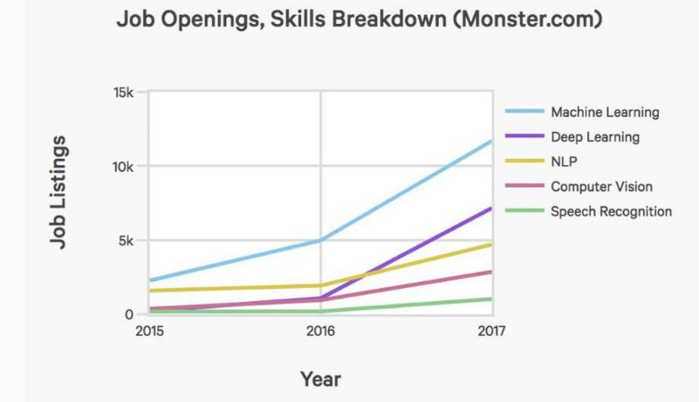

Figure 6 : Chart of Job listing Vs Year

Within narrow domains AI is becoming very powerful and useful. Humans regularly operate across "broad" domains a bad human Go player could still get to a game, move pieces, teach someone new to the game, get home while stopping at a store to buy stuff to make a sandwich and make a sandwich when they got home there is no AI that can do any two parts of that. For repetitive tasks in a narrow domain, AI works great for anything else it doesn't work.

Hence, in recent years, it isn't that AI has reached greater and greater heights it's that the threshold of what is hyperbolically referred to AI has been set lower and lower. Eventually a programmable microwave oven will qualify as "Artificial Intelligence."

Companies like Google, Microsoft, Baidu and many more have start creating products which are based on Artificial Intelligence. That time is not far when we all will experience the influence of artificial intelligence in our daily lives. Exponentially artificial intelligence was started with the movie "HER". It draws a deep impact over the viewers. Following are top AI technologies that are currently ruling the industry like Natural Language Processing (NLP), Robotics Process Automation (RPA), Neural Networks, Biometrics, Machine Learning (ML) and Internet of Things (IoT).

1. **Future Aspects & Outlook of AI :**

The Artificial Intelligence technology seems optimistic and it is expected to create some dramatic changes in future. AI is transforming almost every industry. According to 2016 [Gartner Research](https://www.gartner.com/binaries/content/assets/events/keywords/cio/ciode5/top_strategic_predictions_fo_315910.pdf)shows that by 2020, at least 30% of the companies globally will use AI in at least one fragment of their sales process.

 All aforementioned technologies are not even close to being obsolete and each of them is pioneering AI's progress. Artificial Intelligence isn't new, but its advances are moving at an exponential and unprecedented pace. Bigger breakthroughs are just around the corner. Back in 1951, the First AI-based program was written and 65 years later, in 2016, the Tech industry achieved a landmark event with Alpha Go's victory in defeating world champion Lee Sedol by deep reinforcement learning in the complex Chinese board game of Go. We've come a long way, but something tells me we still have a long way to go. Thus, the impact of AI is going to be profound in coming years.

1. **Conclusion :**

Artificial intelligence advancements are occurring at an unprecedented rate. That being said, we can expect that the trends from the past decade will continue swinging upward in the coming year. A few things to keep our eyes on in 2019 include. The ability of computers (AI) is growing at a faster pace as compared to the past decade. All things these also in mind; these are no second thought about the rise & evolvement it has provided towards the technological advancement.

Hence Artificial intelligence is essential to survive in the current scenario of the cut throat competition and future aspect.

1. **Glossary :**
   1. A.I. - Artificial Intelligence
   2. N.L.P. - Natural Language Processing
   3. R.P.A. - Robotics Process Automation
   4. M.L. - Machine Learning
   5. IoT - Internet of Things
   6. N.E.I.L. - Never Ending Image Learner