Wang MingMing
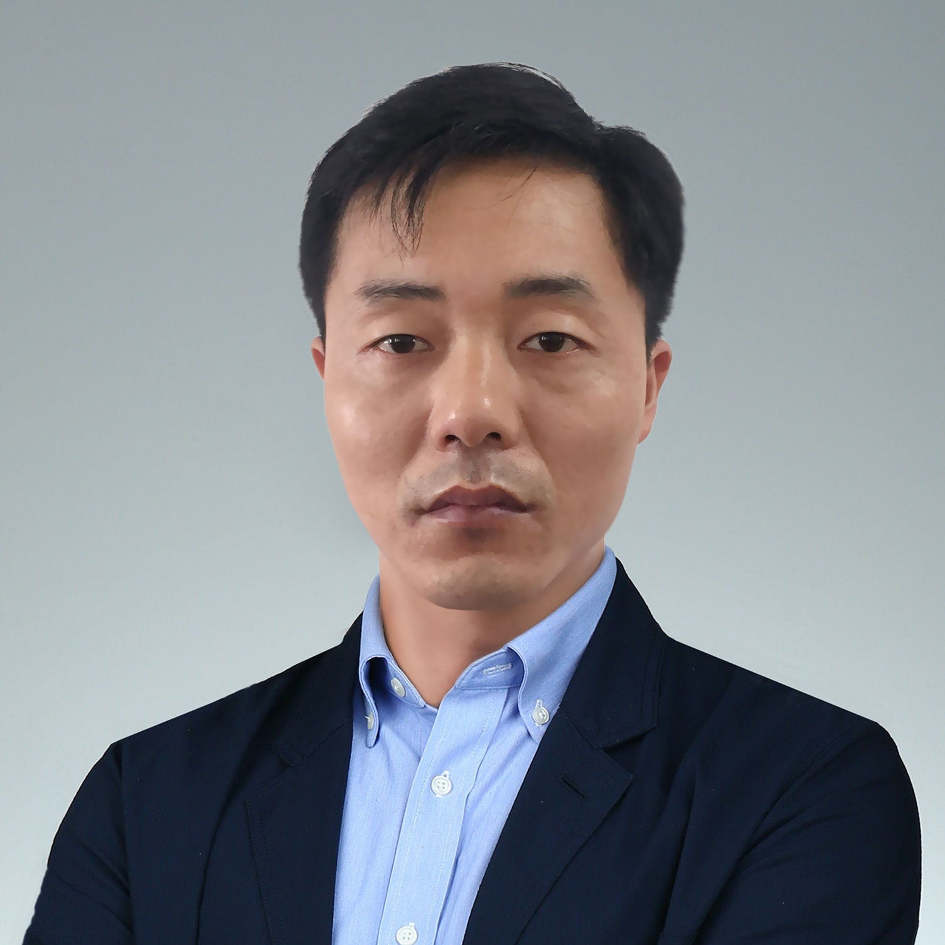

Summary

I have 8+ years of development and project management experience with the last 3 years of expertise in Golang, MERN, MEVN developer. Especially, I have rich experience in Front-end, RESTfull API, GraphQL development. Also I have enough experience in MongDB, MySQL, MSSQL, Sqlite, PostgreeSQL management and C++/Python development.

I am looking for long-term opportunities that appreciate high-quality standards with quality and maintenance code. I very well understand the preciousness of time, and so I have always submitted my jobs in allotted time. I am really looking forward to start the project as soon as possible with your permission. Thanks for considering.

Skill Highlights
- Golang Stack Site development  - MERN, MEVN Stack Site development  - Complex problem solver  - Project management | - Service-focused

Experience
Junior Web Developer- Infopulse Kyiv, 09/2014 to 12/2015 (1 year, 4 months)
- Self-learner, with sense of initiative, perseverance to deliver high quality work.
- Ability to work independently, including at customer premises, but always as part of the team.
Senior Full Stack Developer - Softengi Kyiv, 01/2016 to now (6 years)
- Redesigned and refactored a blockchain explorer and cryptocurrency accounting system.
- Configured and deployed a cryptocurrencies exchange, along with all its many dependencies.
- Leveraged my rich knowledge of blockchain and cryptocurrency to implement the decentralized workflow of the platform.

Education
Bachelor of Science: Computer Information Systems – 2011
Hong Kong Baptist University, Hong Kong

Languages
English – C2

Avaliable Programming Languages
React.js, Vue.js, Node.js, Golang, C/C++, Java, Javascript, HTML, CSS, Python, Django

Address:
Full Win Coml Centre, Yau Ma Tei
State/province/area: Hong Kong
Phone:
+1 315 370 4390
Email:
wangmingming0111@gmail.com

