

BAHIRDAR UNIVERSITY
DEPARTMENT OF INFORMATION SYSTEM
OPERATING SYTEM INDIVIGUAL ASSIGNMENT

STUDENT NAME : MERON MULUGETA
ID = 1602100

SUBMITED TO LEC WUB BAY
SUBMISSION DATE : 06/05/2018

Contents
1. Introduction 3
2. Objectives 3
3. Requirements 3
3. Task 1 8
Assignment Task 1: Mobile Phone Evaluation (Table Format) 8
1. Performance 8
2. Real-World Performance 8
3. Display 8
4. Camera System 9
5. Battery & Charging 9
6. Software / OS 9
7. Build Quality & Design 10
8. Connectivity 10
9. Audio 10
10. Storage & Memory Options 11
11. Security 11
12. Price & Value 11
13. Special Features 11
14. Accessories & Ecosystem 11
15. Reliability & Brand Support 12
Task 2 12
1. Hardware Quality & Performance – Core Components 12
1. Hardware Quality & Performance – Thermals & Noise 12
1. Hardware Quality & Performance – Build & Durability 13
2. Design & Ergonomics 13
3. Display Quality 13
4. Reliability & Brand Reputation 13
5. Battery & Power Efficiency 13
6. Software & Ecosystem 14
7. Security Features 14
8. Upgradeability & Repairability 14
9. Connectivity & Ports 14
10. Price & Value 14
11. Customer Service & Warranty 15
12. Special Use-Case Factors 15
References 16

1. Introduction
An operating system (OS) is core system software that manages hardware resources and provides services to applications.
Solaris is a Unix-based operating system known for stability, scalability, and enterprise reliability.
This project demonstrates installing Solaris in a virtual environment to apply theoretical OS concepts practically.

2. Objectives
- Understand Solaris installation in a virtual environment
- Apply virtualization concepts
- Analyze Solaris filesystem support
- Gain troubleshooting and system administration skills

3. Requirements
- Hardware: Intel/AMD CPU, 4GB RAM (8GB recommended), 40GB storage
- Software: VirtualBox/VMware, Solaris ISO

4. Installation Steps (Sample Screenshot Captions)
Figure 1: Creating a new virtual machine for Solaris in VirtualBox
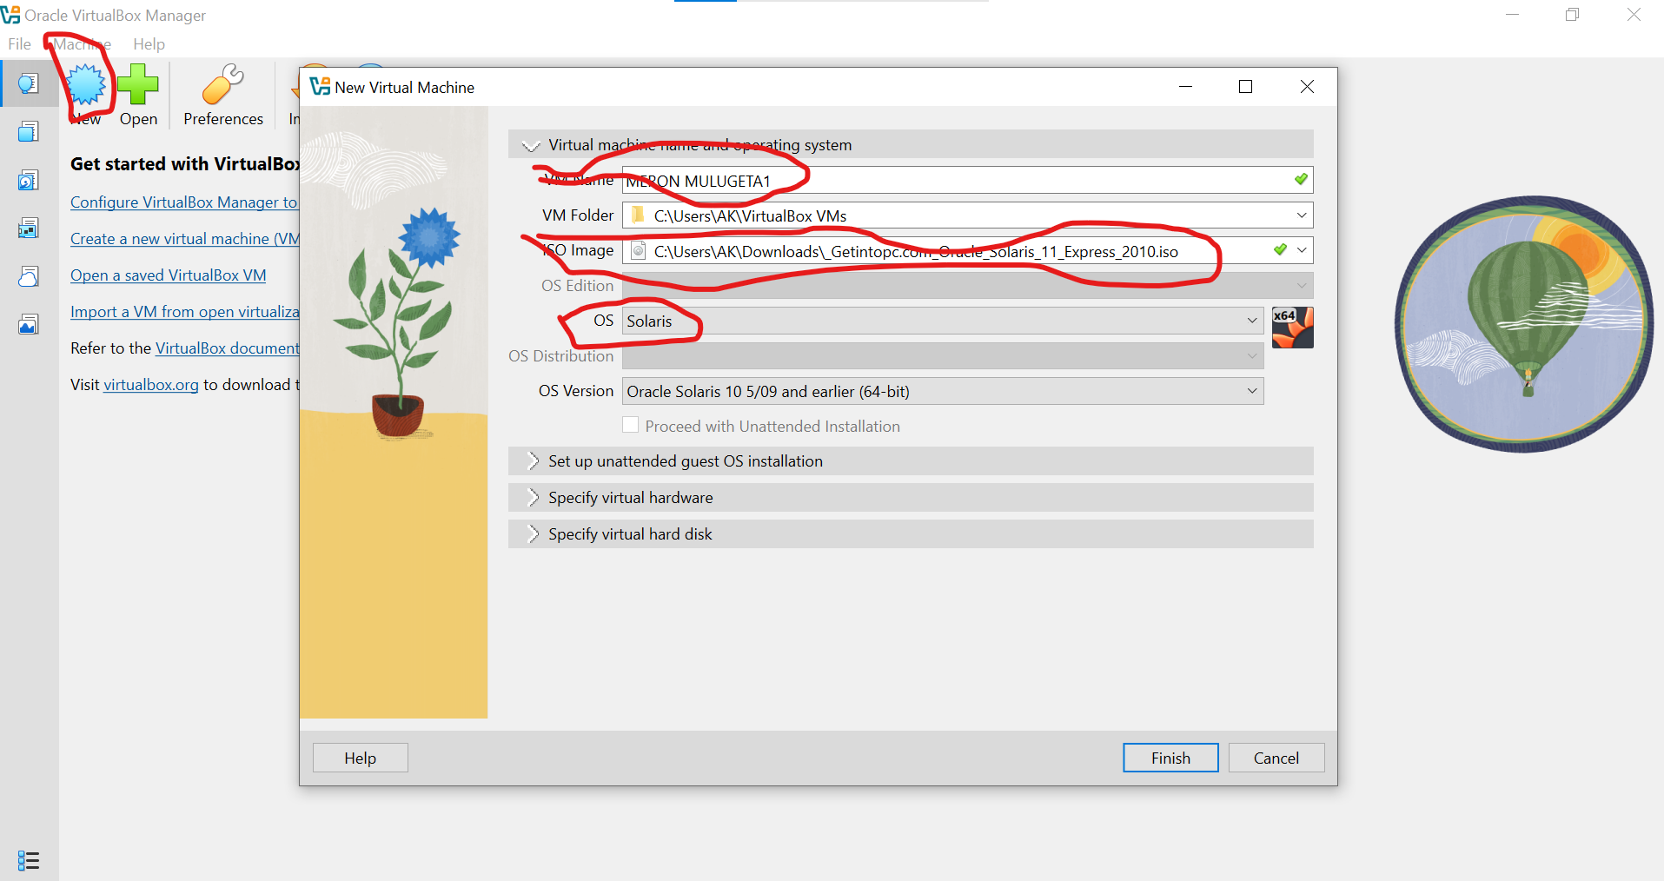
Figure 2: Allocating RAM and CPU resources to the Solaris VM
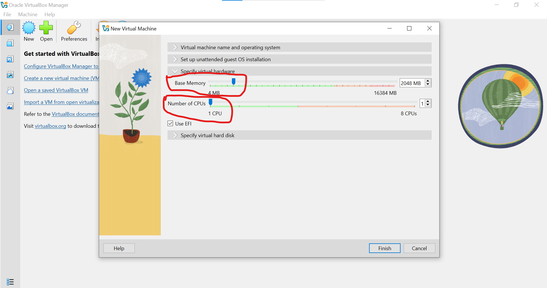

Figure 3: Attaching the Solaris ISO file to the virtual machine
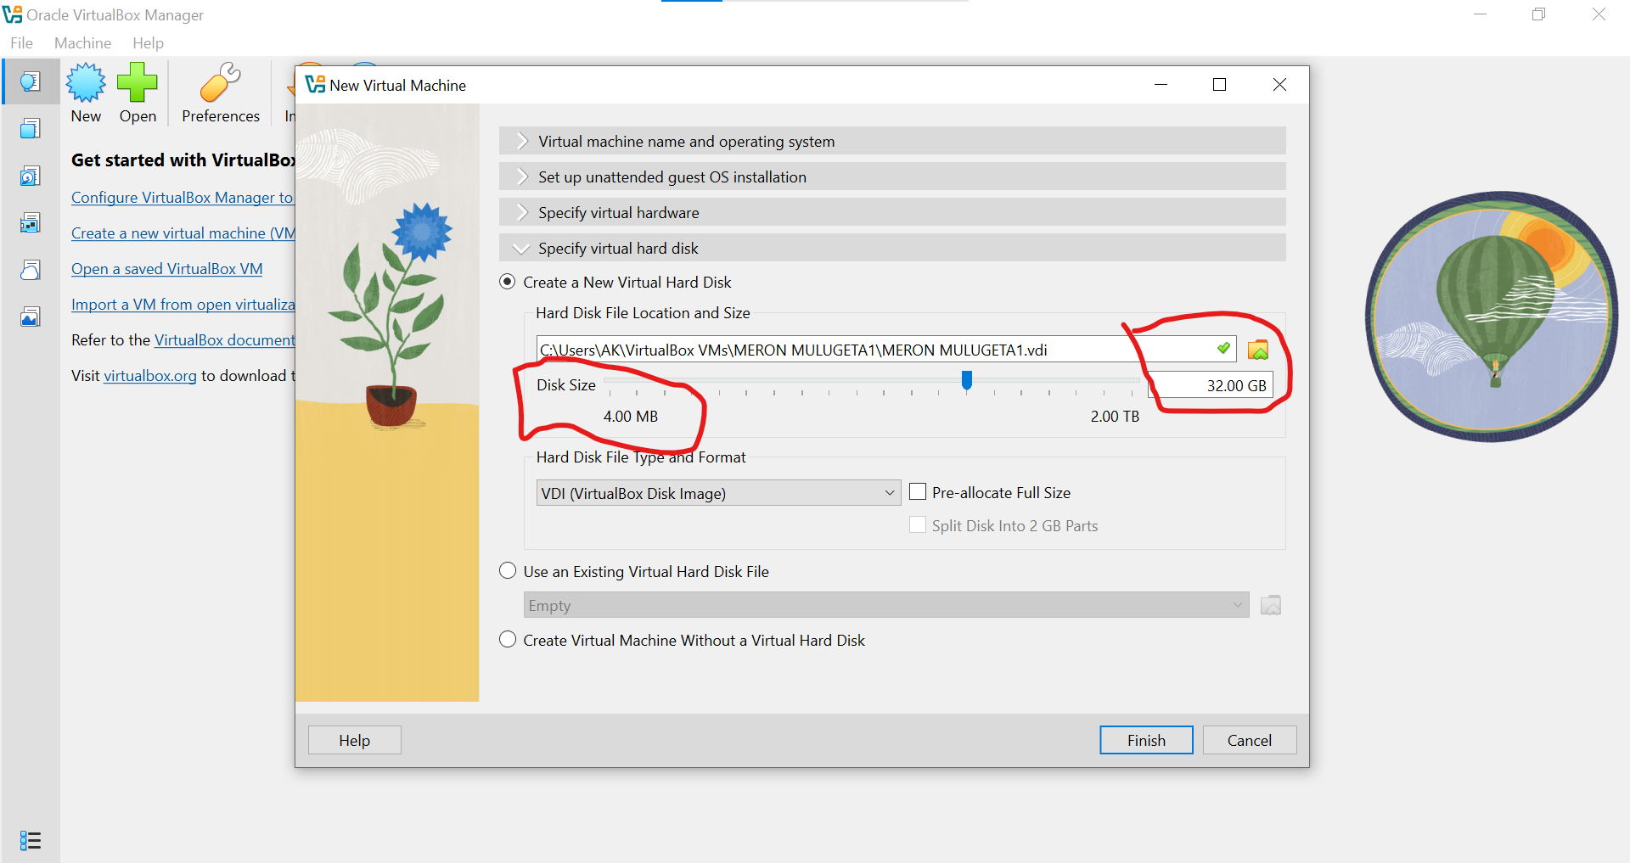
Figure 4: Solaris installation welcome screen
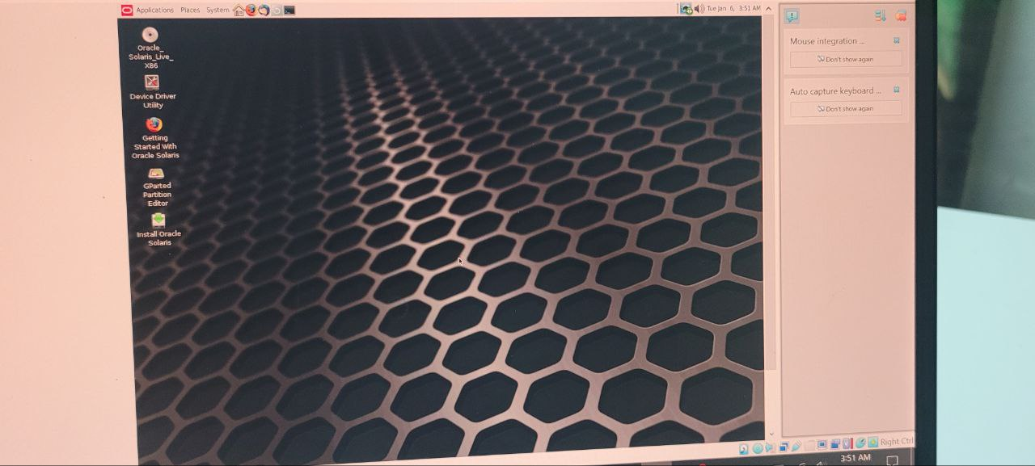

Figure 5: Disk partitioning and ZFS filesystem selection
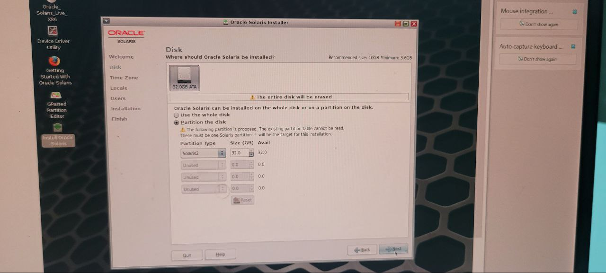
Figure 6: User account creation using full name
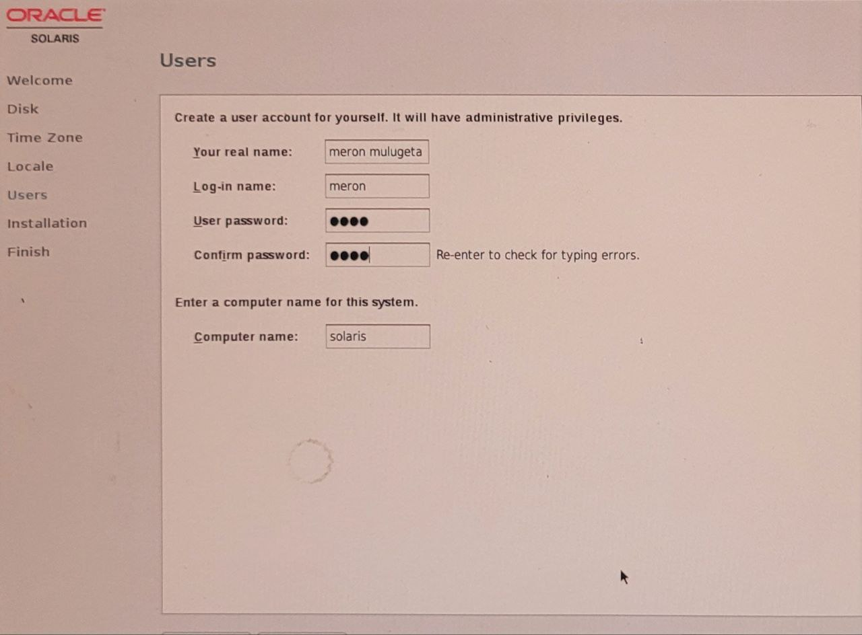

Figure 7: Successful Solaris desktop after installation
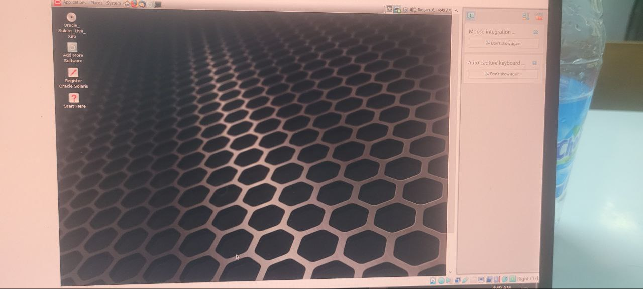

5. Issues and Solutions
Issue: Network not detected → Solution: Changed adapter to NAT
Issue: Slow performance → Solution: Increased RAM and CPU
Issue: Display resolution problem → Solution: Adjusted display settings

6. Filesystem Support
Solaris primarily uses ZFS, offering data integrity, scalability, and snapshot capabilities. ZFS advantages include error correction and easy storage management, while disadvantages include higher memory usage.

7. Virtualization in Modern OS
Virtualization allows multiple OSs to run on one machine. It improves hardware utilization, testing safety, and cost efficiency through hypervisors.

3. Task 1

Assignment Task 1: Mobile Phone Evaluation (Table Format)
Brand: Kyocera
Model: Kyocera DuraForce Ultra 5G

1. Performance
Parameter | Evaluation
Processor / Chipset | Qualcomm Snapdragon 765G (mid-range, 5G capable)
GPU Performance | Adreno 620, suitable for casual gaming
RAM Capacity & Type | 6GB RAM, adequate for daily tasks
Storage Speed & Type | 128GB internal storage, UFS standard
Thermal Management | Stable under normal use, slight throttling under heavy load

2. Real-World Performance
Parameter | Evaluation
App Launch Speed | Fast for common applications
Multitasking Ability | Smooth with moderate multitasking
Gaming Performance | Stable FPS in light to medium games
Heat Generation | Noticeable warmth during extended use
AI / NPU Performance | Basic AI processing via Snapdragon chipset

3. Display
Parameter | Evaluation
Display Type | IPS LCD with Sapphire Shield protection
Size | 5.45 inches
Resolution | FHD+ (1080 x 2160)
Refresh Rate | 60 Hz
Brightness | High outdoor visibility
Color Accuracy | Standard color reproduction
HDR Support | Not emphasized
Screen Protection | Sapphire Shield Glass
Screen-to-Body Ratio | Moderate due to rugged bezels
PWM / Flicker | Minimal flicker, eye-friendly

4. Camera System
Parameter | Evaluation
Rear Cameras | 24MP main + 16MP ultra-wide
Sensor Size | Standard mobile sensors
Aperture | Standard aperture
OIS / EIS | Basic electronic stabilization
Zoom | Digital zoom only
Low-light Performance | Average
Video Recording | Up to 4K
Image Processing | Standard HDR and night mode
Front Camera | 8MP front camera

5. Battery & Charging
Parameter | Evaluation
Battery Capacity | 4500 mAh
Real-world Endurance | One full day of moderate use
Charging Speed | Standard wired charging
Fast Charging Standard | USB Power Delivery
Wireless Charging | Supported
Reverse Charging | Not supported
Charger in Box | Yes
Battery Longevity | Optimized for durability

6. Software / OS
Parameter | Evaluation
Operating System | Android
OS Version at Launch | Android 12
Major OS Updates | Limited
Security Patches | Moderate support
UI Experience | Near stock Android
Bloatware | Minimal
Ads | No ads
Customization | Basic Android customization
Smoothness & Stability | Stable over time

7. Build Quality & Design
Parameter | Evaluation
Material | Reinforced rugged body
Durability | MIL-STD-810H certified
Weight & Balance | Heavy but balanced
Thickness | Thick due to rugged design
IP Rating | Water and dust resistant
Buttons & Haptics | Firm physical buttons
Ergonomics | Good grip, glove-friendly
Aesthetic Design | Industrial rugged look

8. Connectivity
Parameter | Evaluation
5G Support | Sub-6 and mmWave
4G LTE | Wide band support
Wi-Fi | Wi-Fi 6
Bluetooth | Bluetooth 5.0
NFC | Supported
GPS | Accurate multi-system GPS
USB Type | USB-C
USB Speed | USB 3.x
SIM Support | Single SIM
Headphone Jack | Not available

9. Audio
Parameter | Evaluation
Speaker Type | Loud mono/stereo speaker
Bass & Mid | Clear mids, limited bass
Volume | Very loud
Microphone Quality | High clarity
Noise Cancellation | Supported
Hi-Res Audio | Not emphasized
Call Quality | Excellent

10. Storage & Memory Options
Parameter | Evaluation
Available Configurations | 6GB + 128GB
Expandable Storage | microSD up to 1TB
Storage Reliability | High
RAM Management | Efficient for daily use

11. Security
Parameter | Evaluation
Fingerprint Scanner | Physical fingerprint scanner
Face Unlock | 2D face unlock
Hardware Security | Android secure enclave
Biometric Speed | Fast and reliable
Software Security | Android permission controls

12. Price & Value
Parameter | Evaluation
Price-to-Performance | Moderate
Long-term Value | High due to durability
Resale Value | Average
Competition | Other rugged phones

13. Special Features
Parameter | Evaluation
Rugged Certification | Military-grade protection
Underwater Mode | Supported
Gaming Features | Not gaming-focused
AI Features | Basic on-device AI

14. Accessories & Ecosystem
Parameter | Evaluation
Accessory Availability | Cases, mounts, chargers
Smart Device Compatibility | Android ecosystem
Wireless Integration | Nearby Share
Smart Home Integration | Google Home support

15. Reliability & Brand Support
Parameter | Evaluation
Brand Reputation | Strong in rugged devices
Customer Service | Available in select regions
Repair Centers | Limited
Warranty | Standard manufacturer warranty
Spare Parts | Moderately available
Repairability | Moderate

Task 2
Assignment Task 2: PC Brand Evaluation (Table Format)
Brand Evaluated: TUXEDO Computers
Representative Model Category: TUXEDO Infinity / Pulse Series (Linux-focused laptops)

1. Hardware Quality & Performance – Core Components
Parameter | Evaluation
CPU Performance | Latest Intel Core or AMD Ryzen processors; high efficiency and good thermal balance
GPU Performance | Integrated graphics standard; dedicated NVIDIA GPU available in select models
RAM Type & Speed | DDR4 or DDR5 depending on model; user-upgradable
Storage Type & Speed | NVMe SSDs with PCIe Gen 3 or Gen 4 support
Storage Capacity | Multiple configurations available; expandable

1. Hardware Quality & Performance – Thermals & Noise
Parameter | Evaluation
Cooling System Quality | Dual-fan cooling with heat pipes
Fan Noise Under Load | Moderate noise during high workloads
Thermal Throttling | Well-controlled with minimal throttling

1. Hardware Quality & Performance – Build & Durability
Parameter | Evaluation
Chassis Material | Aluminum or magnesium alloy
Hinge Strength | Reinforced hinges
Durability Certification | No official MIL-STD, but solid build quality

2. Design & Ergonomics
Parameter | Evaluation
Weight & Portability | Lightweight and portable for daily use
Keyboard Quality | Good key travel, backlit keyboard
Trackpad Quality | Accurate and smooth
Hinge Design | Traditional clamshell
Aesthetic Design | Minimalist professional design

3. Display Quality
Parameter | Evaluation
Resolution | Full HD to 4K options
Panel Type | IPS or OLED depending on configuration
Brightness | 300–500 nits
Color Coverage | Up to 100% sRGB
Refresh Rate | 60–165 Hz depending on model
Contrast Ratio | High contrast IPS/OLED panels
Touchscreen | Available on select models

4. Reliability & Brand Reputation
Parameter | Evaluation
Reliability Track Record | Strong reputation among Linux users
User Reviews | Generally positive
Repairability Score | High due to modular design
Long-Term Consistency | Stable performance over time

5. Battery & Power Efficiency
Parameter | Evaluation
Real-World Battery Life | 6–10 hours depending on usage
Fast Charging | Supported via USB-C
Battery Health Management | BIOS and OS-level controls
Power Adapter Size | Compact and lightweight

6. Software & Ecosystem
Parameter | Evaluation
Preinstalled Bloatware | Minimal to none
OS Options | Linux (TUXEDO OS, Ubuntu); Windows optional
Brand Software | TUXEDO Control Center
Driver Stability | High stability with frequent updates

7. Security Features
Parameter | Evaluation
BIOS / UEFI Security | Secure UEFI with password protection
TPM | TPM 2.0 supported
Fingerprint Reader | Available on select models
IR Camera | Optional
Privacy Shutter | Physical webcam shutter
Encryption Support | Full disk encryption supported

8. Upgradeability & Repairability
Parameter | Evaluation
RAM Accessibility | User-accessible RAM slots
Storage Expansion | Multiple M.2 slots
Battery Replaceability | Replaceable with tools
Repair Restrictions | Minimal restrictions
Screw Accessibility | Standard screws, modular design

9. Connectivity & Ports
Parameter | Evaluation
USB Ports | USB-A and USB-C available
Thunderbolt / USB4 | Supported on Intel models
Video Output | HDMI and DisplayPort via USB-C
Card Reader | microSD or SD on select models
Ethernet | Available on larger models
Wi-Fi | Wi-Fi 6 / 6E
Bluetooth | Bluetooth 5.x

10. Price & Value
Parameter | Evaluation
Price-to-Performance | Strong value for Linux users
Lifespan Value | High due to upgradeability
Configuration Options | Highly customizable
Upgrade Path Cost | Affordable upgrades
Discounts & Pricing | Student and business discounts available

11. Customer Service & Warranty
Parameter | Evaluation
Warranty Length | 2 years standard
Repair Type | Depot repair
Support Quality | Responsive and knowledgeable
Extended Warranty | Available
Accidental Damage | Optional coverage

12. Special Use-Case Factors
Parameter | Evaluation
Gaming Use | Dedicated GPU models available; good cooling
Business Use | Strong security and reliability
Creative Work | Color-accurate displays; strong CPU/GPU options
Student Use | Portable, affordable, long battery life

8. Conclusion
The project enhanced understanding of Solaris, virtualization, and filesystems, providing practical OS administration experience.
9. Future Outlook
Virtualization will continue to dominate cloud and enterprise computing. Students are encouraged to practice OS installations using virtual machines.

References
Oracle Corporation. (2024). Oracle Solaris operating system documentation. https://www.oracle.com/solaris
TUXEDO Computers GmbH. (2024). TUXEDO laptop specifications and Linux support. https://www.tuxedocomputers.com
Kyocera Corporation. (2023). Kyocera mobile device specifications. https://www.kyoceramobile.com

