**Introduction**

The Kenyan coral reef fishery landings data I have is separated by landings site along the Kenyan coast. Local experts say that we can mostly assume the catch comes from areas near the landing sites (within 1-4 km. sq. surrounding the landing site; T. McClanahan, *personal communication*). While data only comes from fished areas, there are many protected and partially protected marine parks and reserves in the region. Variation in physical characteristics of the fished sites, such as depth, habitat type, and latitude, as well as variation in management and history of fishing pressure, could lead to variable growth between landing sites. It has been shown that maturity and fecundity vary between fished and protected sites (Locham et al. 2015). Therefore, this documented change in fecundity by site could be a hint that there are growth differences by site. While all the sites included in the dataset are of course fished (since the data is from landing sites only), it is possible that boundary effects and other physical characteristics of the system could impact the individual growth rates.

However, it is common practice to pool the length composition data together by stock, removing any accounting for spatial processes that led to the data observed. For example, the Kenyan government’s management plan for rabbitfish, *Siganus sutor*, is pooled for the entire stock within the Kenyan EEZ. The goal of this project is to simulate variable Brody growth coefficient as a 1D spatial process, then generate length composition data arising from each site. We will then estimate the stock status both by location and pooled, to identify where fisheries management could fall short when spatial variability in the growth process is not accounted for.

**Methods**

I generated true values of the Brody growth coefficient (von Bertalanffy k parameter) as a 1D spatial process, assuming process error variability by site, and a trend over approximately the latitude of the Kenyan coastline, from -4 to -1 degrees (Figure 1).

 (1)

Where epsilon is the random process, sigma is the process error standard deviation on the variation in *k* across sites, mu is the global value of *k* (from FishBase or an in situ study, for example), beta is the slope of the spatial trend, and *i* is the site.

The underlying population is age-structured:



(2)

Where N is the abundance at age *a* over time *t,* R is recruitment over time *t,* M is the annual natural mortality rate, F is the annual fishing mortality rate over time, S is the selectivity at age, and amax is the maximum age in the population. A recruitment time series is fed into the operating model as the truth, to explore different true recruitment patterns:



(3)

where mu here is the true recruitment, epsilon is the random effect on recruitment, and sigmaR is the standard deviation representing the process error on recruitment (with a value of 0.6).

Growth follows a von Bertalanffy function:

(4)

Where L is the predicted length-at-age at each site, Linfinity is the asymptotic length, k is the Brody growth coefficient (which varies by site), and t0 is the age at length = 0. Weight at age is an allometric function of the length-at-age:

(5)

Maturity-at-age follows a logistic function:

(6)

Where m is the proportion mature at age, and a50 is the age at 50% maturity.

(7)

Selectivity also follows a logistic curve, parameterized for the age at 50% selectivity (s50) and the age at 95% selectivity (s95). Spawning biomass is a function of the abundance, weight, and proportion mature.

Catch follows the Baranov catch equation. Length measurements are then generated from the observed catch based on the probability of being in a length bin (1cm bins) given age:

(8)

Where P is the probability of being in a length bin given age, phi is the cumulative normal distribution, j is the length bin, and CVl represents the variability in the age-length relationship. I then calculate the probability of being harvested in a given length bi (g):

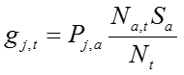

(9)

****The length composition data is then generated using a multinomial distribution to get the predicted number of individuals captured in each length bin over time (y).

(10)

**Some thoughts moving forward**

The problem I am considering is how to maximize the use of the information within the data, but acknowledging that the most reliable data will be length composition by site over time. Because I am already estimating fishing mortality and recruitment as a random effect, I don’t think there is information within the data to inform the estimate of process error on the spatial variability of the growth parameter or the spatial trend in growth on top of the parameters we are more interested in. An interesting parameterization as an alternative within the estimation model I have already written would be to assume that recruitment is constant every year (no variability, removing any estimation relating to recruitment without information on scale of the population), while estimating annual fishing mortality and then the trend and process error associated with the growth process (i.e. treating the variability in the growth parameter by site as a random effect instead of recruitment over time). For coral reef fish, this assumption about constant recruitment may not be any worse than the assumptions made about constant growth over space. This alternative parameterization still addresses the current issues with other length-based data-limited stock assessment models, in allowing for variability in fishing mortality between years. I need to conduct more literature review and correspond with local experts to determine if recruitment variability or differences in growth by area would be more important to model for coral reef fish species.

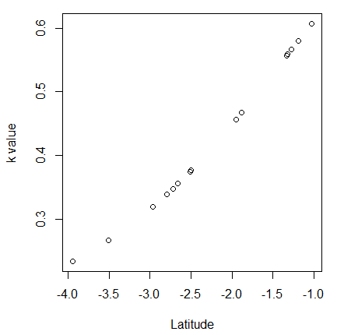

Figure 1. Example of simulated trend and noise in the von Bertalanffy Brody growth coefficient at 15 sites across the latitude of the Kenyan coast. The final project will generate at 1,000 of these trends.

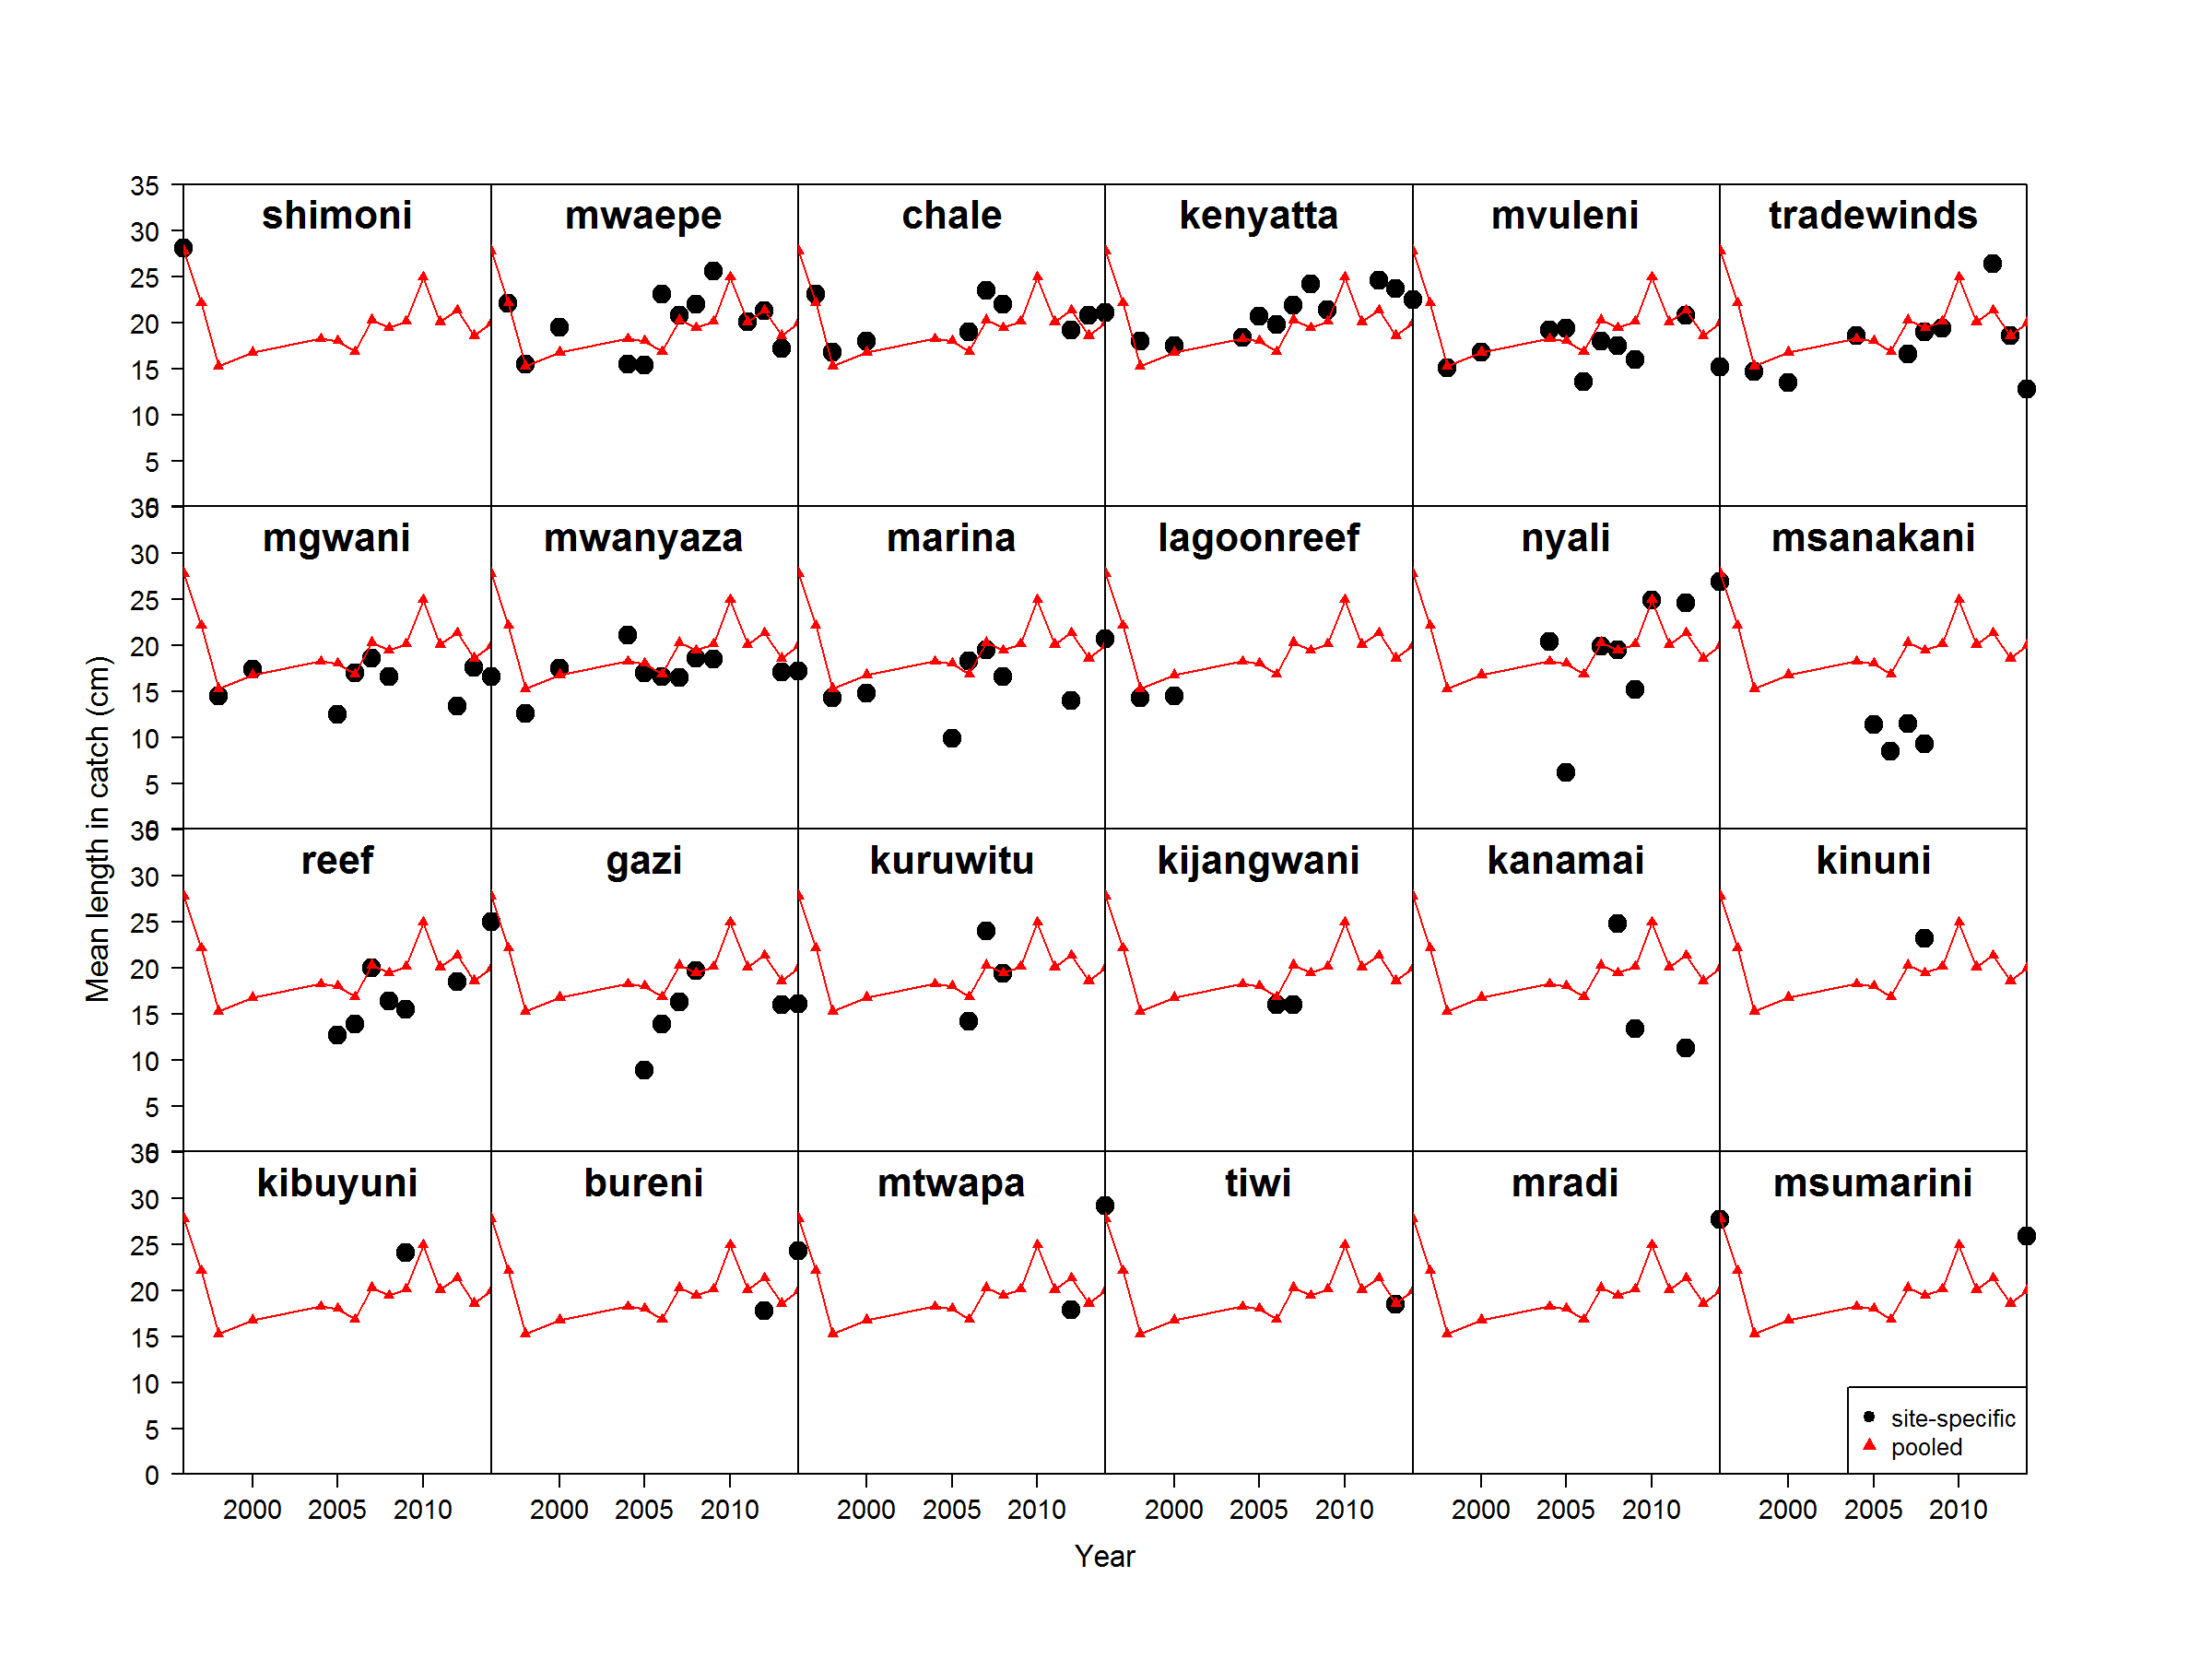

Figure 2. Observed mean length over time of rabbitfish, *Siganus sutor*,from 24 fishery landing sites on the Kenyan coast. Black points represent the mean length at the specific site, and the red triangles and lines represent the pooled mean length of all samples across the Kenyan coast.

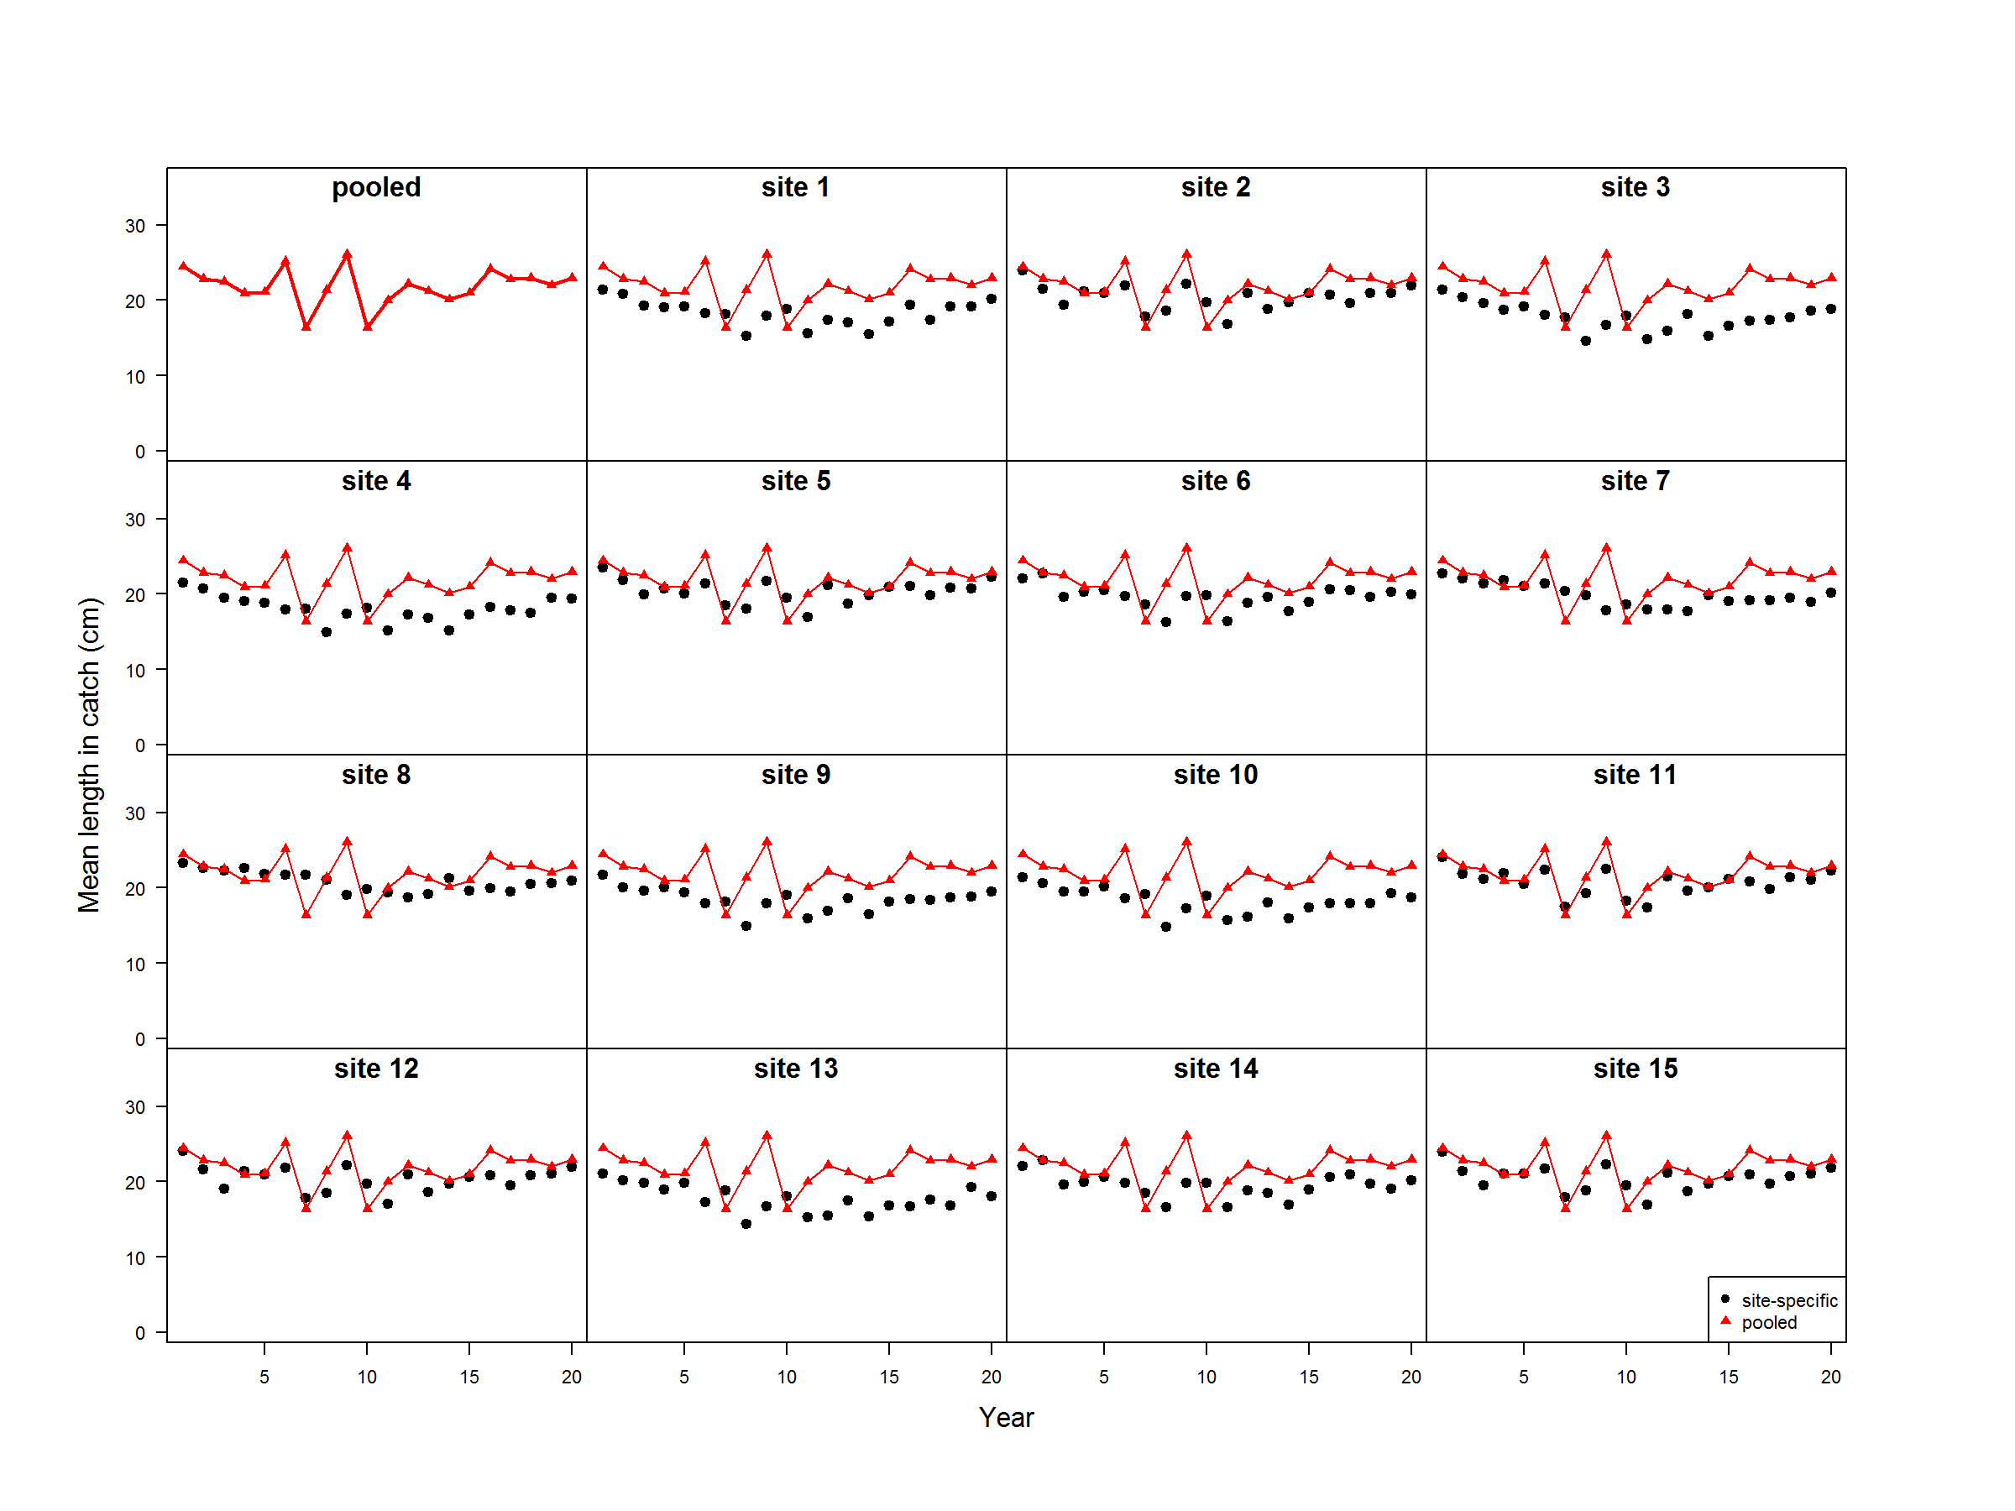

Figure 3. Simulated mean length over time mimicking the life history of rabbitfish, *Siganus sutor*. Red triangles and lines represent the mean length that arises assuming that the individual growth does not vary by area. Black points represent the mean length at a specific site, where the von Bertalanffy Brody growth coefficient varies by site.