**Authors**

Harlan, Merritt E., U.S. Geological Survey, Denver, Colorado

Meyer, Michael F., U.S. Geological Survey, Madison, Wisconsin

Levenson, Eric S., University of Oregon, Eugene, Oregon

Cooley, Sarah, Duke University, Durham, North Carolina

Kraemer, Benjamin M., University of Freiburg, Freiburg, Germany

**2.8**LAKE WATER STORAGE AND LEVEL  **-** M. E. Harlan, M. F. Meyer, E. S. Levenson, S. Cooley, and B. M. Kraemer

In 2024, changes in water storage and levels across 4,522 lakes from two global long-term satellite datasets varied significantly depending on location, lake size, and human influence. Lake water storage (LWS) from the GloLakes dataset (Hou et al. 2024; 4,275 lakes, median lake area 5.73 km2) saw a median increase in LWS of 1.58% in 2024 (representing a net cumulative increase of 31,804 million cubic meters (MCM)), compared to a baseline averaged period between 1993 and 2020 (Figure 1). Average 2024 lake water level (LWL) from the Global Reservoirs and Lake Monitor (GREALM) dataset (Birkett et al. 2011; 364 lakes, median lake area 305.1 km2) was relatively stable (0.054% median increase in LWL relative to 1993-2020 baseline, representing a net cumulative decrease of 0.636 m). However, small global average changes are obscuring more substantial regional changes. In GloLakes, 24.8% of lakes showed a statistically significant increase in LWS in 2024 compared to the 1993-2020 baseline, while 16.0% experienced a significant decrease. In GREALM, 39.6% of lakes showed a statistically significant rise in LWL, whereas 25.8% recorded a decline.

Countries with the largest mean increases in LWL and LWS (21.3% to 56.8%) include Senegal, Belize, Bangladesh, Angola, Sudan, Syria, Ivory Coast, and Myanmar, representing a higher proportion of tropical regions. Countries with the largest mean decreases (-20% to -74.8%) include Niger, Chad, Netherlands, Mongolia, Algeria, Namibia, Morocco, and Botswana, representing more arid climates. Beyond these regional trends, we also note a correlation between lake size, human management, and the degree of variability in lake storage and level, with smaller, managed lakes showing higher anomaly variability (Figure 2). These findings highlight the spatiotemporally complex interactions between climate variability, hydrological processes, and human activities in shaping global lake dynamics. The diverging LWL and LWS trends presented here generally align with previous studies (Kraemer et al. 2020, Feng et al. 2022), and discrepancies in global LWS trends from other studies may be attributed to different lake datasets (Yao et al. 2023). Continuing to monitor lake anomalies at both a global and regional scale is critical for better understanding where excessive LWS fluctuations are occurring to better predict changing dynamics in water availability, ecosystem resilience, and flood and drought risk (e.g. Weyhenmeyer et al. 2024; Han et al. 2024).

For our analysis we relied on the “GloLakes” lake and reservoir storage dataset (Hou et al. 2024) to calculate lake storage anomalies. GloLakes combines laser altimetry data from ICESat2 (Jasinski et al. 2023) and radar altimetry data from GREALM with optical satellite data products from Landsat and Sentinel-2 to estimate lake water storage. We subset GloLakes (4,275 lakes) to ensure a given lake has at least 20 years of coverage between 1993 and 2024 with no more than a three-year data gap, and at least three observations in 2024. These 4,275 lakes represent a small portion of global lake area (3.9% of HydroLAKES; Messager et al. 2016); thus we also incorporate GREALM lake level data (Birkett et al. 2011), adding an additional 364 lakes representing 44% of total lake area in HydroLAKES. We present anomalies based on *both* lake storage and lake level, and rely on a baseline period starting in 1993-2020 to account for GREALM data availability. We caution that our combined dataset is limited and biased in spatiotemporal coverage globally, particularly in its disproportionately large coverage in North America (Plate 2.8), and lack of monitoring in small (< 1 km2) lakes (Figure 2), which dominate global lake variability (Pi et al. 2022; Xu et al. 2024). Further, datasets themselves may contain errors; for the 111 overlapping lakes between GloLakes and GREALM, correlation (R2) in 2024 anomalies between LWS and LWL is only 6.9%, however there is general consensus in the direction of increase (76.6% of lakes agree on anomaly direction). Future incorporation and reconstruction of data from the recently launched Surface Water and Ocean Topography (SWOT) satellite mission or data from longer missions such as MODIS may help alleviate spatial biases.

**References**

Birkett, C., Reynolds, C., Beckley, B., & Doorn, B. (2011). From Research to Operations: The USDA Global Reservoir and Lake Monitor. In S. Vignudelli, A. G. Kostianoy, P. Cipollini, & J. Benveniste (Eds.), *Coastal Altimetry* (pp. 19–50). Springer.<https://doi.org/10.1007/978-3-642-12796-0_2>

Feng, Y., Zhang, H., Tao, S., Ao, Z., Song, C., Chave, J., Le Toan, T., Xue, B., Zhu, J., Pan, J., Wang, S., Tang, Z., & Fang, J. (2022). Decadal Lake Volume Changes (2003–2020) and Driving Forces at a Global Scale. *Remote Sensing*, *14*(4), Article 4.<https://doi.org/10.3390/rs14041032>

Han, Y., Lin, Q., Huang, S., Du, C., Shen, J., & Zhang, K. (2024). Human Impacts Dominate Global Loss of Lake Ecosystem Resilience. *Geophysical Research Letters*, *51*(11), e2024GL109298.<https://doi.org/10.1029/2024GL109298>

Hou, J., Van Dijk, A. I. J. M., Renzullo, L. J., & Larraondo, P. R. (2024). GloLakes: Water storage dynamics for 27,000 lakes globally from 1984 to present derived from satellite altimetry and optical imaging. *Earth System Science Data*, *16*(1), 201–218.<https://doi.org/10.5194/essd-16-201-2024>

Jasinski, M. F., Stoll, J. D., Hancock III, D. W., Robbins, J., Nattala, J., Pavelsky, T. M., Morison, J., Jones, B. M., Ondrusek, M. E., Parrish, C., Carabajal, C., and the ICESat-2 Science Team: ATLAS/ICESat-2 L3A Along Track Inland Surface Water Data, Version 6. Boulder, Colorado USA. NASA National Snow and Ice Data Center Distributed Active Archive Center [data set], <https://doi.org/10.5067/ATLAS/ATL13.006>

Kraemer, B. M., Seimon, A., Adrian, R., & McIntyre, P. B. (2020). Worldwide lake level trends and responses to background climate variation. *Hydrology and Earth System Sciences*, *24*(5), 2593–2608.<https://doi.org/10.5194/hess-24-2593-2020>

Lehner, B., C. Reidy Liermann, C. Revenga, C. Vörösmarty, B. Fekete, P. Crouzet, P. Döll, M. Endejan, K. Frenken, J. Magome, C. Nilsson, J.C. Robertson, R. Rodel, N. Sindorf, and D. Wisser. 2011. [High-resolution mapping of the world’s reservoirs and dams for sustainable river-flow management](http://onlinelibrary.wiley.com/doi/10.1890/100125/abstract). Frontiers in Ecology and the Environment 9 (9): 494-502. <https://doi.org/10.1890/100125>

Messager, M.L., Lehner, B., Grill, G., Nedeva, I., Schmitt, O. (2016). Estimating the volume and age of water stored in global lakes using a geo-statistical approach. Nature Communications, 7: 13603. <https://doi.org/10.1038/ncomms13603>

Pi, X., Luo, Q., Feng, L., Xu, Y., Tang, J., Liang, X., Ma, E., Cheng, R., Fensholt, R., Brandt, M., Cai, X., Gibson, L., Liu, J., Zheng, C., Li, W., & Bryan, B. A. (2022). Mapping global lake dynamics reveals the emerging roles of small lakes. *Nature Communications*, *13*(1), 5777.<https://doi.org/10.1038/s41467-022-33239-3>

Weyhenmeyer, G. A., Chukwuka, A. V., Anneville, O., Brookes, J., Carvalho, C. R., Cotner, J. B., Grossart, H.-P., Hamilton, D. P., Hanson, P. C., Hejzlar, J., Hilt, S., Hipsey, M. R., Ibelings, B. W., Jacquet, S., Kangur, K., Kragh, T., Lehner, B., Lepori, F., Lukubye, B., … Zhou, Y. (2024). Global Lake Health in the Anthropocene: Societal Implications and Treatment Strategies. *Earth’s Future*, *12*(4), e2023EF004387.<https://doi.org/10.1029/2023EF004387>

Xu, N., Lu, H., Li, W., & Gong, P. (2024). Natural lakes dominate global water storage variability. *Science Bulletin*, *69*(8), 1016–1019.<https://doi.org/10.1016/j.scib.2024.02.023>

Yao, F., Livneh, B., Rajagopalan, B., Wang, J., Crétaux, J.-F., Wada, Y., & Berge-Nguyen, M. (2023). Satellites reveal widespread decline in global lake water storage. *Science*, *380*(6646), 743–749.<https://doi.org/10.1126/science.abo2812>

**Figures**

*Fig 1: Percent (a) and quantitative (b) water level and storage anomalies relative to 1993-2020, from 1993-2024. Percent anomalies are median-averaged globally; water level and storage anomalies in b) are shown on dual y axes, expressed in meters (m) and million cubic meters (MCM).*

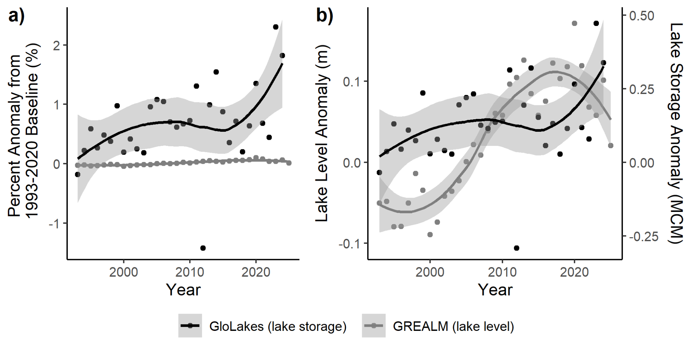

*Fig 2: 2024 lake storage and lake level anomalies (%) relative to 1993-2020 binned by lake size, and categorized as ‘natural’ or ‘reservoir’ based on inclusion in the Global Reservoir and Dam Database (Lehner et al. 2011). Lake bin counts (n) are displayed on top; reservoir counts are shown in grey.*

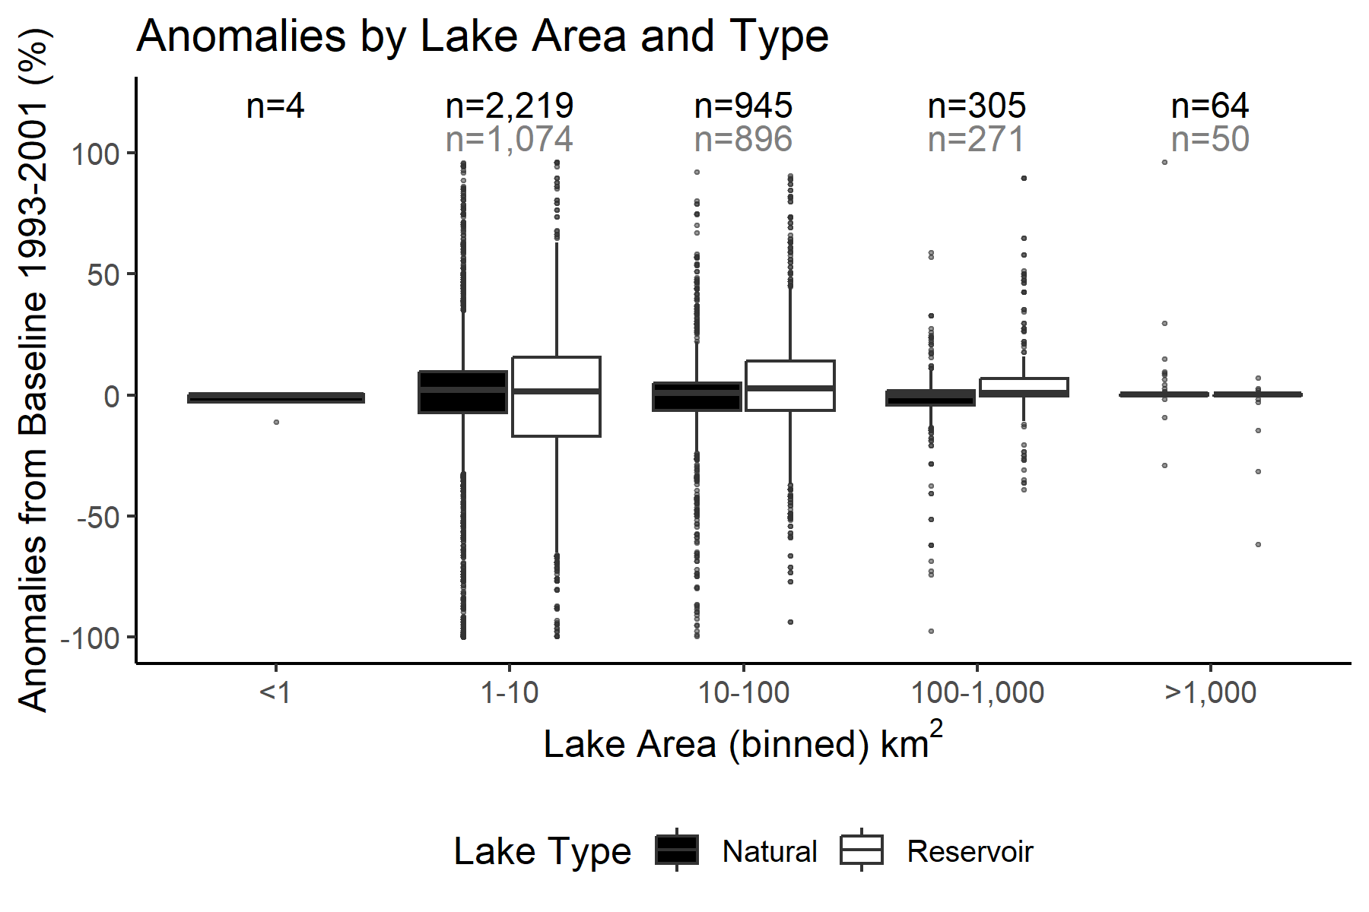

*Plate 2.8 Lake storage (GloLakes) and lake level (GREALM) anomalies (%)*

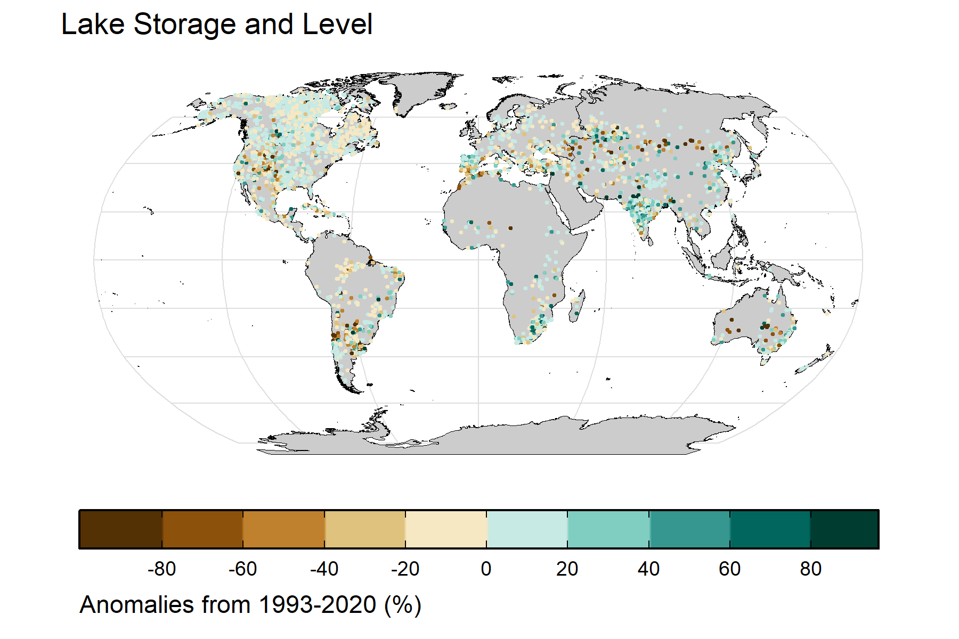

**Datasets used and their URLs**

* ‘GloLakes’ lake and reservoir storage: <https://doi.org/10.5194/essd-16-201-2024>
* Global Lakes and Reservoir Monitor (GREALM) lake level: <https://ipad.fas.usda.gov/cropexplorer/global_reservoir/>

**Acknowledgements**

**Summary bullet points**

* 2024 lake storage across 4,275 lakes on average increased by of 1.58% compared to a baseline averaged period from 1993-2020
* Small global average lake water storage and level changes are obscuring more substantial regional changes, with a large proportion of lakes (42.6%) showing statistically significant positive or negative trends in 2024
* 2024 lake storage and level anomaly variability is correlated with lake size and whether the lake is categorized as a reservoir or dam