**Authors**

Harlan, Merritt E., U.S. Geological Survey, Denver, Colorado

Meyer, Michael F., U.S. Geological Survey, Madison, Wisconsin

Levenson, Eric S., University of Oregon, Eugene, Oregon

Cooley, Sarah, Duke University, Durham, North Carolina

Kraemer, Benjamin M., University of Freiburg, Freiburg, Germany

**2.8**LAKE WATER STORAGE AND LEVEL  **-** M. E. Harlan, M. F. Meyer, E. S. Levenson, S. Cooley, and B. M. Kraemer

In 2024, water storage and levels across 4,487 lakes exhibited slight overall increases, though with considerable lake-specific variability, based on two global datasets. Compared to a baseline averaged period between 1993 and 2020, lake water storage (LWS) increased by 1.61% in 2024, representing a net cumulative increase of 10,566 million cubic meters (MCM) within the GloLakes dataset (Hou et al. 2024; 4,190 lakes, median lake area 5.52 km2). Average 2024 lake water level (LWL) from the Global Reservoirs and Lake Monitor (GREALM) dataset (Birkett et al. 2011; 297 lakes, median lake area 449.2 km2) was relatively stable (0.12 m median increase in LWL relative to 1993-2020 baseline, with LWL anomalies ranging between -53 m and 28.9 m). However, small global average changes obscure more substantial regional changes. In looking across both datasets (n = 4,487), LWL or LWS increased in 57.8% of lakes and decreased in 42.2%, with a subset of these changes showing more statistical robustness in a Welch’s t-test (25.6% increased and 16.5% decreased with p < 0.05).

Countries with the largest mean increases in LWS (ranging from 23.4% to 84%) include Syria, Senegal, Belize, Cambodia, Angola, Bangladesh, Sudan, and Libya. Countries with the largest mean decreases in LWS (ranging from -20% to -74.8%) include Niger, Chad, Mongolia, Algeria, Namibia, Argentina, Botswana, and Bosnia and Herzegovina. Beyond these country trends, we also look at the variance of LWS percent anomalies across binned lake sizes and whether the lake is classified as ‘natural’ or ‘reservoir’ based on inclusion in the Global Reservoir and Dam Database (Lehner et al. 2011). Across both lake area and lake classification, we find statistically robust differences for p < 0.05 using Levene’s test for homogeneity of variance, and note that smaller, managed lakes tend to show higher anomaly variability (Figure 2). The diverging LWL and LWS trends presented here generally align with previous studies (Kraemer et al. 2020, Feng et al. 2022). However, discrepancies exist in global LWS trends compared to more recent work (Yao et al. 2023) likely due to dataset differences. Continuing to monitor lake anomalies at both a global and regional scale is critical for better understanding where LWS fluctuations are occurring to better predict changing dynamics in water availability, ecosystem resilience, and flood and drought risk (e.g. Weyhenmeyer et al. 2024; Han et al. 2024).

For our analysis, we used the “GloLakes” lake and reservoir storage dataset (Hou et al. 2024) to calculate lake storage anomalies. GloLakes combines laser altimetry data from ICESat2 (Jasinski et al. 2023), radar altimetry data from GREALM, and optical satellite data products from Landsat and Sentinel-2 to estimate lake water storage. We refined the GloLakes dataset by selecting lakes with at least 20 years of coverage between 1993 and 2024, no data gaps longer than three-years, and at least three observations in 2024. These 4,190 GloLakes lakes represent a small portion of global lake volume (0.89% of HydroLAKES; Messager et al. 2016); thus we also incorporate GREALM lake level data (Birkett et al. 2011), adding an additional 297 lakes representing 88.7% of total lake volume in HydroLAKES. We present anomalies based on both lake storage and lake level, and rely on a baseline period starting in 1993-2020 to account for GREALM data availability. We caution that both datasets are limited in spatiotemporal coverage globally, particularly in their disproportionately large coverage in North America (Plate 2.8), and lack of monitoring in small (< 1 km2) lakes (Figure 2), which dominate global lake variability (Pi et al. 2022; Xu et al. 2024). Further, datasets may contain errors. Among the 85 lakes shared between GloLakes and GREALM, the median correlation (r2) across each lake between LWS and LWL anomalies is only 36.1%. However there is general agreement in the direction of increase with 82.3% of lakes agreeing on 2024 anomaly direction. For these 85 lakes present in both GloLakes and GREALM, we only provide anomalies for GREALM, given the denser interannual record. Future integration of data from the recently launched Surface Water and Ocean Topography (SWOT) satellite mission or data from longer missions such as MODIS may help increase spatial coverage.

**References**

Birkett, C., Reynolds, C., Beckley, B., & Doorn, B. (2011). From Research to Operations: The USDA Global Reservoir and Lake Monitor. In S. Vignudelli, A. G. Kostianoy, P. Cipollini, & J. Benveniste (Eds.), *Coastal Altimetry* (pp. 19–50). Springer.<https://doi.org/10.1007/978-3-642-12796-0_2>

Feng, Y., Zhang, H., Tao, S., Ao, Z., Song, C., Chave, J., Le Toan, T., Xue, B., Zhu, J., Pan, J., Wang, S., Tang, Z., & Fang, J. (2022). Decadal Lake Volume Changes (2003–2020) and Driving Forces at a Global Scale. *Remote Sensing*, *14*(4), Article 4.<https://doi.org/10.3390/rs14041032>

Han, Y., Lin, Q., Huang, S., Du, C., Shen, J., & Zhang, K. (2024). Human Impacts Dominate Global Loss of Lake Ecosystem Resilience. *Geophysical Research Letters*, *51*(11), e2024GL109298.<https://doi.org/10.1029/2024GL109298>

Hou, J., Van Dijk, A. I. J. M., Renzullo, L. J., & Larraondo, P. R. (2024). GloLakes: Water storage dynamics for 27,000 lakes globally from 1984 to present derived from satellite altimetry and optical imaging. *Earth System Science Data*, *16*(1), 201–218.<https://doi.org/10.5194/essd-16-201-2024>

Jasinski, M. F., Stoll, J. D., Hancock III, D. W., Robbins, J., Nattala, J., Pavelsky, T. M., Morison, J., Jones, B. M., Ondrusek, M. E., Parrish, C., Carabajal, C., and the ICESat-2 Science Team: ATLAS/ICESat-2 L3A Along Track Inland Surface Water Data, Version 6. Boulder, Colorado USA. NASA National Snow and Ice Data Center Distributed Active Archive Center [data set], <https://doi.org/10.5067/ATLAS/ATL13.006>

Kraemer, B. M., Seimon, A., Adrian, R., & McIntyre, P. B. (2020). Worldwide lake level trends and responses to background climate variation. *Hydrology and Earth System Sciences*, *24*(5), 2593–2608.<https://doi.org/10.5194/hess-24-2593-2020>

Lehner, B., C. Reidy Liermann, C. Revenga, C. Vörösmarty, B. Fekete, P. Crouzet, P. Döll, M. Endejan, K. Frenken, J. Magome, C. Nilsson, J.C. Robertson, R. Rodel, N. Sindorf, and D. Wisser. 2011. [High-resolution mapping of the world’s reservoirs and dams for sustainable river-flow management](http://onlinelibrary.wiley.com/doi/10.1890/100125/abstract). Frontiers in Ecology and the Environment 9 (9): 494-502. <https://doi.org/10.1890/100125>

Messager, M.L., Lehner, B., Grill, G., Nedeva, I., Schmitt, O. (2016). Estimating the volume and age of water stored in global lakes using a geo-statistical approach. Nature Communications, 7: 13603. <https://doi.org/10.1038/ncomms13603>

Pi, X., Luo, Q., Feng, L., Xu, Y., Tang, J., Liang, X., Ma, E., Cheng, R., Fensholt, R., Brandt, M., Cai, X., Gibson, L., Liu, J., Zheng, C., Li, W., & Bryan, B. A. (2022). Mapping global lake dynamics reveals the emerging roles of small lakes. *Nature Communications*, *13*(1), 5777.<https://doi.org/10.1038/s41467-022-33239-3>

Weyhenmeyer, G. A., Chukwuka, A. V., Anneville, O., Brookes, J., Carvalho, C. R., Cotner, J. B., Grossart, H.-P., Hamilton, D. P., Hanson, P. C., Hejzlar, J., Hilt, S., Hipsey, M. R., Ibelings, B. W., Jacquet, S., Kangur, K., Kragh, T., Lehner, B., Lepori, F., Lukubye, B., … Zhou, Y. (2024). Global Lake Health in the Anthropocene: Societal Implications and Treatment Strategies. *Earth’s Future*, *12*(4), e2023EF004387.<https://doi.org/10.1029/2023EF004387>

Xu, N., Lu, H., Li, W., & Gong, P. (2024). Natural lakes dominate global water storage variability. *Science Bulletin*, *69*(8), 1016–1019.<https://doi.org/10.1016/j.scib.2024.02.023>

Yao, F., Livneh, B., Rajagopalan, B., Wang, J., Crétaux, J.-F., Wada, Y., & Berge-Nguyen, M. (2023). Satellites reveal widespread decline in global lake water storage. *Science*, *380*(6646), 743–749.<https://doi.org/10.1126/science.abo2812>

**Figures**

*Fig 1: Water level and storage anomalies relative to a baseline averaged period of 1993-2020 across each year from 1993-2024. Yearly median water level (grey) and storage (black) anomalies averaged across each waterbody are shown on dual y axes, expressed in meters for LWL anomalies (m) and million cubic meters (MCM) for LWS anomalies. We apply local regression (loess) smoothing to the annual anomalies represented by the two lines, with the ribbon representing the 95% confidence interval.*

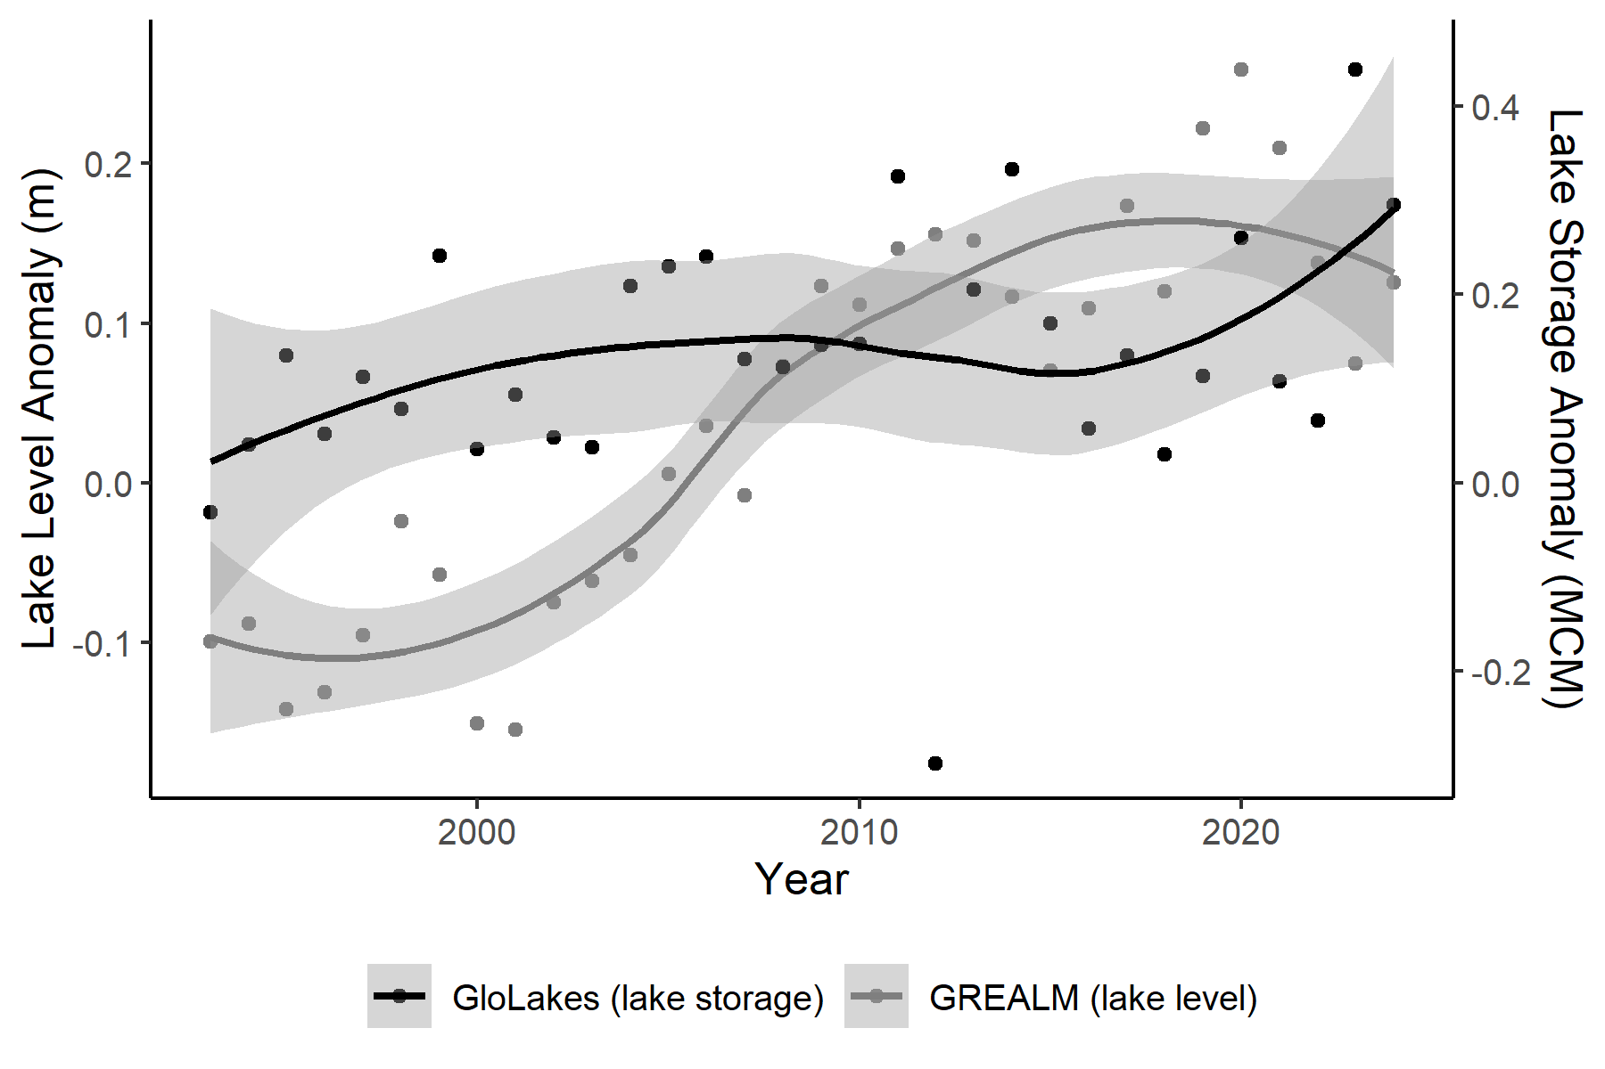

*Fig 2: 2024 lake storage anomalies (%) relative to 1993-2020 binned by lake size, and categorized as ‘natural’ or ‘reservoir’ based on inclusion in the Global Reservoir and Dam Database (Lehner et al. 2011). Lake bin counts (n) are displayed on top; reservoir and dam counts are shown in grey.*

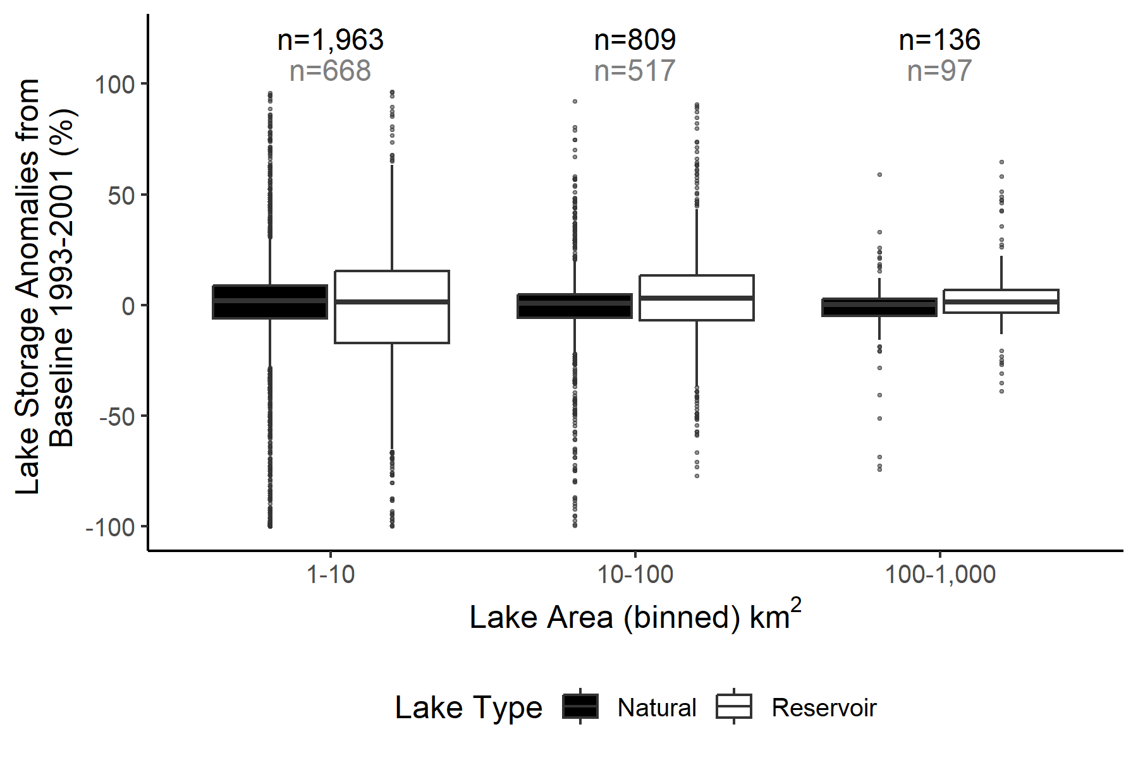

*Plate 2.8 Lake storage (GloLakes) anomalies (%)*

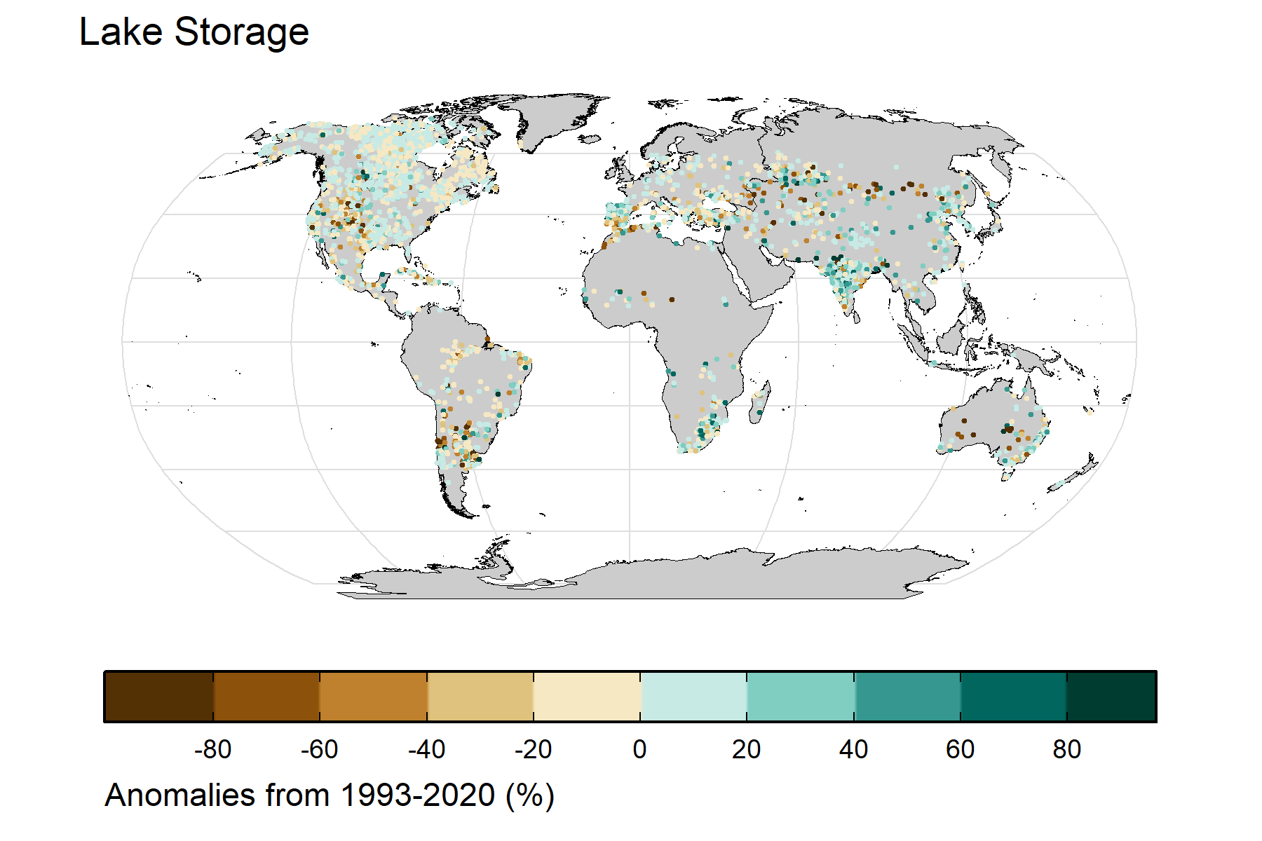

**Datasets used and their URLs**

* ‘GloLakes’ lake and reservoir storage: <https://doi.org/10.5194/essd-16-201-2024>
* Global Lakes and Reservoir Monitor (GREALM) lake level: <https://ipad.fas.usda.gov/cropexplorer/global_reservoir/>

**Acknowledgements**

**Summary bullet points**

* On average, 2024 lake storages across 4,190 lakes were 1.61% higher compared to a baseline averaged period from 1993-2020.
* Although global average lake storage and lake level changes appear small, 42.1% of lakes showed increases or decreases in 2024 in a Welch’s t-test (p < 0.05), highlighting strong lake-specific variability.