# Text game

I created this program as a tool to help develop *Fallout: New Vegas*-style games. Rather than making a whole graphical game, this tool focuses on making it easy to experiment with and develop these features:

* Text descriptions of the game situations and environment.
* Dialog and action trees.
* Character personality scoring (like the “SPECIAL” system in Fallout).
* Characters, factions, backstories, etc.

## Example

Here’s an example of how the game works. This uses a story based on the *Fallout 4* opening, but it’s more detailed about the suburban family we see at the start of the game. The left screen is the opening. If you pick “Vault Tec? I’ve got to talk to them!”, the screen changes to the one on the right:

|  |  |  |
| --- | --- | --- |
|  | 🡺 |  |

## Game source code

The source code for game stories is .*graphml* files produced by yWorks’ graph editing program yEd. Here’s the source code for the first page as seen in yEd. The [merge when …] arrows let you specify optional text, like whether the TV is on or off. The game interpreter edits the parts together:

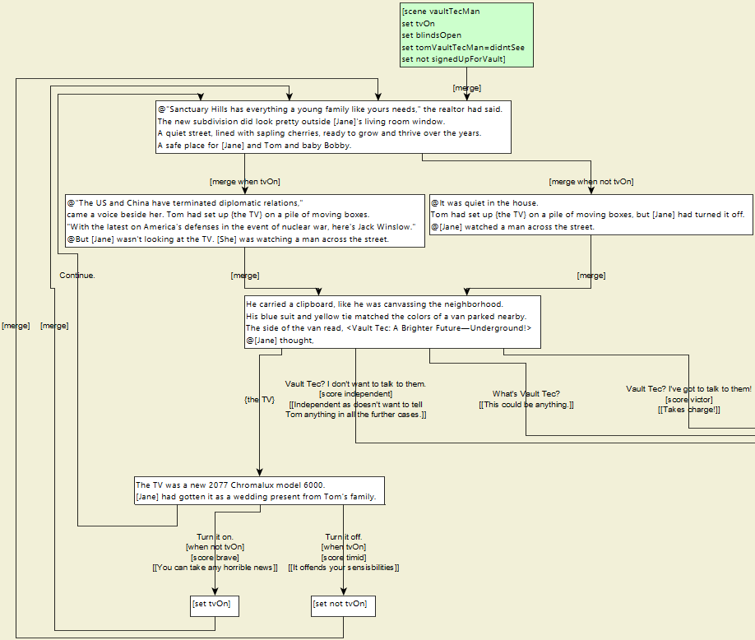

## Personality scoring

In Bethesda’s game Skyrim, if you shoot your bow, your archery skill goes up. Likewise, as you pick options in this game, it increments personality scores, such as independent, victor, brave, and timid:

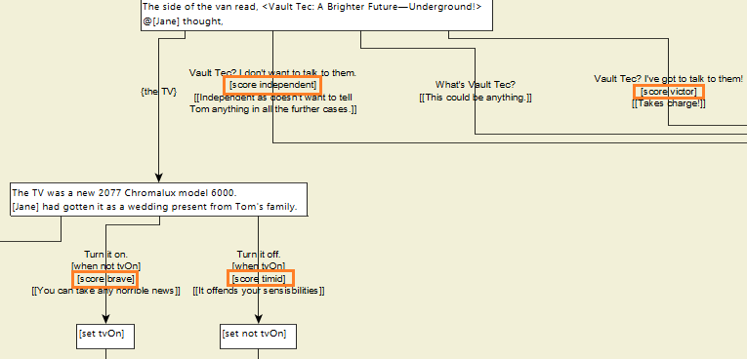

The scores affect what happens later in the game. For example, if you previously scored as cruel, when you ask your husband if he’s all right, your character can’t help but follow up with a critical remark, so he gets angry and leaves in a huff:

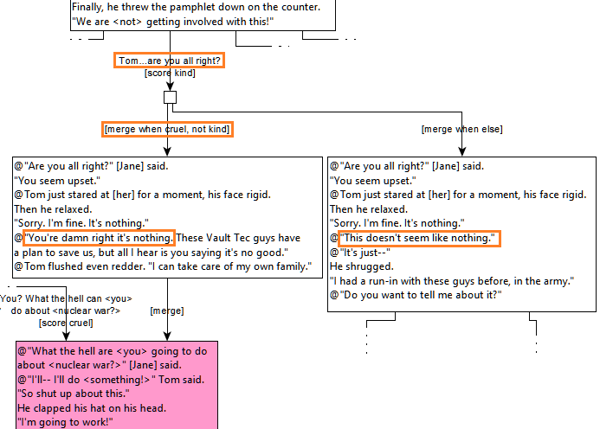

## Conditional editing

You can also do conditional editing within the text boxes:

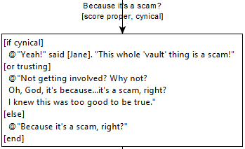

## Program source code example

The interpreter program is written in C#. As an example, here’s how the code that implements conditional editing works. The code uses the object-oriented and functional features of C# to implement execution of code trees in a simple, expressive, and versatile way:

* The program compiles the text box shown above into a tree of “code” objects in memory.
* There are different kinds of code objects: “if” objects, “character text” objects, “block sequence” objects, etc. Thus, the tree contains different kinds of objects that link to other objects in different ways. This is different from the usual binary tree where all the nodes are the same type and link to other nodes in the same way:

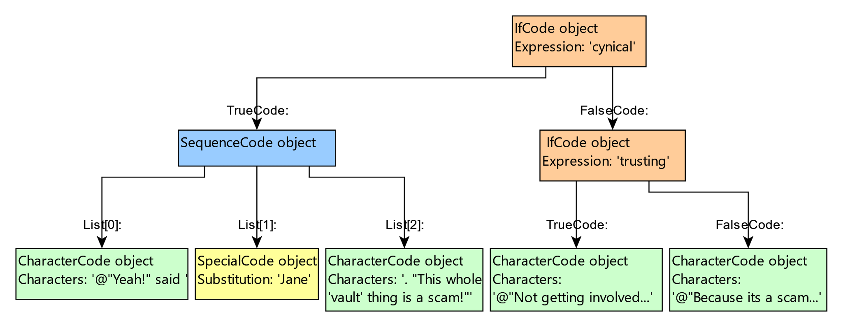

* Even though the objects and links are different, they all implement the same “Traverse” function, which is defined in the abstract base class, “Code”:

public abstract class Code

{

public abstract IEnumerable<Code> Traverse(

Func<List<Expression>, bool?> branchPicker = null);

* Every derived Code class implements the Traverse function appropriately for itself. For example, IfCode yields the values from its TrueCode and/or FalseCode objects:

public class IfCode: Code

{

private readonly List<Expression> Expressions;

public Code TrueCode { get; private set; }

public Code? FalseCode { get; private set; }

public override IEnumerable<Code> Traverse(

Func<List<Expression>, bool?> branchPicker)

{

bool? branchesToExecute =

branchPicker == null? null: branchesToExecute = branchPicker(Expressions);

yield return this;

if (branchesToExecute == null || branchesToExecute == true)

foreach (var code in TrueCode.Traverse())

yield return code;

if (FalseCode != null)

if (branchesToExecute == null || branchesToExecute == false)

foreach (var code in FalseCode.Traverse())

yield return code;

}

SequenceCode has a list of code objects to traverse in sequence. Its Traverse function just iterates through their Traverse functions:

public class SequenceCode: Code

{

private readonly List<Code> Codes;

public override IEnumerable<Code> Traverse(

Func<List<Expression>, bool?> branchPicker)

{

foreach (var code in Codes)

foreach (var subcode in code.Traverse(branchPicker))

yield return subcode;

}

CharacterCode does no traversal. It just yields the object so you can examine the characters:

public class CharacterCode: Code

{

public string Characters { get; private set; }

public override IEnumerable<Code> Traverse(

Func<List<Expression>, bool?> branchPicker)

{

yield return this;

}

* This scheme makes it easy to do all kinds of operations on the code in a functional way. For example, the reaction options are sorted by which one has the highest score. For example, if your character has a high ‘brave’ score, brave options should be listed first. You can find out the highest score for a reaction like this:

highestScore = reactionArrow.Code.Traverse()

.Where(code => code is ScoreCode)

.SelectMany(code => (code as ScoreCode).Ids)

.Select(id => (Settings[id] as ScoreSetting).ScoreValue)

.DefaultIfEmpty(0)

.Max();

* Or you can easily convert the code to the final output string like this:

private string EvaluateText(

CodeTree codeTree)

{

string accumulator = "";

foreach (var code in

codeTree.Traverse(ifExpressions => EvaluateConditions(ifExpressions)))

{

accumulator += code switch

{

CharacterCode characterCode => characterCode.Characters,

SpecialCode specialCode => GetSpecialText(specialCode.Id),

_ => ""

};

}

// Always returns an empty string if there is no useful text.

return NormalizeText(accumulator);

}

## Multi-UI design

Object oriented design makes it easy to switch between different game UIs. The Game object in Game.cs handles all non-UI features (which is most of the code). The Game object returns simple, UI-independent text, like the following, where “@” separates paragraphs, “{…}” marks links, and “<…>” marks italics:

@Sarah was standing in the living room looking at the {pamphlet} when Tom came back in, pulling on his coat. @"<Hey> honey," he said, kissing her cheek. "I'll see you tonight, huh?"

### Windows UI version

The Windows UI code in MainWindow.xaml.cs converts the UI-independent strings to WPF objects, like Hyperlink and Italic:

text += '\0';

int index = 0;

// Search for the marker we stuck on the end.

return BuildInlinesTo('\0');

List<Inline> BuildInlinesTo(

char terminator)

{

var inlines = new List<Inline>();

var accumulator = "";

while (true)

{

switch (text[index++])

{

case '{': // Reaction link.

AddAccumulation(inlines, ref accumulator);

var hyperlink = new Hyperlink();

// No underline.

hyperlink.TextDecorations = null;

hyperlink.Foreground = new SolidColorBrush(Color.FromRgb(0xc0, 0x00, 0x00));

hyperlink.Click += new RoutedEventHandler(HyperlinkClicked);

hyperlink.Cursor = Cursors.Hand;

var position = text.IndexOfAny(new char[] { '}', '\0' }, index);

hyperlink.CommandParameter = text.Substring(index, position - index);

hyperlink.Inlines.AddRange(BuildInlinesTo('}'));

inlines.Add(hyperlink);

break;

case '<': // Italic.

AddAccumulation(inlines, ref accumulator);

var italic = new Italic();

italic.Inlines.AddRange(BuildInlinesTo('>'));

inlines.Add(italic);

break;

case '\0':

--index;

return AddAccumulation(inlines, ref accumulator);

case var letter:

if (letter == terminator)

return AddAccumulation(inlines, ref accumulator);

accumulator += letter;

break;

### HTML version

The ASP.NET web version has practically the same code as the Windows version, but converts to HTML instead of WPF in the GameController.cs file (the controller later sends the HTML to clients via a REST web API):

text += '\0';

int index = 0;

var htmlAccumulator = "";

// Search for the marker we stuck on the end.

BuildParagraphTo('\0');

return htmlAccumulator;

void BuildParagraphTo(

char terminator)

{

while (true)

{

switch (text[index++])

{

case '{': // Reaction link.

var terminatorPosition = text.IndexOfAny(new char[] { '}', '\0' }, index);

var reactionText = text.Substring(index, terminatorPosition - index);

htmlAccumulator += "<a href='ignore' onclick='return onReactionClick(\"" + reactionText + "\");'>";

BuildParagraphTo('}');

htmlAccumulator += "</a>";

break;

case '<': // Italic.

htmlAccumulator += "<i>";

BuildParagraphTo('>');

htmlAccumulator += "</i>";

break;

case '\0':

--index;

return;

case var letter:

if (letter == terminator)

return;

htmlAccumulator += letter;

break;

}