**Assignment 1: Photo Sharing Application Use Descriptions**

**User Stories**

* As a photo sharing user, I want to upload a picture from a local file.
* As a photo sharing user, I want to upload a picture from a hyperlink.
* **Other common/possible user stories**
  + As a photo sharing user, I want to write a caption when I upload a picture.
  + As a photo sharing user, I want to edit pictures when I upload them.
  + As a photo sharing user, I want to pick the users who see the uploaded picture.

**Use Cases**

* Upload a picture from a local file

|  |  |
| --- | --- |
| Actor(user) Actions | System Responses |
| 1. Choose ‘Upload Picture’ command | 2. Display ‘Options of Upload’ Dialog |
| 3. Specify ‘File’ as upload option | 4. Display ‘File Open’ dialog |
| 5. Confirm Selection | 6. Dialog disappears |
|  | 7. Display ‘Picture Upload Confirmation’ Dialog |
| 8. Input caption, edit picture, change view setting, and confirm upload | 9. Display picture and other components on the application feed |

* Upload a picture from a hyperlink

|  |  |
| --- | --- |
| Actor(user) Actions | System Responses |
| 1. Choose ‘Upload Picture’ command | 2. Display ‘Options of Upload’ Dialog |
| 3. Specify ‘Hyperlink’ as upload option | 4. Display ‘Hyperlink Enter’ dialog |
| 5. Enter hyperlink and submit it | 6. Dialog disappears |
|  | 7. Display ‘Picture Upload Confirmation’ Dialog |
| 8. Input caption, edit picture, change view setting, and confirm upload | 9. Display picture and other components on the application feed |

**Mock-Up Interfaces**

* Application feed. Displays pictures (and other attributes) users have uploaded.
*  Indicates file upload command

**Photo Share**

**UserName1**



**Caption**

**UserName2**

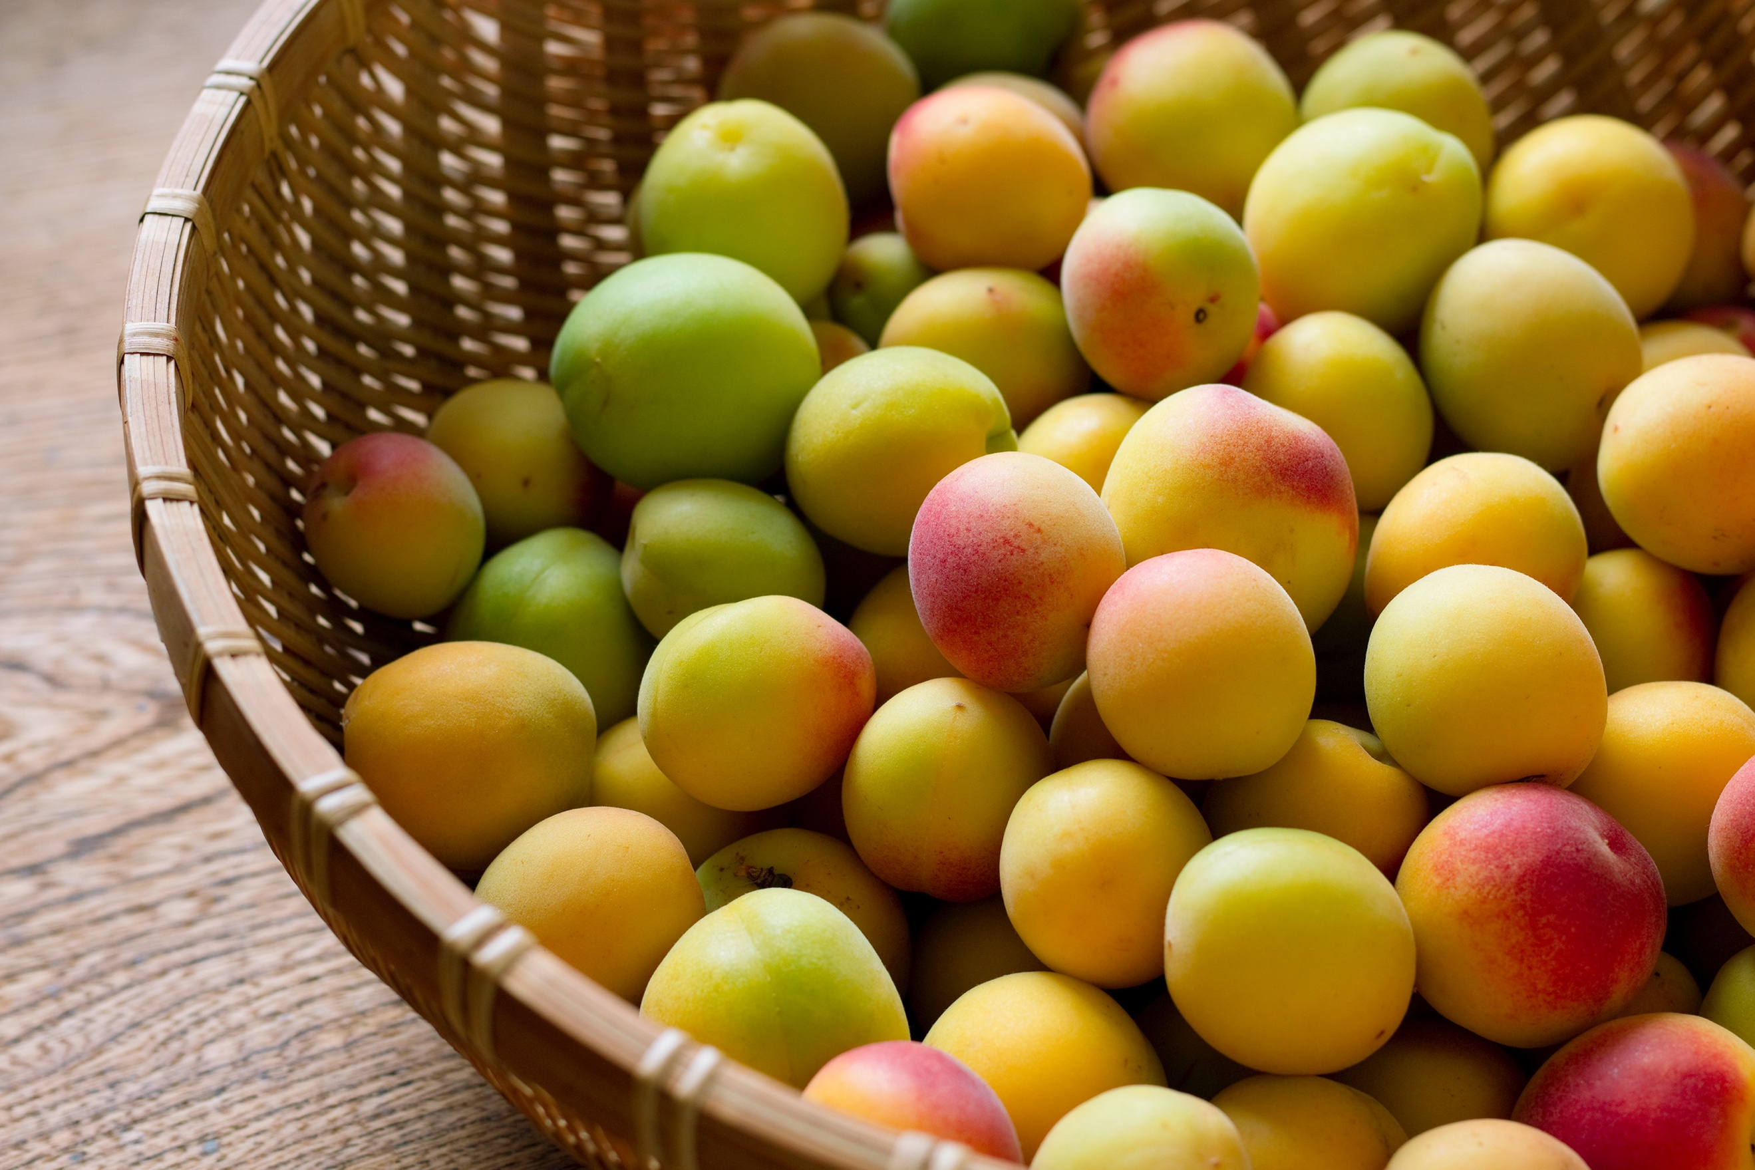

   

* ‘Options of Upload’ dialog

 

Hyperlink

Local File

Choose an upload option:

**Upload Photo**

* ‘File Open’ dialog

**Upload Photo**

Choose a file to open:

* ‘Hyperlink Enter’ dialog

**Upload Photo**

Submit

Ex: https://www.image.com

Please enter hyperlink:

* ‘Picture Upload Confirmation’ dialog

Edit

View: Friends Only 

Upload

Caption: text here



**Upload Photo**