COMP 4320

Introduction to Computer Networks 2022 Summer Mini-Semester II

# Homework 2

Due in Canvas: 11:55 pm July 24, 2022

Reference textbook: Computer Networking: A Top-Down Approach, 8th Edition, by James F. Kurose and Keith W. Ross, published by Pearson Education, Inc., 2021, ISBN 9780135928615.

*All homework assignments must be completed by each student individually. Any copying of someone else's work, or misrepresentation of other work as your own, will be grounds for failing this assignment or the course.*

Penalty for late work is 20 points per day late. All homework must be submitted in Canvas.

There are 6 questions; make sure you answer all the questions.

1. Consider an HTTP client that wants to retrieve a Web document at a given URL. The IP address of the HTTP server is initially unknown. What transport and application-layer protocols besides HTTP are needed in this scenario?

**The application-layer protocol needed is DNS for retrieval of the server’s IP address. The transport-layer protocols needed are UDP and TCP. UDP is what the DNS protocol runs over, and TCP is the underlying transport protocol for HTTP.**

1. Suppose within your Web browser you click on a link to obtain a Web page. The IP address for the associated URL is not cached in your local host, so a DNS lookup is necessary to obtain the IP address. Suppose that *N* DNS servers are visited before your host receives the IP address from DNS; the successive visits incur an RTT of *RTT1, …, RTTN*. Further suppose that the Web page associated with the link contains exactly one object, consisting of a small amount of HTML text. Let *RTTs* denote the *RTT* between the local host and the server containing the object. Assume that the transmission time of the object is *Ti*. How much time elapses from when the client clicks on the link until the client receives the object.

**TIPAddress = RTT1 + RTT2 + … + RTTN**

**TObject = 2RTTs + Ti**

**TTotal = RTT1 + RTT2 + … + RTTN + 2RTTs + Ti**

1. Referring to Problem 2 above, suppose the HTML file references eight very small objects on the same server. Neglecting transmission time, how much time elapses with
   1. Non-persistent HTTP with no parallel TCP connections?

**T = RTT1 + RTT2 + … + RTTN + 2RTTs + 8(2RTTs)**

**= RTT1 + RTT2 + … + RTTN + 18RTTs**

* 1. Non-persistent HTTP with the browser configured for 6 parallel connections?

**T = RTT1 + RTT2 + … + RTTN + 2RTTs + 2RTTs + 2RTTs**

**= RTT1 + RTT2 + … + RTTN + 6RTTs**

* 1. Persistent HTTP? (Assume that pipelining is used.)

**T = RTT1 + RTT2 + … + RTTN + 2RTTs + RTTs**

**= RTT1 + RTT2 + … + RTTN + 3RTTs**

1. Consider a short, 90-meter link, over which a sender can transmit at a rate of 420 bits/sec in both directions. Suppose that packets containing data are 320,000 bits long, and packets containing only control (e.g., ACK or handshaking) are 240 bits long. Assume that *N* parallel connections each get 1/*N* of the link bandwidth. Now consider the HTTP protocol and assume that each downloaded object is 320 Kbit long, and the initial downloaded object contains 6 referenced objects from the same sender. Would parallel download via parallel instances of non- persistent HTTP make sense in this case? Now consider persistent HTTP. Do you expect significant gains over the non-persistent case? Justify and explain your answer.

**6 objects = 6 connections = 420/6 = 70 bits/sec**

**dprop = = 0.3 microsec**

**Parallel instances of non-persistent HTTP:**

**T = ( $\frac{240}{420}+ 0.3s+ \frac{240}{420}+ 0.3s+ \frac{240}{420}+ 0.3s+\frac{320000}{420} + 0.3s)+(\frac{240}{70}+ 0.3s+ \frac{240}{70}+ 0.3s+ \frac{240}{70}+ 0.3s+\frac{320000}{70} + 0.3s)$ = 5345.33 sec + 2.4 $s$ = 5345.33 sec**

**Persistent HTTP:**

**T = ( $\frac{240}{420}+ 0.3s+ \frac{240}{420}+ 0.3s+ \frac{240}{420}+ 0.3s+\frac{320000}{420} + 0.3s)+6\left(\frac{240}{420}+ 0.3s+\frac{320000}{420} + 0.3s\right)$ = 5338.48 sec + 4.8 $s$ = 5338.48 sec**

**Based on the calculations above there is no significant difference in using persistent HTTP over non-persistent HTTP in this scenario. Persistent HTTP is slightly faster by 6.85 seconds but overall, the timings are too close for there to be any significant gains from using persistent HTTP.**

1. Consider the scenario introduced in Question (4) above. Now suppose that the link is shared by Tom with seven other users. Tom uses parallel instances of non-persistent HTTP, and the other seven users use non-persistent HTTP without parallel downloads.
   1. Do Tom’s parallel connections help him get Web pages more quickly? Why or why not?

**Yes, since Tom has multiple connections, he has more of the bandwidth than the other users have with their single connections.**

* 1. If all eight users open parallel instances of non-persistent HTTP, then would Tom’s parallel connections still be beneficial? Why or why not?

**Yes, Tom will still get more bandwidth by having multiple connections than if he just has a single connection even if there are others who also have parallel connections.**

1. Consider Figure 1 in which there is an institutional network connected to the Internet. Suppose that the average object size is 675,000 bits and that the average request rate from the institution’s browser to the origin server is 20 requests per second. Also suppose that the amount of time it takes from when the router on the Internet side of the access link forwards an HTTP request until it receives the response is 2.0 seconds on average. Model the total average response time as the sum of the average access delay (that is, the delay from Internet router to institution router) and the average Internet delay.

The average access delay is related to the traffic intensity as given in the following table.

|  |  |  |  |  |  |  |  |  |  |  |
| --- | --- | --- | --- | --- | --- | --- | --- | --- | --- | --- |
| Traffic Intensity | 0.50 | 0.55 | 0.60 | 0.65 | 0.70 | 0.75 | 0.80 | 0.85 | 0.90 | 0.95 |
| Average access delay (msec) | 26 | 33 | 41 | 52 | 64 | 80 | 100 | 137 | 250 | 1000 |

Traffic intensity is calculated as follows: Traffic intensity = *aL/R,* where *a* is the arrival rate, *L* is the packet size and *R* is the transmission rate.

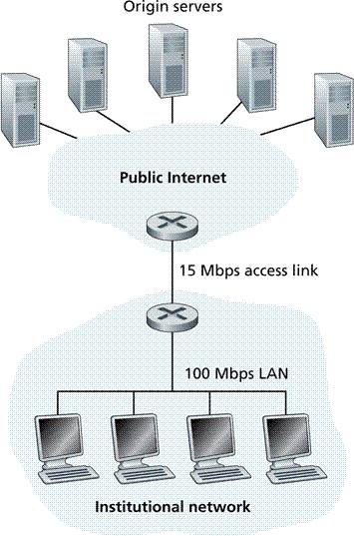

Figure 1. Access Link Connecting an Institutional Network to the Internet

* 1. Find the total average response time.

$$\frac{L}{R}=\frac{675000 bits}{15000000 bits/sec}=0.045 sec$$

**Traffic intensity = $\frac{aL}{R}=\frac{20 req}{sec} × \frac{0.045 sec}{req}=0.9$**

**Average access delay = $0.250 sec$ (from chart)**

**Total average response time = 2.0 sec + 0.250 sec = 2.25 sec**

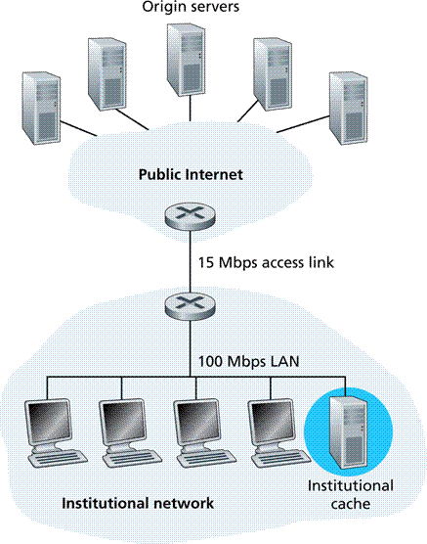

Figure 2. Adding a Cache to the Institutional Network

* 1. Now suppose a cache is installed in the institutional LAN as shown in Fig. 2. Suppose the hit rate is 0.333. Find the total average response time.

**Cache response is very fast ≈ 0 sec**

**Traffic intensity internet = 0.667(0.9) = 0.6003**

**Average access delay = 0.041 sec (from chart)**

**Total average response time for miss = 0.041 + 2.0 = 2.041 sec**

**Total average response time = 0.667(2.041) + 0 = 1.36 sec**