**XML Assignment 1**

**Creating an XML Compound Document and validating it with DTD\***

1. Create 2 XML vocabularies **teams.xml**, for the team series, and **cars.xml**, for the cars available for the racing team based on the description provided in Figure 1.

(Note: You should show a minimum of 2 teams in teams.xml and for cars.xml, define each car which you define in teams.xml since both the namespaces shown below are connected to each other through ‘cars’. Also remember that one car can belong to more than 1 team. Don’t forget to include namespaces for both xml vocabularies. )

***Related text: page 71-80 of the XML book***

1. Create a **souths.xml** master document, see the file relationship in Figure 2 that:
   1. Contains an *internal DTD* for the **teams** and **cars** *name spaces*;
   2. Uses entities to read information from different documents into the compound document.

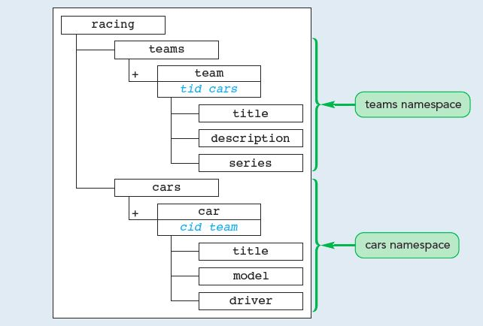

**Figure 1: Structure of the compound document**

**Recommended Reading:** Fig 2-14 on page 95

(Note: Both carID and teamID could be considered as required attributes and the elements of both team and cars could use PCDATA content model. Use ENTITY to make reference between the files. Related text: page 108 in the book.)

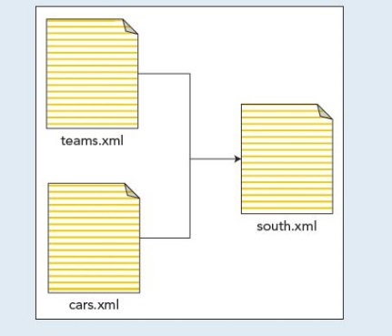

**Figure 2: Files relationship for the compound document**

**\*** Carefully study Lecture 1 & 2 before starting to work on Assignment 1