*Here's How Much Money Bad Credit Will Really Cost You*

*Bad credit can have some costly repercussions.*

**

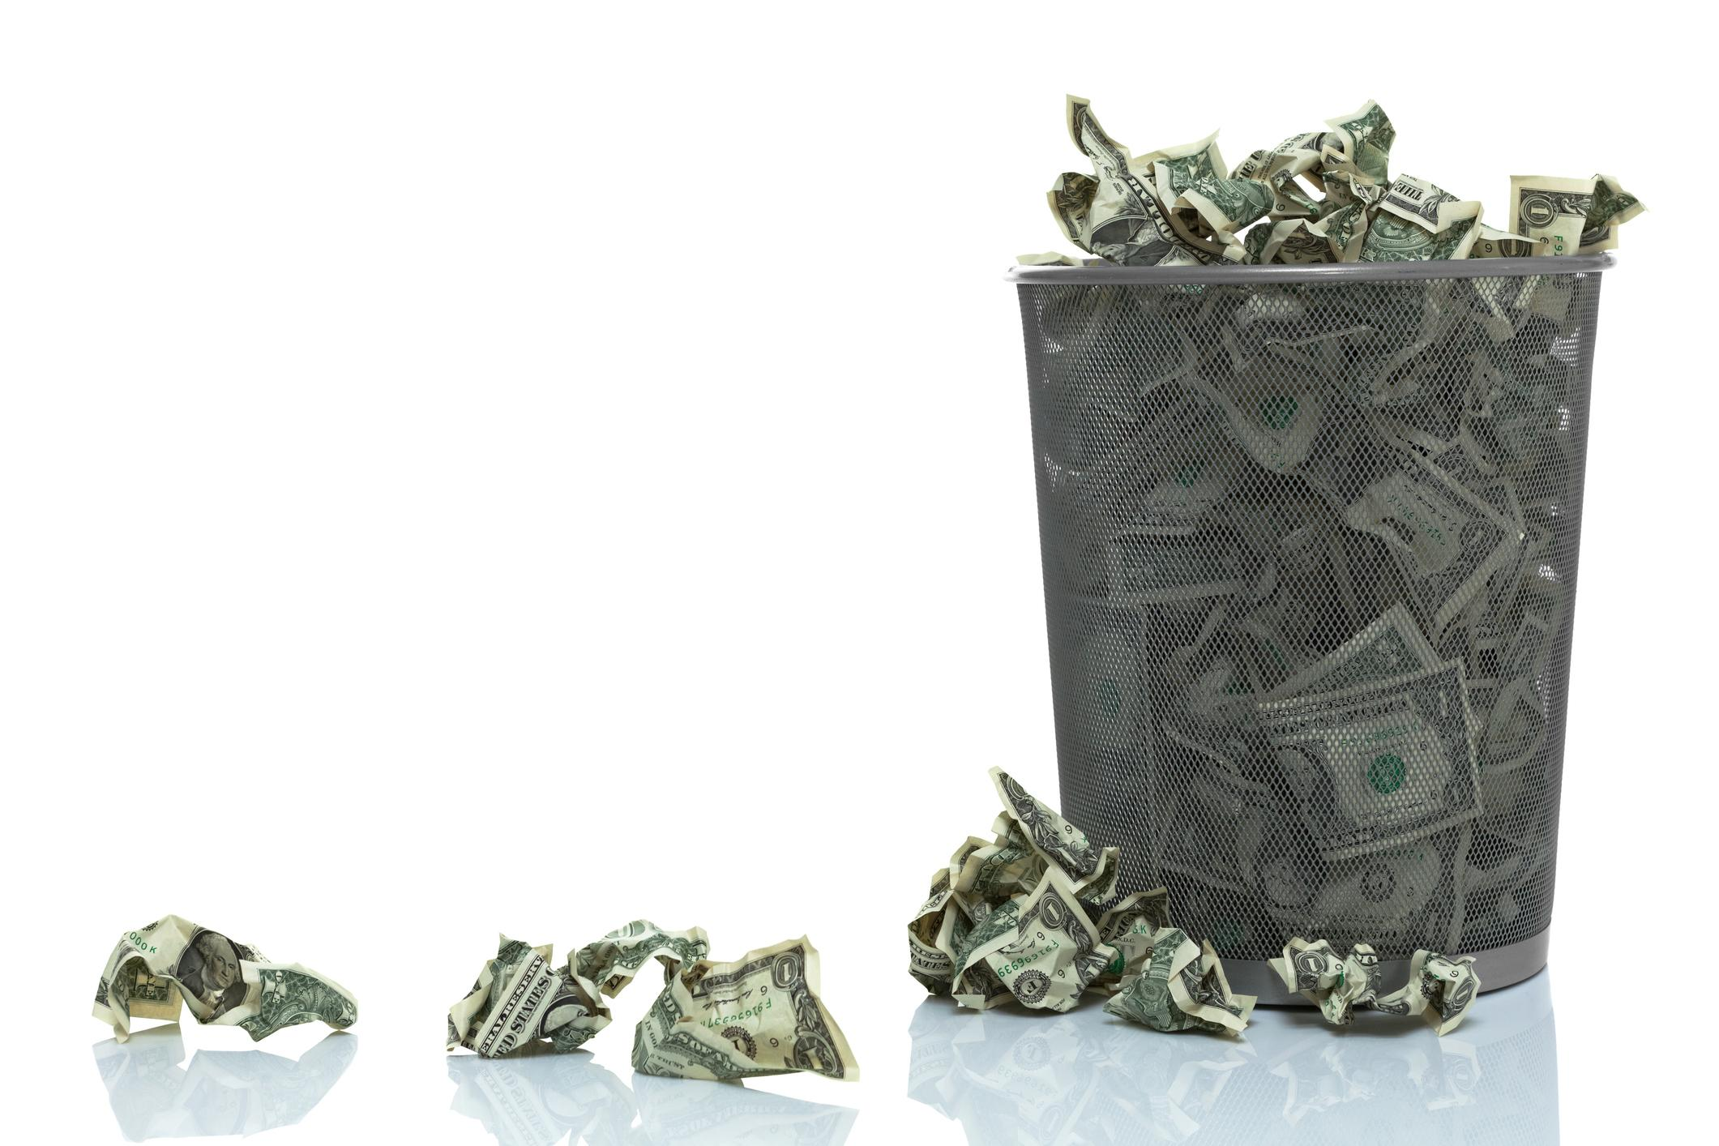

*Image source: Getty Images.*

It's no secret that bad credit can cost you money, but what consumers often don't realize is just how expensive it can be.

Your credit score will obviously come into play whenever you're borrowing money, and it can also affect monthly expenses, such as your auto insurance premiums. If your credit isn't the best right now, a look at how much that costs you could be just the motivation needed to boost your score.

Here's how much more you'll pay with bad credit for a home, insurance, and more.

## Mortgages

According to MyFICO, the annual percentage rate (APR) on a mortgage can vary by over 1.5% depending on your credit score. That may not seem like much, but it makes a huge impact on how much you pay over the lifespan of the loan.

To qualify for a traditional mortgage, you typically need a credit score of 620 or higher. Here's how much your payments will differ on a 30-year, fixed-rate $250,000 mortgage with excellent credit compared to that minimum of 620.

**760 or above:**

* **APR:** 027%
* **Monthly mortgage payment:** $1,197
* **Total interest paid:** $181,076

**620 to 639:**

* **APR:** 616%
* **Monthly mortgage payment:** $1,438
* **Total interest paid:** $267,579

**Total cost of bad credit:** $241 per month and $86,503 over the life of the loan

## Auto loans

Auto loans are available to consumers with almost any credit score, but you'll pay much more if you don't have good credit. Let's look at what your rates would be with a credit score of 720 or higher, which qualifies you for the lowest auto loan interest rates, compared to any score below 590.

For this example, we're going with a 60-month new car loan for $20,000 and using rate estimates from MyFICO.

**720 or above:**

* **APR:** 567%
* **Monthly loan payment:** $373
* **Total interest paid:** $2,408

**589 or below:**

* **APR:** 188%
* **Monthly loan payment:** $499
* **Total interest paid:** $9,945

**Total cost of bad credit:** $126 per month and $7,537 over the life of the loan

## Auto insurance

Although it may seem unfair to have your credit score affect your auto insurance premiums, statistics show that drivers with lower credit scores file claims more often. For that reason, insurance carriers base your premiums in part on your credit score.

The only exception is if you live in California, Massachusetts, or Hawaii, because those three states have outlawed this practice.

Otherwise, here's what the average driver pays for auto insurance with an excellent and not-so-excellent credit score, according to The Zebra's 2019 "The State of Auto Insurance" report:

* **800 or higher credit score** -- Approximately $1,297 per year
* **579 or lower credit score** -- Approximately $2,717 per year

**Total cost of bad credit:** $1,420 per year

## Renting an apartment

There are two ways bad credit can hurt you when you apply to rent an apartment.

First, the landlord may deny your application due to your credit. This will depend on both what credit score the landlord will accept and also the credit scores of any other applicants for the apartment. If another applicant has a higher credit score, odds are that the landlord will choose them.

If you are approved, you'll likely need to pay a larger security deposit. The advertised security deposit is typically on approved credit, meaning you only qualify for that if your credit is good enough. With bad credit, your deposit may be double that amount or the equivalent of another month's rent.

## Utilities

Utilities companies will often require consumers with bad credit to pay a deposit when they first set up their service. The amount of the deposit will depend on the laws in the state where you live. You could end up paying an estimate for one month's worth of service -- or multiple months' worth.

Since this is a deposit, though, you'll get it back if you pay your bill on time.

## Credit cards

Bad credit can be extremely costly when it comes to credit cards.

First and foremost, when you have a credit score below 580, you'll probably only qualify for [**secured credit cards**](https://www.fool.com/the-ascent/credit-cards/secured-credit-cards/). With these types of credit cards, you must pay a security deposit up front, and typically your security deposit is equal to your credit limit. At a minimum, you'll likely need to put up $100 to $200 just to open a secured credit card account.

Where bad credit will really cost you is in the missed opportunities. Many of the [**best credit cards**](https://www.fool.com/the-ascent/credit-cards/) offer [**sign-up bonuses worth hundreds of dollars**](https://www.fool.com/the-ascent/credit-cards/best-sign-up-bonus-cards/) and also earn rewards on all your spending. But you can only take advantage of those offers with good to excellent credit.

## Saving money with better credit

It can be frustrating how much more you spend when you have bad credit. Fortunately, anyone can raise their credit if they're willing to follow the right habits and put in the work. Get started by learning [**what goes into your credit score**](https://www.fool.com/the-ascent/credit-cards/blog/how-is-your-credit-score-calculated/) and [**how you can boost it**](https://www.fool.com/the-ascent/credit-cards/blog/3-simple-ways-to-raise-your-credit-score/), and you won't need to worry about your credit holding you back anymore.