VACON
PARAMETER REGISTERS
Signal | VACON ID (Reg) | Command (Hex frame) | Meaning
Motor Current | 0003h | 01 03 00 03 00 01 85 DB | Read 1 register at 0003h
Output Frequency | 0001h | 01 03 00 01 00 01 84 0A | Read 1 register at 0001h
Frequency Reference | 0019h (25 dec) | 01 03 00 19 00 01 25 C8 | Read 1 register at 0019h
Motor Voltage | 0006h | 01 03 00 06 00 01 85 D8 | Read 1 register at 0006h
Motor Power | 0005h | 01 03 00 05 00 01 54 09 | Read 1 register at 0005h
Motor Torque | 0004h | 01 03 00 04 00 01 C5 D9 | Read 1 register at 0004h

WIRING
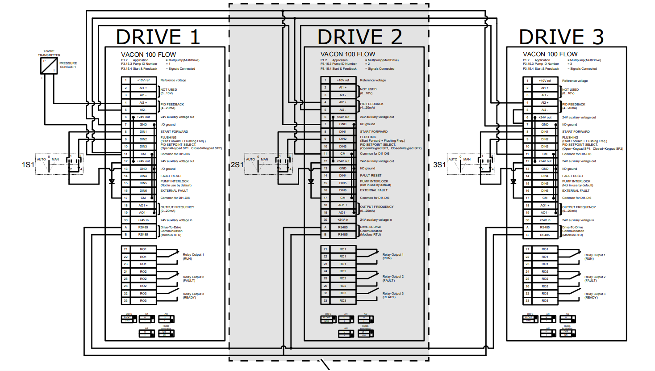RS485-A and RS485-B manual didn’t suggest external terminating resistor it has ha switch for terminating resistor
TERMINATION WIRING AND TERMINATING DIP SWITCH 