**MODBUS RTU SETUP FOR TECO A510 A510S DRIVES**

**RS485 COMMUNICATION WIRING**  
The communication parameters are located in Parameter Group 09. The A510s uses an RJ45 connector for its built-in RS485 port, labeled S(+) / S(-).

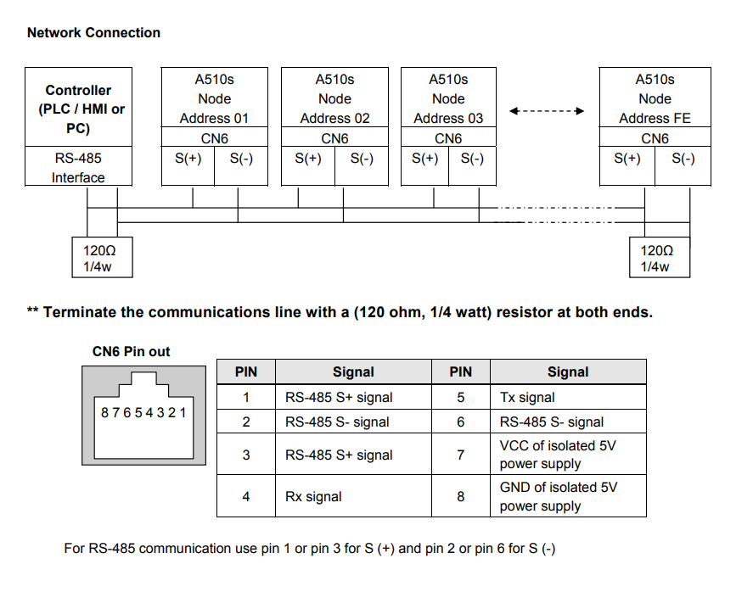

**1. Enable Modbus RTU Communication**

Parameter 09-00: Protocol Selection

Default Value: 0 (TECO standard protocol)

Required Value: Set to 1 to select Modbus RTU protocol.

This is the primary setting that enables the drive to interpret incoming messages as Modbus RTU.

**2. Set the Device (Slave) Address**

Parameter 09-01: Communication Address

Default Value: 1

Required Value: Set to 1 (or any unique address from 1 to 247 for your network).

This is the slave ID that the drive will respond to on the Modbus network.

**3. Set the Baud Rate**

Parameter 09-02: Baud Rate Selection

Default Value: 3 (4800 bps)

Required Value: Set to 5 to select 9600 bps.

*Common baud rate options in this parameter are: 0=1200, 1=2400, 2=4800, 3=9600, 4=19200, 5=38400. Please verify the exact numerical options in your parameter list, as the manual extract did not include the full description for 09-02. Setting it to 3 or 5 is typical for 9600 bps.*

**4. Set the Data Format (8N1)**

Parameter 09-03: Communication Data Format

Default Value: 0 (8 data bits, No parity, 1 stop bit - 8N1)

Required Value: Ensure this is set to 0 for 8N1.

This parameter configures the frame format. Value 0 is the standard for Modbus RTU.

**5. Set the Run/Stop Command Source (Optional but Recommended)**

**To control the drive via Modbus, you must set the command source to communication.**

Parameter 00-02: Main Run Command Source Selection

Default Value: 1 (External Terminal)

Required Value: Set to 2 for Communication Control (RS-485).

**6. Set the Frequency Reference Source (Optional but Recommended)**

**To set the speed reference via Modbus, you must set the frequency source to communication.**

Parameter 00-05: Main Frequency Command Source Selection

Default Value: 1 (External Terminal - Analog AI1)

Required Value: Set to 3 for Communication Control (RS-485).

Keypad Navigation Sequence:

**Press the DSP/FUN key until you are in the Parameter Group Mode.**

**Use the ▲ or ▼ keys to scroll to Group 09.**

**Press READ/ENTER to enter the group.**

**Use the ▲ or ▼ keys to select parameter 09-00.**

**Press READ/ENTER to view its current value.**

**Use the ▲, ▼, and ◀ keys to change the value to 1.**

**Press READ/ENTER to save the value.**

**Press DSP/FUN to go back to the parameter list within Group 09.**

**Repeat steps 4-7 for parameters 09-01, 09-02, and 09-03.**

**Press DSP/FUN multiple times to exit to the main monitor screen.**

**Verification:**

After configuration, wire the RS485 connection to terminals S(+) and S(-). Use a Modbus test tool (e.g., ModScan32, CAS Modbus Scanner) and configure it for:

Protocol: Modbus RTU

Port: COM port of your USB-to-RS485 converter

Settings: 9600, 8, None, 1

Slave ID: 1

Test Poll:

Read the Output Frequency register (a 32-bit value).

Function: Read Holding Registers (03)

Start Address: 8192 (Decimal) or 0x2000 (Hex)

Number of Registers: 2

If the configuration is correct, the tool will successfully read back the drive's output frequency (e.g., 0.00 Hz if stopped). Writing a value to the Set Frequency register (8194 dec / 0x2002 hex) should change the drive's frequency reference.

