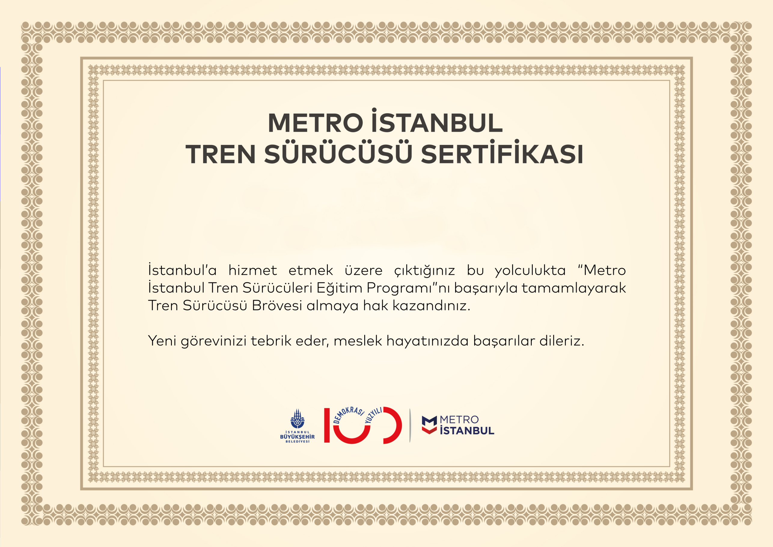

Sayın AD

|  |  |  |  |  |  |  |  |
| --- | --- | --- | --- | --- | --- | --- | --- |
| METRO | |  | TRAMVAY | |  | FUNİKÜLER/TELEFERİK | |
| M1 ABB | AAA |  | T1 BOMBARDİER | AAI |  | F1 | AAP |
| M2 ROTEM1 | AAB |  | T1 ALSTOM | AAJ |  | F4 | AAQ |
| M2 ROTEM2 | AAC |  | T3 GOTHA | AAK |  | TF1 | AAR |
| M3 ALSTOM | AAD |  | T4 İTA | AAL |  | TF2 | AAS |
| M4 CAF | AAE |  | T4 ROTEM | AAM |  |  |  |
| M5 CAF | AAF |  | T4 KTA | AAN |  |  |  |
| M7 ROTEM | AAG |  | T5 DURMAZLAR | AAO |  |  |  |
| M8 ROTEM | AAH |  |  |  |  |  |  |
|  |  |  |  |  |  |  |  |
|  |  |  |  |  |  |  |  |
|  |  |  |  |  |  |  |  |