REDUCING THE COST OF ELECTRIC TRANSMISSION AND DISTRIBUTION SYSTEMS WITH WIND GENERATION BY MEANS OF ENERGY STORAGE AND DEMAND SIDE MANAGEMENT

A THESIS SUBMITTED TO
THE GRADUATE SCHOOL OF NATURAL AND APPLIED SCIENCES
OF
MIDDLE EAST TECHNICAL UNIVERSITY

BY

MERT BİLDİRİCİ

IN PARTIAL FULFILLMENT OF THE REQUIREMENTS
FOR
THE DEGREE OF MASTER OF SCIENCE
IN
ELECTRICAL AND ELECTRONICS ENGINEERING

JANUARY 2018

Approval of the thesis:
REDUCING THE COST OF ELECTRIC TRANSMISSION AND DISTRIBUTION SYSTEMS WITH WIND GENERATION BY MEANS OF ENERGY STORAGE AND DEMAND SIDE MANAGEMENT

submitted by MERT BİLDİRİCİ in partial fulfillment of the requirements for the degree of Master of Science in Electrical and Electronics Engineering Department, Middle East Technical University by,

Prof. Dr. Gülbin Dural Ünver  Dean, Graduate School of Natural and Applied Sciences | _____________
Prof. Dr. Tolga Çiloğlu  Head of Department, Electrical and Electronics Engineering | _____________
Assist. Prof. Dr. Ozan Keysan  Supervisor, Electrical and Electronics Eng. Dept., METU | _____________
Examining Committee Members:
Prof. Dr. Ali Nezih Güven  Electrical and Electronics Engineering Dept., METU | _____________
Assist. Prof. Dr. Ozan Keysan  Electrical and Electronics Engineering Dept., METU | _____________
Assist. Prof. Dr. Murat Göl  Electrical and Electronics Engineering Dept., METU | _____________
Assist. Prof. Dr. Ayşe Selin Kocaman  Industrial Engineering Dept., Bilkent Uni. | _____________
Assist. Prof. Dr. Oğuzhan Ceylan  Management Information Systems Dept., Kadir Has Uni. | _____________
Date: | 19.01.2018

I hereby declare that all information in this document has been obtained and presented in accordance with academic rules and ethical conduct. I also declare that, as required by these rules and conduct, I have fully cited and referenced all material and results that are not original to this work.

Name, Last Name | : | Mert BİLDİRİCİ
Signature | :

ABSTRACT

REDUCING THE COST OF ELECTRIC TRANSMISSION AND DISTRIBUTION SYSTEMS WITH WIND GENERATION BY MEANS OF ENERGY STORAGE AND DEMAND SIDE MANAGEMENT

Bildirici, Mert
M.S., Department of Electrical and Electronics Engineering
Supervisor: Assist. Prof. Dr. Ozan Keysan

January 2018, 99 pages

Today, wind energy is the most popular renewable energy source and share of wind generation in overall electric power generation is expected to grow significantly for the next years. Considering this increase, energy balance problem will become harder to achieve due to unpredictable and varying nature of wind power. In order to handle with the negative impacts of wind power, it is essential to provide flexibility to power systems.

This thesis focuses on the transmission system upgrade deferral for a hypothetical scenario; where a wind generation farm is connected to a near organized industrial zone. The main purpose of this study is to investigate the feasibility of the transmission structure upgrade deferral for the constructed scenario by increasing flexibility of the power system via demand side management and energy storage applications.

Using real generation and load data, proposed applications are examined for different cases. The analysis of the problem and system models are given with simulation results and obtained results are compared and discussed.

Keywords: Transmission and Distribution Upgrade Deferral, Demand Side Management, Energy Storage Systems

ÖZ

ENERJİ DEPOLAMA VE TALEP TARAFI YÖNETİMİ VASITASIYLA RÜZGAR ENERJİSİ ÜRETİMİ BULUNAN ELEKTRİK İLETİM VE DAĞITIM SİSTEMLERİNİN MALİYETİNİN DÜŞÜRÜLMESİ

Bildirici, Mert
Yüksek Lisans, Elektrik ve Elektronik Mühendisliği Bölümü
Tez Yöneticisi: Assist. Prof. Dr. Ozan Keysan

Ocak 2018, 99 sayfa

Günümüzde rüzgar enerjisi en popüler yenilenebilir enerji kaynağı durumundadır ve toplam elektrik üretimi göz önüne alındığında, rüzgar enerjisi üretim payının ilerleyen yıllarda önemli bir ölçüde artacağı beklenmektedir. Bu artış göz önüne alındığında, rüzgar enerjisinin öngörülemeyen ve değişken doğası nedeniyle enerji dengeleme sorunu daha da güçleşecektir. Rüzgar enerjisinin olumsuz etkileriyle başa çıkabilmek için güç sistemlerine esneklik sağlamak gereklidir.

Bu tez, bir rüzgar üretim çiftliğinin yakında bulunan organize sanayi bölgesine bağlı olduğu varsayımsal bir senaryo üzerinden iletim sistemlerinin geliştirilmesinin ertelenmesi üzerinde yoğunlaşmaktadır. Bu çalışmanın temel amacı, talep tarafı yönetimi ve enerji depolama uygulamaları vasıtasıyla güç sistemi esnekliğini arttırarak, oluşturulmuş senaryo üzerinde iletim sistemi yapısının geliştirilmesinin ertelenmesi üzerine uygulanabilirlik araştırması yapılmasıdır.

Önerilen uygulamalar, gerçek üretim ve yük verileri kullanılarak, farklı durumlar için incelenmektedir. Problem analizi ve sistem modelleri, simülasyon sonuçları ile birlikte verilmekte ve elde edilen sonuçlar karşılaştırılarak değerlendirilmektedir.

Anahtar Kelimeler: İletim ve Dağıtım Sistemlerinin Geliştirilmesinin Ertelenmesi, Talep Tarafı Yönetimi, Enerji Depolama Sistemleri

To my family

ACKNOWLEDGEMENTS

Firstly, I would like to express my deepest gratitude to my supervisor Assist. Prof. Dr. Ozan Keysan for his significant guidance, useful advice and encouragement throughout this study.
I would like to thank Dr. Cem Özgür Gerçek, for his guidance and support. I also would like to thank all my colleagues in Electrical Power Technologies Group of TÜBİTAK MAM Energy Institute for their support and friendship.
Finally, and most importantly, I owe my greatest gratitude to my family for their enduring support and love.

TABLE OF CONTENTS

ABSTRACT v
ÖZ vii
ACKNOWLEDGEMENTS x
TABLE OF CONTENTS xi
LIST OF TABLES xiii
LIST OF FIGURES xv
CHAPTERS
1. INTRODUCTION 1
1.1. Motivation for the Thesis 1
1.2. Aims of the Thesis 5
1.3. Outline of the Thesis 6
2. PROVIDING FLEXIBILITY INTO POWER SYSTEMS 7
2.1. Introduction 7
2.2. Energy Storage Systems 8
2.2.1. Classification of Energy Storage Systems 12
2.2.2. Applications of Energy Storage Systems 16
2.2.3. Planning of Energy Storage Systems 19
2.3. Demand Side Management 23
2.3.1. Classification of Demand Side Management 24
2.3.2. Applications of Demand Side Management 26
2.3.3. Planning of Demand Side Management 27
2.4. Summary and Conclusion 34
3. TRANSMISSION AND DISTRIBUTION UPGRADE DEFERRAL 35
3.1. Introduction 35
3.2. Description of the Scenario 38
3.3. Modeling and Approaches 47
3.3.1. Power Flow on Grid Side 47
3.3.2. Battery Energy Storage System 48
3.3.3. Heating, Ventilation and Air-Conditioning Units 50
3.4. Summary and Conclusion 56
4. SIMULATIONS AND RESULTS 57
4.1. Introduction 57
4.2. Specifications 60
4.2.1. Demand Side Management 60
4.2.2. Battery Energy Storage System 61
4.3. Control Algorithms 62
4.3.1. Control of HVAC Units 62
4.3.2. Control of BESS 66
4.4. Cases 68
4.4.1. Effect of the Industrial Growth 68
4.4.2. Effect of Additional Wind Power Generation 78
4.5. Complementary Uses of the BESS 80
4.6. Summary and Conclusion 84
5. CONCLUSION AND FUTURE WORK 89
5.1. Conclusion 89
5.2. Future Work 94
REFERENCES 95

LIST OF TABLES

TABLES
Table 1: ESS applications for different energy to power ratios 10
Table 2: Generation and system level applications of ESSs 15
Table 3: Characteristics of lithium-ion batteries 22
Table 4: Characteristics of lead-acid batteries 23
Table 5: Electric prices for different time periods in Turkey 25
Table 6: Information of missing values in chosen data 40
Table 7: Summary of data after imputation of missing values 40
Table 8: Summary of power flow from/to grid 46
Table 9: Mode variables of BESS 48
Table 10: Mode variables of HVAC units 50
Table 11: Summary of monthly temperature data taken from USCRN 54
Table 12: Summary of monthly temperature data taken from TSMS 55
Table 13: 154 kV transmission line conductor types and characteristics 58
Table 14: 380 kV transmission line conductor types and characteristics 58
Table 15: Approximate costs of transmission structure 59
Table 16: Approximate investment costs of BESSs with lead-acid and lithium-ion
battery technologies 62
Table 17: Total and industrial electricity consumption throughout the years 68
Table 18: Maximum projected power flow on the grid side transmission structure
for next 10 years 70
Table 19: Maximum projected power on the grid side transmission structure for
different block additions on the wind farm 78
Table 20: Overall results of the cost analysis 85

LIST OF FIGURES

FIGURES
Fig. 1: Historical development of installed wind energy capacity globally 2
Fig. 2: Market forecast of wind energy capacity 2
Fig. 3: Historical development of installed wind energy capacity in Turkey 3
Fig. 4: Daily generation of a wind farm in Turkey 4
Fig. 5: Impact of wind generation on net-load 8
Fig. 6: Response time of an ESS 11
Fig. 7: Classification of energy storage technologies 12
Fig. 8: Comparison of storage technologies 14
Fig. 9: Average of hourly market clearing prices in Turkey (2016) 18
Fig. 10: DSM categories according to timing and impact of the appliances 24
Fig. 11: Impact of energy efficiency and demand response 26
Fig. 12: End-use energy consumption for residential and commercial sectors 28
Fig. 13: Thermal behavior of a HVAC unit 29
Fig. 14: DSM categories according to control methods 30
Fig. 15: DSM direct load control operations: (A) Deferred consumption, (B) Delta
control, (C) Scheduled operation, (D) Direct control 32
Fig. 16: Planned upgrade of a distribution system due to increasing peak demand
36
Fig. 17: ESS usage for transmission system upgrade deferral 37
Fig. 18: Schematic of the constructed system 38
Fig. 19: Power generation of the wind farm throughout the year 41
Fig. 20: Daily power generation of the wind farm 42
Fig. 21: Histogram of the wind power generation 42
Fig. 22: Power consumption of the organized industrial zone throughout the year
43
Fig. 23: Weekly power consumption of the organized industrial zone 43
Fig. 24: Histogram of the organized industrial zone power consumption 44
Fig. 25: Power flow on grid side as a result of chosen generation and load profiles
45
Fig. 26: Histogram of power flow on grid side 45
Fig. 27: Schematic of the system with BESS integration 47
Fig. 28: Equivalent thermal parameters model of a space temperature 52
Fig. 29: Temperature of the chosen area from USCRN for one year period 54
Fig. 30: Temperature of the chosen area from TSMS for one year period 55
Fig. 31: Datasheet of a constant speed HVAC unit 60
Fig. 32: Flowchart of HVAC central controller algorithm 63
Fig. 33: Flowchart of HVAC local controller algorithm 64
Fig. 34: Flowchart of DSM algorithm 65
Fig. 35: Flowchart of BESS control algorithm 67
Fig. 36: Projection of electricity consumption in Turkey for the next 20 years 69
Fig. 37: Maximum projected power demand on the grid side for next 10 years 71
Fig. 38: Overload on the grid side transmission structure 71
Fig. 39: Power flow on the grid side transmission structure with the control
algorithm for first case 73
Fig. 40: Power output of the HVAC units for first case 73
Fig. 41: Room temperatures of the corresponding HVAC units for first case 74
Fig. 42: Power output of the BESS for first case 74
Fig. 43: SoC of the BESS for first case 75
Fig. 44: Power output of the BESS for first case (2nd year deferral) 76
Fig. 45: SoC of the BESS for first case (2nd year deferral) 77
Fig. 46: Power flow on the grid side transmission structure with the control
algorithm for second case 79
Fig. 47: Wind power generation output before and after complementary usage of
the BESS 83
Fig. 48: Power output of the BESS after the addition of complementary usage 84
Fig. 49: SoC of the BESS after the addition of complementary usage 84
Fig. 50: Typical BESS module (Courtesy of ABB) 87

INTRODUCTION

  - Motivation for the Thesis

Energy supply is one of the main interests of today’s society and energy consumption is considered as an important parameter to determine the level of development of a society. World’s total energy consumption has been increasing throughout the years and it is expected to rise from 549x10²⁴ BTU in 2012 to 815x10²⁴ BTU in 2040, an increase of 48% [1]. Since the industrial revolution, fossil fuels are remained as the main source of energy. However, negative impacts of these sources led the search for alternative methods to fulfill energy requirements. Climate change, which is the result of increasing greenhouse gases in the atmosphere, is the main concern about fossil fuels. Moreover, fossil fuels are non-renewable energy sources, so there is a limited supply.

Renewable energy generation has been growing rapidly, with wind power having the highest percentage. In 2015, 3.7% of the global electricity was delivered by wind energy and this percentage is expected to increase for the next years [2]. Annual installations of wind energy capacity have been in excess of 50 GW for the last three years and at the end of 2016, total installed wind power capacity has reached to 487 GW. Historical development of global installed wind energy capacity over the years and forecast of wind energy capacity for the next years can be observed in Fig. 1 and Fig. 2 [3], respectively. Cumulative capacity growth rate is expected to be over 10% for the next 5 years and total wind energy capacity is expected to reach around 817 GW in 2021.

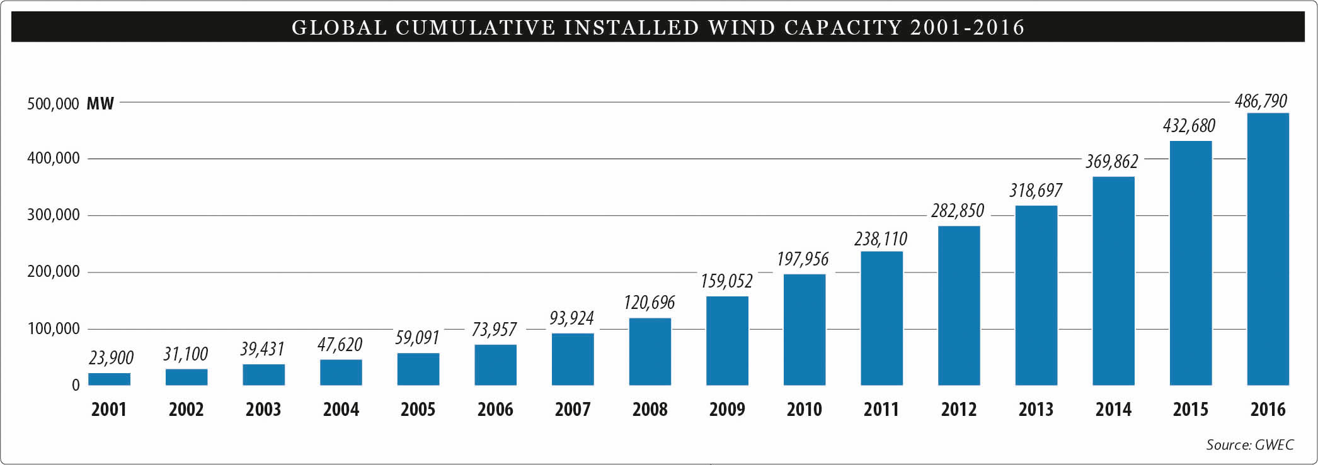
Fig. 1: Historical development of installed wind energy capacity globally [3]⁠

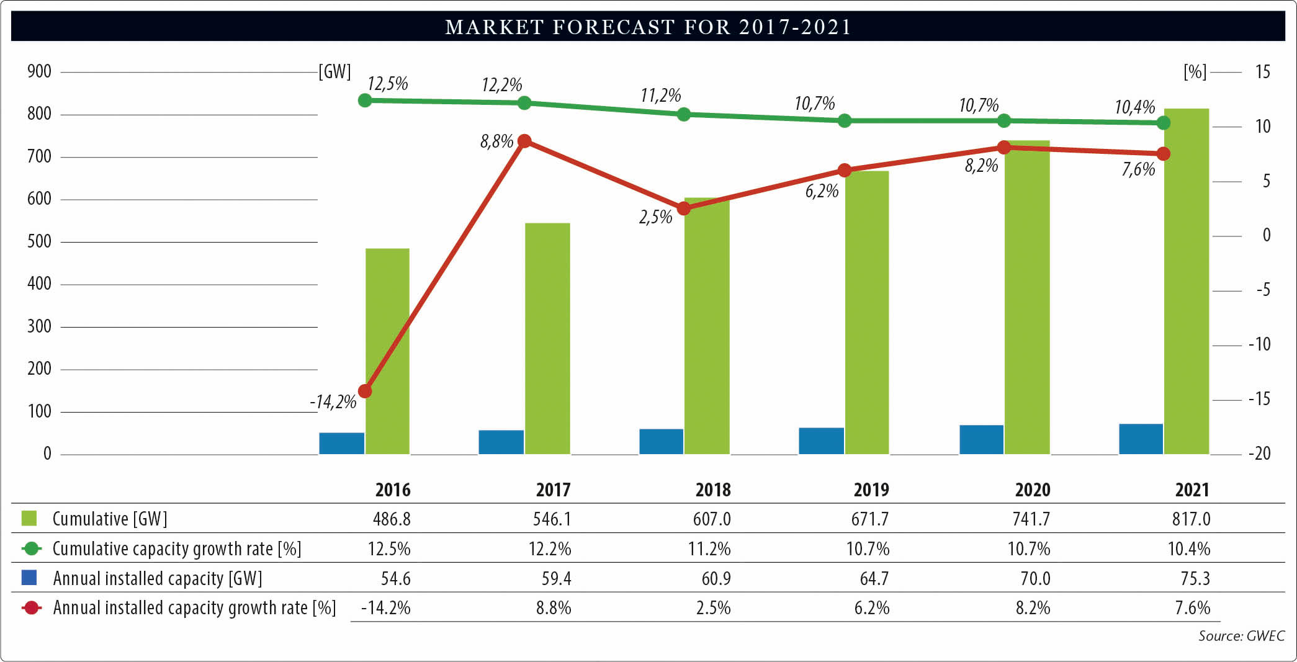
Fig. 2: Market forecast of wind energy capacity [3]⁠

In a similar way to global development, wind energy capacity in Turkey also has been increasing over the years. Installed wind energy capacity for the last decade in Turkey can be observed in Fig. 3 [4]. With 1,387 MW installation in 2016, total wind capacity of Turkey is brought to 6,106 MW, which was enough to supply 7.3% of electricity demand of the country for the same year.

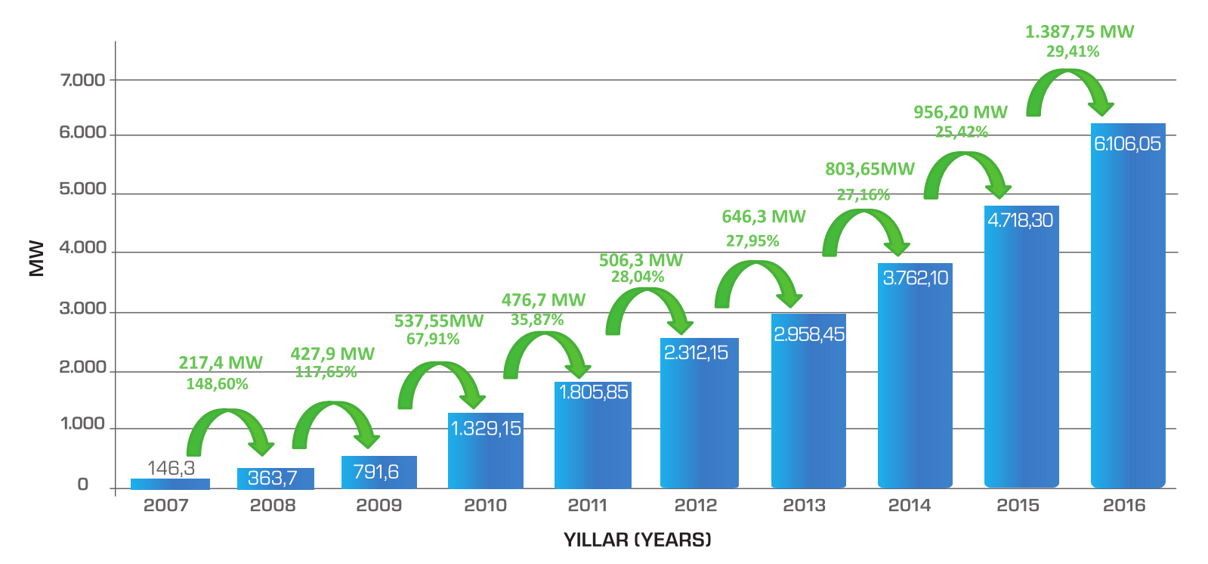
Fig. 3: Historical development of installed wind energy capacity in Turkey [4]⁠

Power output of a wind turbine can be expressed as follows:

(1.1)

where:

power output (W)
air density (kg/m³)
swept area (m²)
wind speed (m/sec)
power coefficient
As it can be observed from Eq. 1.1, power output of a wind turbine is proportional to the cube of the wind speed, so even small variations of the wind speed can cause large fluctuations on the power output. In Fig. 4, 10 minutes interval power output measurements of a wind farm in Turkey is shown. Hourly fluctuations of the wind power output due to variable wind speed throughout the day can be also recognized in this figure.

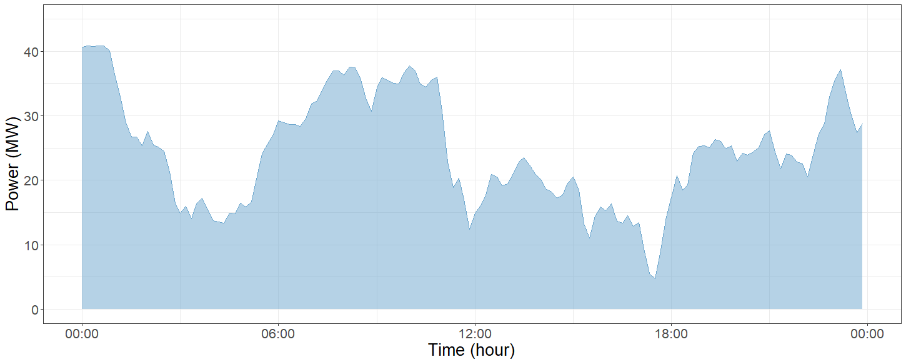
Fig. 4: Daily generation of a wind farm in Turkey

Due to intermittent nature of the wind, high level penetration of wind energy brings uncertainty and variability into power systems, therefore energy balance problem becomes harder to achieve. The impact of increasing wind power penetration level to stability and reliability of the power system can be summarized as follows:

Reliability problems: Net-load variations can be tracked by conventional generators at low level integration of wind power to the power system [5]⁠. However, increasing penetration of wind energy eventually affects the system reliability as wind power output fluctuations are not controllable and generally wind generation is not related to the demand pattern, which leads an increase on the difference between peak and off-peak periods. As a result, committed conventional generators cannot compensate the sudden and large changes of wind power output.

Stability Problems: Speed governors can be regulated by synchronous generators to support frequency control. However, different from synchronous generators, wind turbine generators can only contribute to primary frequency support for a small amount [6]. Wind power output fluctuations will also weaken grid voltage stability due to generation and load mismatch [7].

Considering expected share of wind generation in overall electric power generation to grow significantly over the years, more flexibility in power systems will be required to handle with the negative impacts of wind power. In the near future, system flexibility needs, which has been driven by variable demand up to this day, will begin to be driven by supply variability.

For the integration of renewable energy into the power systems effectively, four main options are proposed to increase the flexibility [8]:

- Dispatchable generation
- Transmission and distribution expansion
- Demand side management
- Energy storage

  - Aims of the Thesis

With the high level penetration of wind generation, power systems are affected negatively due to intermittent nature of the wind. One of the effects of wind power integration over power systems is transmission and distribution (T&D) upgrade need over existing structures. Considering the high investment cost of upgrade, T&D upgrade deferral becomes very profitable in specific cases by increasing flexibility of the power system. Energy storage systems (ESS) and demand side management (DSM) are two main methods that can be integrated into power systems to supply the additional flexibility.

In this study, a system is constructed where a wind farm is connected to a near organized industrial zone and overall system is connected to the grid through transmission structure. Power overload on the grid side for the constructed system is analyzed for the next years, considering different cases. Using ESS and DSM with the proper control methods to absorb the excess power flow on the transmission structure, deferral of the grid side transmission structure upgrade is investigated.

  - Outline of the Thesis

Outline of the thesis can be formed as follows:

- Chapter 2 explains the flexibility concept and gives a general idea of the impact of wind generation on power systems. Literature review on energy storage systems (ESS) and demand side management (DSM) is also provided in this chapter.

- Chapter 3 introduces transmission and distribution (T&D) upgrade deferral concept. Constructed scenario with selection and implantation of the proper data are explained in this chapter. Mathematical modeling of the ESS and DSM elements used in the constructed scenario are also given in this chapter.

- Chapter 4 illustrates the contribution of ESS and DSM to economical aspects of transmission systems. Specifications of ESS and DSM used in the study is explained and control algorithms used in the simulations are also provided in this chapter. At the end of this chapter, simulation results are given and evaluated considering the feasibility of the proposed suggestion.

- Chapter 5 summarizes the overall work shortly. Possible future works that can be integrated to this study are also discussed briefly in this chapter.

PROVIDING FLEXIBILITY INTO POWER SYSTEMS

  - Introduction

The main concern about planning and operation of the power systems is maintaining the equilibrium between safety and efficiency. As the share of renewable energy over power systems increases, sustaining this equilibrium becomes a more complicated problem to be solved. In order to reduce the impacts of renewable generation on power systems, further flexibility is required. Flexibility of a power system is defined as the ability of the power system to respond to changes in demand and supply over a range of operating conditions [9]. All power systems contain some degree of flexibility, as variability and uncertainty are always an issue and systems are designed to match the supply and demand all the time. However, with the renewable generation integration into power systems, variability and uncertainty become a problem of generation side, in addition to load side.

For better understanding, the impact of wind generation on net-load can be observed in Fig. 5 [10]⁠. Here, the net-load represents the demand which will be supplied by the conventional generators when the wind generation is utilized. It can be observed that wind generation leads to steeper ramps, deeper turn downs and shorter peaks on net-load, which affects the operations of conventional generators.

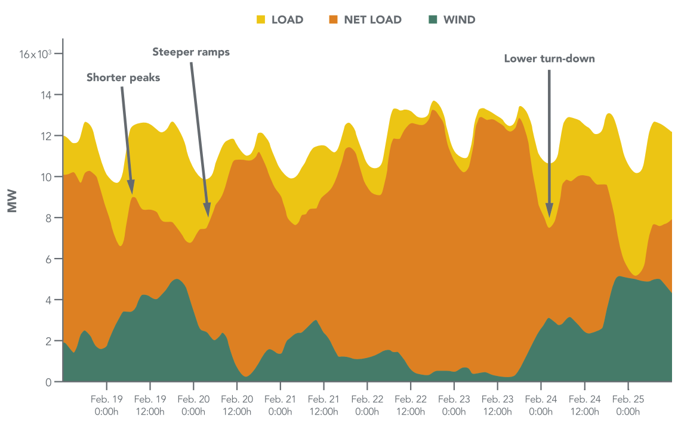
Fig. 5: Impact of wind generation on net-load [10]⁠

In conventional power systems, generators with fast start time, high ramp-up/down rates and low minimum up/down times are used to provide flexibility. However, considering the impacts of renewable generation on power systems, alternative methods are needed to compensate emerging effects. Energy storage systems (ESSs) and demand side management (DSM) are two main methods that can be integrated into power systems to supply additional flexibility. In this chapter, main characteristics and applications of ESSs and DSM are explained and evaluated.

  - Energy Storage Systems

In a power system, energy demand must be supplied instantaneously to preserve stability and quality of the system. In addition, scheduling of power systems with varying net-load profile decreases the overall efficiency because of the deviations from optimal generation spot.
Conventional power systems operate effectively without storage, but efficiency of the systems can be increased with the integration of ESSs. Additionally, ESSs can be used to reduce the effects of renewable generation integration and increase reliability and stability of the systems.

Main ESS specifications can be described as follows [11]:

Storage capacity (kWh) is the amount of energy that can be stored by the ESS.

Power rating (kW) is the rate of energy transfer per unit time which can be supplied or consumed by the ESS.

Energy to power ratio is the ratio of ESS storage capacity to its power rating. ESSs with higher energy to power ratio can deliver power for longer periods. ESS applications for different energy to power ratios are listed in Table 1 [11].

Depth of discharge is the ratio of discharged energy to storage capacity of the ESS. For a fully discharged storage system, depth of discharge (DoD) is 100%.

State of charge is the ratio of remaining energy to usable storage capacity of the ESS. For a fully charged storage system, state of charge (SoC) is 100%.

Efficiency is the ratio of output energy to input energy of ESS. With increasing losses, efficiency of the ESS decreases.

Self discharge is the energy loss of ESS due to internal processes at standby.

Table 1: ESS applications for different energy to power ratios [11]

Seconds to minutes | - Frequency control  - Spinning reserve  - Voltage control  - Black start capability  - Peak shaving  - Island grids  - Uninterruptible power supply
Daily | - Tertiary frequency control  - Standing reserve  - Load leveling  - Island grids  - Residential storage systems  - Uninterruptible power supply
Weekly to monthly | - Storage for “Dark calm” periods  - Island grids

Start-up time (sec) is the time period between power request and first power delivery.

Ramp-up time (sec) is the time period required from zero to full power transition.

Ramp rate (kW/sec) is the ratio of maximum power to ramp-up time.

Deployment/response time (sec) is the time period between power request and full power delivery. In Fig. 6 [11], time parameters of an ESS can be observed.

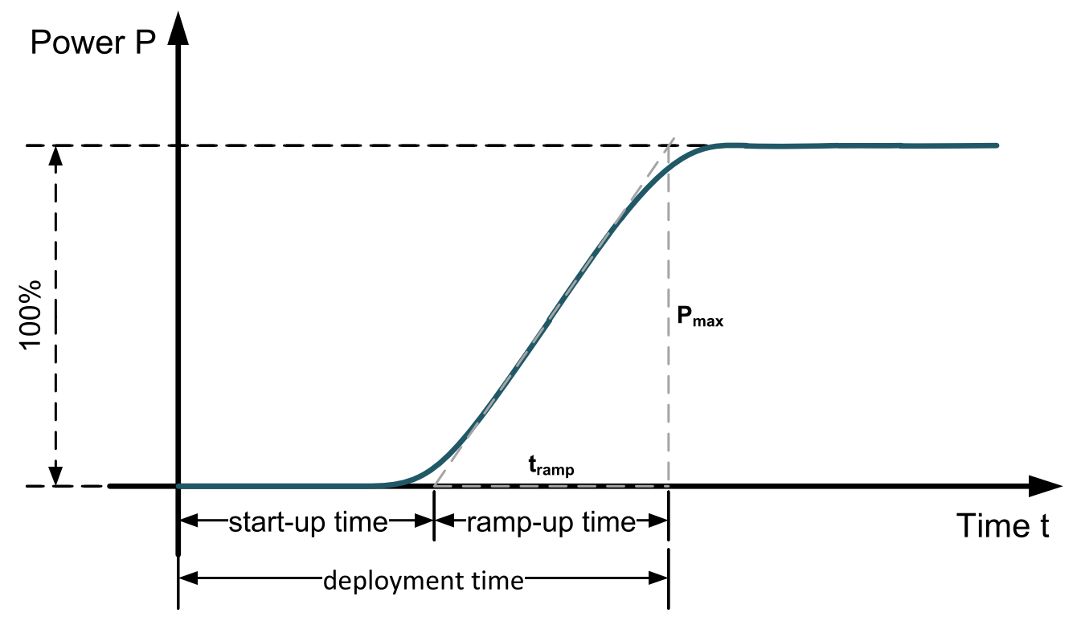
Fig. 6: Response time of an ESS [11]⁠

Full cycle is the complete discharging and charging process of the ESS. Discharging the system to minimum energy limit and then charging it to maximum energy limit is regarded as one full cycle of the ESS.

Equivalent full cycle is the overall discharging and charging process with any depth of discharge (DoD) per cycle divided by available capacity. Discharge and charge of the system 2 times with 50% DoD or 4 times with 25% DoD are both considered as one equivalent full cycle.

Cycle life is the number of full cycles that can be delivered by the ESS under specified conditions before the ESS cannot meet specified criteria.

Calendar life is the lifetime of the ESS when it is not used.

    - Classification of Energy Storage Systems

A widely-used classification of energy storage technologies is according to the energy usage form; mechanical, electrochemical, chemical, electromagnetic and thermal, which is presented in Fig. 7 [12].

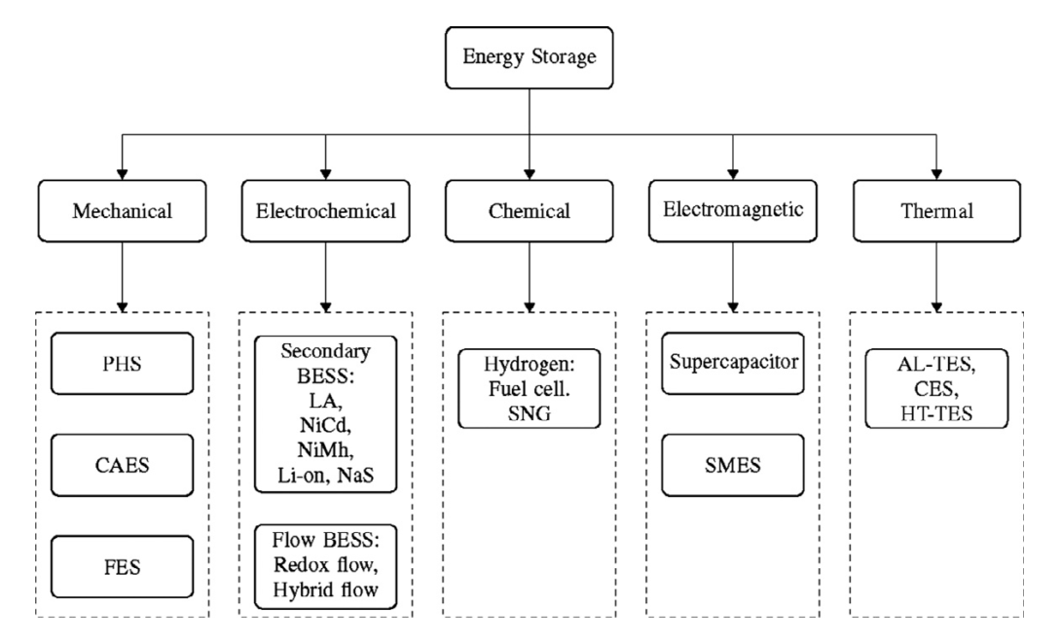
Fig. 7: Classification of energy storage technologies [12]

ESSs can be also categorized according to duration and frequency of the power supply [11]:

Short-term ESSs: Short term ESSs are used for instant energy supply. This type of ESSs are used mainly in primary/secondary frequency control and reactive power compensation applications. These storage systems have low storage capacity compared to their power ratings, typically energy to power ratio of minutes and high charging and discharging rates. Generally, equivalent full cycles per day are very high for these systems.

Medium-term ESSs: Medium-term ESSs are used for matching the demand fluctuations between day and night. Energy to power ratio of these systems are typically several hours. These type of systems have typically one or two equivalent full cycles per day.

Long-term ESSs: Long-term ESSs are used for power supply during several days or weeks. These systems have very high energy to power ratio, and due to this high storage capacity and relatively low power, the number of equivalent full cycles per year is very few. This kind of systems can be used to overcome the power generation shortage periods in power systems with high renewable energy penetration.

Different energy storage technologies with their rated power and energy levels are shown in Fig. 8 [13]. ESS applications with their definitions for generation support, transmission and distribution support and end-customer uses are also listed in Table 2 [14]⁠.

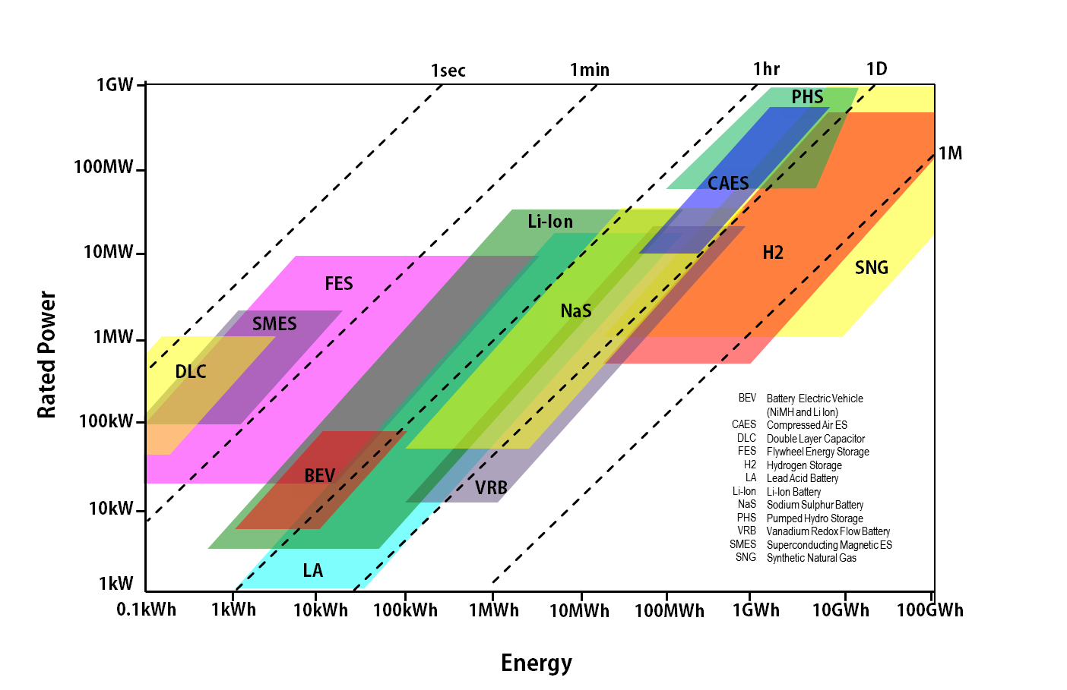
Fig. 8: Comparison of energy storage technologies [13]

Table 2: Generation and system level applications of ESSs [14]

Usage area | Application | Description
Generation and system level applications | Wholesale Energy Services | Utility-scale storage systems for bidding into energy, capacity and ancillary services markets
Generation and system level applications | Renewable Integration | Utility-scale storage systems providing renewable time shifting, load and ancillary services for grid integration
Generation and system level applications | Stationary Storage for Transmission and Distribution Support | Storage systems for improving transmission and distribution system utilization factor, and transmission and distribution capital deferral
Transmission and distribution system applications | Transportable Storage for Transmission and Distribution Support | Transportable storage systems for transmission and distribution system support and transmission and distribution deferral at multiple sites as needed
Transmission and distribution system applications | Distributed Energy Storage Systems | Centrally managed modular systems providing increased customer reliability, grid transmission and distribution support and potentially ancillary services
Transmission and distribution system applications | Energy Services Company Aggregated Systems | Aggregated and centrally managed residential-customer-sited storage to provide distribution system benefits
Transmission and distribution system applications | Commercial and Industrial Power Quality and Reliability | Systems to provide power quality and reliability to commercial and industrial customers
End-user applications | Commercial and Industrial Energy Management | Systems to reduce time of use energy charges and demand charges for commercial and industrial customers
End-user applications | Home Energy Management | Systems to shift retail load to reduce time of use energy and demand changes
End-user applications | Home Backup | Systems for backup power for home offices with high reliability value
    - Applications of Energy Storage Systems

ESS applications for wind integration support can be categorized as generation side, grid side and demand side applications [12]:

Generation Side Applications:

Unlike conventional power plants, wind farm power output cannot be controlled in a strict way as a result of intermittent nature of wind energy. Power intermittency, ramp rates and limiting wind power output are the main challenges coming along with wind power integration into the power systems [15]⁠. Looking from the generation side to overall system, controllability of a wind farm can be increased with the usage of ESS.

Time shifting: Wind power generation is a non-dispatchable source of electricity production and can only be forecasted with a limited certainty. The mismatch between wind power output with the demand pattern, e.g. high wind power generation during off-peak demand periods and vice versa, is a big challenge as the difference between peak and off-peak periods of the system net-load increases. Energy storage technologies can be used to match the wind power generation with load cycles by storing extra energy during high wind power generation and releasing it later during peak demand periods. In time shifting applications, huge amount of energy is required to be stored for long time periods, so it is important to consider storage capacity and energy to power ratio parameters of the ESSs in these applications.

Output smoothing: Wind power generation can have sudden drops and steep rises as a result of variable wind speed. System stability will be affected with the sudden power output changes which will create frequency and voltage fluctuations. Power output of a wind farm can be smoothed out with energy storage technology applications, by storing excess energy during instantaneous increase in power generation and releasing the stored energy during sudden output power drops. Ramping capability of the ESSs is the most important parameter in these applications, as the storage system must match the quick changes of wind power output.

Transmission utilization efficiency: Rich wind resources are often located in remote locations and transmission networks limitations becomes a serious problem to supply the energy demand, which is far from wind farm sites [16]. With the usage of energy storage technology, efficiency of transmission utilization can be increased by reducing congestion over the network. Additionally, transmission and distribution upgrades can be deferred or in some cases avoided at all with proper usage of the ESSs.

Grid Side Applications:

Increasing wind power generation reduces the stability and reliability of the grid, because of the intermittent nature of these supplies. Considering the distributed generation of wind farms over the system, net variability of the entire grid is lower compared to the integration of single wind power plant, so overall requirement of services is less than considering grid side applications. Energy storage technologies can be used to provide ancillary services to decrease the impact of wind power generation over system stability and reliability.

Energy arbitrage/load leveling: In the electricity market, electricity prices vary during peak and off-peak hours. The variation of market clearing prices in Turkey in 2016 can be observed in Fig. 9 [17]. Energy storage technologies can be used to reduce the gap between peak and off-peak prices, by storing low-cost energy during off-peak periods and releasing stored energy during peak periods with the higher price [18].

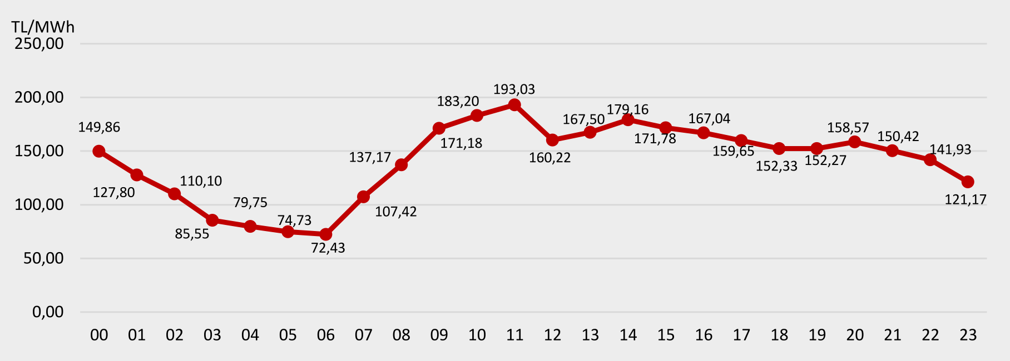
Fig. 9: Average of hourly market clearing prices in Turkey (2016) [17]

Frequency regulation: ESSs can be used to provide frequency regulation to the wind farms by controlling active power output of storage with frequency deviation. Primary frequency control can be applied by using droop control in local systems. Active power output of the ESSs can be controlled according to frequency change on the grid [19]. For secondary frequency control, an automatic control system can arrange the power outputs to response frequency deviations.

Inertia emulation: The impact of sudden wind generation changes on frequency changes can be reduced by increasing inertia of grid. Apparent inertia of a grid can be increased with the integration of the ESSs, by controlling the active power output of the storage systems.

Oscillation damping: Sudden power changes of wind farms can cause oscillations in an interconnected system which may lead to synchronization loss of some machines [20]. Energy storage technologies can be used to damp the system oscillations caused by variable wind generation output and increase the stability of the power system.

Voltage control support: Voltage stability of the grid can decrease with the variable nature of wind generation output. Integration of energy storage technologies can increase reactive power support for voltage regulation by controlling converters connected to the grid [20].

Low Voltage Ride Through support: Today, low voltage ride through (LVRT) capability of wind turbine generators are determined by grid codes. During severe grid faults, wind turbines should remain connected for reactive power support and in some situations maximum reactive power needs to be delivered by wind turbines [21]. For such cases, energy storage technologies can support the power need by converters and control systems.

Reserve application: For the stability and reliability of the system, emergency reserves are required as a result of forecast error of wind power output. Integration of energy storage technologies can be an option for the reserve applications.

Emergency power supply: In the situation of a fatal failure, ESSs can be used to energize the power system from a shut-down condition [22].

Transmission utilization efficiency: Integration of energy storage technologies into power systems can increase the efficiency of transmission network usage and transmission and distribution costs can be reduced by deferral of network upgrade.

Demand Side Applications:

With the combination of ESSs and DSM, ancillary services can be provided for the grid using huge amount of variable loads as a virtual power plant (VPP).

    - Planning of Energy Storage Systems

Technical characteristics of an energy storage system (ESS), such as storage capacity, rating power and charging/discharging duration range can be determined by analyzing characteristics of a wind farm.

Fluctuations of wind generation output at different time scales is an important parameter for the ESS selection. While generation reserve and energy dispatch applications are related to low frequency fluctuations (minutes to hours) [23]⁠, power system frequency control applications are related to high frequency applications (seconds to minutes) [24]⁠. High frequency fluctuations on the wind power output has an insignificant overall effect and can be damped out by inertia of the turbine generator. As a result, it is required that energy to power ratio of the ESSs to be in the order of a few hours for wind integration support [12].

As the increasing rating capacity of wind farms is considered, large-scale energy storage technologies are required for wind integration applications. Battery energy storage system (BESS), pumped hydroelectric storage (PHS) and compressed air energy storage (CAES) technologies are suitable for the large-scale applications for their capability of storing energy for long periods at a high power rating. Among these three technologies, BESS is more suitable for the purpose, as PHS and CAES are limited by topographical constraints [12]⁠. By taking account of these findings and rapid development in battery technology and cost reduction, it is decided to study the BESS technology for the wind power applications. Some of the battery types are introduced in the following with their advantages and disadvantages [25]:

Lead-acid Batteries:

Advantages: Easy installation, high overall efficiency, low investment cost and low self-discharge

Disadvantages: Poor performance at low temperatures, short life time, periodic maintenance requirements, low specific power, frequent power cycling difficulties

Nickel-based Batteries:

Advantages: Fast discharge cycles due to low internal resistance, long life time, low maintenance requirements, good performance at low temperatures, diverse size and performance options, integration with renewable energy sources for long term storage [26]

Disadvantages: Higher cost compared to lead-acid batteries even they have lower energy efficiency and higher discharge rate [26], [27]⁠, high toxicity, full charge deficiency after series of full discharges [28], continuous maintenance requirements

Sodium-Sulphur Batteries:

Advantages: Long life time, high storage capacity and power density, good performance at ambient conditions [29]

Disadvantages: Thermal management, safety

Lithium-based Batteries:

Lithium-based Batteries can be divided into two categories; Lithium-Ion Batteries and Lithium-Polymer Batteries. Lithium-Ion batteries have higher efficiency and lifetime compared to Lithium-Polymer batteries.

Advantages: High specific energy and energy density, fast charge and discharge capability, high efficiency, light weight, decreasing cost [27]

Disadvantages: Life time dependency on operating temperature, high flammability and fragility, maximum charge and discharge current limitations

Flow Batteries:

Flow Batteries can be divided into three categories; Vanadium Redox Flow Batteries (VRB), Zinc-Bromine Flow Batteries (ZBB) and Polysulphide-Bromide Flow Batteries (PSB).

Advantages: Scalability, high power rating, long duration, fast response and quick transition between charge and discharge modes, zero self-discharge [30]

Disadvantages: High operating cost, low energy density, thermal management need for safety.

Two most commonly used battery types; lithium-ion, lead-acid batteries are tabulated with their characteristics in Table 3 and Table 4 [11], including future expectations.

Table 3: Characteristics of lithium-ion batteries [11]

Lithium-ion batteries
Parameters | 2013 | 2030 (Expected)
Round-trip efficiency | 83-86% | 85-92%
Energy density | 200-350 Wh/l | 250-550 Wh/l
Power density | 100-3500 W/l | 100-5000 W/l
Cycle life | 1000-5000 full cycles | 3000-10000 full cycles
Calender life | 5-20 years  (depending on temperature and SoC) | 10-30 years  (depending on temperature and SoC)
Depth of discharge | Up to 100% | Up to 100%
Self discharge | 5% per month | 1% per month
Power installation cost (converter) | 150-200 €/kW | 35-65 €/kW
Energy installation cost | 300-800 €/kW | 150-300 €/kW
Deployment time | 3-5 ms
Site requirements | None
Main applications | - Frequency control  - Voltage control  - Peak shaving  - Load leveling  - Electromobility  - Residential storage systems
Table 4: Characteristics of lead-acid batteries [11]

Lead-acid batteries
Parameters | 2013 | 2030 (Expected)
Round-trip efficiency | 75-80% | 78-85%
Energy density | 50-100 Wh/l | 50-130 Wh/l
Power density | 10-500 W/l | 10-1000 W/l
Cycle life | 500-2000 full cycles | 1500-5000 full cycles
Calendar life | 5-15 years  (depending on temperature and SoC) | 10-20 years  (depending on temperature and SoC)
Depth of discharge | 70% | 80%
Self discharge | 0.1-0.4% per day | 0.05-0.2% per day
Power installation cost (converter) | 150-200 €/kW | 35-65 €/kW
Energy installation cost | 100-250 €/kW | 50-80 €/kW
Deployment time | 3-5 ms
Site requirements | Ventilation due to gassing
Main applications | - Frequency control  - Peak shaving  - Load leveling  - Island grids  - Residential storage systems  - Uninterruptible power supply

  - Demand Side Management

In a conventional power system, the balance between generation and demand is maintained by controlling the power output of limited number of power plants. However, with the increasing penetration of renewable generation to the system, dispatch of generation capacity to provide the required services to follow the load profile becoming much more challenging. As an alternative way, controlling load side to increase flexibility of the power system attracts increasing attention. Loads can be dispatched according to system needs with the help of global communication infrastructure and embedded systems [31].

Flexible loads can be scheduled considering the grid needs with demand side management (DSM). If individual loads can be aggregated and controlled on command according to the requirement of power systems, the result will be the same as generation dispatch. For example, turning off a large number of loads when the demand exceeds generation will have the same effect of increasing generation or vice versa.

    - Classification of Demand Side Management

DSM technologies can be categorized according to timing and impact of the applications on customer process, which can be observed in Fig. 10 [31].

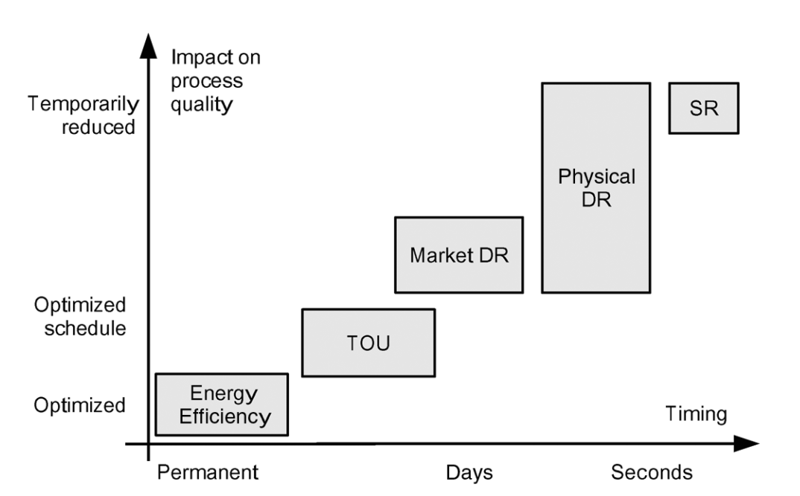
Fig. 10: DSM categories according to timing and impact of the appliances [31]
Energy Efficiency (EE): EE applications include increasing the efficiency of appliances and improvements on the system properties. Changing a refrigerator with a more efficient one or applying thermal insulation to a building are some examples that can be considered as EE applications. In addition, behavioral changes of users to increase efficiency of energy usage can be included in these applications.

Time of Use (ToU): In ToU tariffs, electricity prices change according to power consumption at that time. Electricity prices for third quarter of 2017 in Turkey for different end-users are tabulated in Table 5 [32]. Considering the high difference between electricity prices for different time periods of the day, customers are encouraged to arrange their power consumption to reduce the overall cost.

Table 5: Electric prices for different time periods in Turkey [32]

 | Day period  (06:00-17:00) | Peak period  (17:00-22:00) | Night period  (22:00-06:00)
Industrial | 289.4x10⁻³ TL/kW | 448.5x10⁻³ TL/kW | 174.6x10⁻³ TL/kW
Commercial | 333.4x10⁻³ TL/kW | 502.7x10⁻³ TL/kW | 211.0x10⁻³ TL/kW
Residential | 330.5x10⁻³ TL/kW | 499.8x10⁻³ TL/kW | 208.1x10⁻³ TL/kW

Demand Response (DR): DR is defined as controlling flexible loads to shift power consumption from peak periods to off-peak periods. By doing so, energy consumption is not decreased but only shifted through time. However, by shifting peak power consumption through time, the overall efficiency of power system is increased. Difference impacts of EE and DR applications can be observed in Fig. 11 [31]. While EE applications affect the energy consumption permanently, DR applications only delay the energy consumption.

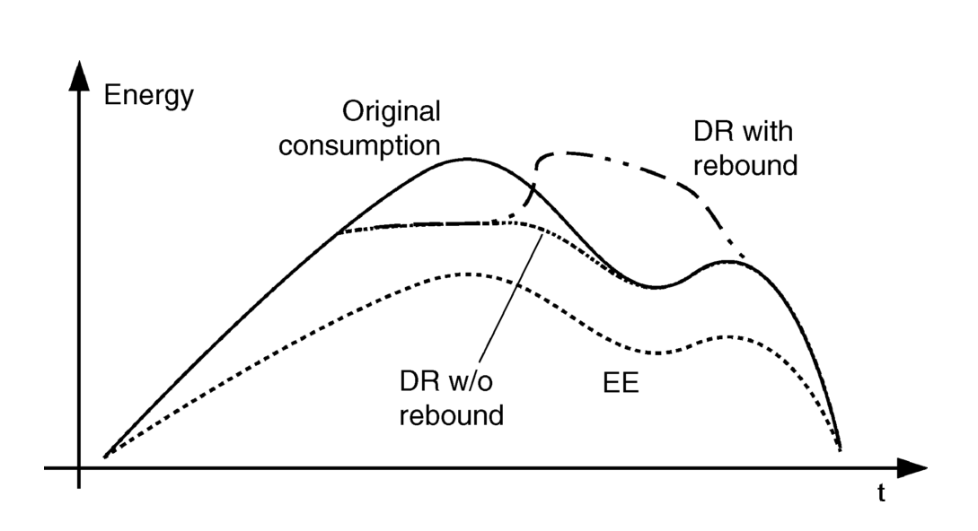
Fig. 11: Impact of energy efficiency and demand response [31]

Spinning Reserve (SR): Combination of large number of loads can be used for frequency regulation applications, namely primary and secondary frequency control. Primary frequency control is done by controlling active power, considering frequency changes over time. In secondary frequency control, frequency is restored with additional active power to the system. With SR applications, combination of large number of loads can be controlled like a virtual power plant with negative power output to the grid.

    - Applications of Demand Side Management

DSM applications can be classified according to the time scale of the load control (from milliseconds to hours) [33]:

Under a second: Frequency changes in a system can be observed and dispatchable loads can respond to these changes to maintain system security. Either loads can be shut down when a steep frequency drop occurs on the grid, or they can response to frequency changes according to frequency error, similar like droop control of conventional power plants. As wind power plants can participate to frequency control only in small amounts, demand dispatch can be a solution for the intermittent wind power output.

Seconds to minutes: The ancillary services for power system regulation is provided by power plants in today’s power systems. An alternative way for serving these services to the power system is DSM. By controlling high number of loads with fast response, regulation can be provided in an efficient way.

Hours: Dispatchable loads can be controlled to match highly varying wind generation profile for a wind farm or even for a region, depending on the limits of aggregated loads. Rapid changes in wind power generation can be followed by DSM control, as the flexible loads generally have a fast response time. With the introduction of DSM into the power systems, the required fast-response generation capacity will be reduced.

    - Planning of Demand Side Management

DSM takes advantage of controllable loads and support the grid considering changing needs, so in order to dispatch loads, some flexibility is needed in demand side. Some suitable loads for DSM applications can be listed as follows [33]:

- Dishwashers
- Washers and dryers
- Electric hot water heaters
- Heating, ventilation and air-conditioning (HVAC) systems
- Battery charges for consumer electronics
- Plug-in vehicles

Considering the large number of aggregated flexible loads, demand dispatch can be an important factor for the power systems applications. However, there are some constraints for the flexible loads, so important parameters must be defined for each individual load, such as minimum and maximum power limits, how much and when energy is needed and number of cycles for a given time period. The main objective of demand dispatch is to serve the grid needs by dispatching loads while considering these limitations. Suitable services for the power systems can be developed by considering power and energy limitations of flexible loads as well as their response characteristics.

HVAC systems are chosen to be controlled in this study, as they are responsible for a high percentage of residential and commercial energy usage. End-use energy consumption in United States for residential and commercial sectors in 2016 with the expectations in 2040 can be observed in Fig. 12 [34]. Considering the energy consumption share overall, HVAC systems can participate in matching generation and load, as well as ancillary services to support grid with suitable control methods.

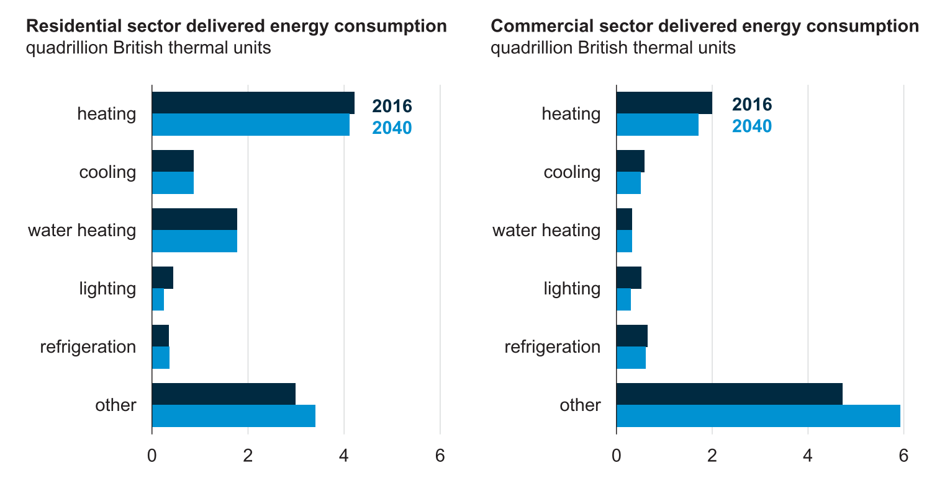
Fig. 12: End-use energy consumption for residential and commercial sectors [34]
Thermal behavior of a HVAC unit without an external control can observed in Fig. 13 [35]. In this case, HVAC unit works as a heater and operates according to set temperature limits with the help of the thermostat, simply turning on when room temperature is under the lower set limit and turning off when room temperature is over the upper set limit.

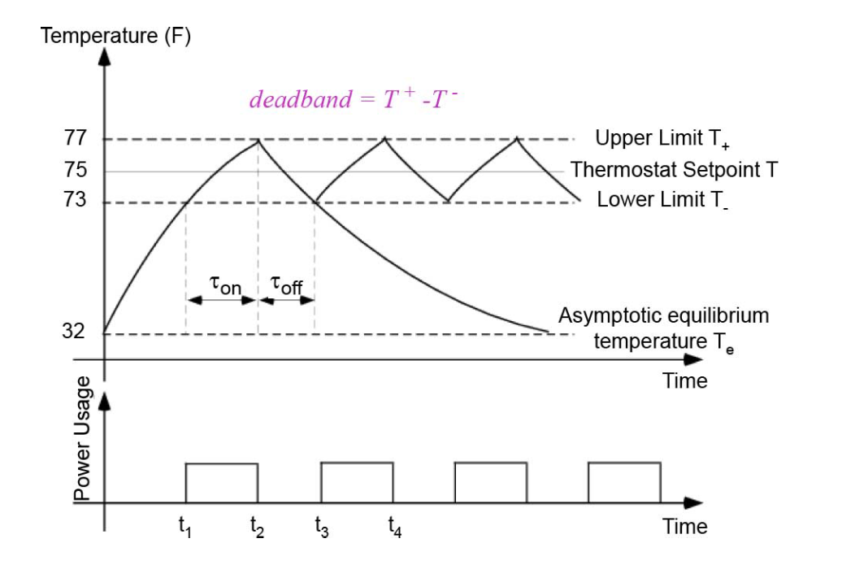
Fig. 13: Thermal behavior of a HVAC unit [35]

The thermal output of a HVAC unit can be described using energy efficiency ratio (EER), which is the ratio of output cooling power to electrical input power and coefficient of performance (COP), which is the ratio of output heating power to electrical input power of the HVAC unit [36]⁠.
DSM applications can have different control methods, which usually divided into two categorizes; direct load control (DLC) and indirect load control (ILC) [37], [38]⁠. A detailed categorization according to control methods is presented in Fig. 14 [39]:

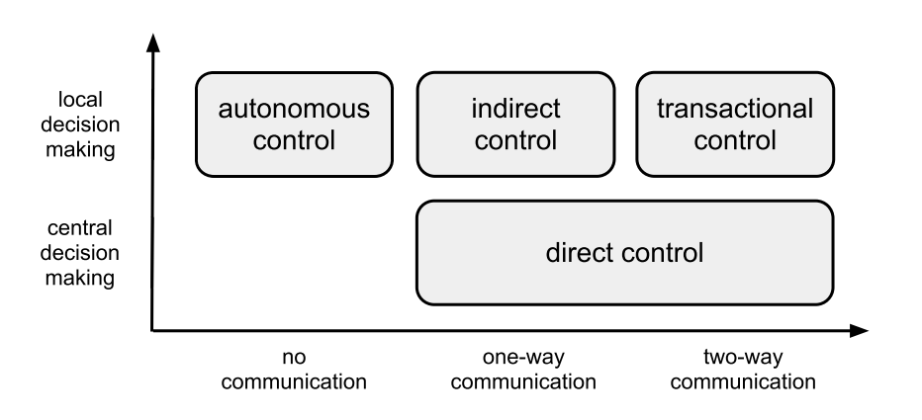
Fig. 14: DSM categories according to control methods [39]

Direct control:

In direct control method, specific commands are sent to controllable loads via an external controller, which has the information about load operation. One-way or two-way communication can be used for information exchange between direct controller and loads. For one-way communication infrastructure, commands are sent to loads via external controller and it is expected from the loads to follow the specific commands if there isn’t any violation of operation limits or failure. In case of two-way communication structure, the loads acknowledge the specific commands sent by external controller and send back the information about the applicability of the command with the status.
Different types of direct load control schemes commonly found in literature are deferred consumption, delta control, scheduled operation and direct control [40];

Deferred consumption: The consumption of the certain amount of energy is shifted through time. The command signal sent to load is a time shift (Δt).

Delta control: The consumption of the certain amount of energy is decreased or increased, which may result in change of operation duration. The command signal sent to load is a power difference (ΔP).

Scheduled operation: Schedule of power set points with time stamps is sent to load and executed locally. The command signal includes power set point and time stamp (P, t).

Direct control: Power set point is sent to load in real-time. The command signal is power set point (P).

Operations of different direct load control types are presented in Fig. 15 by illustrating before and after power consumption with corresponding control methods [39].

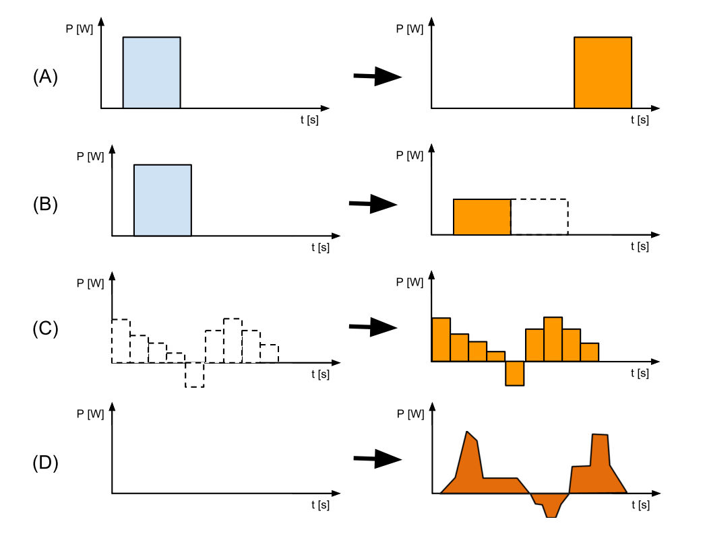
Fig. 15: DSM direct load control operations: (A) Deferred consumption, (B) Delta control, (C) Scheduled operation, (D) Direct control [39]⁠

Indirect Control:

In case of indirect control, loads receive the command signals sent by an external controller, but not necessarily behave as commanded. The relationship between control objective and observables is indirect in indirect load control, which can lead random unobservable behavior. Non-deterministic behavior of the loads due to independent decision making of the local controllers is another characteristic of this control method [38]. As the communication is one-way, external controller does not receive any feedback from the loads. External controller broadcasts command signals in indirect control method and any load can behave according to commands at any time or loads can follow special and dynamic objectives depending on local decision making algorithms. Indirect control methods can be divided into two categories; control with indirect functional variables and indirect control via price signals [39].

Control with indirect functional variables: Objective of external controller is to modify the operation of the loads by sending a command signal to the load which contains a functional variable. As the state of the loads are unknown due to the lack of feedback, system behavior is non-deterministic. Functional variable signal can be generated by using the observable or estimated aggregated response and statistical models can be used to decrease the mismatch between control goal and system behavior.

Indirect control via price signals: External controller uses energy prices to generate command signals. Instantaneous and scheduled price operations are two options for this control type. In case of instantaneous price operation, the command signal consists of a single price with a time stamp which states the validation time of the price. In case of scheduled price operation, command signal consists a time series of prices and time stamps for the future.

Transactional control:

Transactional control method depends on negotiations in a bid-based market in which loads are used for trading products, e.g. power, energy and flexibility. Local controllers independently determine the bidding amount and compete with each other. With the transactions, local controllers optimize the consumption by using equilibrium value determined by the market. This control method includes the price negotiation and biding strategies. Local controllers decide the bid offers and operation of the loads. Price equilibrium for all participating loads are determined by the constructed market.

Autonomous control:

Local measurements are used to control the loads locally in autonomous control method. Communication infrastructure is not needed as all the decisions are taken by local controllers and due to independent local measurements, loads can response faster compared to the other control methods. This control method can be used for local power system services.

  - Summary and Conclusion

This chapter started with the introduction of power system flexibility concept and two proposed methods for additional flexibility on power systems are presented; energy storage system (ESS) technologies and demand side management (DSM) with their characteristics, classifications and applications.

Suitable ESSs are compared in order to choose the most suitable technology for the integration to wind energy generation. Due to their capability of storing energy for long periods at a high power rating, battery energy storage (BESS), pumped hydroelectric storage (PHS) and compressed air energy storage (CAES) are the most suitable technologies for the wind generation integration purposes. However, considering the limitation of PHS and CAES due to topographical constraints, BESS is chosen for the energy storage technology to be used in this study. By looking the advantages and disadvantages of commercial battery types, lithium-ion and lead-acid batteries are found more suitable due to high energy and power density, fast charge and discharge capability, long life time and high efficiency.

Heating, ventilation an air-conditoning (HVAC) units are chosen for the DSM application as they occupy a high percentage of energy usage in residential and commercial areas. Aggregated HVAC units in fact can be used for grid support in different applications. In order to control HVAC units according to changing grid power for every time step, direct control method is chosen in this study.

TRANSMISSION AND DISTRIBUTION UPGRADE DEFERRAL

  - Introduction

As a result of continuous growing peak demand, overloading of the existing transmission and distribution (T&D) structures used in the power systems over time becomes a critical problem. In order to maintain the safety of the system and the equipment, upgrade of the present structures becomes inevitable even in the situation of modest overload. The main problem of upgrading an existing T&D structure is the high investment cost, which is highly variable due to various factors such as; installation requirements and location. However, upgrade of a T&D system can be deferred in specific conditions, depending on the characteristics of the power flow. Viability of T&D upgrade deferral can be examined by checking some criteria over present systems [41]:

- High T&D investment cost (direct costs and “soft” costs such as; utility reputation and customer goodwill)
- High peak-to-average demand ratio (peak demand for short periods)
- Modest projected overload (expected peak overloading on the T&D structure by a modest amount)
- Slow peak demand growth
- Uncertainty about timing and/or likelihood of block load additions
- T&D construction delays or construction resource constraints
- Budget optimization (T&D upgrade competing with other important projects for capital)

- Benefit aggregation (additional benefits provided by the distributed resource)
  - electric supply capacity
  - value enhancement for electricity from renewable energy resources
  - reduced transmission congestion and energy losses
  - electricity end-user energy/demand bill reduction
  - electric supply reserve capacity
  - improved local power quality and/or reliability

In need of an upgrade over existing structure, T&D upgrade factor is defined as the ratio of load carrying capacity to be added to present T&D structure. An example of the T&D upgrade deferral concept is demonstrated in Fig. 16 [41].

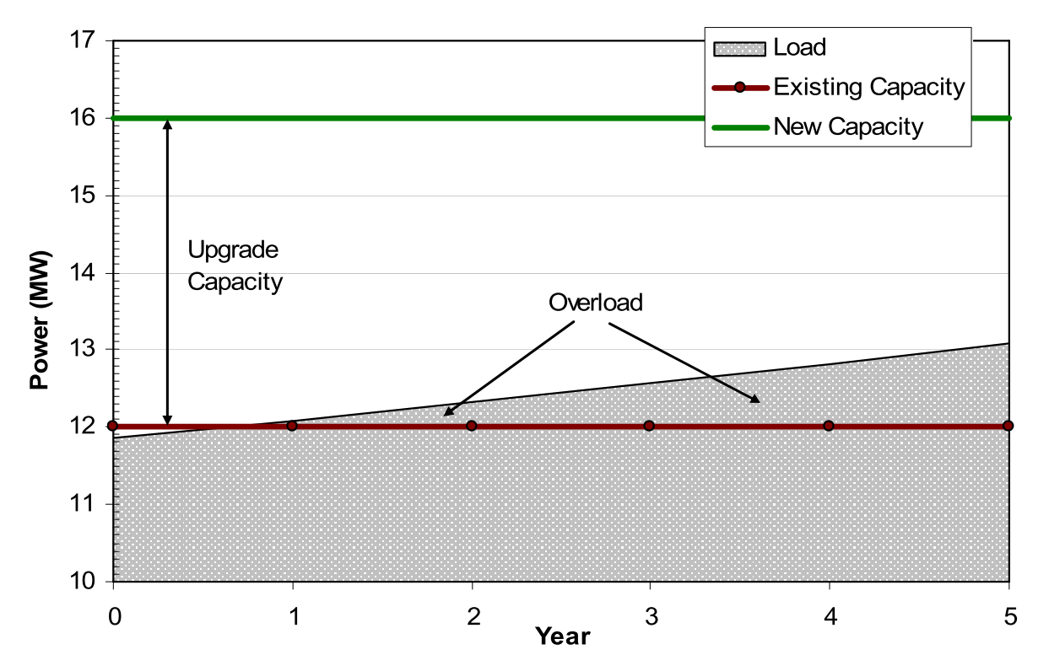
Fig. 16: Planned upgrade of a distribution system due to increasing peak demand [41]

For the illustrated case in Fig. 16, an existing distribution system with a rated load carrying capacity of 12 MW is expected to be overloaded next year, considering a 2% load growth rate per year. In order to avert overloading of the equipment, load carrying capacity of the distribution structure is planned to be increased with an upgrade factor of 0.33, from 12 MW to 16 MW. Taking the modest overload projection over the structure into account, required upgrade can be delayed for some time using proper solutions.

Energy storage systems (ESSs) and demand side management (DSM) can be used to deliver a portion of peak demand and large T&D structure upgrades can be deferred with small capacity additions. ESS usage for the transmission system upgrade deferral is illustrated in Fig. 17 [42]. In this example, storage system is committed to absorbing excess power flow on the transmission line only. As it can be observed from the figure, BESS is discharged when the power demand exceeds the threshold level in order to compensate the excess power over the transmission line and charged shortly after, when the power demand drops below the critical level.

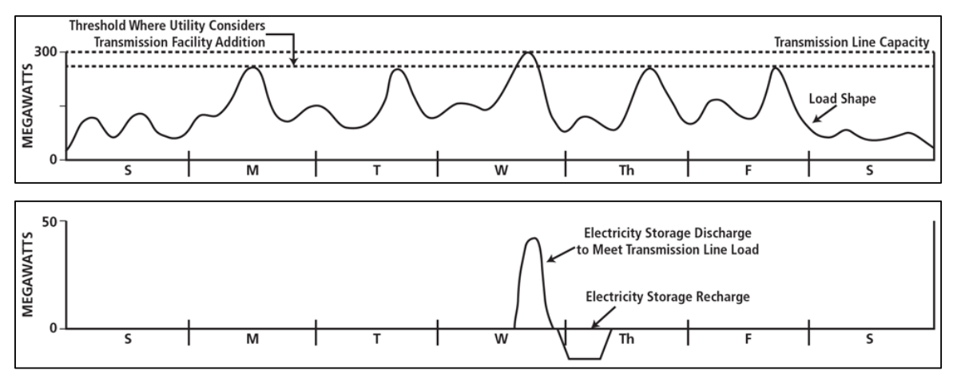
Fig. 17: ESS usage for transmission system upgrade deferral [42]

In this chapter, constructed scenario for the T&D upgrade deferral application is explained with the analysis of obtained data integrated into the scenario. Modeling and approaches of ESS and DSM are also introduced in the next part of this chapter.

  - Description of the Scenario

In this study, a hypothetical scenario is constructed where a wind farm connected to a near organized industrial zone and the overall system is connected to the grid as shown in Fig. 18. Capacity of grid side transmission structure is occupied by the power flow from/to the grid (P_{grid}) depending on the wind power generation (P_{wind}) and industrial power consumption (P_{oiz}). Overload on the grid side is examined for the different cases; increase on the industrial load through years and block capacity addition to the wind farm. Impact of ESS and DSM integration on the grid side structure is analyzed for these cases.

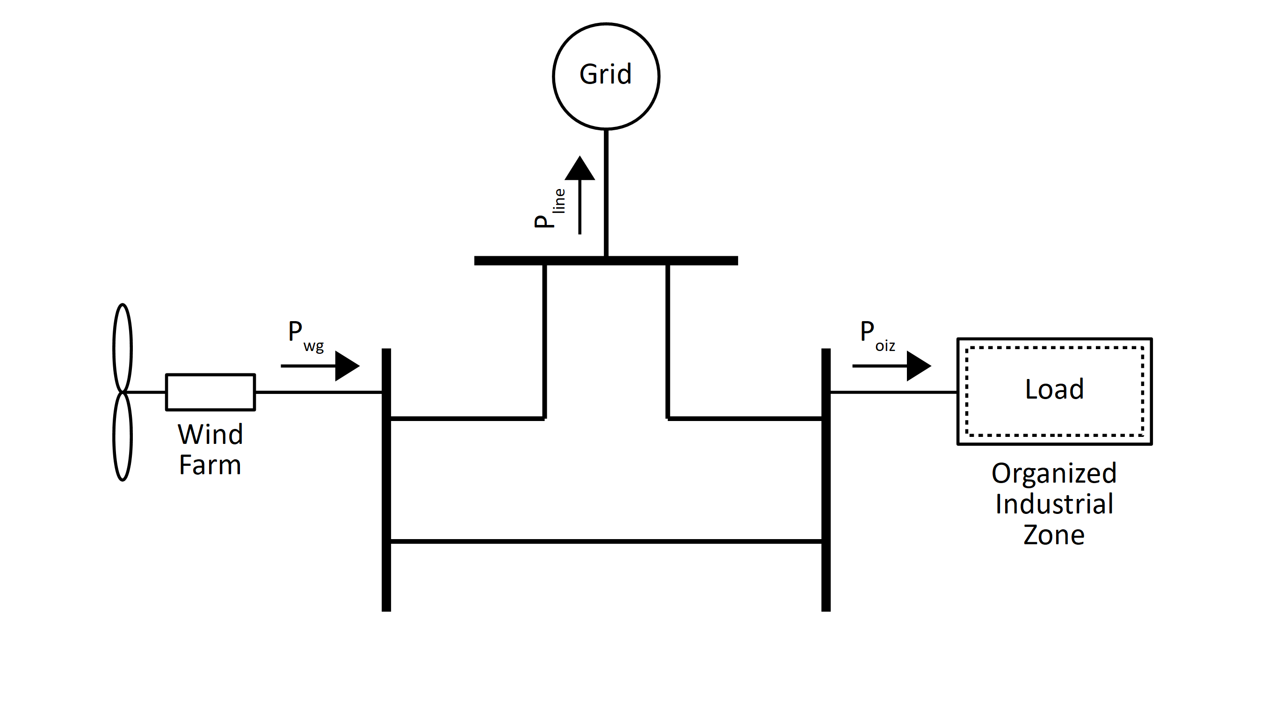
Fig. 18: Schematic of the constructed system
Wind power generation and organized industrial zone power consumption data used in this study are obtained from the databases of Monitoring and Forecasting System Development for Wind Generated Electrical Power in Turkey (RİTM, in native initials) and National Power Quality Project (MGKP, in native initials) of The Scientific and Technological Research Council of Turkey, Marmara Research Center, Energy Institute (TÜBİTAK MAM EE, in native initials). In order to use the available data, raw data are organized and processed using R [43], which is an open source software environment for data manipulation, calculation and graphical display.

Missing data are common problem for data analysis and can have significant effect considering the overall study. Percentage and distribution of missing data are two important factors which needed to be taken account. Databases of aforementioned projects are examined in order to find suitable data to be used in this study.

With the analysis of these databases, wind generation measurements of a wind farm in the Aegean Region of Turkey and industrial consumption measurements of an organized industrial zone in the Marmara Region of Turkey is decided to be used for this study. Both generation and consumption data are acquired in 2016 with 10 minute intervals. Summary of missing values in raw data used in this study is tabulated in Table 6. The percentage of missing data is below 1% for wind power generation, which is an acceptable value considering the distribution of missing values. Industrial power consumption data used in this study does not contain any missing value. The missing data are interpolated by Kalman Smoothing method using the “imputeTS” package of R [44].

Table 6: Information of missing values in chosen data

 | Wind power generation | Industrial power consumption
Missing data percentage | 0.77 % | -
Maximum number of consecutive missing data | 8 | -

Summary of wind power generation and industrial power consumption data after imputation of missing values are provided in Table 7. The high difference between installed wind generation and industrial consumption is not favourable for this study, as the generation and consumption wanted to be close to each other for the constructed scenario to limit both power supplied to and drawn from the grid between same levels. In order to compensate for the difference, wind power generation data is multiplied by 4, which brings the maximum generation and consumption levels near 160 MW.

Table 7: Summary of data after imputation of missing values

Data | Min. (MW) | 1st Qu. (MW) | Median (MW) | Mean (MW) | 3rd Qu. (MW) | Max. (MW)
Wind generation | -0.24 | 2.78 | 9.62 | 13.2 | 22.13 | 40.83
Industrial consumption | -0.39 | 95.73 | 115.45 | 104.72 | 126.09 | 157.03

Power generation of the wind farm used in this study is plotted in Fig. 19. Highly variable nature of wind generation through the year can be seen in this figure. Daily wind generation of the wind farm is also plotted in Fig. 20, where the steep rises and sudden drops of the power output can be observed in more detail. An important factor for the feasibility of transmission side upgrade deferral is the high peak to average ratio of power flow, which is the case for power generation of the wind farm. Low percentage of high power generation levels can be observed from the histogram presented in Fig. 21.

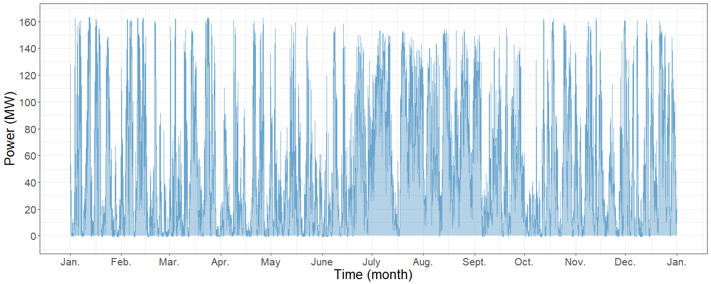
Fig. 19: Power generation of the wind farm throughout the year

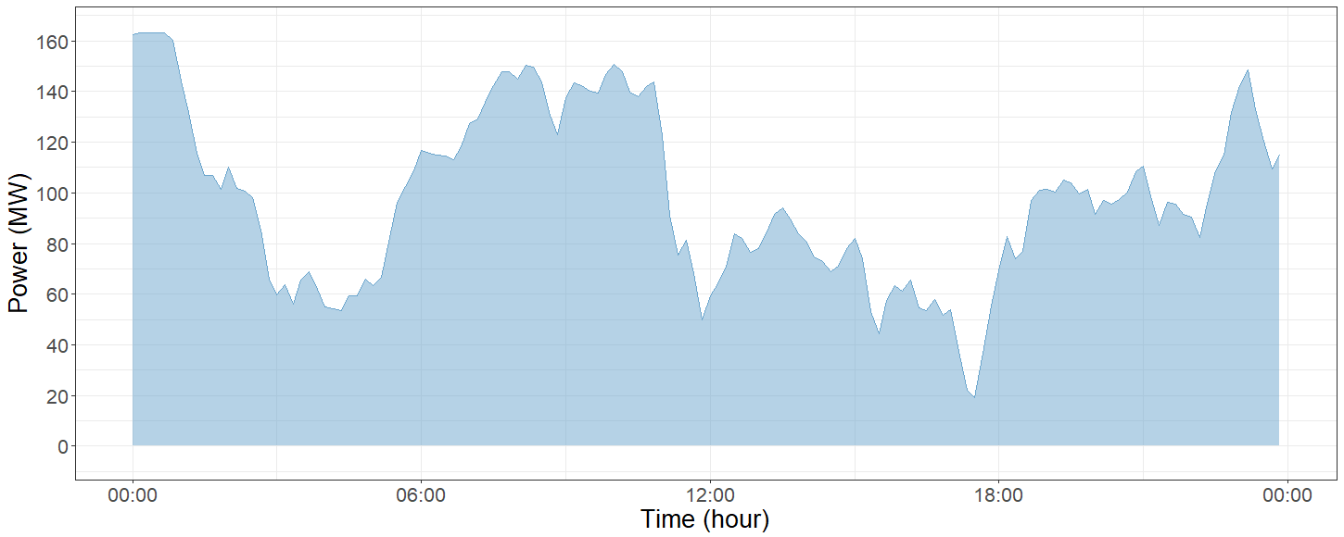
Fig. 20: Daily power generation of the wind farm

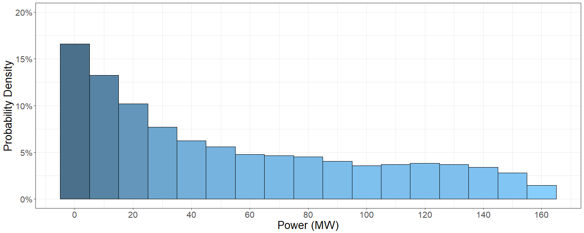
Fig. 21: Histogram of the wind power generation

Power consumption of the organized industrial zone used in this study is plotted in Fig. 22. Weekly pattern of the industrial power consumption can be observed throughout the year except the first week of July and second week of September, which are corresponding to holidays in Turkey, Ramadan and Sacrifice Feasts, respectively. Weekly power consumption of the industrial zone starting from Monday is also plotted in Fig. 23. As it can be observed from this figure, power consumption on weekdays has a similar pattern and on weekends, power consumption decreases significantly compared to weekdays. Power consumption levels are distributed around 120 MW for weekdays and 50 MW for weekends, which can be observed from the histogram presented in Fig. 24.

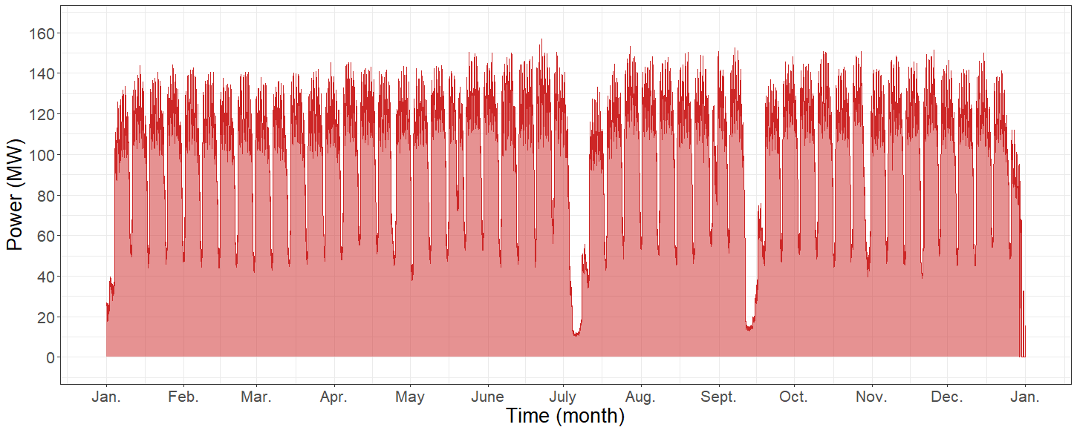
Fig. 22: Power consumption of the organized industrial zone throughout the year

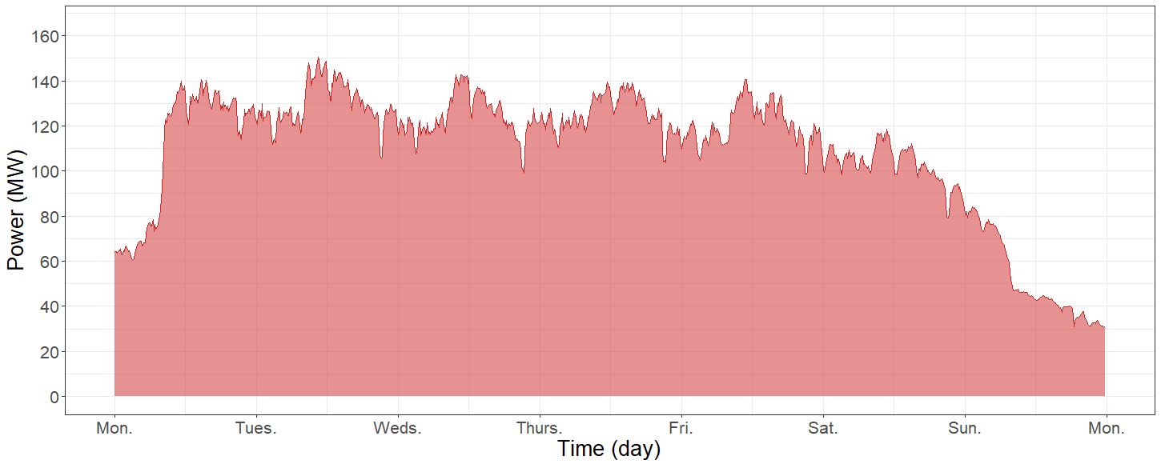
Fig. 23: Weekly power consumption of the organized industrial zone
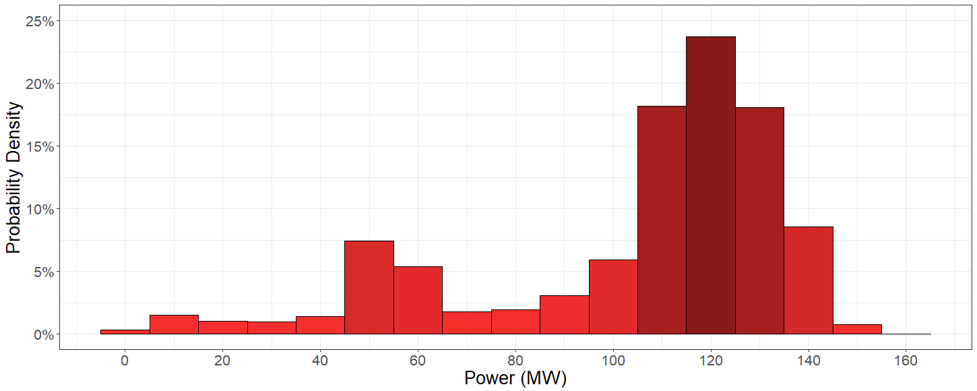
Fig. 24: Histogram of the organized industrial zone power consumption

With the integration of aforementioned wind generation and industrial consumption profiles to the system, power flow on the transmission side and histogram of power flow levels are shown in Fig. 25 and Fig. 26, respectively. In these figures, positive power values correspond to excess power generation of wind farm which is supplied to the grid, and negative power values correspond to power demand from the grid where wind generation cannot supply the industrial load. Low percentage of peak power flow can be observed in these figures. Summary of the power flow data is also tabulated in Table 8.

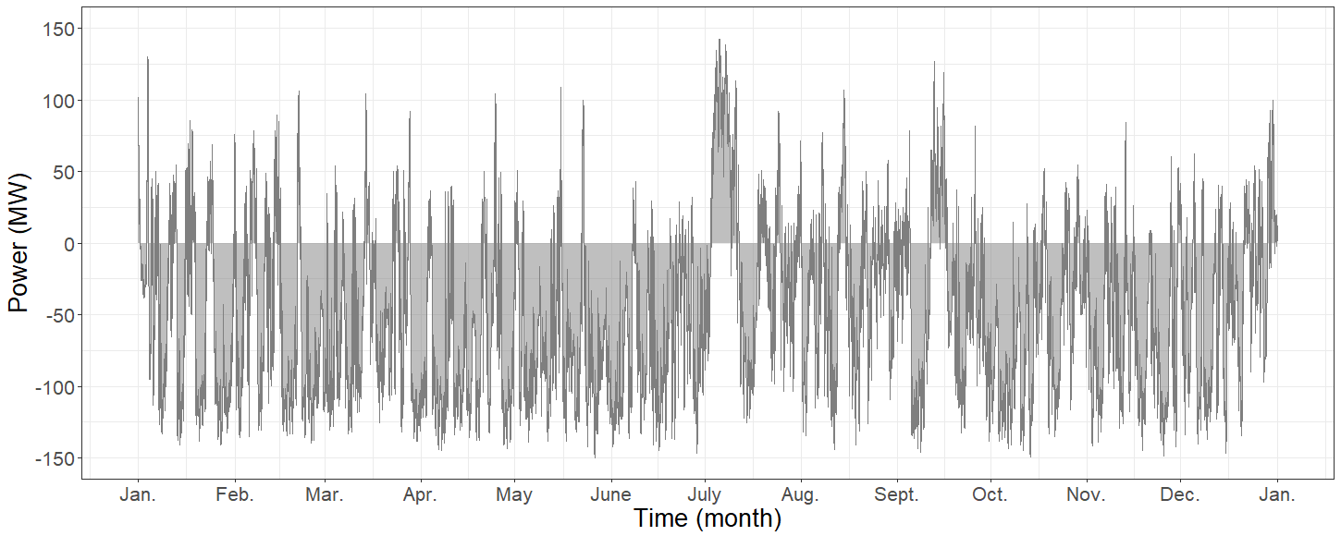
Fig. 25: Power flow on grid side as a result of chosen generation and load profiles

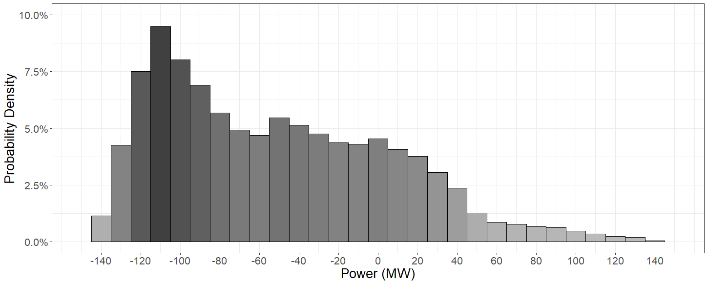
Fig. 26: Histogram of power flow on grid side

Table 8: Summary of power flow from/to grid

Data | Min. (MW) | 1st Qu. (MW) | Median (MW) | Mean (MW) | 3rd Qu. (MW) | Max. (MW)
Grid power flow | -149.77 | -102.13 | -60.46 | -51.94 | -8.98 | 142.40

Int this study, the impact of ESS and DSM on transmission side upgrade deferral is investigated for the explained scenario. As mentioned in the previous chapter, battery energy storage system (BESS) is chosen for the energy storage technology on the system. The BESS is integrated to the system at the point of common coupling of wind farm as shown in Fig. 27. For DSM application, HVAC units are determined as a suitable option because of the high percentage of end-use consumption occupied by these units. HVAC units’ power load over the system is considered in the consumption of organized industrial zone. The main purpose of this study is to use ESS and DSM concepts, in our case BESS and aggregated HVAC units, as a tool to absorb the excess power flow occurring on the transmission side of the system.

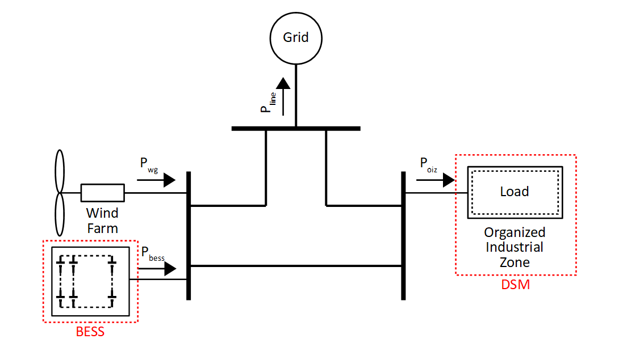
Fig. 27: Schematic of the system with BESS integration

  - Modeling and Approaches

    - Power Flow on Grid Side

Analysis of transmission upgrade deferral by keeping power flow on grid side within the limits of existing structures is the main purpose of this study. Power flow constraints of the grid side is expressed as follows:

(3.1)

where:

maximum transmission line loading capacity (MW)
wind farm power generation at time step k (MW)
organized industrial zone power consumption at time step k (MW)
BESS power output at time step k (MW)

    - Battery Energy Storage System

BESS can operate in three different modes; discharging, charging and idle. In charging mode, batteries are charged with the power drawn from grid and BESS can be considered as a load. In discharging mode, the power is supplied to the grid with discharge of the batteries and BESS can be considered as a generation unit. In idle mode, batteries are neither charged nor discharged. Mode variables of BESS are tabulated at Table 9.

Table 9: Mode variables of BESS

Variable | Idle  mode | Discharging mode | Charging mode
 | 0 | 1 | 0
 | 0 | 0 | 1

where:

discharging mode indicator of the BESS at time step k
charging mode indicator of the BESS at time step k

Discharging efficiency of a BESS is defined as the ratio of power supplied to grid to rate of change in stored energy in BESS. Charging efficiency of a BESS is defined as the ratio of rate of change in stored energy in BESS to power drawn from grid. Battery charging and discharging powers are limited by the physical and chemical characteristics of the BESS. Considering these information, power equations of the BESS are expressed as follows:

(3.2)

where:

rated power of the BESS (MW)
power output of the BESS at time step k (MW)
discharging mode indicator of the BESS at time step k
charging mode indicator of the BESS at time step k
discharging efficiency of the BESS
charging efficiency of the BESS

State of charge (SoC) of a battery is defined as the available capacity of the battery expressed as a percentage of its rated capacity. SoC is an indication of how longer a battery can continue to perform before recharging is needed [45]. Depleting or overcharging a battery is not desired, so proper limitations (i.e., 30%-100%) should be defined for SoC of the battery. Considering these information, SoC equations of the BESS are expressed as follows:

(3.3)

(3.4)

where:

state of charge of BESS at time step k
power output of the BESS at time step k (MW)
discharging mode indicator of the BESS at time step k
charging mode indicator of the BESS at time step k
discharging efficiency of the BESS
charging efficiency of the BESS
storage capacity of the BESS (MWh)
rated power of the BESS (MW)
minimum allowed state of charge of the BESS
maximum allowed state of charge of the BESS
time interval between time steps (minutes)

    - Heating, Ventilation and Air-Conditioning Units

HVAC units can operate in three different modes; cooling, heating and idle. In cooling mode, HVAC units draw power from the grid to extract heat from the room. In heating mode, HVAC units draw power from the grid to release heat to the room. In idle mode, HVAC units neither cool nor heat the room. Mode variables of HVAC units are tabulated at Table 10.

Table 10: Mode variables of HVAC units

Variable | Idle  mode | Heating mode | Cooling mode
 | 0 | 1 | 0
 | 0 | 0 | 1

where:

heating mode indicator of the HVAC_{i} at time step k
cooling mode indicator of the HVAC_{i} at time step k

HVAC units draw power from the grid both for cooling and heating modes. Total power drawn from the grid by HVAC units can be expressed as follows:

(3.5)

where:

power demand of aggregated HVAC units at time step k (MW)
rated power of HVAC_{i} (MW)
heating mode indicator of the HVAC_{i} at time step k
cooling mode indicator of the HVAC_{i} at time step k
number of HVAC units

Coefficient of performance (COP) is defined as the as the ratio of the delivered heat to electrical input power and energy efficiency ratio (EER) is defined as the ratio of the removed heat to electrical input power [36]⁠. Considering these information, thermal power output of HVAC units can be expressed as follows:

(3.6)

where:

equivalent thermal power output of HVAC_{i} at time step k (MW)
rated power of HVAC_{i} (MW)
heating mode indicator of the HVAC_{i} at time step k
cooling mode indicator of the HVAC_{i} at time step k
coefficient of performance of HVAC_{i}
energy efficiency ratio of HVAC_{i}

For modeling the HVAC units, a simplified model for temperature dynamics of a space can be created using a resistance-capacitance (RC) circuit analogy [35], [46]⁠. The simplified thermal mass model can be used for energy conversion problems, considering entire building and average temperature of all building spaces, as shown in Fig. 28.

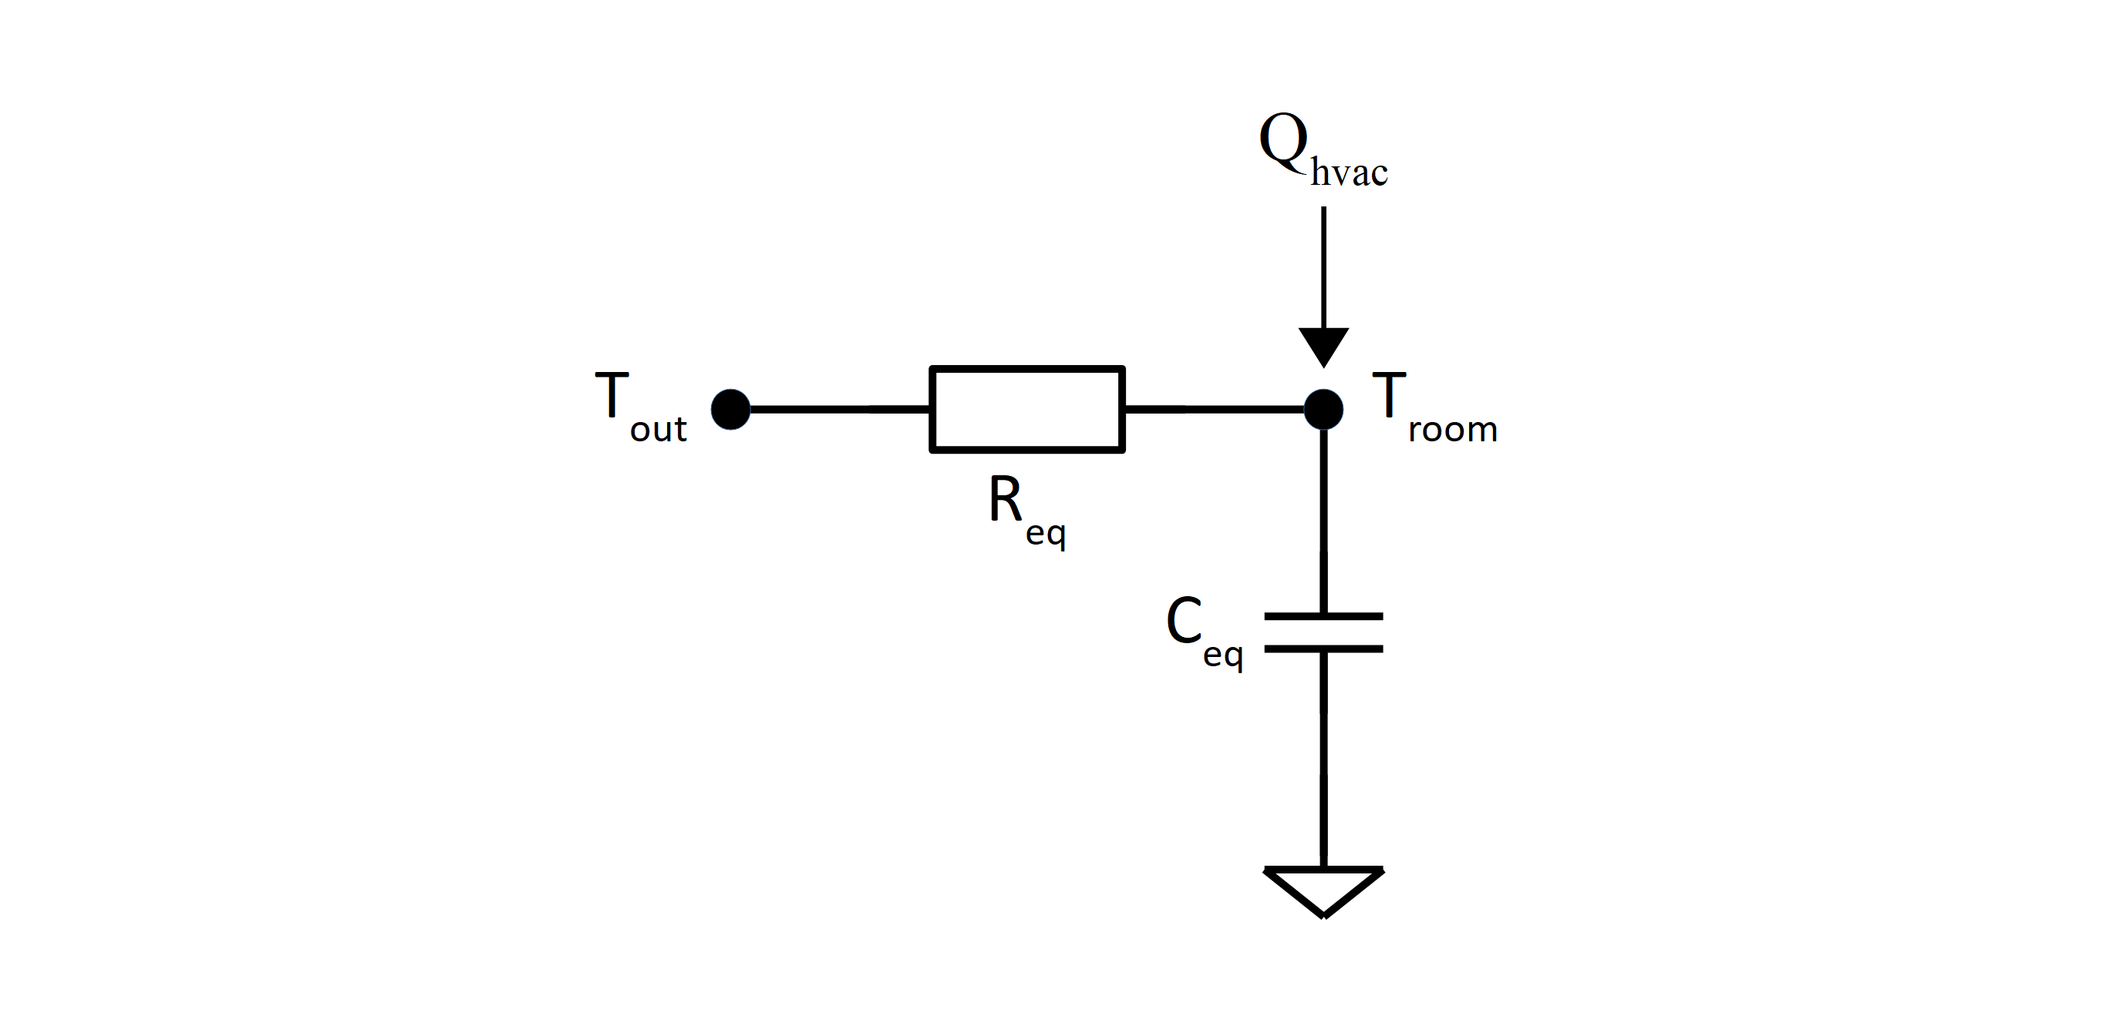
Fig. 28: Equivalent thermal parameters model of a space temperature [35], [46]⁠

With the information given above, temperature dynamics of the rooms can be expressed as follows:

(3.7)

(3.8)

where:

temperature of room_{i} at time step k (Cº)
minimum allowed temperature of room_{i} (Cº)
maximum allowed temperature of room_{i} (Cº)
ambient temperature at time step k (Cº)
equivalent thermal resistance of room_{i} (Cº/kW)
equivalent thermal capacity of room_{i} (kJ/Cº)
equivalent thermal power output of HVAC_{i} at time step k (kW)

For this thesis, ambient temperature data is collected from U.S. Climate Reference Network (USCRN) [47], as there is no accessible weather dataset of Turkey for subhourly periods. In order to simulate suitable ambient temperature conditions for the operations of HVAC units, USCRN monthly temperature data for 2016 are compared with the monthly temperature data collected from Turkish State Meteorological Service (MGM, in native initials) [48] for an area in Turkish Aegean Region. Monthly data of average temperature with minimum and maximum temperature averages taken from USCRN and MGM are tabulated in Table 11 and Table 12, and collected data are plotted in Fig. 29 and Fig. 30, respectively.

Table 11: Summary of monthly temperature data taken from USCRN [47]

 | Average Temperature (ºC) | Average Low Temperature (ºC) | Average High Temperature (ºC)
January | 6.4 | 3.2 | 10.2
February | 10.5 | 4.7 | 17.9
March | 10.9 | 5.7 | 16.8
April | 14.9 | 8.1 | 22.5
May | 17.7 | 10.8 | 25.5
June | 23.5 | 15.2 | 32.4
July | 26.2 | 16.6 | 36.1
August | 26.2 | 16.6 | 37.1
September | 22.6 | 13.8 | 32.6
October | 14.1 | 9.3 | 19.9
November | 9.6 | 5.7 | 15.4
December | 5.2 | 0.6 | 11.2

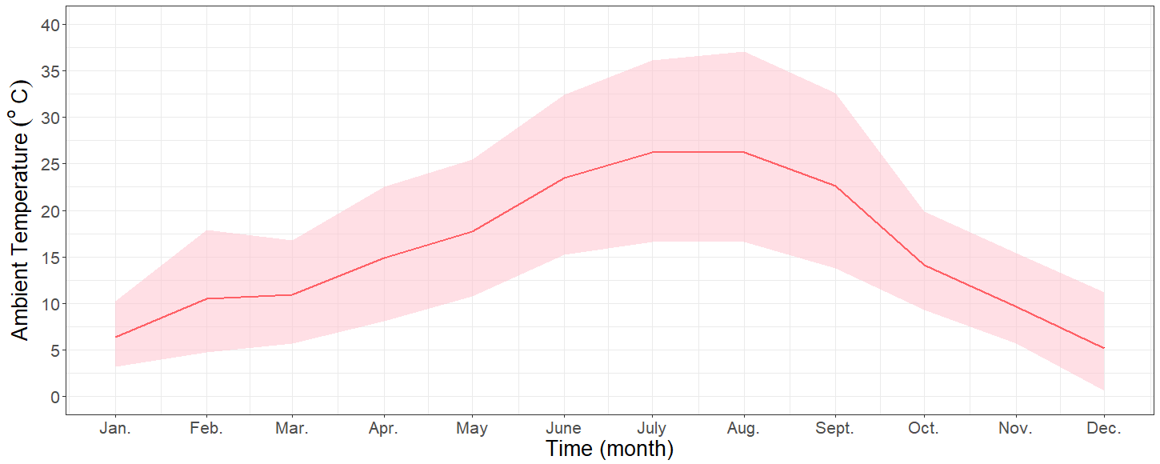
Fig. 29: Temperature of the chosen area from USCRN for one year period

Table 12: Summary of monthly temperature data taken from TSMS [48]

 | Average Temperature (ºC) | Average Low Temperature (ºC) | Average High Temperature (ºC)
January | 6.7 | 3.0 | 10.8
February | 7.9 | 3.6 | 12.6
March | 10.6 | 5.2 | 16.1
April | 15.2 | 8.8 | 21.3
May | 20.4 | 13.2 | 27
June | 25.3 | 17.4 | 32.1
July | 28.0 | 20.3 | 34.9
August | 27.6 | 20.2 | 34.9
September | 23.3 | 16.0 | 30.6
October | 17.8 | 11.6 | 24.3
November | 12.2 | 7.4 | 17.5
December | 8.2 | 4.5 | 12.5

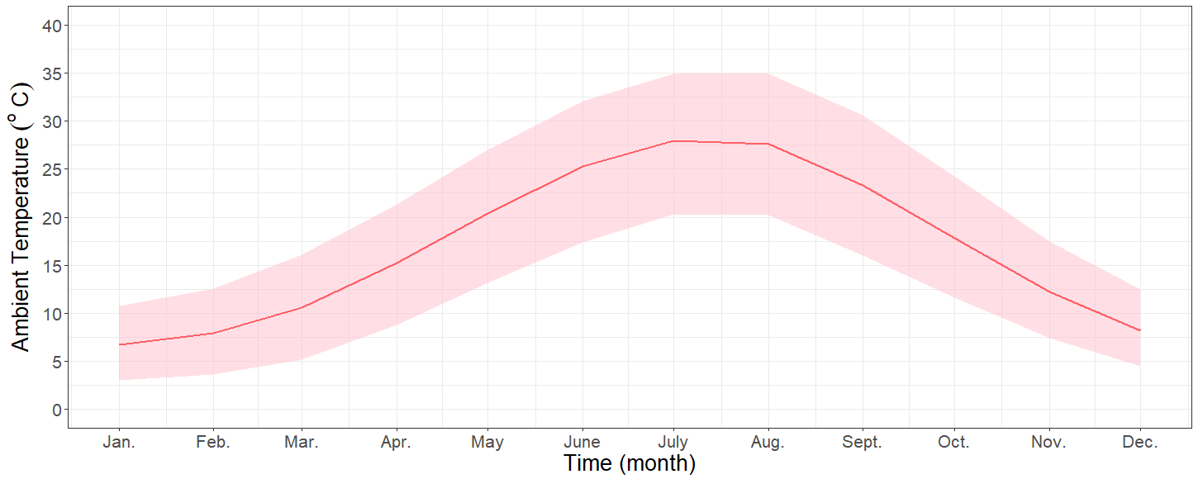
Fig. 30: Temperature of the chosen area from TSMS for one year period

  - Summary and Conclusion

This chapter starts with the explanation of transmission and distribution (T&D) upgrade deferral application and the scenario constructed for this application is presented, where a wind farm connected to a near organized zone and the overall system is connected to the grid.

Raw data of wind farm generation and industrial zone consumption used in this study are taken from large databases of the RİTM and MGKP projects of TUBITAK MAM EE. Considering the suitable power levels, raw data are processed and investigated for a better understanding of the scenario.

At the end of this chapter, mathematical models used for the simulations are presented. Mode variables of the BESS model are defined as idle, discharging and charging modes and output power and state of charge (SoC) equations and limitations of BESS model are generated using these mode variables. Mode variables of the HVAC unit model are defined as idle, heating and cooling modes and equations and limitations of the aggregated load power and thermal output power are generated using these mode variables. In order to model the thermal characteristics of a room, equivalent thermal parameters model (RC circuit analogy) is used. Room temperature equation is constructed using the thermal power output of the HVAC units and ambient temperature, which is taken from U.S. Climate Reference Network (USCRN) [47]⁠.

SIMULATIONS AND RESULTS

  - Introduction

In this chapter, demand side management (DSM) and energy storage system (ESS) control methods will be performed for the constructed scenario and corresponding results will be presented. Power flow on the grid side transmission structure is analyzed using the active power component of the wind farm generation and industrial consumption data which are mentioned in the previous chapter. For the aforementioned scenario, maximum power supplied to the grid is 142 MW and maximum power drawn from the grid is 150 MW.

In order to define a power carrying capacity for the grid side transmission structure in this scenario, conductor types used in Turkish electricity grid are examined and tabulated in Table 13 and Table 14 with their characteristics at 80 ºC conductor temperature, 40 ºC ambient temperature and 0.25 m/sec wind speed. Considering the maximum power flow on the grid side of the present scenario, it is reasonable to choose the grid side structure as 154 kV, 795 MCM with 182 MVA capacity limit. It is important to note that, reactive power is not examined in this study and active power is implied by the introduced power values.

Table 13: 154 kV transmission line conductor types and characteristics

Type | Total conductor area (mm²) | Wire gauge (MCM) | Current carrying capacity (A) | Thermal capacity (MVA)
Hawk | 281 | 477 | 496 | 132
Drake | 468.4 | 795 | 683 | 182
Cardinal | 547 | 954 | 765 | 204
2B, Cardinal | 2x547 | 2x954 | 2x765 | 408
Pheasant | 726 | 1272 | 925 | 247

Table 14: 380 kV transmission line conductor types and characteristics

Type | Total conductor area (mm²) | Wire gauge (MCM) | Current carrying capacity (A) | Thermal capacity (MVA)
2B, Rail | 2x517 | 2x954 | 2x755 | 995
2B, Cardinal | 2x547 | 2x954 | 2x765 | 1005
3B, Cardinal | 3x547 | 3x954 | 3x765 | 1510
3B, Pheasant | 3x726 | 3x1272 | 3x925 | 1825

It is verified from Turkish Electricity Transmission Company (TEİAŞ, in native initials) that in case of a projected overload on an existing transmission structure, instead of an upgrade over the existing structure, a new parallel transmission line is assigned for the region. With this information, upgrade factor of the grid side is defined as 1, which corresponds to a new transmission structure with the same capacity (154 kV, 795 MCM transmission structure with another 182 MVA capacity, for this study). The information about the general capital expenses for a new transmission structure is also verified from TEİAŞ and tabulated in Table 15. As the expenses are highly variable for every project, depending mainly on the geography of the construction site, stated expenses can be considered as an average and used for a general understanding of the results.

Table 15: Approximate costs of transmission structure

Transmission line | Capital Expenditure
Transmission line (per km) | € 200/MVA
Power transformer | € 4400/MVA
Substation | € 900/MVA

In this chapter, control algorithms used to control aggregated heating ventilation and air-conditioning (HVAC) units and battery energy storage system (BESS) for the upgrade deferral of grid side transmission structure are introduced. Two separate cases are investigated over the constructed scenario;

- Industrial electricity consumption increase ratio is applied to the industrial load.

- A block addition is introduced to the power generation of the wind farm.

The effects of DSM and ESS control methods are analyzed for the upgrade deferral of the existing grid side transmission structure for both cases, using the obtained simulation results. The chapter is concluded with the interpretation of the simulation results.

  - Specifications

    - Demand Side Management

In this study, constant speed HVAC units are chosen as the aggregated load to be controlled. Constant speed HVAC units, unlike HVAC units with inverter technologies, can only operate at full power. Depending on the specific conditions, HVAC units can operate either in cooling mode or heating mode. In order to define specifications of the HVAC units, different catalogs are examined and compared. A datasheet of typical constant speed casette type HVAC unit used in small to medium-sized office buildings is shown in Fig. 31 [36]⁠. Using the information on this datasheet, input power of the HVAC units is defined as 1.80 kW and 1.90 kW for cooling and heating modes, respectively. Energy efficiency ratio (EER) which corresponds to cooling power ratio and coefficient of performance (COP) which corresponds to heating power ratio are defined as 2.74 and 2.83, respectively.

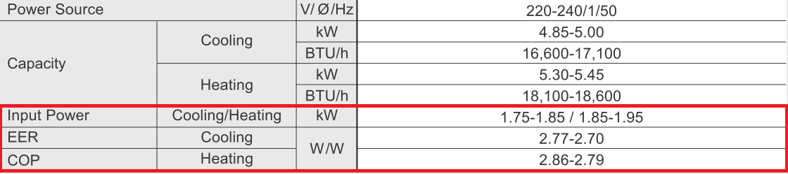
Fig. 31: Datasheet of a constant speed HVAC unit [36]⁠

Thermal capacitance and thermal resistance of the equivalent thermal model used to model room temperature dynamics are chosen as 9,200 kJ/ºC and 50 ºC/kW, as presented in [46]⁠. Using these parameters for the equivalent thermal model, temperature of a room can be decreased/increased about 1 ºC from ideal room temperature in approximately 30 minutes when HVAC units with defined specifications operate, assuming 23 ºC ambient temperature.

10,000 HVAC units are defined for the organized industrial zone and HVAC units divided into 50 groups with 200 HVAC units each, in order to control the HVAC load with less than 0.5 MW step. Full load of the HVAC units occupy approximately 12% of the maximum industrial load.

    - Battery Energy Storage System

Main battery energy storage system (BESS) specifications; rated power and energy to power ratio, are defined differently for two separate cases, according to the system needs, analyzing the power flow characteristics on the grid side transmission structure. Charging and discharging limits of the BESS are defined as the rated power of the BESS. State of charge (SoC) limits for the BESS is chosen as 0.30 and 0.90 in order to extend the lifetime of the battery [49]⁠, so available storage capacity of the BESS is limited to 60% of the total capacity. Considering the battery and converter losses, efficiency of both charging and discharging cycle is defined as 93% with an overall efficiency of 86.5%.

Three components are included for the investment costs of the BESS; the power conversion system costs corresponding to power electronics equipment expressed per unit of BESS rated power (€/kW), the energy storage unit costs corresponding to battery expressed per unit of BESS storage capacity (€/kWh) and the balance of plant costs corresponding to other services (engineering, grid connection, etc.) expressed per unit of BESS storage capacity (€/kWh). Approximate investment costs of lead-acid and lithium-ion type battery technologies are tabulated in Table 16 [50]⁠.

Table 16: Approximate investment costs of BESSs with lead-acid and lithium-ion battery technologies [50]⁠

Cost parameters | Lead-acid | Lithium-ion
Power conversion system | € 150/kW | € 150/kW
Energy storage system | € 125/kWh | € 450/kWh
Balance of plant | € 45/kWh | € 25/kWh

  - Control Algorithms

    - Control of HVAC Units

Without demand side management (DSM) control method, HVAC units are controlled simply by local controllers, using predefined temperature limits set by thermal comfort zone of the rooms and critical temperature limits change between cooling and heating operation modes. Total load of the HVAC units without the DSM control is defined as the base load of HVAC units and extracted from the industrial load data in order to find the organized industrial zone power consumption without the usage of the HVAC units.

For the DSM application, a central controller is defined over the local controllers. Direct control method is chosen to control the aggregated load of the HVAC units; the set power is calculated for every time step and sent to units in order to manage the demand side efficiently according to grid needs. Flowcharts of central controller and local controller algorithms are presented in Fig. 32 and Fig. 33, respectively. Flowchart of overall control algorithm is also presented in Fig. 34.

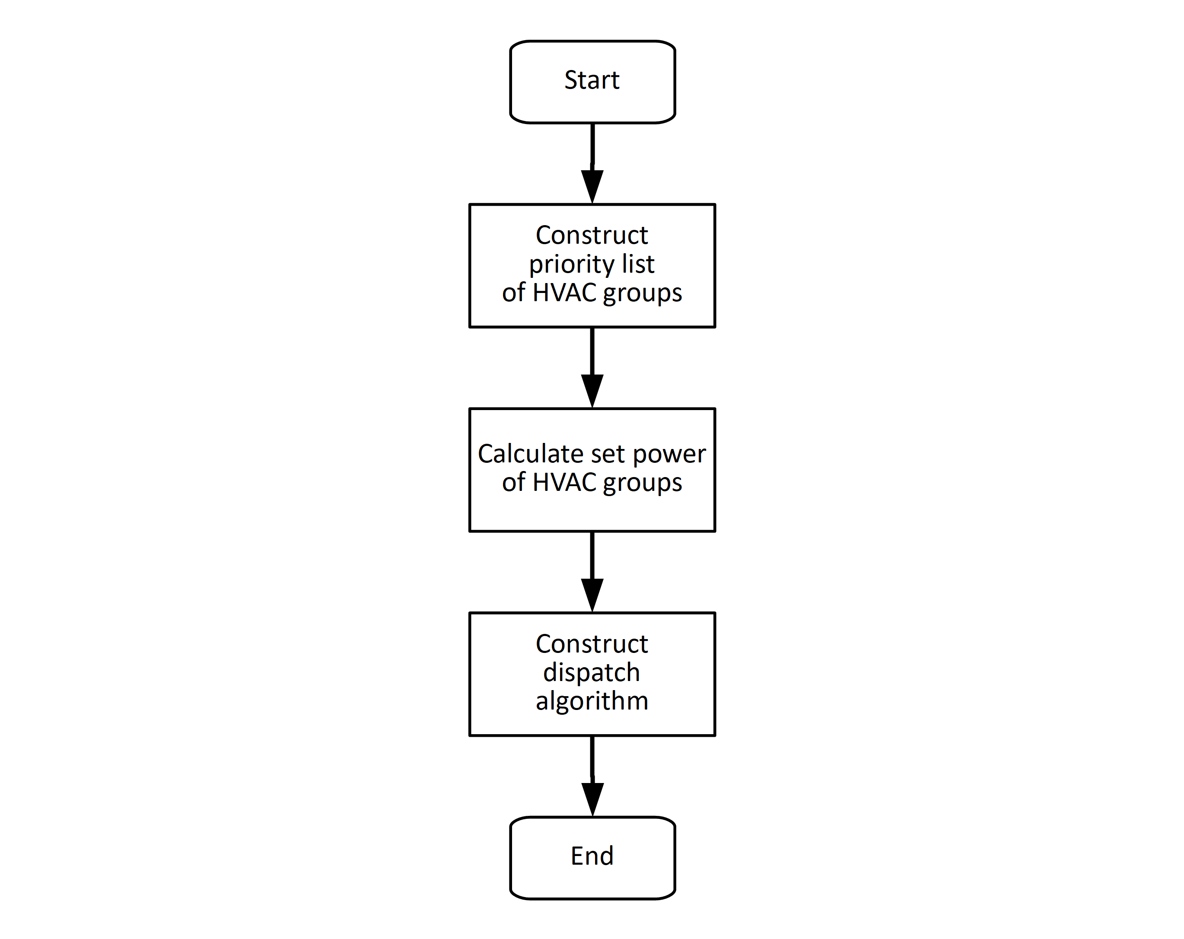
Fig. 32: Flowchart of HVAC central controller algorithm

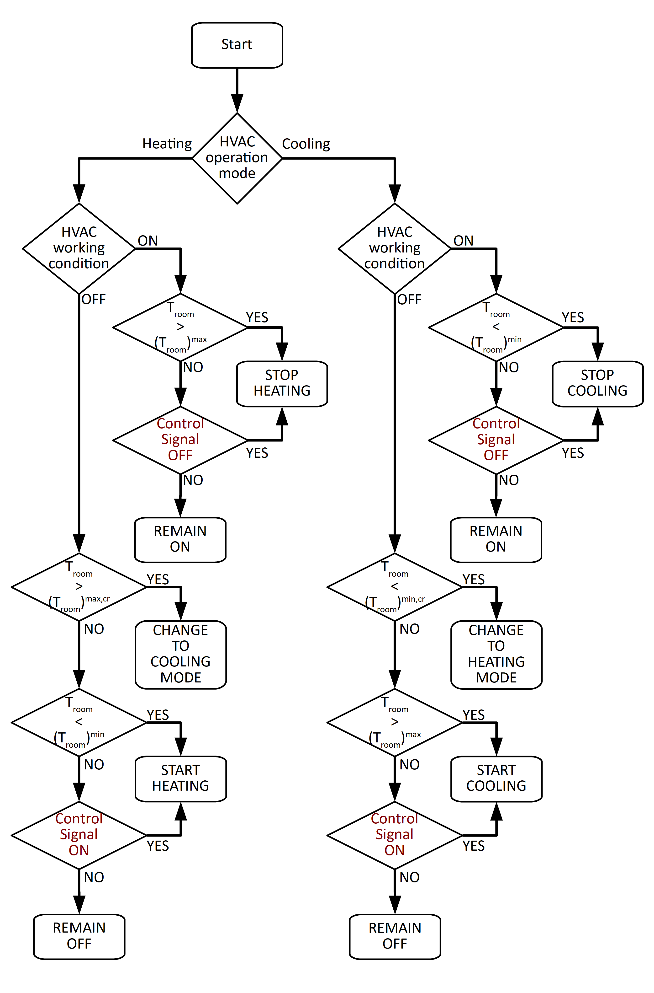Fig. 33: Flowchart of HVAC local controller algorithm
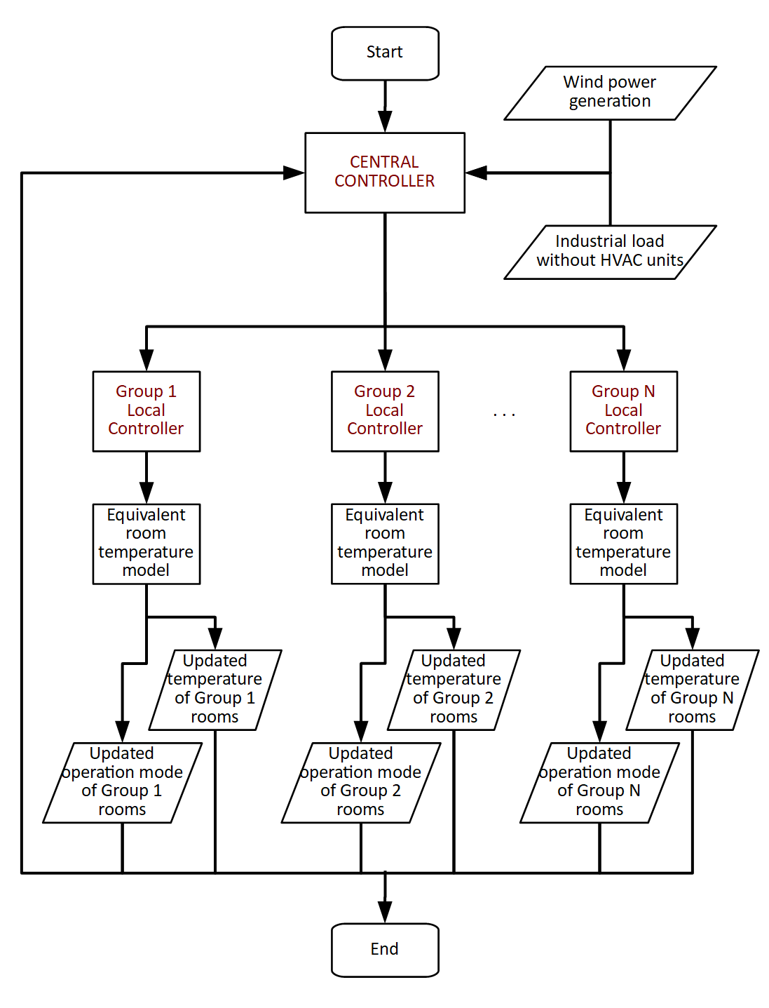
Fig. 34: Flowchart of DSM algorithm

The calculations and decisions of DSM algorithm at every time step can be summarized as follows:

- Central controller calculates the set power for the total HVAC load by using the wind power generation and industrial load data (extracting the base load of HVAC units) information and taking the grid side capacity into account.

- Central controller creates the priority list for HVAC groups by using HVAC operation mode and room temperature information sent from local controllers.

- Central controller constructs the dispatch algorithm, combining calculated set power and created priority list. Dispatch signals are sent to all local controllers.

- Local controllers dispatch the HVAC groups according to control signals sent from central controller, provided that temperature limits of the thermal comfort zone are not exceeded.

- Operation mode of the HVAC groups and room temperatures are updated for the next time step using the equivalent thermal model, and these information are sent back to central controller.

    - Control of BESS

In order to maintain the power flow on the grid side between the limits of transmission capacity, battery energy storage system (BESS) is controlled according to grid requirements where demand side management (DSM) control cannot meet the intended operation. Flowchart of BESS control algorithm is presented in Fig. 35.

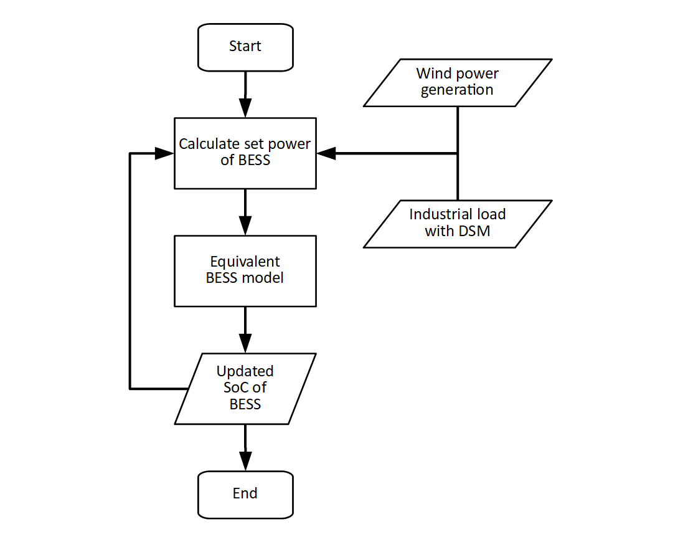
Fig. 35: Flowchart of BESS control algorithm

The calculations and decisions of BESS control algorithm at every time step can be summarized as follows:

- The BESS controller calculates the set power for the BESS by using the wind power generation and total industrial power consumption, also considering state of charge (SoC) of the BESS.

- BESS is operated according to calculated set power, either in charge or discharge mode.

- SoC of the BESS is updated according to equivalent BESS model and sent back to the BESS controller.

  - Cases

    - Effect of the Industrial Growth

As a result of ongoing industrial development in Turkey, electricity consumption increases over the years, which leads shortcoming in the present power system structures. Total and industrial energy consumption of Turkey between 2006 and 2015 are tabulated in Table 17, which are taken from the database of Turkish Statistical Institute (TÜİK, in native initials) [51]. Increase in both total and industrial electricity consumption can be observed throughout the years but 2009, which can be interpreted as a consequence of global financial crisis in 2008.

Table 17: Total and industrial electricity consumption throughout the years [51]

 | Total Electricity Consumption  (GWh) | Total Electricity Consumption Change (%) | Industrial Electricity Consumption  (GWh) | Industrial Electricity Consumption Change (%)
2006 | 143.07 | 10.03 | 67.96 | 8.38
2007 | 155.14 | 8.44 | 73.84 | 7.97
2008 | 161.95 | 4.39 | 74.82 | 1.30
2009 | 156.89 | -3.12 | 70.45 | -6.21
2010 | 172.05 | 9.66 | 79.31 | 11.18
2011 | 186.10 | 8.17 | 88.03 | 9.89
2012 | 194.92 | 4.74 | 92.39 | 4.73
2013 | 198.05 | 1.61 | 93.28 | 0.95
2014 | 207.38 | 4.71 | 97.88 | 4.70
2015 | 217.31 | 4.79 | 103.44 | 5.37
In the Electricity Demand Projection Report prepared by Republic of Turkey Ministry of Energy and Natural Resources, electricity consumption for 3 scenarios (low, reference and high consumption) are tabulated for the next 20 years, which are shown in Fig. 36 [52]⁠. In this report, yearly electricity consumption projection results for 3 scenarios are calculated as 3.5%, 4.2% and 5.3%, respectively.

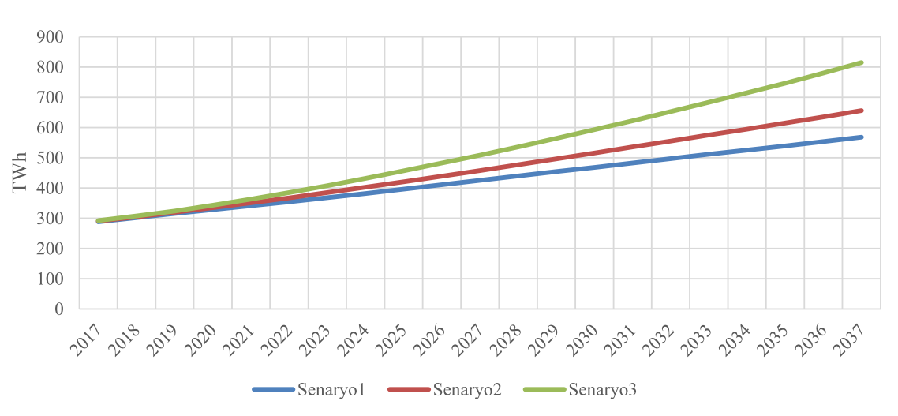
Fig. 36: Projection of electricity consumption in Turkey for the next 20 years [52]⁠

Using aforementioned electricity consumption increase percentages on organized industrial zone data chosen for this study, maximum power demand on the transmission line for 3 different scenarios are tabulated in Table 18 and plotted in Fig. 37. For the chosen transmission line structure (182 MVA), with a 5% safety margin, the transmission overload occurs;

- In Year 5 for 3.5% industrial load increase
- In Year 4 for 4.2% industrial load increase
- In Year 3 for 5.3% industrial load increase
These results show that the transmission system defined in the constructed scenario will need an upgrade in just 3-5 years (depending on the demand growth). In the simulations, the base scenario with 4.2% yearly increase of industrial load is used. Maximum power demand on the grid side transmission structure for the base scenario in Year 4, Year 5 and Year 6 are plotted in Fig. 38.

Table 18: Maximum projected power flow on the grid side transmission structure for next 10 years

 | Maximum power flow using 3.5% increase (MW) | Maximum power flow using 4.2% increase (MW) | Maximum power flow using 5.3% increase (MW)
Year 1 | 155.01 | 156.06 | 157.70
Year 2 | 160.43 | 162.61 | 166.06
Year 3 | 166.04 | 169.44 | 174.86
Year 4 | 171.86 | 176.56 | 184.13
Year 5 | 177.88 | 183.97 | 193.89
Year 6 | 184.10 | 191.70 | 204.17
Year 7 | 190.55 | 199.75 | 215.00
Year 8 | 197.22 | 208.14 | 226.43
Year 9 | 204.12 | 216.90 | 238.45
Year 10 | 211.27 | 226.03 | 251.12

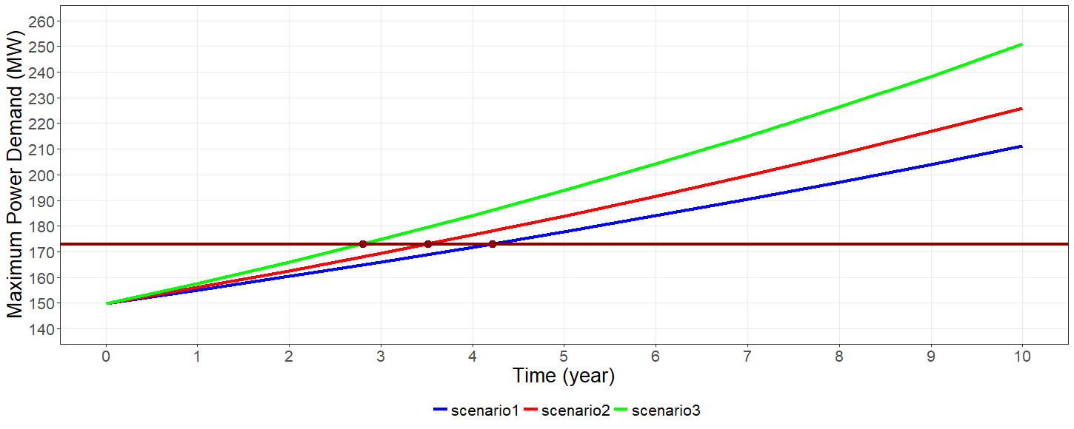
Fig. 37: Maximum projected power demand on the grid side for next 10 years

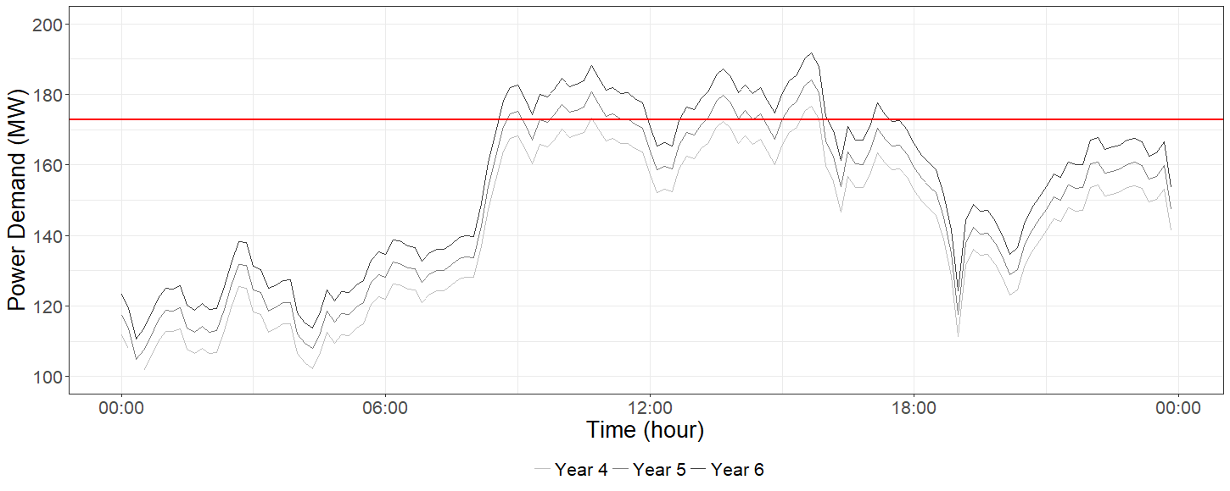
Fig. 38: Overload on the grid side transmission structure

Using the present generation and load data with 4.2% increase on the industrial load, maximum overload on the grid side transmission structure in Year 4 is projected with approximately 176.5 MW. Taking the 5% safety margin defined for the transmission structures into account, maximum excess power flow over the grid side is approximately 3.6 MW and power demand from the grid exceeds the capacity of the transmission structure with a maximum of 3 time-steps (30 minutes) intervals.

As mentioned before, total load of the heating, ventilation and air-conditioning (HVAC) units is chosen approximately as 12% of the total industrial load. Using the defined increase ratio on the industrial load, full load of the HVAC units is also increased with a ratio of 18% for this case. With this increase ratio, the full load capacity of the HVAC units becomes approximately 22.5 MW, which is sufficient to absorb the excess power in normal conditions. However, it is important to note that this capacity can be unavailable for the critical intervals, as the thermal comfort of the room limits the control over HVAC units. With this analysis, it is suitable to choose the BESS with 4 MW rated power and 2 MWh storage capacity, in order to maintain power flow on the grid side between the limits of transmission capacity throughout the year.

Power flow on the grid side with the control algorithm is shown in Fig. 39. As it can be observed from this figure, excess power flow on the grid side is prevented and power flow is maintained in the safe zone (which is defined as the 95% of the capacity of existing transmission structure). Power output of the HVAC units and corresponding room temperatures are presented in Fig. 40 and Fig. 41. These figures show that HVAC units are operated considering grid needs, as long as the room temperatures between 22-24 ºC. Power output and state of charge (SoC) of the BESS are also presented in Fig. 42 and Fig. 43. SoC of the BESS is kept between 0.3 and 0.9 all the time, in order to extend the battery life. From these figures, it can be easily seen that the BESS is idle most of the time and operated when the load of the HVAC units are insufficient to keep power flow on the safe zone. Usage of the BESS can be made more effective by adding complementary uses and benefits to the control algorithm, which will be discussed later in this chapter.

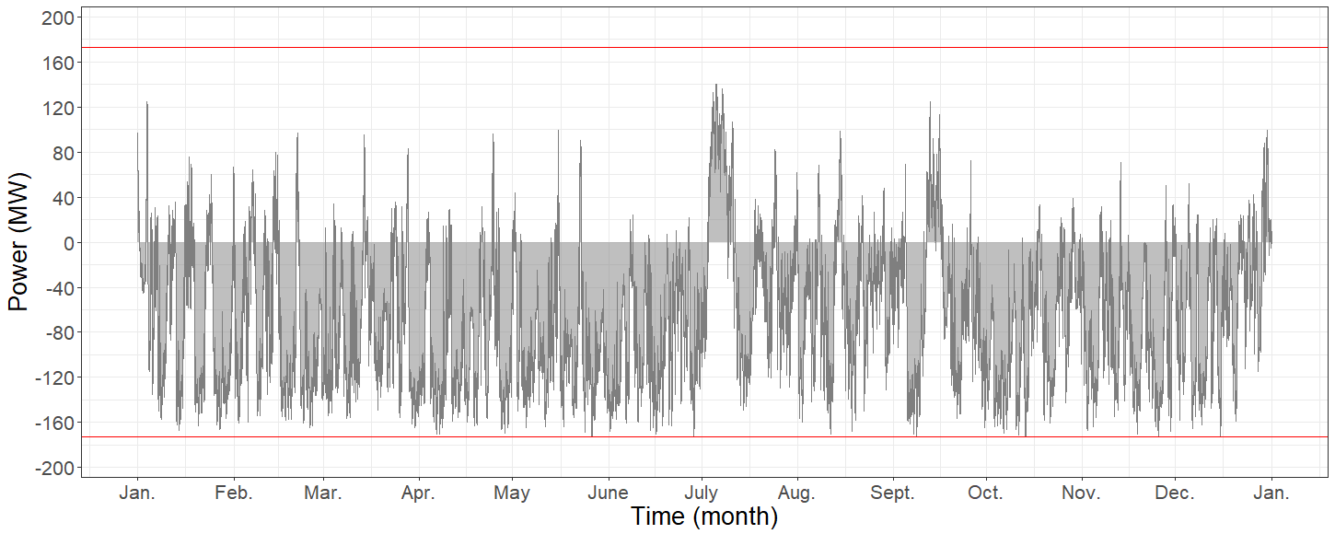
Fig. 39: Power flow on the grid side transmission structure with the control algorithm for first case

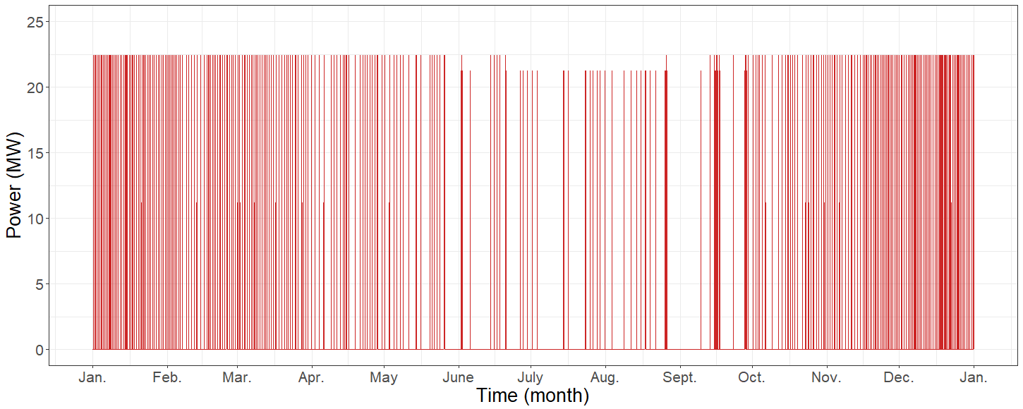
Fig. 40: Power output of the HVAC units for first case

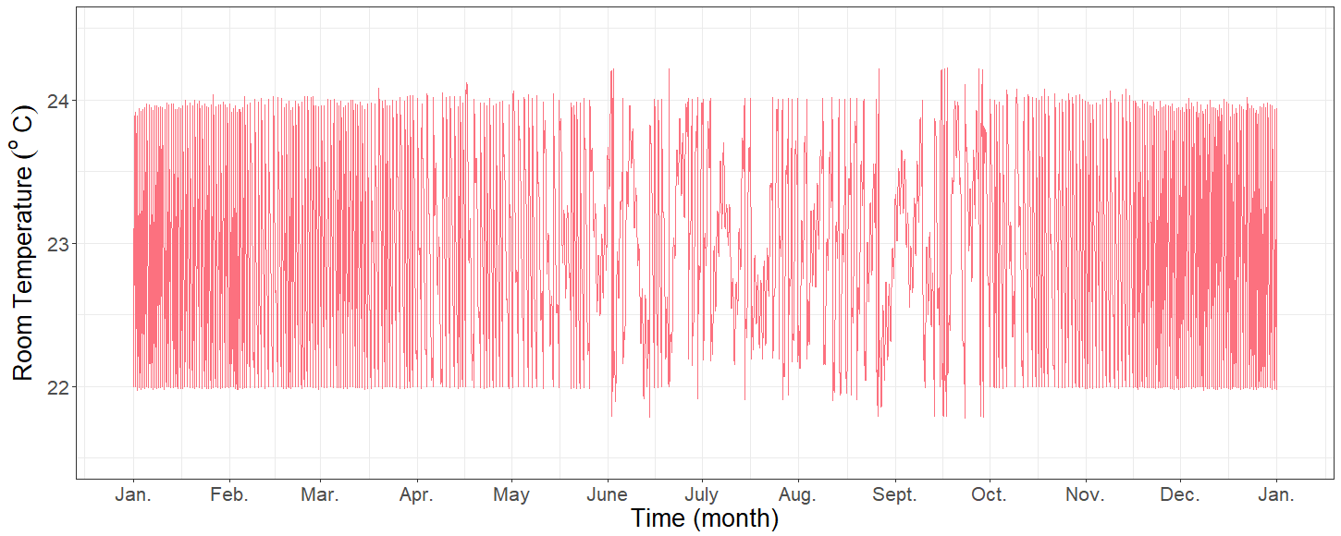
Fig. 41: Room temperatures of the corresponding HVAC units for first case

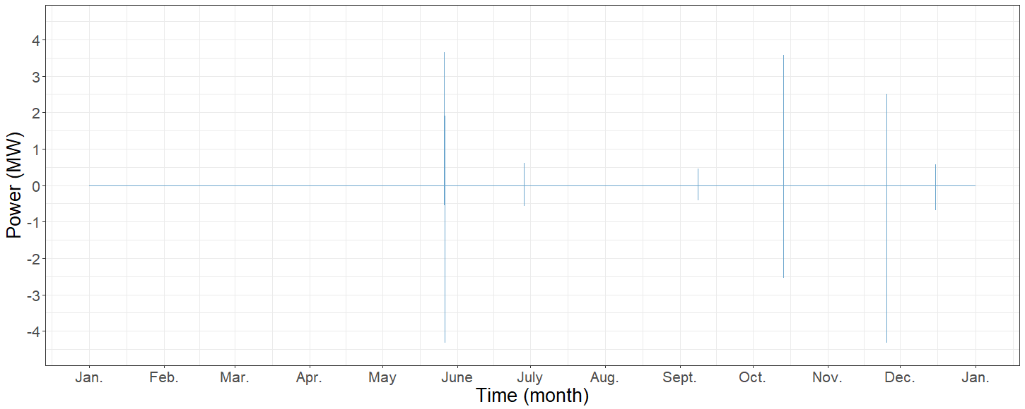
Fig. 42: Power output of the BESS for first case

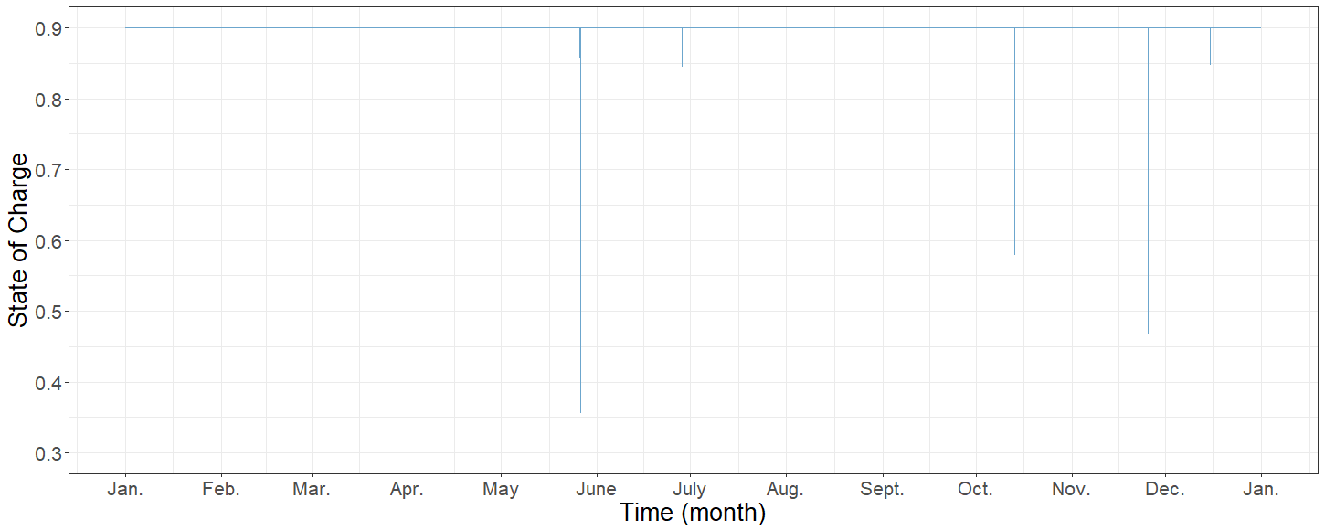
Fig. 43: SoC of the BESS for first case

Capital expenditure (CAPEX) of a new transmission structure in case of an overload depends on the length of the transmission line. For this study, length of the transmission line is taken as 30 km, by taking the transmission structure of chosen wind farm into account. With this information, CAPEX of a new transmission line (182 MVA rating) with the power transformers and protection and control equipments (200 MVA rating) on both sides of the line becomes € 3,212,000. CAPEX of the BESS in industrial load increase case for one-year deferral application is calculated as € 940,000 for lead-acid batteries and € 1,550,000 for lithium-ion batteries.

In order to convert total capital cost of the BESS and transmission structures to annualized cost, fixed charge rate (FCR) is used. FCR of the transmission structure is taken as 11% [41]⁠ and FCR of the BESS is taken as 12% [53]⁠. With chosen FCR values, annual cost of the transmission structure becomes € 353,320 and annual cost of the BESS becomes € 112,800 for lead-acid batteries and € 186,000 for lithium-ion batteries.

Power flow on the grid side is also analyzed for the second year deferral of the transmission structure upgrade for this case. In Year 5, maximum power flow over the grid side transmission structure is calculated as approximately 184 MW. In order to keep power flow on the safe zone for a second year deferral, an additional BESS of 8 MW rated power with 16 MWh storage capacity is needed. It is important to note that, usable capacity of the total BESS becomes 10.8 MWh as the SoC is limited between 0.3 and 0.9. Power output and SoC of the BESS for the second year deferral are presented in Fig. 44 and Fig. 45. It can be observed from these figures that the BESS operates more often compared to the first year, but still it stays in idle mode for most of the time.

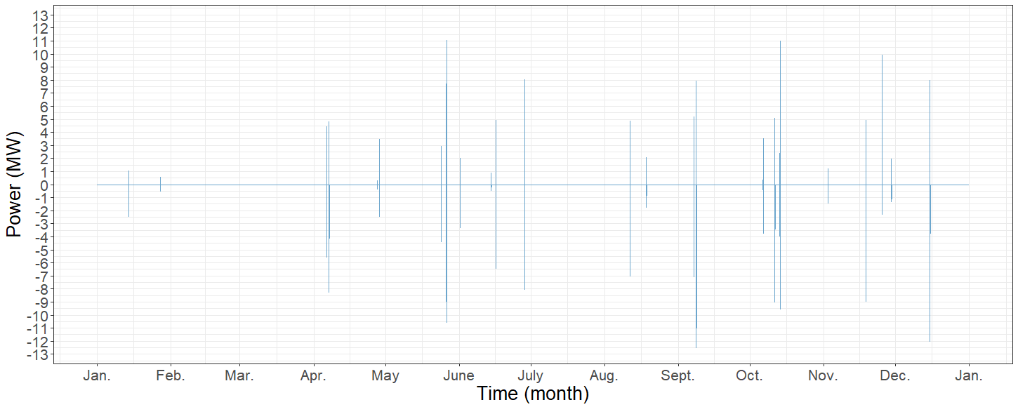
Fig. 44: Power output of the BESS for first case (2nd year deferral)

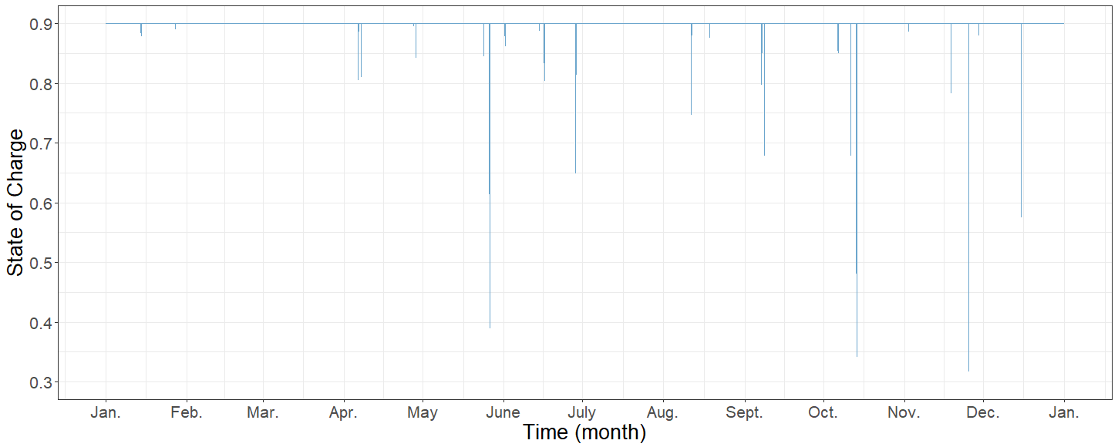
Fig. 45: SoC of the BESS for first case (2nd year deferral)

CAPEX of the additional BESS is calculated as € 3,920,000 and € 8,800,000 for lead-acid and lithium-ion battery types for the second year deferral. Using the FCR, annual costs become € 470,400 and € 1,056,000, respectively. Considering the annual cost of transmission structure, € 353,320, second year deferral of the grid side upgrade is concluded as infeasible for the transmission structure with a transmission length of 30 km.

However, the length of the transmission line is another important factor for the feasibility analysis. For every 5 km increase on the line length, € 182,000 is added to transmission line CAPEX, as the power transformer and substation costs are independent of the transmission line length. Using this information, minimum transmission length for a feasible second year deferral is calculated as 60 km for the lead-acid battery type and 210 km for the lithium-ion battery type. These calculated lengths can be used to have a general idea on the overall situation. The overall results are tabulated at Table 20.

    - Effect of Additional Wind Power Generation

Installed wind energy capacity in Turkey has been increasing over the years in a similar to the global trend. Considering the growing trend on the wind energy, a block addition is defined on the wind farm for the second case, which will lead the power flow on the transmission structure over the capacity of the structure. Maximum projected power on the grid side transmission structure is tabulated for different block additions on the wind farm in Table 19. Considering the installed wind energy capacity increase rates in Turkey for the last decade [4]⁠, 25% capacity increase on the wind farm is defined for one year period, in this case.

Table 19: Maximum projected power on the grid side transmission structure for different block additions on the wind farm

Percentage | Power flow (MW)
10% | 157.70
15% | 165.35
20% | 173.01
25% | 180.66
30% | 188.31
35% | 195.97

Using the present generation and load data with 25% increase on the wind generation, maximum overload on the grid side transmission structure is projected as 180.7 MW. Taking the 5% safety margin into account, the maximum excess power flow over the grid side transmission structure is approximately 7.8 MW and power demand from the grid exceeds the capacity of transmission structure with a maximum of 5 time-steps (50 minutes) interval. As stated before, heating, ventilation and air-conditioning (HVAC) units cannot contribute to the support of the grid needs in some situations, as certain boundaries are defined for the thermal comfort of the rooms. Taking the worst case situation into account, it is suitable to choose the battery energy storage system (BESS) with 7.5 MW rated power with 10 MWh storage capacity (80 minutes energy to power ratio).

Power flow on the grid side with the control algorithm for this case is shown in Fig. 46. As it can be observed from this figure, excess power flow on the grid side is prevented (which is defined as the 95% of the capacity of existing transmission structure). For this case, BESS usage is limited to a very narrow region, where the wind power generation peaks and industrial load stays low for approximately 2 hours. It is important to point out that HVAC loads cannot support the grid needs in that period because of two main reasons; either they work on full load condition or some HVAC groups cannot work in order to maintain temperature comfort zones of the rooms.

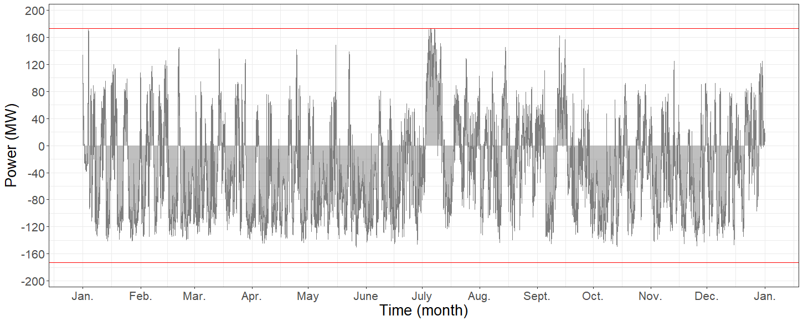
Fig. 46: Power flow on the grid side transmission structure with the control algorithm for second case

Capital expenditure (CAPEX) of the new transmission structure in case of an overload for defined 30 km length is € 3,212,000, as calculated in the previous case. For a 25% wind generation capacity increase, CAPEX of the BESS for the deferral application is calculated as € 2,825,000 for lead-acid batteries and € 5,875,000 for lithium-ion batteries.

Using the FCR values presented in the previous case, annual cost of the transmission structure is € 353,320 and annual cost of the BESS becomes € 339,000 for lead-acid batteries and € 705,000 for lithium-ion batteries. For the defined 25% wind generation capacity increase, deferral of the transmission structure upgrade can be applied by using lead-acid type BESS for the chosen 30 km transmission length. Minimum transmission length for lithium-ion type BESS to be efficient for the first year deferral is calculated as 120 km. These results are also tabulated in Table 20. Above 25% block additions to wind generation, total capital cost of the BESS will increase extremely because of the high storage capacity need, which will make the deferral application infeasible for the analyzed case.

  - Complementary Uses of the BESS

For the both cases analyzed in this study, battery energy storage (BESS) operates only for short intervals and stays in the idle mode for the most of the time. As the idle usage of the BESS is infeasible, it is important to add complementary uses and benefits, which can compensate the high capital expenses and increase the applicability of the proposed method. However, complementary uses should not conflict with the transmission capacity related application and should add value to the benefits came from the primary use of the BESS. Complementary uses which can be added to the main purpose of the storage system can be summarized as follows [41]⁠:

- Wholesale electric energy time-shift: By storing the energy when the market price is low and selling the stored energy with higher price, time-shifting can be profitable for the suppliers.
- Voltage (reactive power) support: Voltage stability of a grid can be increased with BESS; using the converters to support the reactive power need.

- Electricity service reliability: Reliability of the transmission of electric power from suppliers to end-users can be increased, by using BESS to support the grid in case of emergencies.

- Electric supply capacity: The cost of generation equipment can be reduced by using energy storage, simply by storing the energy when the load is low and releasing the stored energy when the load exceeds generation capacity. By doing so, generation power need can be reduced equal to the amount of storage power.

- Seasonal deployment: By analyzing the seasonal trends of a grid, BESS can be used to store the energy when there is excess generation and release the stored energy later when needed. Excess generation is stored for weeks to months in seasonal deployment applications.

- Retail time-of-use energy cost reduction: Electric energy pricing changes according to peak and off-peak hours. Storing the energy in low price periods and using this energy when demand and price are high can be profitable for the end-user.

- Renewable energy time-shift: Renewable generation is not controllable but can be stored at off-peak periods by using BESS and stored energy can be sold later at peak periods, when energy prices are high, increasing the profit.

For this study, BESS is operated for wholesale electric energy time-shift and power output smoothing complementary applications. As the main purpose of this study is the transmission structure upgrade deferral application, BESS is kept available for the main usage by limiting complementary application between a limited area; where the power flow on the grid side is between critical limits. When these limits are exceeded, BESS is prepared for the upgrade deferral operation and waited as long as power flow drops below the critical limits.

As mentioned before, BESS operation is restricted to a short time interval for the transmission upgrade deferral application. Using this information, SoC limits of the BESS is expanded between 0.2 and 1.0 for the deferral application and kept between 0.3 and 0.9 for the complementary usage for complementary usage analysis. By doing so, the BESS can be selected with same power rating, but storage capacity is reduced for each case as follows:

Industrial Growth (1 year deferral): Storage capacity is reduced by 0.4 MWh, from 2 MWh to 1.6 MWh. CAPEX of the BESS becomes € 872,000 for lead-acid batteries and € 1,360,000 for lithium-ion batteries. With this selection, annual cost of the BESS becomes € 104,640 and € 163,200, respectively.

Industrial Growth (2 years deferral): Storage capacity is reduced by 3 MWh, from 18 MWh to 15 MWh. CAPEX of the additional BESS becomes € 3,478,000 for lead-acid batteries and € 7,565,000 for lithium-ion batteries. With this selection, annual cost of the BESS becomes € 417,360 and € 907,800, respectively.

Additional Wind Generation: Storage capacity is reduced by 1.5 MWh, from 10 MWh to 8.5 MWh. CAPEX of the BESS becomes € 2,570,000 for lead-acid batteries and € 5,162,500 for lithium-ion batteries. With this selection, annual cost of the BESS becomes € 308,400 and € 619,500, respectively.

For the wholesale electric energy time-shift application, using average of hourly market clearing prices in Turkey (2016) [17]⁠, it is observed that only by storing the energy when the daily price is at the lowest point and selling the stored energy with the highest daily price, annual costs of the BESS can be compensated at a certain level. Yearly profits are approximately € 13,500 for the industrial load increase case with one year upgrade deferral, € 106,600 for the same case with second year upgrade deferral and € 56,800 for the wind power generation increase case. As it can be observed from these results, using the benefits of complementary usage, feasibility of the upgrade deferral application can be increased significantly.

For the second complementary usage, fluctuations on the wind power generation is tried to be smoothed, using the available capacity of the BESS. Wind power generation of a 6 hours period before and after the power output smoothing complementary usage of the BESS in additional wind generation case are shown in Fig. 47. Power output and state of charge (SoC) of the BESS after the addition of complementary usage for the same time interval are also plotted in Fig. 48 and Fig. 49. It can be observed from these figures that the BESS supports the wind generation on the fluctuations when its capacity is sufficient.

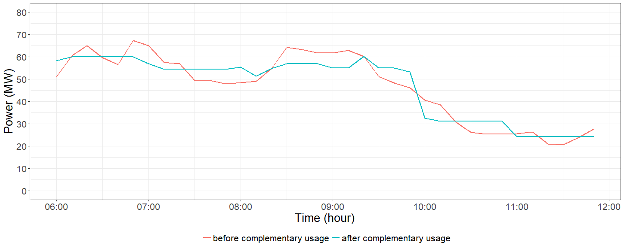
Fig. 47: Wind power generation output before and after complementary usage of the BESS

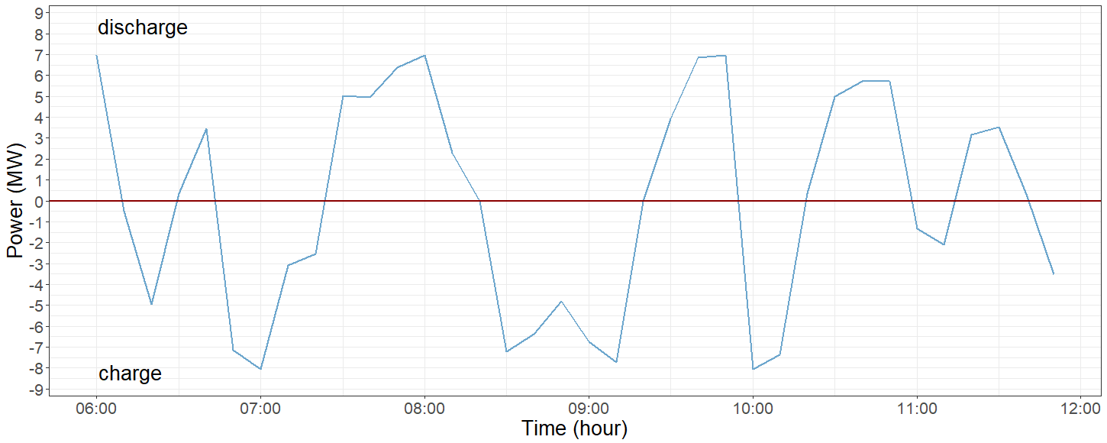
Fig. 48: Power output of the BESS after the addition of complementary usage

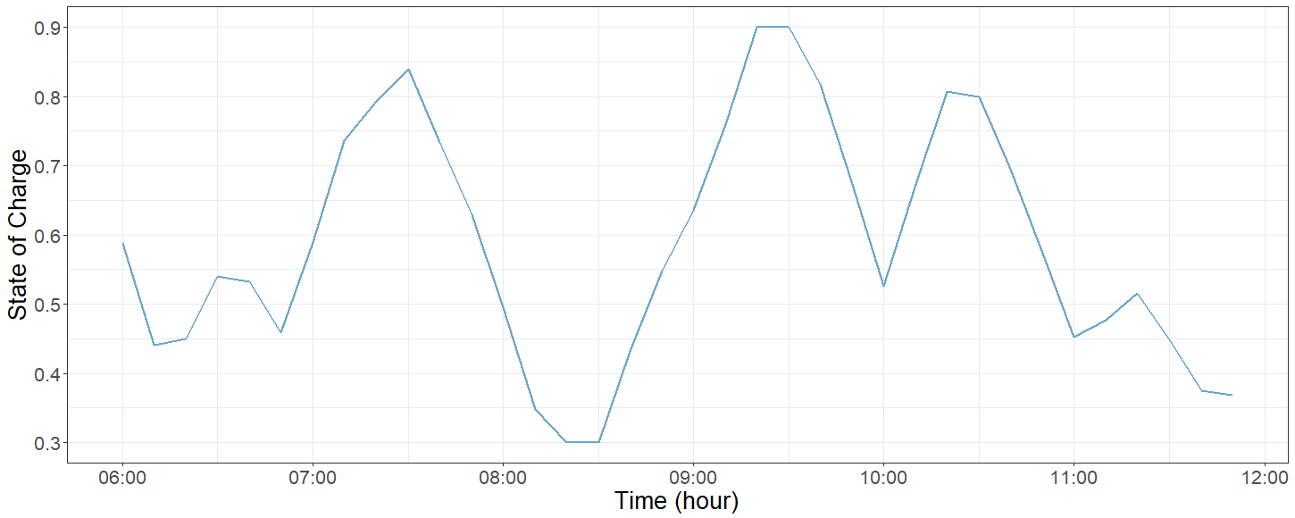
Fig. 49: SoC of the BESS after the addition of complementary usage

  - Summary and Conclusion

In this chapter, the effects of demand side management (DSM) control on the heating, ventilation and air-conditioning (HVAC) units and battery energy storage (BESS) control are investigated for the constructed scenario and control algorithms are explained for the upgrade deferral application. Two different cases are defined for the specific scenario; increase on the industrial load and block addition to the wind generation. Simulation results are presented and commented for both cases. Economical analysis on the simulation results are also done using the approximate capital costs. Overall results of cost analysis for both cases are tabulated at Table 20.

Table 20: Overall results of the cost analysis

 | Industrial growth |  | Additional wind power generation
 | 1 year  (23% increase) | 2 years  (28% increase) | 1 year  (25% increase)
Transmission  stucture | € 353,320
Lead-acid type  BESS | € 112,800 | € 470,400 | € 339,000
Lithium-ion type BESS | € 186,000 | € 1,056,000 | € 705,000
Transmission length for feasibility | 30 km | lead-acid: 60 km  lithium-ion: 210 km | lead-acid: 30 km  lithium-ion: 120 km
Lead-acid type  BESS (with expansion of SoC boundaries) | € 104,640 | € 417,360 | € 308,400
Lithium-ion type BESS (with expansion of SoC boundaries) | € 163,200 | € 907,800 | € 619,500
Yearly profits using wholesale electric energy time-shift | € 13,500 | € 106,600 | € 56,800

It is concluded that the deferral of the transmission structure upgrade becomes infeasible after 1 year deferral for the first case and beyond 25% wind capacity increase for the second case for the constructed scenario. However, using the BESS with complementary uses as long as the main control purpose is not contradicted, can add value to this specific application, which is also investigated in this chapter.

As the BESS can only support the grid needs for the upgrade deferral applications in a limited way, the operation of the BESS is limited for a short interval. An approach to this problem is redeployable BESS which are modular and transportable [41]⁠. Modular BESS with lithium-ion technology up to 100 MW rated power and 200 MWh storage capacity is commercially available and an example of a single module up to 2.1 MW rated power and 2.4 MWh storage capacity is shown in Fig. 50 [54]⁠. This system includes the batteries, controls, protection cabinets and transformers. The dimensions of the given system is 13.56x2.35x2.7m (WxDxH) and weights 35 to 45 tons; which can be transferred by semi-trailer trucks, as proposed. An example of these modular BESS are installed in Hawaii, with 6 MW rated power and 4.6 MWh storage capacity, integrated to a 12 MW solar photovoltaic plant [55]⁠. For the aforementioned system, the main objects are the smoothing the solar power output for grid integration and frequency regulation. It is important note that the rated power of the BESS integrated to this system is 50% of the rated power of the solar plant. In this study, storage capacity is kept as low as possible, approximately 4% of the wind generation capacity in the defined case with the complementary usage of the BESS, in order to lower the capital costs.

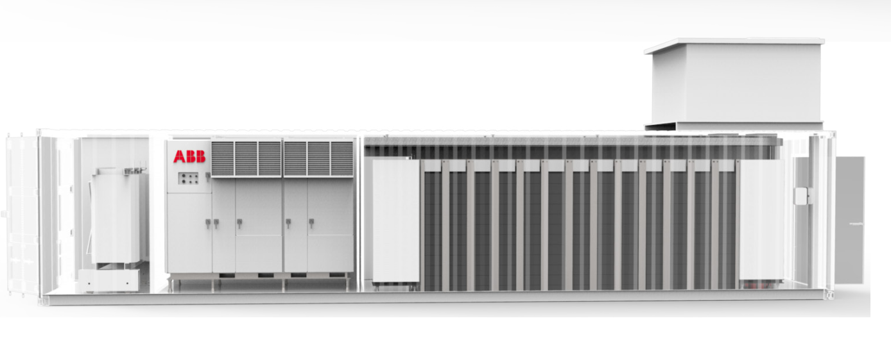
Fig. 50: Typical BESS module (Courtesy of ABB) [54]⁠

Using modular and transportable BESS can be a great advantage for the overall power system, as the BESS modules can be transferred where they are needed. When the operation of a BESS becomes infeasible for a region, modules can be redeployed for different regions, which can be determined by proper power system analysis. By using this method, BESS modules can be used for upgrade deferral application of several regions, but not restricted with this specific application only.

CONCLUSION AND FUTURE WORK

  - Conclusion

In this thesis, effects of energy storage systems (ESSs) and demand side management (DSM) are examined for the transmission structure upgrade deferral application in the presence of wind power generation.

In the beginning, characteristics of ESSs and aggregated loads for DSM applications are analyzed for the specific application. Considering the large-scale energy storage requirement for the wind integration applications, battery energy storage system (BESS), pumped hydro system (PHS) and compressed air storage system (CAES) technologies are found suitable for the study. By taking the topographical constraints of PHS and CAES technologies into account, BESS technology is chosen for this study [12]⁠. Comparing the advantages and disadvantages of battery types, lithium-ion and lead-acid batteries are investigated due to their high energy and power density, fast charge and discharge capability, long life time and high efficiency [25]⁠. For the DSM application, constant speed heating, ventilation and air conditioning (HVAC) units are chosen as the aggregated load, considering the high percentage energy usage in residential and commercial areas (in United States, approximately 50% of the total energy consumption in residential sector and 25% of the total energy consumption in commercial sector, in 2016 [34]⁠). Two-way communication direct control method is selected to control the aggregated load; HVAC units are controlled by a central controller, local controllers acknowledge the specific commands sent to them and send applicability information back to the controller [37]⁠.
With the selection of storage technology and controllable load, a hypothetical scenario is constructed, where a wind farm is connected to a nearby organized industrial zone with the transmission structures. Wind power generation and organized industrial zone load data are obtained from Monitoring and System Development for Wind Generated Electrical Power in Turkey (RİTM, in native initials) and National Power Quality Project (MGKP, in native initials) of The Scientific and Technological Research Council of Turkey, Marmara Research Center, Energy Institute (TÜBİTAK MAM EE, in native initials). Obtained raw data from databases of the aforementioned projects are organized and processed using R. Data used in this study are acquired in 2016 with 10 minute intervals.

For the next step, mathematical models are constructed for the simulations. Critical parameters are defined for each model with boundary conditions, which are stated below:

BESS: Mode variables of the BESS are defined as idle, discharging and charging modes. Power output is limited to the selected rated power for each case and state of charge (SoC) is maintained between the critical levels in order to extend the battery life [49]⁠.

HVAC: HVAC mode variables are defined as idle, heating and cooling modes. Thermal power output of the HVAC units are calculated using coefficient of performance (CoP) of heating mode and energy efficiency ratio (EER) of cooling mode. A simplified model of a resistance-capacitance (RC) circuit analogy is used for temperature dynamics of a space [35]⁠, [46]⁠.

Considering the constructed scenario, specifications for the transmission line, energy storage and demand side control are defined. Transmission capacity is defined as 182 MVA (154 kV, 795 MCM conductor type). 10,000 HVAC units are defined for industrial load, combination of 50 groups with 200 HVAC units each. Critical limits for BESS SoC is defined as minimum 0.3 and maximum 0.9, in order to increase the battery life. Taking both the battery and converter losses, efficiency of charging and discharging cycles are defined as 93%, with an overall efficiency of 86.5%. Suitable control methods are developed for both BESS usage and load side arrangements. These control models are embedded into the simulations in order to observe the affects of the proposed control algorithms.

Two separate cases are investigated; using the projected industrial electricity consumption increase ratio and defining a block addition for the wind farm capacity. For both cases, overload situations on the grid side transmission structures are analyzed and power flow is tried to be kept between the critical limits (including 5% safety margin) of the transmission line using the capacity of storage system and aggregated loads.

Transmission line length for this study is chosen as 30 km. With this length, capital cost of the transmission structure (including power transformer, substation and transmission line) becomes € 3,212,000. Annualized cost of the transmission structure is € 353,320, using the 11% fixed charge rate (FCR).

- Effect of the Industrial Growth

Using electricity consumption projection results introduced in the Electricity Demand Projection Report prepared by Republic of Turkey Ministry of Energy and Natural Resources on the data selected for the constructed scenario, grid side transmission load capacity is exceeded in Year 4 by approximately 3.6 MW [52]⁠. Total load of the HVAC units is selected as 12% of the maximum industrial load, approximately 22 MW. For this case, BESS rated power is chosen 4 MW with 2 MWh storage capacity, in order to support the maximum loading of the structure when DSM is insufficient to do so.

Capital cost of the BESS with defined specifications is € 940,000 for lead-acid type batteries and € 1,550,000 for lithium-ion type batteries. Using 12% FCR, annualized costs become € 112,800 for lead-acid technology and € 186,000 for lithium-ion technology. As seen from these results, deferral of the transmission structure upgrade is profitable for the first year. However, for the second year deferral, an additional BESS with 8 MW rated power and 16 MWh storage capacity is needed and the annualized costs of BESS becomes € 470,400 and € 1,056,000 for lead-acid and lithium-ion batteries, respectively. Comparing these results with annualized cost of transmission structure, it can be seen that the second year deferral is infeasible for this case. In order to apply a feasible second year deferral in this case, minimum transmission lengths are calculated as 60 km for the lead-acid battery type and 210 km for the lithium-ion battery type.

- Effect of Additional Wind Power Generation

25% block addition on the installed wind generation capacity is defined for this case. After the wind generation capacity increase, overload on the transmission structure becomes 7.8 MW. Total load of the HVAC units is chosen same as first case, 12% of the maximum industrial load, approximately 20 MW in this case. In order to keep the transmission line loading between the critical limits, BESS rated power is chosen 7.5 MW with 10 MWh storage capacity.

Using these specifications, capital cost of the BESS becomes € 2,825,000 for lead-acid batteries and € 5,875,000 for lithium-ion batteries. Using 12% FCR, annualized costs of lead-acid and lithium-ion type batteries become € 339,000 and € 705,000. For defined 30 km transmission length, upgrade deferral can be profitable for the lead-acid type batteries. Minimum transmission length is 120 km for a feasible lithium-ion type battery usage in this case. Above 25% wind generation capacity increase, deferral application becomes infeasible as the capital cost of the BESS increases extremely.

Another important observation is that the BESS stays on idle mode most of the time throughout the year in both cases, as it operates when the load of the HVAC units are insufficient to keep the power flow between the limits. In order to increase the applicability of proposed method, BESS usage is not restricted with only transmission upgrade deferral application. For the complementary usage, BESS is operated for wholesale electric energy time-shift and power output smoothing applications. SoC limits are defined as 0.2 and 1.0 for the main application (transmission upgrade deferral) and kept between 0.3 and 0.9 for the complementary usage. With this modification, CAPEX of the BESS becomes:

- € 872,000 for lead-acid batteries and € 1,360,000 for lithium-ion batteries for 1 year deferral on industrial growth case.

- € 3,478,000 for lead-acid batteries and € 7,565,000 for lithium-ion batteries for 2 years deferral on industrial growth case.

- € 2,570,000 for lead-acid batteries and € 5,162,500 for lithium-ion batteries for additional wind generation case.

For the wholesale electric energy time-shift application, using average of hourly market clearing prices in Turkey (2016) [17]⁠, it is observed that only by storing the energy when the daily price is at the lowest point and selling the stored energy with the highest daily price, annual costs of the BESS can be compensated at a certain level. Yearly profits are approximately € 13,500 for the industrial load increase case with 1 year upgrade deferral, € 106,600 for the same case with 2 years upgrade deferral and € 56,800 for the wind power generation increase case. As it can be observed from these results, using the benefits of complementary usage, feasibility of the upgrade deferral application can be increased significantly.

Another important factor that need to be take into account is the calculation results of the BESS specifications for defined cases. As the power rating of the BESS is in the range of MW level and after 1 year operation the BESS becomes insufficient for the transmission deferral application, it can be feasible to use modular and transportable BESS. Modular BESS with lithium-ion technology is commercially available up to 100 MW rated power and 200 MWh storage capacity [54]⁠. A single module up to 2.1 MW rated power and 2.4 MWh, dimensions of 13.56x2.35x2.7m (WxDxH) and weights 35 to 45 tons, can be transferred by trucks for the aforementioned systems. Using the modular and transportable BESS, modules can be transferred to several other regions according to grid needs; when the upgrade deferral becomes infeasible in our scenario.

  - Future Work

In this study, all simulations are done using real data, and behavior of battery energy storage system (BESS) and heating, ventilation and air-conditioning (HVAC) units are shaped according to instant data. For a better optimization on the storage system and demand side management, forecast algorithms can be applied for power flow and ambient temperature analysis.

Wholesale electric energy time shift and power output smoothing complementary uses are investigated briefly for the BESS operation. In order to maximize the feasibility of the systems, different complementary usage of the BESS can be modified and investigated.

For the DSM control, additional thermostatically controlled appliances can be investigated and applied to the overall system. Enabling different appliances can result in lower BESS capacity, thus decreasing the overall cost.

REFERENCES

[1] U.S. Energy Information Administration (EIA), “International Energy Outlook 2016,” 2016.
[2] Global Wind Energy Council (GWEC), “Wind in Numbers.” [Online]. Available: http://www.gwec.net/global-figures/wind-in-numbers/. [Accessed: 11-May-2017].
[3] Global Wind Energy Council (GWEC), “Global Wind Report - 2016,” 2017.
[4] Turkish Wind Energy Association (TWEA), “Turkish Wind Energy Statistics Report,” 2017.
[5] K. Dvijotham, S. Backhaus, and M. Chertkov, “Operations-Based Planning for Placement and Sizing of Energy Storage in a GridWith a High Penetration of Renewables,” 2011.
[6] Y. Sun, Z. Zhang, G. Li, and J. Lin, “Review on Frequency Control of Power Systems with Wind Power Penetration,” in Power System Technology, 2010, pp. 1–8.
[7] H. T. Le, S. Santoso, and T. Q. Nguyen, “Augmenting Wind Power Penetration and Grid Voltage Stability Limits Using ESS: Application Design, Sizing, and a Case Study,” IEEE Trans. Power Syst., vol. 27, no. 1, pp. 161–171, 2012.
[8] Various Authors, “Commercialisation of Energy Storage in Europe,” 2015.
[9] J. Cochran et al., “Flexibility in 21st Century Power Systems,” 2014.
[10] M. Milligan, “Capacity Value of Wind Plants and Overview of U.S. Experience,” 2011.
[11] G. Fuchs, B. Lunz, M. Leuthold, and D. U. Sauer, “Technology Overview on Electricity Storage,” 2012.
[12] H. Zhao, Q. Wu, S. Hu, H. Xu, and C. N. Rasmussen, “Review of Energy Storage System for Wind Power Integration Support,” Appl. Energy, vol. 137, pp. 545–553, 2015.
[13] International Electrotechnical Commission (IEC), “Electrical Energy Storage,” 2011.
[14] Electric Power Research Institute (EPRI), “Electric Energy Storage Technology Options,” 2010.
[15] S. Teleke, M. E. Baran, a Q. Huang, S. Bhattacharya, and L. Anderson, “Control Strategies for Battery Energy Storage for Wind Farm Dispatching,” IEEE Trans. Energy Convers., vol. 24, no. 3, pp. 725–732, 2009.
[16] Office of Energy Efficiency and Renewable Energy (EERE), “Advantages and Challenges of Wind Energy.” [Online]. Available: https://energy.gov/eere/wind/advantages-and-challenges-wind-energy. [Accessed: 08-Jun-2017].
[17] Enerji Piyasaları İşletme A.Ş. (EPİAŞ), “2016 Yılı Elektrik Piyasası Özet Bilgiler Raporu,” 2017.
[18] G. Celli, S. Mocci, F. Pilo, and M. Loddo, “Optimal Integration of Energy Storage in Distribution Networks,” in IEEE PowerTech, 2009.
[19] J. Morren, W. H. de H. Sjoerd, W. L. Kling, and J. A. Ferreira, “Wind Turbines Emulating Inertia and Supporting Primary Frequency Control,” IEEE Trans. Power Syst., vol. 21, no. 1, pp. 433–434, 2006.
[20] M. Swierczynski, R. Teodorescu, C. N. Rasmussen, P. Rodriguez, and H. Vikelgaard, “Overview of the Energy Storage Systems for Wind Power Integration Enhancement,” in IEEE International Symposium on Industrial Electronics (ISIE), 2010, pp. 3749–3756.
[21] D. D. Banham-Hall, G. A. Taylor, C. A. Smith, and M. R. Irving, “Flow Batteries for Enhancing Wind Power Integration,” IEEE Trans. Power Syst., vol. 27, no. 3, pp. 1690–1697, 2012.
[22] Electric Power Research Institute (EPRI), “Energy Storage for Grid Connected Wind Generation Applications - EPRI-DOE Handbook Supplement,” 2004.
[23] P. Sørensen et al., “Power Fluctuations From Large Wind Farms,” IEEE Trans. Power Syst., vol. 22, no. 3, pp. 958–965, 2007.
[24] W. Li, G. Joós, and C. Abbey, “Wind Power Impact on System Frequency Deviation and an ESS Based Power Filtering Algorithm Solution,” in IEEE PES Power Systems Conference and Exposition (PSCE), 2006, pp. 2077–2084.
[25] A. H. Fathima and K. Palanisamy, “Battery Energy Storage Applications in Wind Integrated Systems - A Review,” in International Conference on Smart Electric Grid (ISEG), 2014.
[26] I. Hadjipaschalis, A. Poullikkas, and V. Efthimiou, “Overview of Current and Future Energy Storage Technologies for Electric Power Applications,” Renew. Sustain. Energy Rev., vol. 13, no. 6–7, pp. 1513–1522, 2009.
[27] F. Díaz-González, A. Sumper, O. Gomis-Bellmunt, and R. Villafáfila-Robles, “A Review of Energy Storage Technologies for Wind Power Applications,” Renew. Sustain. Energy Rev., vol. 16, no. 4, pp. 2154–2171, 2012.
[28] H. Chen, T. N. Cong, W. Yang, C. Tan, Y. Li, and Y. Ding, “Progress in Electrical Energy Storage System: A Critical Review,” Prog. Nat. Sci., vol. 19, no. 3, pp. 291–312, 2009.
[29] S. Koohi-Kamali, V. V. Tyagi, N. A. Rahim, N. L. Panwar, and H. Mokhlis, “Emergence of Energy Storage Technologies as the Solution for Reliable Operation of Smart Power Systems: A Review,” Renew. Sustain. Energy Rev., vol. 25, pp. 135–165, 2013.
[30] K. C. Divya and J. Østergaard, “Battery Energy Storage Technology for Power Systems-An Overview,” Electr. Power Syst. Res., vol. 79, no. 4, pp. 511–520, 2009.
[31] P. Palensky and D. Dietrich, “Demand Side Management: Demand Response, Intelligent Energy Systems, and Smart Loads,” IEEE Trans. Ind. Informatics, vol. 7, no. 3, pp. 381–388, 2011.
[32] Republic of Turkey Energy Market Regulatory (EPDK), “Elektrik Faturalarına Esas Tarife Tabloları.” [Online]. Available: http://www.epdk.org.tr/TR/Dokumanlar/TDB/Elektrik. [Accessed: 02-Aug-2017].
[33] A. Brooks, E. Lu, D. Reicher, C. Spirakis, and B. Weihl, “Demand Dispatch - Using Real-Time Control of Demand to Help Balance Generation an Load,” IEEE Power Energy Mag., vol. 8, no. 3, pp. 20–29, 2010.
[34] U.S. Energy Information Administration (EIA), “Annual Energy Outlook 2017,” 2017.
[35] N. Lu, “An Evaluation of the HVAC Load Potential for Providing Load Balancing Service,” IEEE Trans. Smart Grid, vol. 3, no. 3, pp. 1263–1270, 2012.
[36] Fujitsu General Limited, “Fujitsu Product Catalogue,” 2015.
[37] M. Ifland, N. Exner, and D. Westermann, “Appliance of Direct and Indirect Demand Side Management,” in IEEE EnergyTech, 2011.
[38] K. Heussen, S. You, B. Biegel, L. H. Hansen, and K. B. Andersen, “Indirect Control for Demand Side Management – A Conceptual Introduction,” 2012.
[39] A. M. Kosek, G. T. Costanzo, H. W. Bindner, and O. Gehrke, “An Overview of Demand Side Management Control Schemes for Buildings in Smart Grids,” in IEEE International Conference on Smart Energy Grid Engineering (SEGE), 2013.
[40] O. Gehrke and F. Isleifsson, “An Aggregation Friendly Information Model for Demand Side Resources,” in IEEE Conference on Local Computer Network (LCN), 2010.
[41] J. Eyer, “Electric Utility Transmission and Distribution Upgrade Deferral Benefits from Modular Electricity Storage,” 2009.
[42] A. A. Akhil et al., “Electricity Storage Handbook in Collaboration with NRECA,” 2013.
[43] R Core Team, “R: A Language and Environment for Statistical Computing.” 2017.
[44] S. Moritz, “imputeTS: Time Series Missing Value Imputation.” 2017.
[45] “State of Charge (SOC) Determination.” [Online]. Available: http://www.mpoweruk.com/soc.htm. [Accessed: 12-May-2017].
[46] Y. Ma, A. Kelman, A. Daly, and F. Borrelli, “Predictive Control for Energy Efficient Buildings with Thermal Storage: Modeling, Stimulation, and Experiments,” IEEE Control Syst. Mag., vol. 32, no. 1, pp. 44–64, 2012.
[47] H. J. Diamond et al., “U.S. Climate Reference Network After One Decade of Operations - Status and Assessment,” 2013.
[48] Turkish State Meteorological Service (MGM), “Resmi İstatistikler.” [Online]. Available: https://mgm.gov.tr/veridegerlendirme/il-ve-ilceler-istatistik.aspx. [Accessed: 31-Jul-2017].
[49] S. Teleke, M. E. Baran, S. Bhattacharya, and A. Q. Huang, “Optimal Control of Battery Energy Storage for Wind Farm Dispatching,” IEEE Trans. Energy Convers., vol. 25, no. 3, pp. 787–794, 2010.
[50] B. Marchi, M. Pasetti, and S. Zanoni, “Life cycle cost analysis for BESS optimal sizing,” Energy Procedia, vol. 113, pp. 127–134, 2017.
[51] Turkish Statistical Institute (TÜİK), “Net Elektrik Tüketiminin Sektörlere Göre Dağılımı.” [Online]. Available: http://www.tuik.gov.tr/UstMenu.do?metod=temelist. [Accessed: 20-Sep-2017].
[52] Republic of Turkey Ministy of Energy and Natural Resources, “Türkiye Elektrik Enerjisi Talep Projeksiyonu Raporu,” 2016.
[53] J. M. Eyer, J. J. Iannucci, and G. P. Corey, “Energy Storage Benefits and Market Analysis Handbook - A Study for the DOE Energy Storage Systems Program,” 2004.
[54] ABB Ltd., “EssProTM Grid Battery energy storage systems - The power to control energy,” 2017.
[55] ABB Ltd., “KIUC case note - EssProTM PCS to enable solar integration for the island of Kauai,” 2017.

