HEATING, VENTILATION, AND AIR CONDITIONING (HVAC) MODEL
With the smart grid technology, demand-side management (DSM) is becoming an important option for flexible energy control. Thermostatically controlled appliances (TCAs) is one of the choices for DSM, when high number of TCAs is considered, they can be used for load balancing. HVAC systems, electric water heaters and refrigerators are the main TCAs.
For load balancing application, TCAs should operate frequently, have a high capacity and broad temperature setting ranges. HVAC loads are suitable for this application, considering these specifications [1].
For modelling HVAC units, simplified space heating unit model, which described in [1] is used for the simulations. With these model, the equations when the heater is turned off and turned on becomes,
(1)
(2)
T_{room} room temperature (ºC);
C equivalent heat capacity (J/ºC);
R equivalent thermal resistance (ºC/W);
Q equivalent heat rate (W);
t time (minute);
∆t time step (5 minute);
T_{o} ambient temperature (ºC).
HVAC model is created and used in PSCADTM/EMTDCTM as a control block, which can be observed in Figure 1.
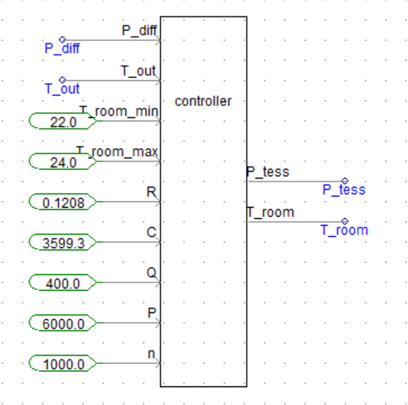
Figure 1
P_diff generation and load difference (MW);
T_out output temperature (ºC);
T_room_min minimum room temperature limit (ºC);
T_room_max maximum room temperature limit (ºC);
R equivalent thermal resistance (ºC/W);
C equivalent heat capacity (J/ºC);
Q equivalent heat rate (W);
P HVAC unit rated power
n number of HVAC units
For the operation of HVAC units, minimum and maximum temperature limits are set as boundaries; if room temperature drops below minimum temperature, heater will turn on and vice versa. Between the temperature limits, HVAC units are controlled according to power difference, so that the difference level will be reduced.
[1] N. Lu, “An evaluation of the HVAC load potential for providing load balancing service,” IEEE Trans. Smart Grid, vol. 3, no. 3, pp. 1263–1270, 2012.

