CHAPTER 1

INTRODUCTION

Motivation For the Thesis
In today’s society, energy supply is one of the main interests and energy consumption is considered as an important parameter to analyze the economical situation and growth of a society. Total world energy consumption has been increasing throughout the years and it is expected to grow by 45% in 2040 [1]⁠.
Fossil fuels are remained as the main energy resources since the industrial revolution. However, with the negative impacts of these sources such as coal and oil, search for alternative methods to fulfill energy requirements began.
Climate change, which is the result of increasing greenhouse gases in the atmosphere, is the main concern about these resources. Moreover, fossil fuels are non-renewable energy sources and there is a limited supply. At some point, these resources will reach a point where supply cannot meet the demand. Considering these facts, it is important for humanity to find alternative energy resources.
With the developments and investments in the renewable technologies, renewable generation has been growing rapidly over the years. Among all the renewable sources, wind energy is the most popular resource with 3.7% of global electricity supply and this percentage is expected to increase for the next years [2]⁠. Total installed wind power capacity has reached to approximately 487 GW at the end of 2016 and is expected to reach around 790 GW in 2020 [3]⁠. Increase in the installed global wind capacity over years can be observed in Fig. 1-2 [4]⁠.
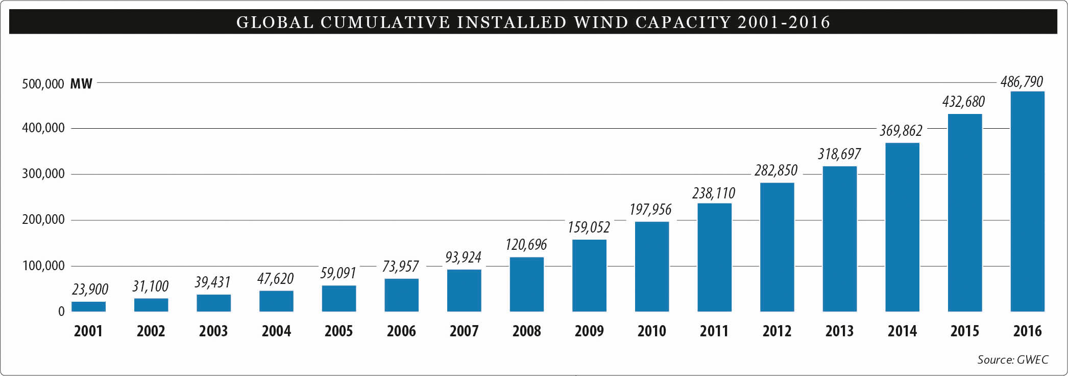
Fig. 1-1: Historical development of global installed wind capacity
In a similar way as global development, wind generation capacity in Turkey has been increasing over the years, which can be observed in Fig. 1-3 [5]⁠.
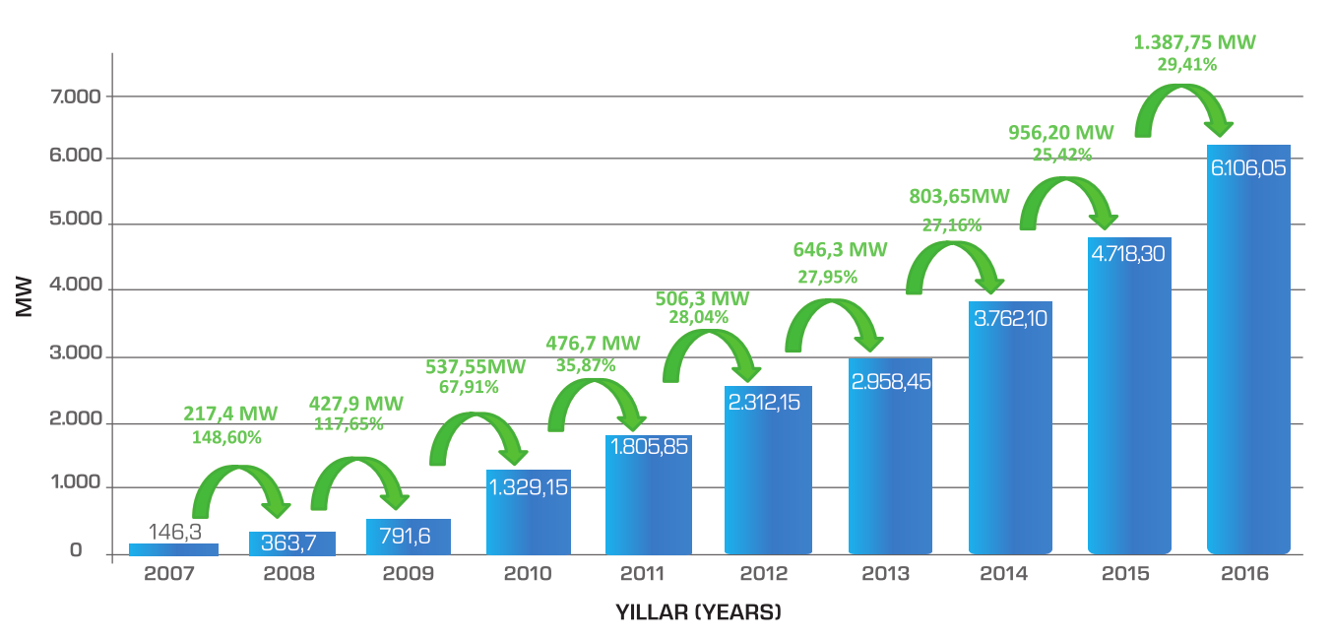
Fig. 1-2: Historical development of installed wind capacity in Turkey
With the increasing penetration of wind energy to power systems, energy balance problem becomes harder to achieve, as a consequence of unpredictable and varying nature of wind. To maintain the balance between generation and consumption over changing conditions coming along with renewable resources, much higher flexibility will be needed in the system. In the near future, system flexibility needs, which has been driven by variable demand up to this day, will begin to be driven by supply variability.
Power output of a wind turbine is highly dependent on wind speed and can be expressed as follows:

where:
power output
air density
power coefficient, a function of tip speed ratio λ and pitch angle β
blade length
wind speed
As it can be observed in Equation X, power output of a wind turbine is proportional to cube of the wind speed, so even small variations of wind speed can cause large fluctuations in the power output.
Typical output of a wind turbine with changing wind speed is shown in Fig. 1-3 [6]⁠. Important parameters in this graph can be explained as follows:
At low speeds, enough torque cannot be exerted by the wind to rotate the turbine blades. With increasing wind speed, at some point the turbine blades will overcome friction and begin to rotate. The speed at which the turbine begins to rotate is cut-in speed (typically 3-5 m/s).
Above cut-in speed, power output of the wind turbine rapidly increase, which is marked as “Fast Ramp” in Fig. 1-3. The power output reaches the maximum limit of the generator in some point (typically 12-17 m/s) which is called rated power output. After this point, increase in wind speed does not affect the power output of the wind turbine, as the design of the turbine is arranged to limit the power output.
With increasing wind speed, the forces on the turbine structure also increase and at some point the rotor is brought to a standstill with a breaking system in order to prevent possible damage. This critical speed is cut-out speed (typically 25 m/s).
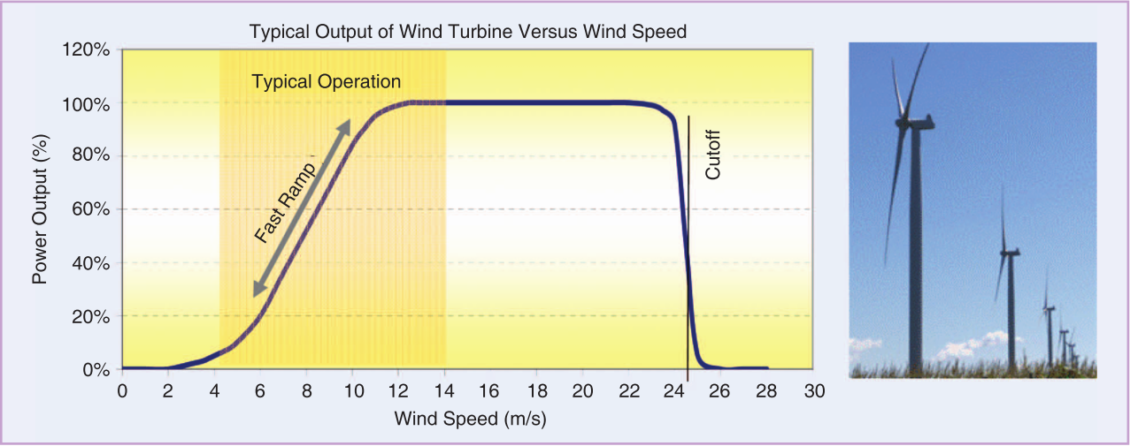
Fig. 1-3: Typical output of wind turbine versus wind speed
In Fig. 1-4, daily fluctuations of power output of a wind farm in Turkey can be observed. It can be seen that the power output can have steep rises and sudden drops.
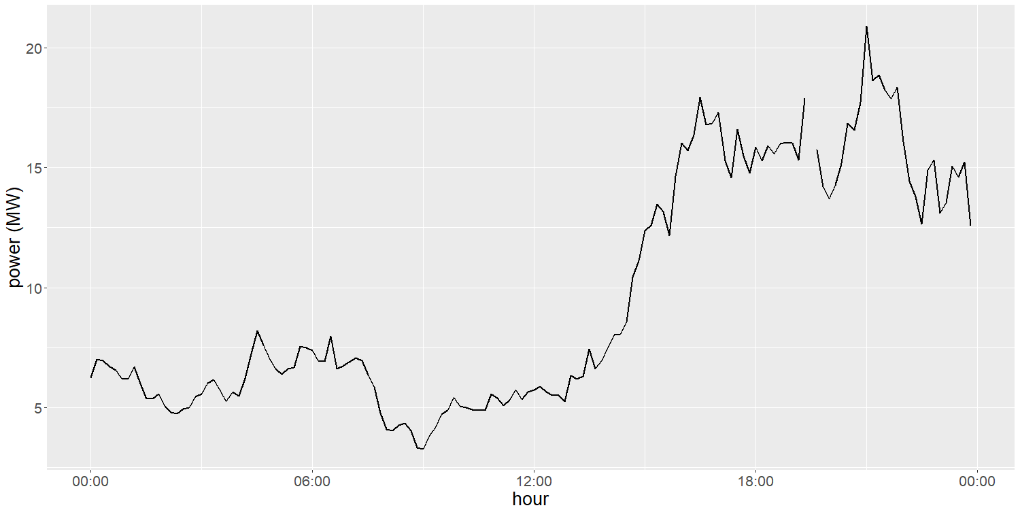
Fig. 1-4: Daily generation of a wind farm in Turkey
With the integration of wind generation into power systems, maintaining the stability and reliability of the system becomes more complicated because of the intermittent nature of wind power. Considering expected share of wind generation in overall electric power generation to grow significantly over the years, more flexibility in power systems will be required to handle with the negative impacts of wind power. The impact of increasing wind power penetration level to stability and reliability of the system can be summarized as follows [7]⁠:
- Reliability problems: Net-load variations can be tracked by Conventional Generators (CGs) at low level integration of wind power to the power system [8]⁠. However, increasing penetration of wind energy eventually affects the system reliability as wind generation is generally not related to the demand pattern which leads to an increase on the net-load difference between peak and off-peak periods, which can be observed in Fig. 1-5. As a result, committed CGs cannot catch the sudden and large changes of wind power output and additional operating reserves with better dynamic performance to compensate the difference will be required to maintain system reliability.
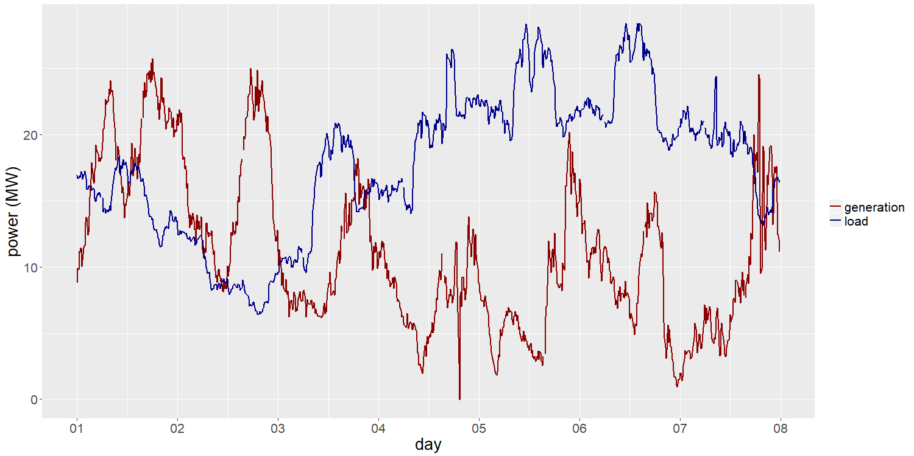
Fig. 1-5: Wind generation and industrial load comparison
- Stability problems: Wind Turbine Generators (WTGs) can contribute to frequency stability only at a low level, which is not the case with synchronous generators [9]⁠. Wind power output fluctuations will also weaken voltage stability of the system due to generation and load mismatch [10]⁠.
Four main options are proposed to integrate renewable energy into power system effectively: dispatchable generation, transmission and distribution expansion, demand side management and energy storage [11]⁠.

Aims of the Research
Variability and uncertainty are important issues for power systems, and to cover the deviations from equilibrium and unexpected situations, enough energy resources are needed. However, the capacity of resources for the flexibility of given power system must be analyzed carefully as providing flexibility is rather expensive.
In this thesis, contribution of energy storage and demand side management technologies to high penetration of wind power generation is studied.
Applications of energy storage for this purpose can be summarized as follows [11]⁠:
- Electricity time shift: Electric power can be stored when generation exceeds demand and stored power can be supplied to grid when demand exceeds generation. With electricity time shift, the stability of the power system increases as the net load is reduced.
- Conversion to other energy carriers: Electric power can be transformed into a different energy form and stored for later use in this form. Thermal energy is one example of this usage, as the heat is used for space and water heating in residential and commercial buildings.
- Provision of frequency reserve and grid services: When an unexpected excess in power generation occurs, storage capacity can be committed to charging and when an unexpected excess in power demand occurs, storage capacity can be committed to discharging. By doing so, the effects of unexpected fluctuation in the balance of supply and demand can be reduced.
- Transmission and distribution investment deferral: Storage can be used for absorbing power above the capacity of T&D line or component and releasing the stored energy when the T&D capacity is suitable. High costs of T&D upgrades can be deferred with relatively small amounts of storage.

Outline of the Thesis

CHAPTER 2

INTEGRATION OF ENERGY STORAGE TO WIND GENERATION
In a power system, energy demand must be supplied instantaneously to preserve stability and quality of the system. Stability and quality of a power system decreases as an imbalance between supply and demand occurs. In addition, scheduling of power systems with varying net load profile decreases the overall efficiency because of the deviations from optimal generation spot.
With the wind generation penetration in power systems, further flexibility is required to decrease the impacts coming along with. Security and reliability issues must be handled carefully, because of unpredictable and inconsistent nature of wind generation.
Considering the recent development and advances in energy storage technology, ESSs have become a suitable solution for the negative impacts of wind power integration.

Properties of ESS
An ESS can be described in terms of the following properties [12]⁠:
Storage Capacity is the amount of energy that can be stored by the ESS.
Power Rating is the rate of energy transfer per unit time which can be supplied or consumed by ESS.
Energy to Power Ratio is the ratio of the ESS storage capacity to its power. ESSs with higher energy to power ratio can deliver power for longer periods. Suitable applications for ESSs according to their maximum charge/discharge duration at rated power are summarized in Table 2.1 [12]⁠.
Table 2.1: ESS applications for different energy to power ratio
Energy to power ratio | seconds to minutes | daily | weekly to monthly
Applications | Primary/Secondary frequency control  Spinning reserve  Voltage control  Black start capability  Peak shaving  Island grids  Electromobility (Hybrid electric vehicle)  Uninterruptible power supply | Tertiary frequency control  Standing reserve  Load leveling  Island grids  Electromobility (Full electric vehicle)  Residential storage systems  Uninterruptible power supply | Storage for “Dark calm” periods  Island grids
Energy density is the ratio of the ESS storage capacity to its volume. ESSs with higher energy density can be used for applications where the volume of storage system is limited. Energy densities for different ESSs are shown in Table 2.2 [12]⁠.
Table 2.2: Comparison of different energy density values
 | Technology | Energy Density (kWh/m³)
Mechanical Energy Storage | Potential energy (e.g. pumped hydro) | 1
Mechanical Energy Storage | Kinetic energy (e.g. flywheel) | 10
Electrical Energy Storage | Electrostatic fields (capacitors) | 10
Electrical Energy Storage | Electromagnetic fields (coils) | 10
Electrochemical Energy Storage | Lead-acid batteries | 100
Electrochemical Energy Storage | Lithium-ion batteries | 500
Thermal Energy Storage | Sensible heat (e.g. water) | 116
Thermal Energy Storage | Latent heat (e.g. water to ice) | 636
Chemical Energy Storage | Liquid hydrogen | 2400
Chemical Energy Storage | Gasoline | 8500
Power density is the ratio of the ESS power to its volume. ESSs with high power density can be used for high power applications with short duration of power usage.
Specific energy is the ratio of the ESS energy capacity to its weight. ESSs with high specific energy can be used for application with high energy demand and weight limitations.
Specific power is the ratio of the ESS power to its weight. ESSs with high specific power can be used for applications with high power demand and weight limitations.
Depth of Discharge (DoD) is the ratio of the amount of discharged energy to the energy capacity of ESS. DoD limitations are used for several ESS technologies, as dull discharge of ESSs are not allowed for technical reasons.
State of Charge (SoC) is the ratio of the amount of remaining energy to the usable energy capacity of ESS.
Efficiency is the ratio of output energy to input energy of ESS. Wiht increasing losses, efficiency of the ESSs decreases.
Self discharge is the energy loss of ESS due to internal processes.
Start-up time is the time period between power request and first power delivery.
Ramp-up time is the time period from zero to full power.
Ramp rate is the ratio of maximum power to ramp-up time.
Deployment/response time is the time period between power request and full power delivery. In Fig. 2-1, time parameters of a storage system can be observed.
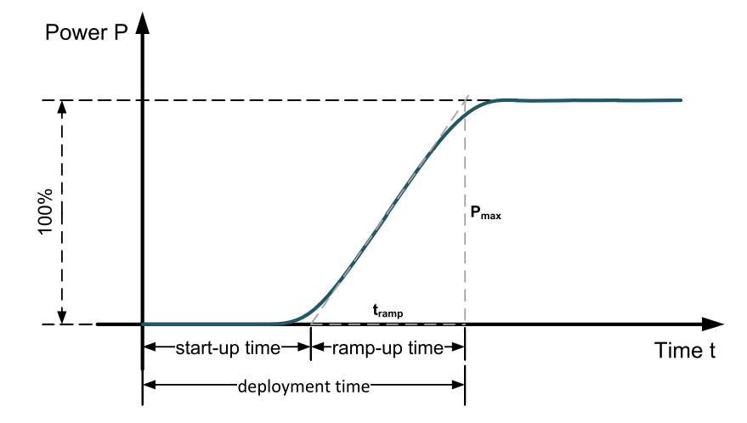
Fig. 2-1: Response time of a storage system
Full cycle is the complete discharging and charging process of ESS.
Equivalent full cycle is the overall energy throughput with any DoD per cycle divided by available capacity.
Cycle life is the number of full cycles that can be delivered by ESS under specified conditions before ESS cannot meet specified criteria.
Calendar life is the lifetime of an ESS when not used.
While choosing the suitable ESS for a given power system, these given properties must be carefully analyzed. Capacity and power are two important parameters for these systems. Capacity rate can be determined by control and energy management procedures while power rate can be determined by the difference between supply and demand.

Classification of ESS
A widely-used classification of energy storage technologies is according to the form of energy used [13]⁠:
- Mechanical:
  - Pumped hydro storage (PHS)
  - Compressed air energy storage (CAES)
  - Flywheel energy storage (FES)
- Electrochemical:
  - Secondary batteries
  - Flow batteries
- Chemical:
  - Hydrogen storage
  - Natural gas storage
- Electrical:
  - Super capacitor
  - Superconducting magnetic energy storage (SMES)
- Thermal:
  - Sensible heat storage
  - Phase change materials (PCM)
ESSs can be also classified according to duration and frequency of power supply of storage [12]⁠.
- Short term ESSs are used for instant energy supply. This type of ESSs are used mainly in primary and secondary frequency control and reactive power compensation applications. This storage systems have low energy to power ratio of ranging minutes to hours, and high charging and discharging rates. Generally, charging/discharging cycles per day are very high for this systems.
- Medium term ESSs are used for matching the demand fluctuations between day and night. Energy to power ratio of this systems are between 1 to 10 hours. This type of systems have typically one or two cycles per day.
- Long term ESSs are used for power supply during several days or weeks. These systems have very high energy to power ratio, and due to this high energy capacity and relatively low power, the number of full cycles per year is very few.

ESS Applications for Wind Integration Support
ESS applications for wind integration support can be categorized according to different stakeholders; generation side, grid side and demand side applications [13]⁠.

Generation-side Applications
Different from conventional power plants, wind farm power output cannot be controlled in a strict way as a result of stochastic nature of wind. Power intermittency, ramp rates and limiting wind power output are the main challenges coming along with wind power integration to the power systems [14]⁠. Looking from the generation-side to overall system, controllability of a wind farm can be increased with the usage of ESS.
- Time shifting:
Wind power generation is a non-dispatchable source of electricity production and can only be forecasted with a limited certainty. The mismatch between wind power output with the demand pattern, e.g. high wind power generation during off-peak demand and vise versa, is a big challenge as the difference between the peak and off-peak periods of system net-load increases.
Energy storage technologies can be used to match the wind power generation with load cycles by storing extra energy during high wind power generation and releasing it later during peak demand periods.
In time shifting applications, huge amount of energy is required to be stored for long time periods, so it is important to consider energy capacity and energy to power ratio parameters of an ESS in these applications.
- Output smoothing:
Wind power generation can have sudden drops and steep rises as a result of changing wind speed. System stability will be affected with the sudden power output changes which will create frequency and voltage fluctuations.
Power output of a wind farm can be smoothed out with energy storage technology applications, excess energy can be stored during instantaneous increase in power generation and released when output power drops suddenly.
Ramping capability of ESS is the most important parameter in these applications, as storage system must response the sudden changes at wind power output.
- Transmission utilization efficiency:
Wind resources are often located in remote locations and transmission networks limitations becomes a serious problem to supply the energy demand, which is far from wind farm sites [15]⁠.
With the usage of energy storage technology, efficiency of transmission utilization can be increased by reducing congestion over the network. Additionally, transmission and distribution upgrades can be deferred or in some cases avoided at all with proper usage of ESS.

Grid-side Applications
Increasing wind power generation reduces the stability and reliability of the grid. Considering the distributed generation of wind farms over the system, net variability of the entire grid is lower compared to the integration of single wind power plant, so overall requirement of services is less than considering grid-side applications.
Energy storage technology can be used to provide ancillary services to decrease the impact of wind power generation over system stability and reliability. Grid-side applications of ESS is listed according to response time of the systems in Table 2.3 [7]⁠.
Table 2.3 Grid-side applications of ESS
Application | Response time | Example
Energy arbitrage,  Load leveling | Hours to days | PHS, NaS, CAES, VRB
Frequency regulation | Seconds to minutes | Li-ion, NaS, FES, VRB
Inertia emulation,  Oscillation damping,  Voltage support,  LVRT | Less than a second | LA, NaS, FES, VRB
Reserves | Minutes to hours | PHS, FES, BESS
Efficiency use of transmission network | Minutes to hours | Li-ion
Emergency power supplying  Black start | Minutes to hours | LA
- Energy arbitrage/load leveling
In the electricity market, electricity price varies during peak and off-peak hours. By storing low-cost energy during off-peak periods and releasing stored energy during peak periods with the higher price can reduce the gap between the peak and off-peak prices [16]⁠.
- Frequency regulation
ESS can be used to provide frequency regulation to the wind farms by controlling active power output of storage with frequency deviation [17]⁠.
- Inertia emulation
The impact of sudden wind generation changes can be reduced with the grid inertia [9]⁠. The addition of ESS can increase the apparent inertia of a grid.
- Oscillation damping
Sudden power changes of wind farms can cause oscillations in an interconnected system. To damp the system oscillations, ESS can be installed to the system.
- Voltage control support
Voltage stability of the grid can decrease with the variable nature of wind generation output. ESS integration can provide reactive power support for voltage regulation.
- Low Voltage Ride Through (LVRT) support
Today, LVRT capability of wind turbine generators (WTGs) are determined by grid codes. During severe grid faults, WTGs should remain connected for reactive power support and in some situations maximum reactive power needs to be delivered by WTGs. For such cases, ESS can support the power need by converters and control systems.
- Reserve applications
For the stability and reliability of the system, emergency reserves are required as a result of forecast error of wind power output. Integration of ESS can be an option for the reserve application.
- Emergency power supply/black start
In the situation of a fatal failure, ESS can be used to energize the power system from a shut-down condition.
- Transmission utilization efficiency
ESS integration can increase the efficiency of transmission network usage and transmission and distribution costs can be reduced by deferral of network upgrade.

Demand-side Applications
Variable loads can be used as a Virtual Power Plant (VPP) considering huge amounts. With the combination of ESS and demand side management, ancillary services can be provided using VPP.

ESS Planning for Wind Power Integration Applications

Determination of ESS Type
Technical requirements of the ESS, such as power and energy capacity and charging/discharging duration range can be determined by analyzing characteristics of a wind farm.
Fluctuations of wind generation output at different time scales is an important parameter for ESS selection. Generation reserve and energy dispatch of the system is related to low frequency fluctuations (minutes to hours). On the other hand, power system frequency control is affected with high frequency fluctuations (seconds to minutes) [18]⁠.
High frequency fluctuations on the wind power output has an insignificant effect overall [19]⁠ and can be damped out by inertia of the turbine generator [20]⁠. As a result, it is required that ESS can be charged/discharged at full power capacity in hours for wind integration support [7]⁠.
Considering increasing rating capacity of wind farms, large-scale energy storage technologies are required for wind integration applications. As can be seen in Fig. 2-2 [21]⁠, BESS, PHS and CAES technologies are suitable for these applications, which can store energy for long periods at a high power rating. Among these three technologies, BESS is more suitable for the purpose, as PHS and CAES are limited by topographical constraints [22]⁠.
By taking account of the findings mentioned above and rapid development in battery technology and cost reduction, it is decided to study the BESS technology for the wind power applications.
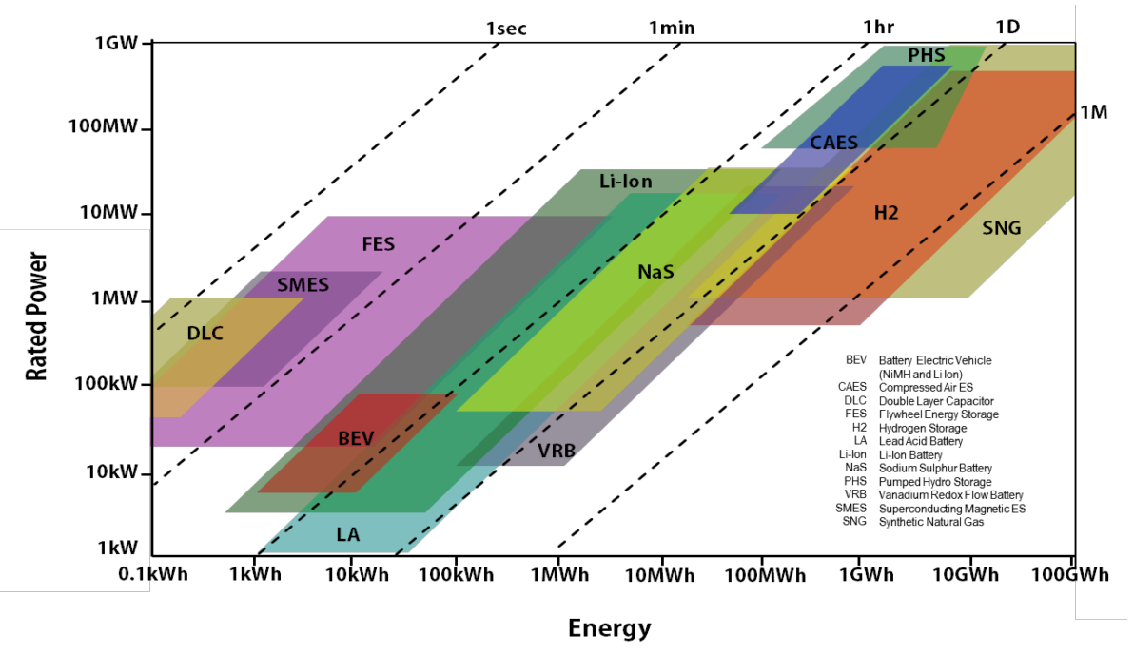
Fig. 2-2: Comparison of power density and energy density of storage technologies

Determination of ESS Size
Energy capacity and power ratings are the main parameters to be determined for the wind power applications of storage systems. ESS size determination can be modeled as an optimization problem considering application purpose, control strategy and economical aspects [7]⁠.
BESS technology is chosen for the applications in this study. It is important to adapt control strategies for optimal use of BESSs, as large-scale utilization of BESSs is not a cost effective choice [14]. Two mainly used battery types in BESSs are lithium-ion and lead-acid batteries and their characteristics are summarized including future expectations, in Table 2.4 and Table 2.5 [12]⁠ respectively.
Table 2.4: Characteristics of lithium-ion batteries
Lithium-ion batteries
Parameters | 2013 | 2030
Round-trip efficiency | 83-86 % | 85-92 %
Energy density | 200-350 Wh/l | 250-550 Wh/l
Power density | 100-3500 W/l | 100-5000 W/l
Cycle life | 1000-5000 full cycles | 3000-10000 full cycles
Calender life | 5-20 years (depending on temperature and SoC) | 10-30 years (depending on temperature and SoC)
Depth of discharge | Up to 100 % | Up to 100 %
Self discharge | 5 % per month | 1 % per month
Power installation cost (converter) | 150-200 €/kW | 35-65 €/kW
Energy installation cost | 300-800 €/kW | 150-300 €/kW
Deployment time | 3-5 ms
Site requirements | None
Main applications | Frequency control, Voltage control, Peak shaving, Load leveling, Electromobility, Residential storage systems
Table 2.5: Characteristics of lead-acid batteries
Lead-acid batteries
Parameters | 2013 | 2030
Round-trip efficiency | 75-80 % | 78-85 %
Energy density | 50-100 Wh/l | 50-130 Wh/l
Power density | 10-500 W/l | 10-1000 W/l
Cycle life | 500-2000 full cycles | 1500-5000 full cycles
Calendar life | 5-15 years (depending on temperature and SoC) | 10-20 years (depending on temperature and SoC)
Depth of discharge | 70 % | 80 %
Self discharge | 0.1-0.4 % per day | 0.05-0.2 % per day
Power installation cost (converter) | 150-200 €/kW | 35-65 €/kW
Energy installation cost | 100-250 €/kW | 50-80 €/kW
Deployment time | 3-5 ms
Site requirements | Ventilation due to gassing
Main applications | Frequency control, Peak shaving, Load leveling, Island grids, Residential storage systems, Uninterruptible power supply

BESS Model

Operation Mode
BESS can operate in three modes; charging, discharging and idle. In charging mode, batteries are charged with the power drawn from grid and BESS can be considered as a load. In discharging mode, batteries are discharged and deliver power to the grid and BESS can be considered as a generation unit. In idle mode, batteries are neither charged nor discharged.

Energy Constraints
Charging efficiency of a BESS is defined as the ratio of rate of change in stored energy in BESS to power drawn from grid in charging mode.
Discharging efficiency of a BESS is defined as the ratio of power supplied to grid to rate of change in stored energy in BESS in discharging mode.
SoC of a battery is defined as available capacity of the battery expressed as a percentage of its rated capacity. SOC is an indication of how longer a battery can continue to perform before recharging is needed [23]. Depleting or overcharging a battery is not desired, so proper limitations (i.e., 30%-100%) should be defined for SoC of the battery.
Considering above definitions and limitations, energy equations for BESS model are expressed as;

Power Constraints
Battery charging and discharging speeds are limited by the physical and chemical characteristics of the BESS. With increasing depth of discharge (DoD), cycle life of a battery decreases and deep discharge can cause permanent damage over battery cells. To protect the battery from a permanent damage and increase the battery cycle life, proper limitation should be set for maximum discharge rating of the battery [24].
Considering above limitations, power equations for BESS model are expressed as;
(X)
(X)

CHAPTER 4

INTEGRATION OF DEMAND DISPATCH TO WIND GENERATION

In a conventional power system, the balance between generation and demand is maintained by controlling generation to match load. Except emergent situations, when the generation is not sufficient to supply demand, loads are not controlled directly in today’s power systems [25]⁠. However, with the increasing penetration of renewable generation to the system, dispatch of generation capacity to provide the required services to follow load becoming much more difficult. As and alternative way, decreasing dispatchability of generation-side can be compensated by making load-side more dispatchable.
With demand dispatch, flexible loads can be scheduled according to grid needs. If individual loads can be aggregated and controlled on command according to needs of power systems, the result will be the same as generation dispatch. For example, turning off a large number of loads when the demand exceeds generation will affect the system as if the generation is increased and vice versa. Demand dispatch can be an alternative method to balance generation and load for a power grid, as the intermittent renewable generation levels increasing.
Flexible loads can be categorized by their impact to the end-user [25]⁠:
- Controlling some loads can affect the comfort of end-user, e.g. lights, air conditioning.
- Some loads can be controlled and affect end-user slightly or not at all, e.g. charging a plug-in vehicle at night.
There are several approaches to define demand side contribution to the system, considering demand and generation interactions.

Applications of Demand Dispatch
By combining large number of flexible loads, demand dispatch can be an important factor for the power systems applications. However, dispatchable loads can only draw limited energy, which is not the case with conventional power plants as their generation is only limited by availability of the fuel [25]⁠. The combination of large loads will have minimum and maximum power limits which they can draw from the grid, in addition to maximum energy drawing capacity.
Some important parameters must be defined for each individual load, such as minimum and maximum power limits, how much and when energy is needed and number of cycles for a given time period. The main objective of demand dispatch is to serve the grid needs by dispatching loads while considering these limitations. Suitable services for the power systems can be developed by considering power and energy limitations of flexible loads as well as their response characteristics.
One of the most important characteristic of demand dispatch applications is the time scale of the load control [25]⁠:

Hours
Dispatchable loads can be controlled to match highly varying wind generation profile for a wind farm or even for a region, depending on the limits of aggregated loads. Rapid changes occuring in wind power generation can be followed by demand dispatch control, as the flexible loads generally have a fast response. With the usage of demand dispatch into the power systems, the required fast-response generation capacity will be reduced.

Seconds to minute
The ancillary services for power system regulation is provided by power plants in today’s power systems. An alternative way for serving these services to the power system is demand dispatch. By controlling high number of loads with fast response, regulation can be provided in an efficient way.

Under a second
Frequency changes in a system can be observed and dispatchable loads can respond to these changes to maintain system security. Either loads can be shut down when a steep frequency drop occurs in the grid, or they can response to frequency changes according to frequency error, similar like droop control of conventional power plants. As wind power plants cannot participate to droop control, demand dispatch can be a solution for the intermittent wind power output.

HVAC and TES Combination Model
TES technology is used for storing thermal energy by heating or cooling a storage medium, to be used for heating and cooling needs later. Buildings and industrial processes are the main sectors where TES units are used. With the utilization of TES units, electricity consumption of the buildings does not have to be instantenously with the heating or cooling demand, as heating or cooling demand can be supplied with stored energy, which can be applied to shift electricity consumption. With the effective control of TES units, electric load profile for building’s thermal needs can be rearranged without affecting total energy consumption or temperature comfort for the buildings.
Thermal energy can be stored in three ways, in the form of sensible heat, latent heat or thermo-chemical energy. In the form of sensible heat storage, thermal energy is stored by heating or cooling a liquid or solid storage medium. In the form of latent heat storage, phase change materials (PCMs) are used for storing thermal energy. Thermo-chemical storage (TCS) is based on chemical reactions to store and release thermal energy.
Sensible heat storage is based on the specific heat of a storage medium which limits the storage capacity of these systems. PCMs use latent heat of the phase change and stored energy can be much more higher compared to sensible heat storage. In TCS, thermo-chemical reactions are used to store thermal energy for heating and cooling applications and in these systems storage capacity can be much higher.
Performance of TES units depends on system application and needs. PCM and TCS systems are more expensive compared to sensible heat storage and are suitable for applications where high number of storage cycles are needed.

Operating Mode
TESS can operate in three modes; charging, discharging and idle. In charging mode, when the output cooling power of chillers is greater than the cooling power need by buildings, the excess cooling power is stored in TESS. In discharging mode, when the output cooling power of chillers is less than the cooling power need by buildings, TESS compensates for the cooling power difference. In idle mode, TESS is neither charged or discharged.

Energy Constraints
Charging efficiency of a TESS is defined as the ratio of rate of change in stored energy in TESS to power drawn from chiller in charging mode. Energy of TESS decreases with charging as the chilled water mass is increases.
Discharging efficiency of a TESS is defined as the ratio of rate of change in stored energy in TESS to power supplied to buildings in discharging mode. Energy of TESS increases with discharging as the chilled water mass is decreases.
Energy limitations of the TESS is defined as internal energy of the water, which is set with the cool and warm water mass limitations.
Considering above definitions and limitations, energy equations for BESS model are expressed as;
(X)
(X)

Power Constraints
Efficiency of a chiller is defined as the ratio of output cooling power to input electrical power.
Charging and discharging speeds of TESS are limited by the chiller and pump characteristics of the system.
Considering above limitations, power equations for TESS model are expressed as;
(X)
(X)
(X)

Temperature Constraints
A simplified model for temperature dynamics of a space can be created using a resistance-capacitance (RC) circuit analogy [26]⁠,

where
T inside temperature
P_{d} external disturbance load
T_{o} outside temperature
u heating and cooling power input
The simplified thermal mass model can be used for energy conversion problems, considering entire building and average temperature of all building spaces.
For discrete time, Equation X can be represented with a sampling time of Δt,

where:
, ,
For the simplification of building model, P_{d} is ignored and Equation X becomes,

CHAPTER 4

SIMULATIONS AND RESULTS
In this thesis, power system computer-aided design (PSCAD)/ electromagnetic transients including dc (EMTDC) is used for the simulations.
Actual power generation and power consumption datas from different wind farms and organized industrial zones are used in simulations. R programming language is used for data analysis and missing data interpretation and processed datas are imported to PSCAD/EMTDC to be used in simulations.
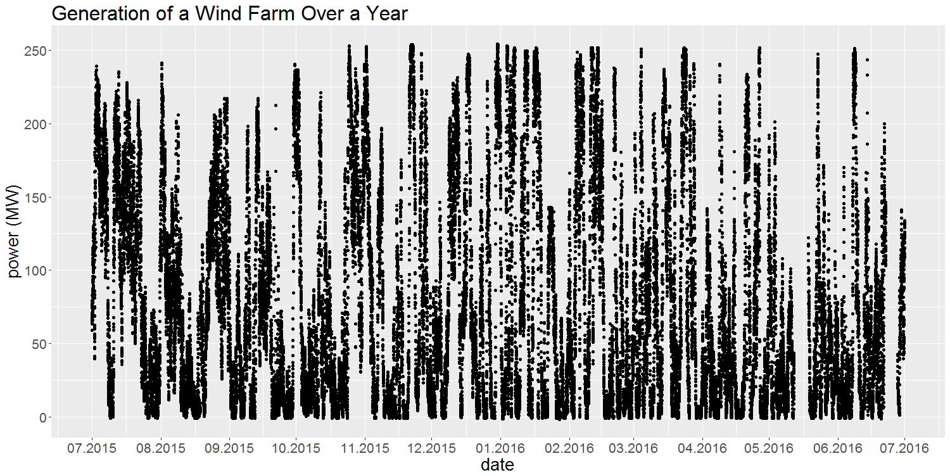
Fig. 4-1: Annual generation of a wind farm
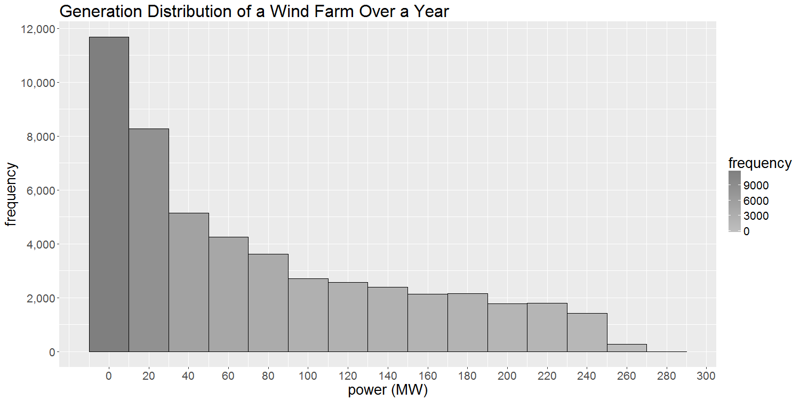
Fig. 4-2: Distribution of generation levels of a wind farm over a year

CHAPTER 5

CONCLUSIONS AND FUTURE WORK

REFERENCES
[1] U.S. Energy Information Administration, International Energy Outlook 2016, vol. 0484(2016), no. May 2016. 2016.
[2] “WIND IN NUMBERS | GWEC.” [Online]. Available: http://www.gwec.net/global-figures/wind-in-numbers/. [Accessed: 11-May-2017].
[3] “Cumulative-Market-Forecast-by-Region-2016-2020-1.jpg (2091×1123).” [Online]. Available: http://www.gwec.net/wp-content/uploads/2016/04/Cumulative-Market-Forecast-by-Region-2016-2020-1.jpg. [Accessed: 11-May-2017].
[4] “Global-Cumulative-Installed-Wind-Capacity-2001-2016.jpg (2092×739).” [Online]. Available: http://www.gwec.net/wp-content/uploads/2012/06/Global-Cumulative-Installed-Wind-Capacity-2001-2016.jpg. [Accessed: 23-May-2017].
[5] Turkish Wind Energy Association, “Türkiye Rüzgar Enerjisi İstatistik Raporu,” 2017.
[6] A. Ipakchi and F. Albuyeh, “Grid of the future,” IEEE Power Energy Mag., vol. 7, no. 2, pp. 52–62, 2009.
[7] H. Zhao, Q. Wu, S. Hu, H. Xu, and C. N. Rasmussen, “Review of energy storage system for wind power integration support,” Appl. Energy, vol. 137, pp. 545–553, 2015.
[8] K. Dvijotham, S. Backhaus, and M. Chertkov, “Operations-Based Planning for Placement and Sizing of Energy Storage in a Grid With a High Penetration of Renewables,” vol. 98195, 2011.
[9] Y. Sun, Z. Zhang, G. Li, and J. Lin, “Review on frequency control of power systems with wind power penetration,” Power Syst. Technol. ( …, pp. 1–8, 2010.
[10] H. T. Le, S. Santoso, and T. Q. Nguyen, “Augmenting wind power penetration and grid voltage stability limits using ESS: Application design, sizing, and a case study,” IEEE Trans. Power Syst., vol. 27, no. 1, pp. 161–171, 2012.
[11] “Commercialisation of Energy Storage in Europe,” no. March, p. 96, 2015.
[12] G. Fuchs, B. Lunz, M. Leuthold, and D. U. Sauer, “Technology Overview on Electricity Storage,” Inst. Power Electron. Electr. Drives (ISEA), RWTH Aachen Univ., no. June, p. 66, 2012.
[13] K. Han and T. Carson, “Executive summary,” Management, vol. II, pp. 10–16, 2008.
[14] S. Teleke, M. E. Baran, S. Member, S. Bhattacharya, and A. Q. Huang, “Optimal Control of Battery Energy Storage for Wind Farm Dispatching,” IEEE Trans. Energy Convers., vol. 25, no. 3, pp. 787–794, 2010.
[15] “Advantages and Challenges of Wind Energy | Department of Energy.” [Online]. Available: https://energy.gov/eere/wind/advantages-and-challenges-wind-energy. [Accessed: 08-Jun-2017].
[16] G. Celli, S. Mocci, F. Pilo, and M. Loddo, “Optimal integration of energy storage in distribution networks,” 2009 IEEE Bucharest PowerTech, pp. 1–7, 2009.
[17] J. Morren, S. Member, S. W. H. De Haan, W. L. Kling, and J. A. Ferreira, “Wind Turbines Emulating Inertia and Supporting Primary Frequency Control,” vol. 21, no. 1, pp. 2005–2006, 2006.
[18] T. Zhang, Z. J. Bao, G. Chen, Q. Yang, and W. J. Yan, “Control strategy for a hybrid energy storage system to mitigate wind power fluctuations,” 2013 6th Int. Conf. Adv. Comput. Intell. ICACI 2013 - Proc., vol. 28, no. 1, pp. 27–32, 2013.
[19] H. Chen, T. N. Cong, W. Yang, C. Tan, Y. Li, and Y. Ding, “Progress in electrical energy storage system: A critical review,” Prog. Nat. Sci., vol. 19, no. 3, pp. 291–312, 2009.
[20] W. Li, G. Jo??s, and C. Abbey, “Wind power impact on system frequency deviation and an ESS based power filtering algorithm solution,” 2006 IEEE PES Power Syst. Conf. Expo. PSCE 2006 - Proc., vol. 2, pp. 2077–2084, 2006.
[21] A. K. Yoon, H. S. Noh, and Y. S. Yoon, “Analysis of Vanadium Redox Flow Battery Cell with Superconducting Charging System for Solar Energy,” Electr. Electron. Eng., vol. 6, no. 1, pp. 1–5, 2016.
[22] D. L. Yao, S. S. Choi, K. J. Tseng, and T. T. Lie, “Determination of short-term power dispatch schedule for a wind farm incorporated with dual-battery energy storage scheme,” IEEE Trans. Sustain. Energy, vol. 3, no. 1, pp. 74–84, 2012.
[23] “Battery State of Charge Determination.” [Online]. Available: http://www.mpoweruk.com/soc.htm. [Accessed: 12-May-2017].
[24] “Battery Life and How To Improve It.” [Online]. Available: http://www.mpoweruk.com/life.htm. [Accessed: 12-May-2017].
[25] A. Brooks, E. Lu, D. Reicher, C. Spirakis, and B. Weihl, “Demand dispatch,” IEEE Power Energy Mag., vol. 8, no. 3, pp. 20–29, 2010.
[26] Y. Ma, A. Kelman, A. Daly, and F. Borrelli, “Predictive Control for Energy Efficient Buildings with Thermal Storage: Modeling, Stimulation, and Experiments,” IEEE Control Syst., vol. 32, no. 1, pp. 44–64, 2012.

