## Integration of Wind Power

Renewable generations such as wind and solar energies are rapidly penetrating power systems today, as environmental impacts of electricity production becomes more important than ever before. Today, 3.7% of global electricity is supplied by wind power and this percentage is expected to increase for the next years **[1]**. Total installed wind power capacity has reached approximately 487,000 MW at the end of 2016 and is expected to reach around 790.000 MW in 2020 **[2].** Installed wind capacity over years can be observed in **Figure 1** **[3].**

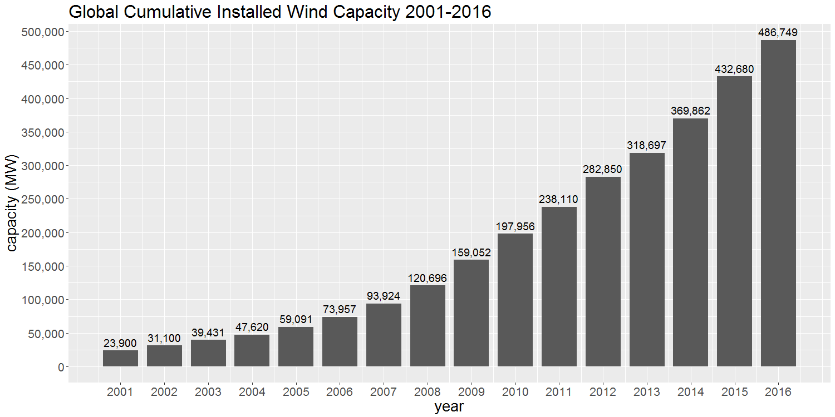**Figure 1 Historical development of global installed wind capacity [3]**

With the increasing penetration of wind energy to power systems, security and reliability of power systems are negatively affected, as a consequence of unpredictable and varying nature of wind. Power output of wind turbine is higly dependent on wind speed and can be expressed as follows:

$P=\frac{1}{2}ρ_{air}C_{p}\left(λ,β\right)πr^{2}v^{3}$ (1)

where:

Cp(λ,β): power coefficient, a function of the tip speed ratio λ and the pitch angle β

r: blade length

v: wind velocity

As it can be observed from **Equation 1**, even small variations of wind speed can cause large power fluctuations. In **Figure 2**, fluctuations of power output for a wind farm in Turkey can be observed. Power level frequencies of the wind farm can also be seen in **Figure 3**.

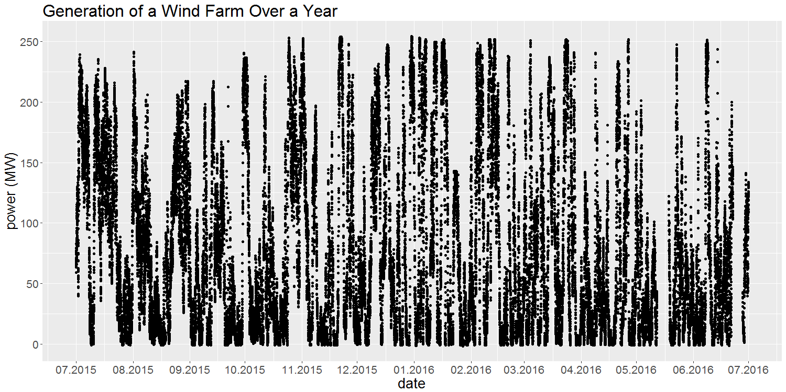**Figure 2 Scatterplot of a wind farm annual generation**

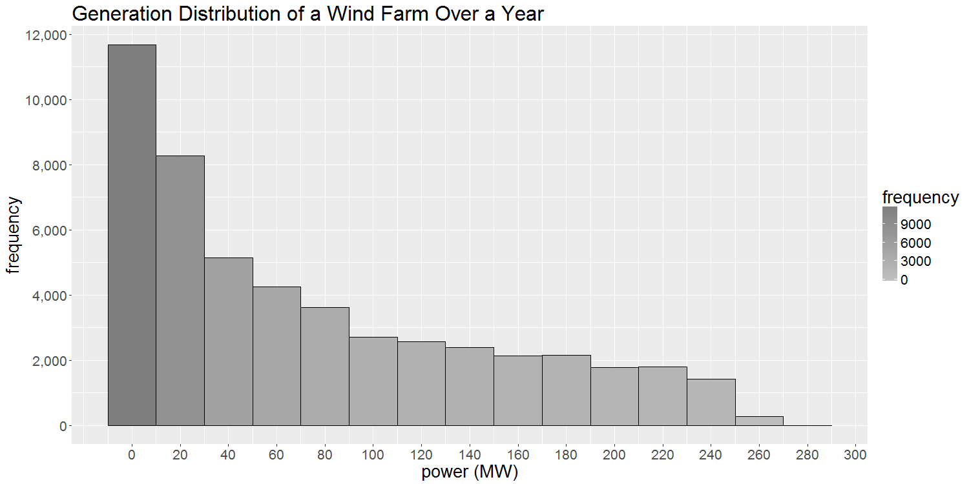**Figure 3 Histogram of a wind farm annual generation**

To cope with unpredictable and variable nature of wind, more power system flexibility is needed for high wind power penetration. One of the solutions for improving power system flexibility is integration of energy storage systems (ESSs). With the help of ESSs, security and reliability of the system can be increased.

**[1]** [**http://www.gwec.net/global-figures/wind-in-numbers**](http://www.gwec.net/global-figures/wind-in-numbers)

**[2]** [**http://www.gwec.net/wp-content/uploads/2016/04/Cumulative-Market-Forecast-by-Region-2016-2020-1.jpg**](http://www.gwec.net/wp-content/uploads/2016/04/Cumulative-Market-Forecast-by-Region-2016-2020-1.jpg)

**[3] Fried, L. (2017, February 10). Global wind statistics 2016**