Coil type | Magnetic Field(mT) | Detector Coil | Impedance(Ohm) | Enductance(mH) | Inductive reactance(Ohm)
Klasik | 2 | 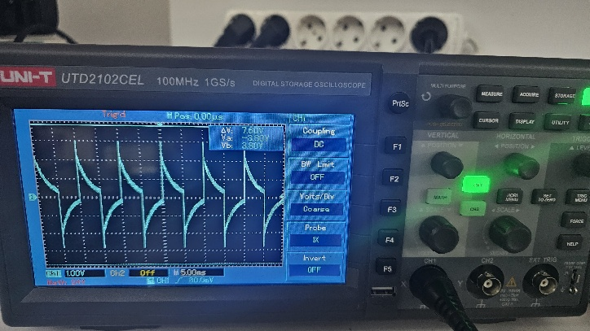 | 8.9 | 21.4 | 13.44
500N(10V) | 10 | 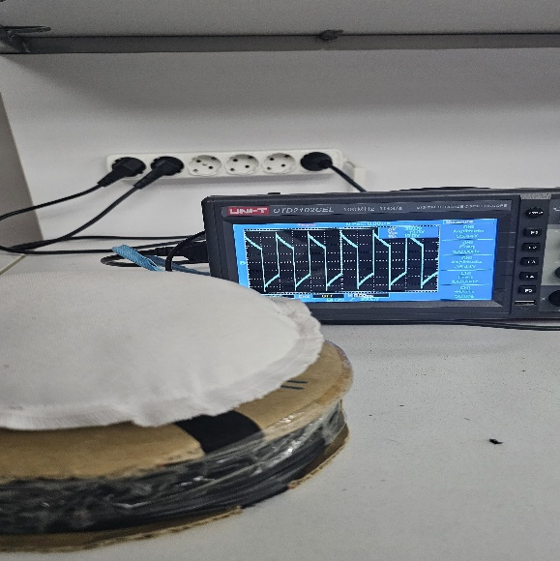 | 12.5 | 76.7 | 48.19
Butterfly Coil | 1 | 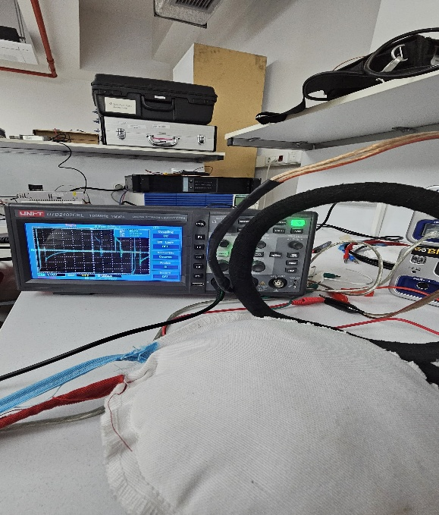
beyaz | 5 | 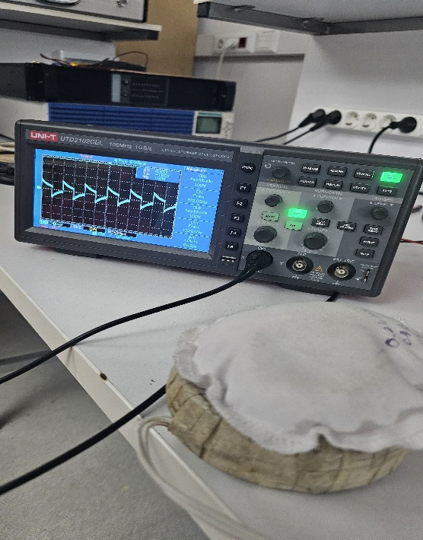
120 spin | 0.5 | 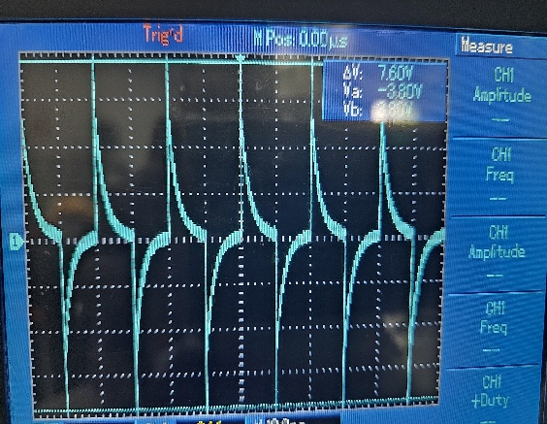 |  | 65 | 41
Helmholtz | 0.3 |  |  | 15 | 9.42
Pasco:Voltage:15v Voltage offset:5V Current:1.5A Frequency:100hz Duty cycle:%50 Amplitude:10V

Stm32:Frequency:100hz Duty cycle:%50
Coil type | Magnetic Field | Voltage | Current(A) | Power(W)
Klasik | 9 | 23.25 | 0.9 | 20.93
 | 8 | 19.18 | 0.7 | 13.43
 | 5.5 | 13.37 | 0.5 | 6.69
 | 12 | 28.24 | 1.09 | 30.78
 | 13.5 | 30 | 1.14 | 34.20

Detector 5.5mT 13.5mT
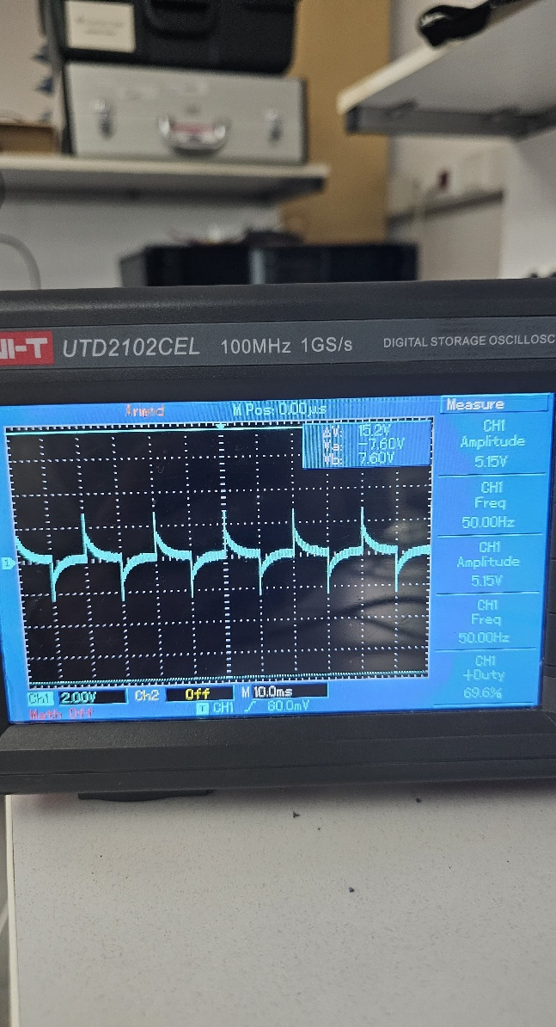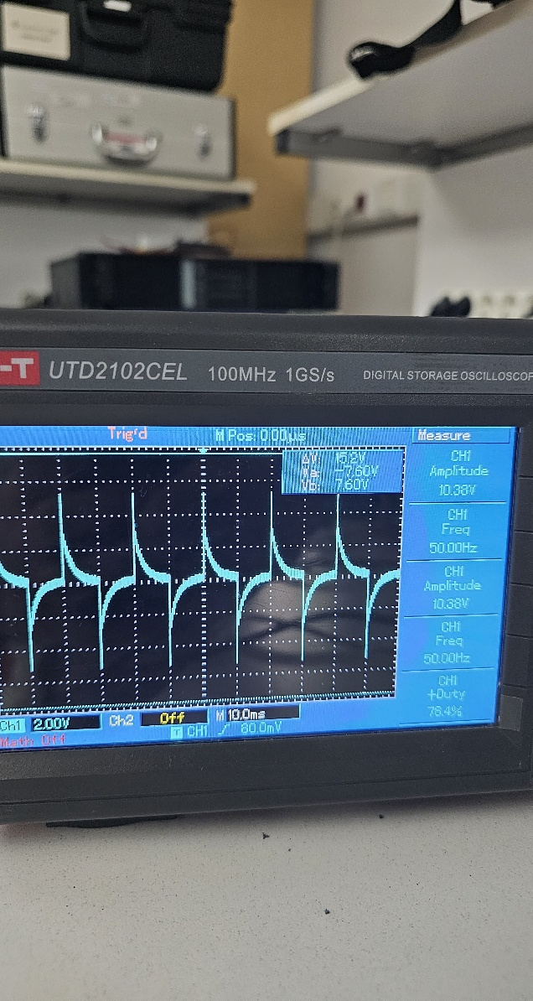

Coil type | Magnetic Field(mT) | Voltage(V) | Current(A) | Power(W)
Helmholtz | 1.5 | 16.9 | 0.14 | 2.37
 | 1.8 | 20.7 | 0.17 | 3.52
 | 2.1 | 24.62 | 0.2 | 4.92
 | 2.4 | 27.6 | 0.22 | 6.07
 | 2.8 | 32 | 0.26 | 8.32

Detector 1.5mT 2.8mT
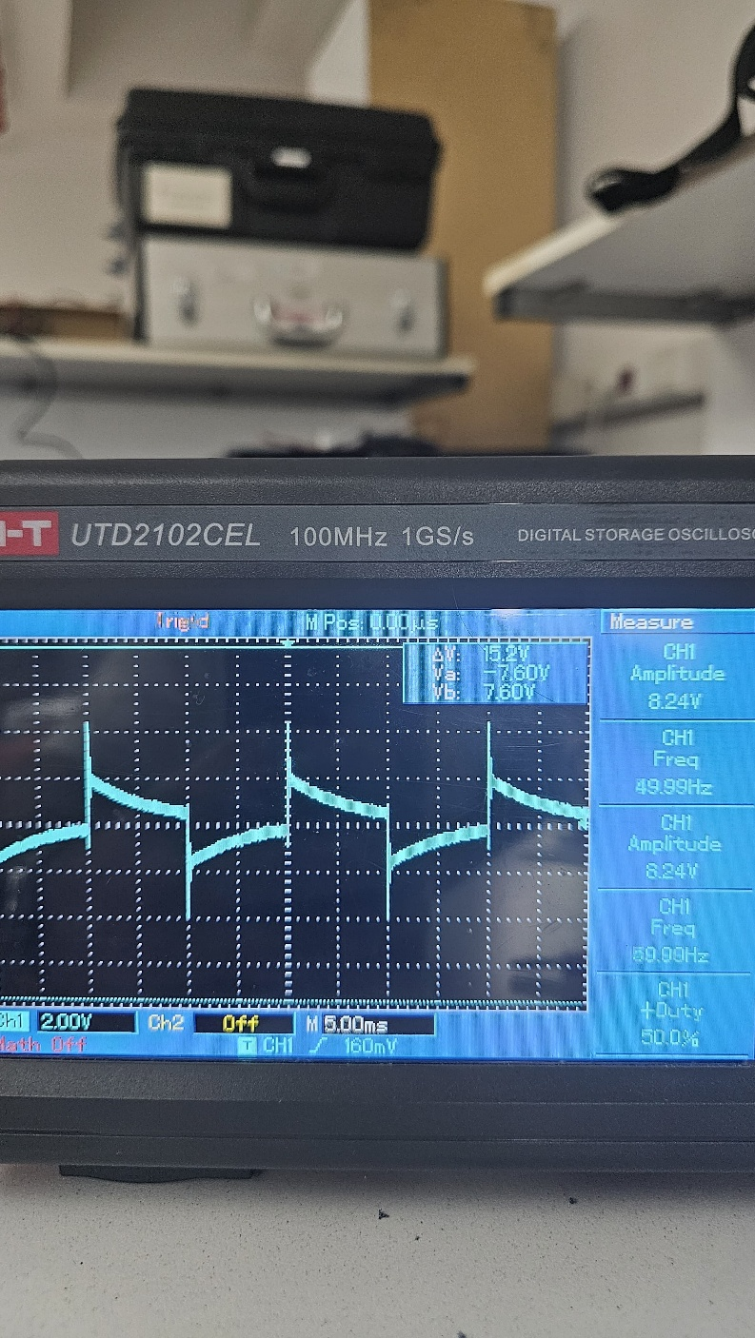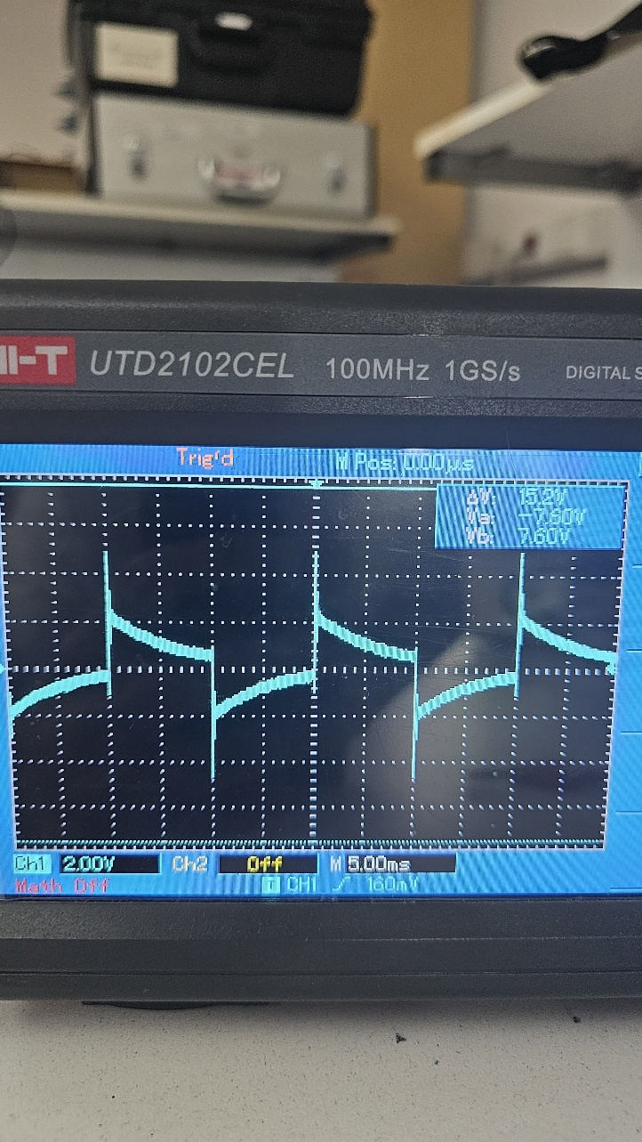

Coil type | Magnetic Field(mT) | Voltage(V) | Current(A) | Power(W)
500N | 6 | 16 | 0.41 | 6.6
 | 8 | 20.3 | 0.52 | 10.6
 | 9.8 | 24.1 | 0.62 | 14.9
 | 11 | 27.6 | 0.7 | 19.54
 | 12.5 | 31 | 0.79 | 24.42

Detector 6mT 12.5mT
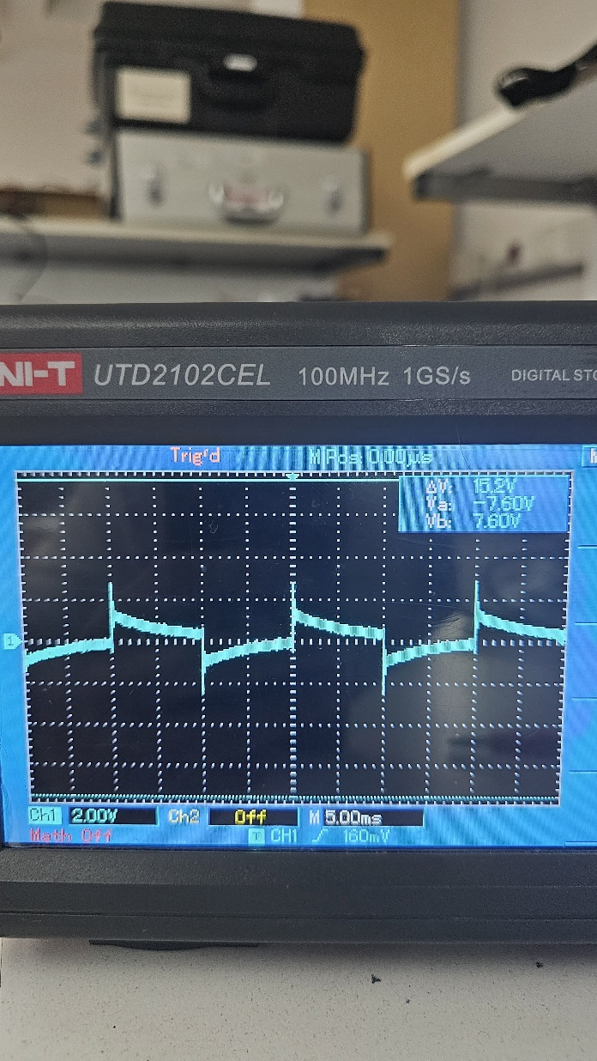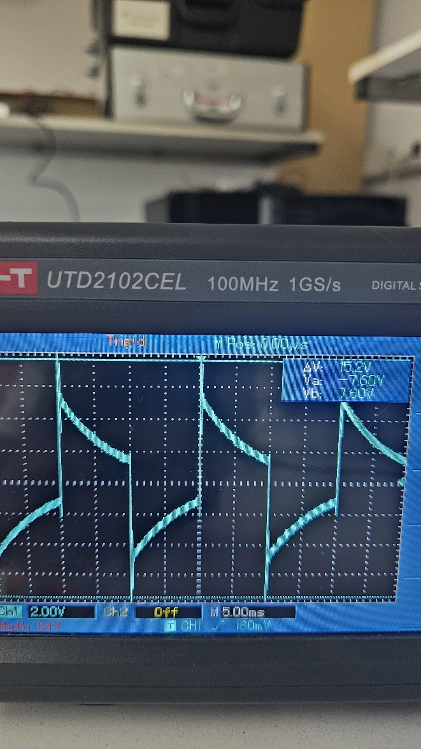
Coil type | Magnetic Field(mT) | Voltage(V) | Current(A) | Power(W)
Butterfly Coil | 0.4 | 5.5 | 0.27 | 1.52
 | 1 | 7 | 0.8 | 5.69
 | 1.4 | 8.4 | 0.97 | 8.2
 | 2 | 9.75 | 1.15 | 11.2

Detector 0.4mT 2mT

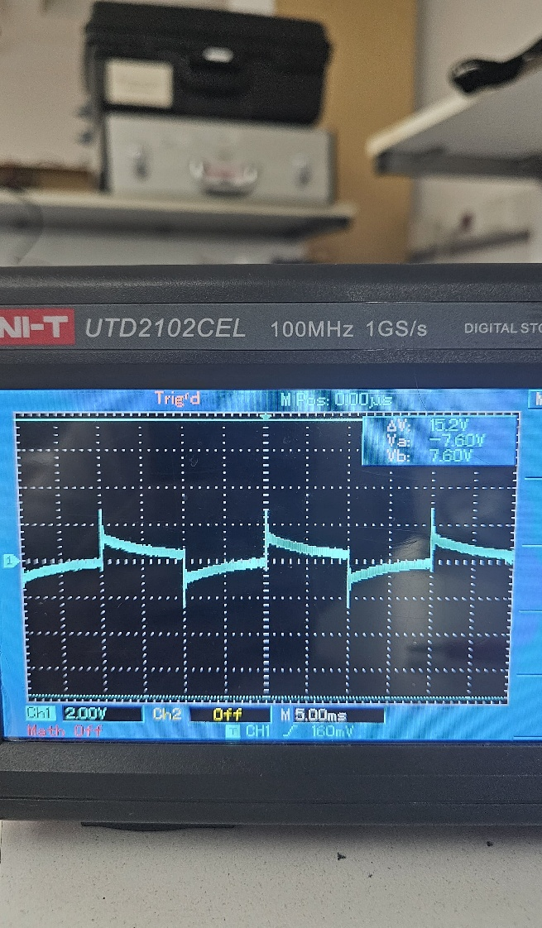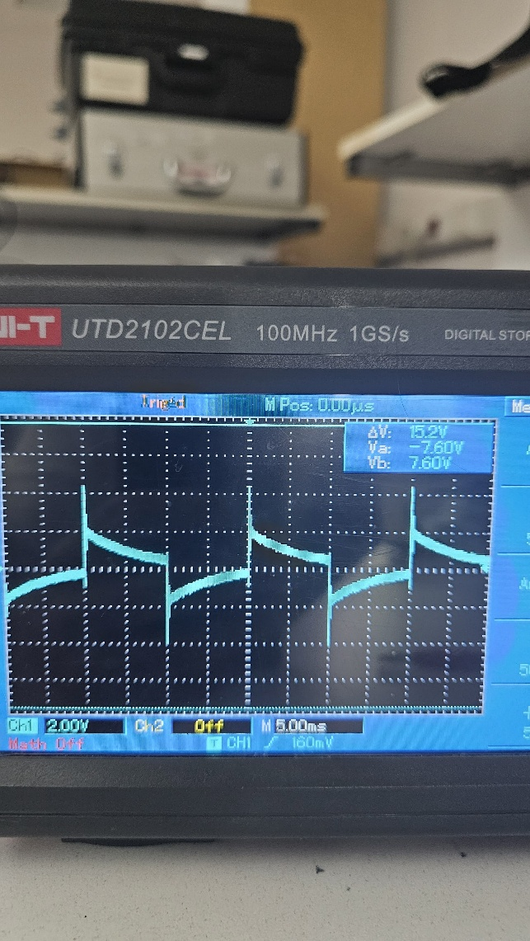
Coil type | Magnetic Field(mT) | Voltage(V) | Current(A) | Power(W)
120n | 4 | 7 | 0.22 | 1.57
 | 5 | 10.1 | 0.32 | 3.26
 | 7.5 | 13.85 | 0.42 | 5.9
 | 9.5 | 17.14 | 0.52 | 8.9
 | 12 | 22.32 | 0.68 | 15.15

Detector 4mT 12mT
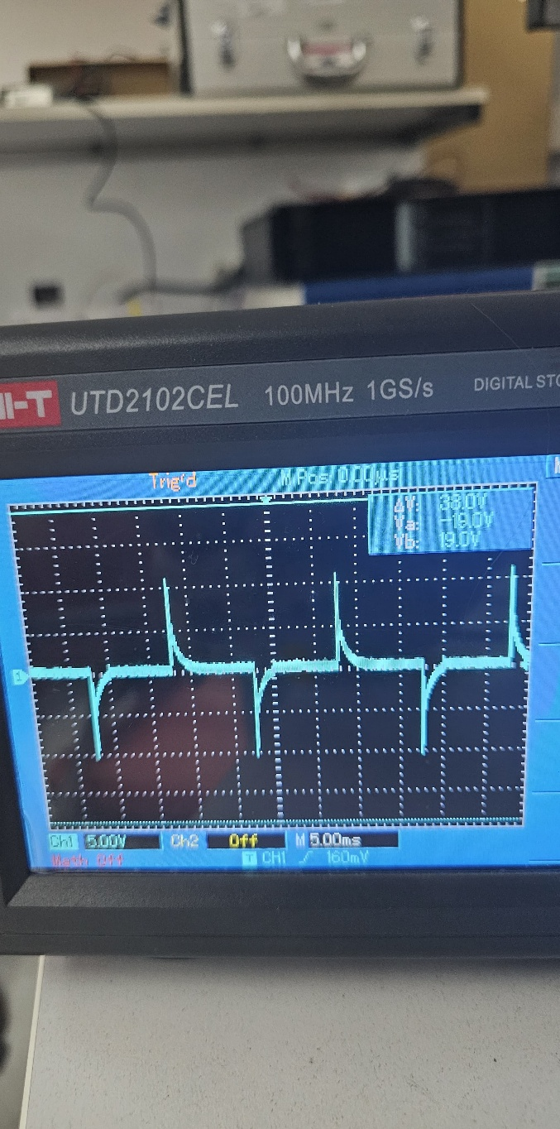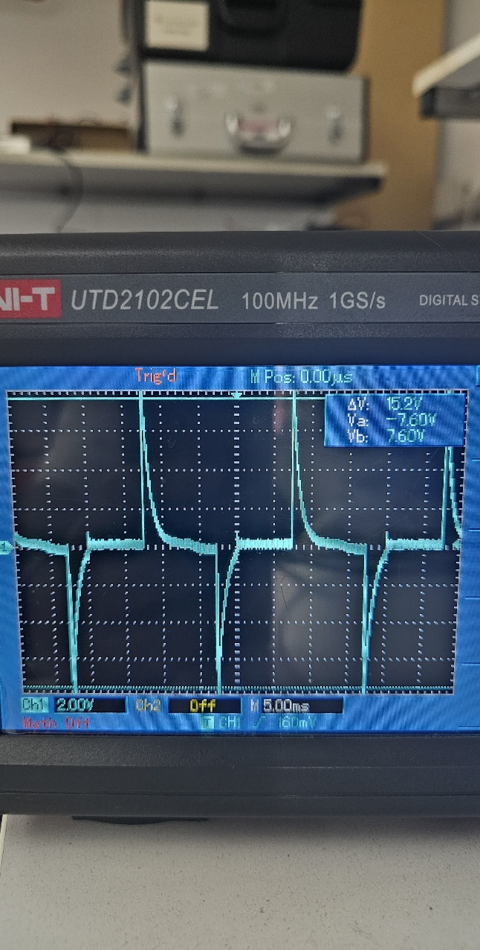

Coil type | Magnetic Field(mT) | Voltage(V) | Current(A) | Power(W)
Tms | 0.4 | 5.71 | 0.84 | 4.87
 | 0.5 | 5.47 | 1.04 | 5.72
6.23mh | 4.5 | 5.71 | 0.9 | 5.14
 | 0.5 | 5.19 | 0.1 | 0.56
 | 6 | 5.7 | 1.08 | 6.3

Detector 0.4mT 6mT
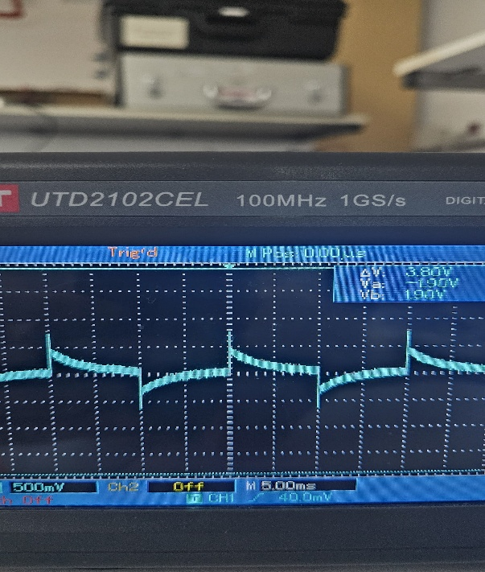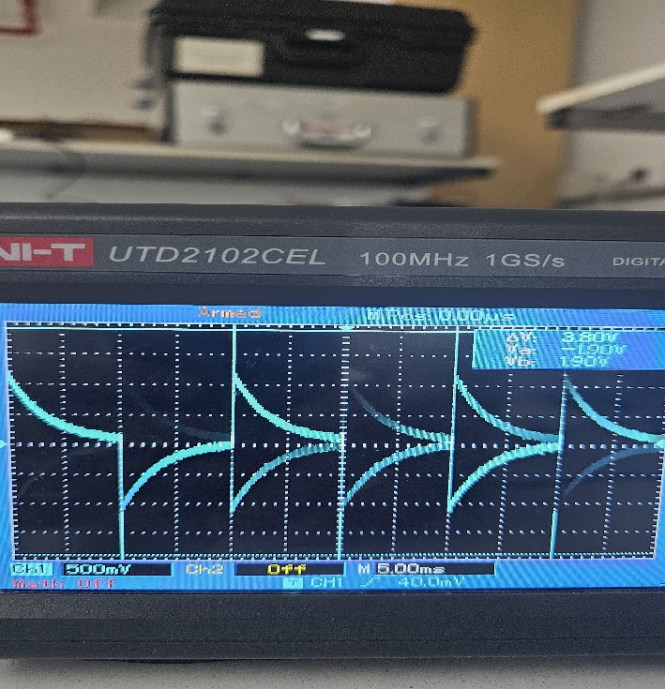

Coil type | Magnetic Field(mT) | Voltage(V) | Current(A) | Power(W)
Logarithmic | 1.8 | 0.05 | 29.6 | 1.45
 | 2 | 0.052 | 31.5 | 1.6

Detector 2mT
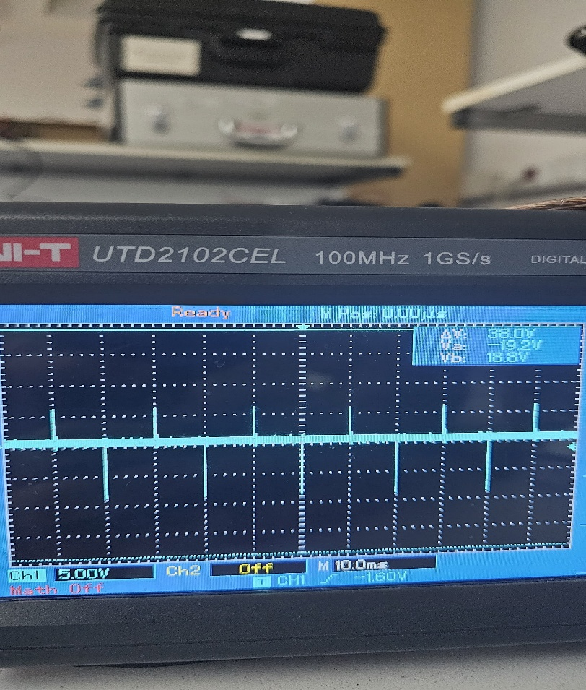

Pasco vs STM32
Coil type | Magnetic field (Pasco)15v  (mT) | Magnetic field(STM32)  (mT)
Klasik | 2 | 5.5 for 13.37V 0.5A
Helmholtz | 0.3 | 1.5 for 16V 0.14A
500n | 10 for 10V( power supply) | 12.5 for 31V 0.79A
Butterfly | 1 | 2 for 9.75V 1.15A

